**CS 555**

**HOMEWORK 7**

**Name:** Ivan Sangines Escrig

**ID#:** 968606

**Instructor:** Dr. Mahmood

**Date:** November 27, 2018

**TABLE OF CONTENT**

**INTRODUCTION** 3

**SCREENSHOTS:** 4

**CONCLUSION:** 9

**INTRODUCTION**

The objective of this assignment is to get used to and understand bootstrap better. This will be done by doing all the examples in the handout and comparing it with the first part which is done in HTML.

**SCREEN SHOTS:**

**EStore:**

Home page for the EStore, all the colors and formats in this html page as well as all the others (Home, Products, Customers…) is done using a style sheet in the CSS folder.

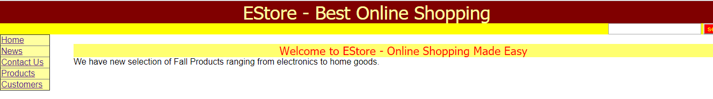

This screenshot belongs to the News html page. As we can see on the right part of the page, the News link is highlighted with green. This is done by the style sheet using the property hover for all the td in the nav table.

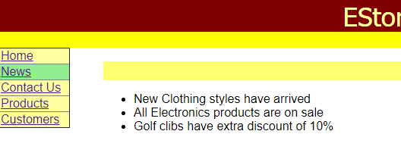

Very similar to the News page, we have the contactUs page with some information. Once again, most of the style for the page is done in the style sheet.

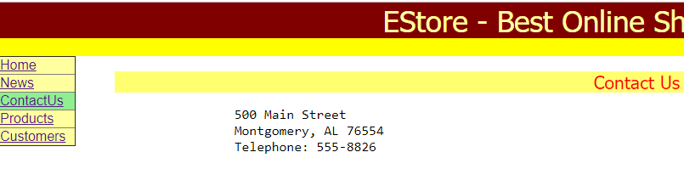

On the Products page we can see a table with couple of pictures (imported from the images folder). The table is divided in three columns: Picture, Description and Price

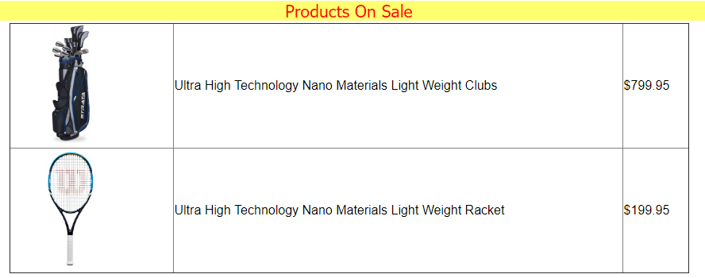

Finally we have the customer’s page which has a table with different customer’s info. As we can see, the table has the even rows with an orange background, this is achieved in the style sheet by creating a style for the table “custdata” and setting the even rows with orange background. The table also have de hover attribute set to orange for all the td in the custdata table (see Mike Row).

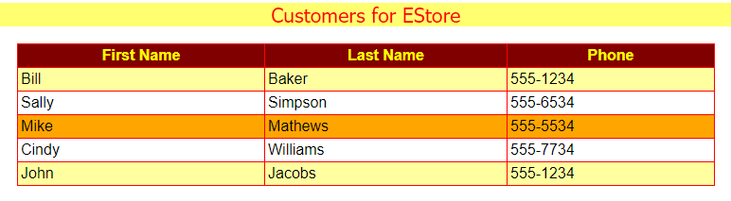

**BootstrapApp:**

In this screenshot we can see a form created using bootstrap. This was very useful in order to understand how textboxes, radio buttons and dropdowns are created in bootstrap. Also, the Submit button has a default class btn-success which highlights it with green.

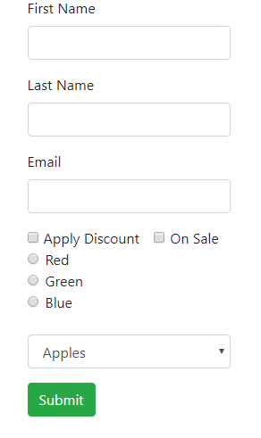

The next screenshot shows a table created with bootstrap, as we can see the head of the table is highlighted with green, which is achieved by declaring a style class at the beginning of the HTML page. Also, the even rows are darker than the odd ones, this is done by table-striped style.

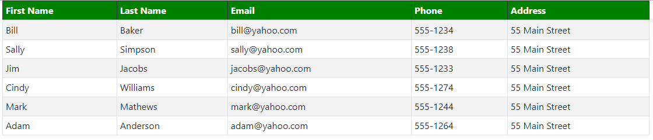

**EStoreBoot**

The objective of this part of the assignment was recreate the EStore using bootstrap. Even though the outcome is very similar, there are some differences in the code as the declarations for the tables and some style features which come predetermined in bootstrap.

Contact page:

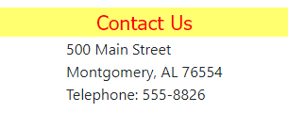

News page:

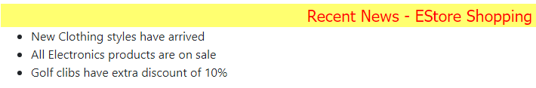

Products page:

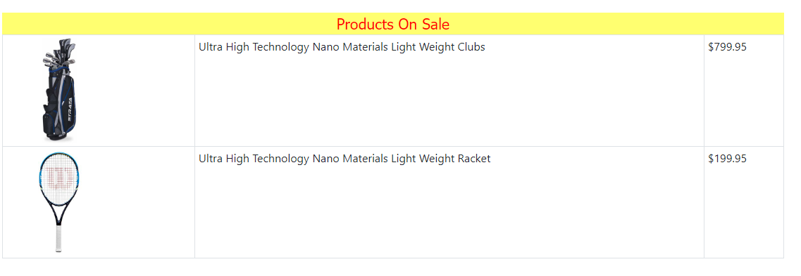

Customer’s page:

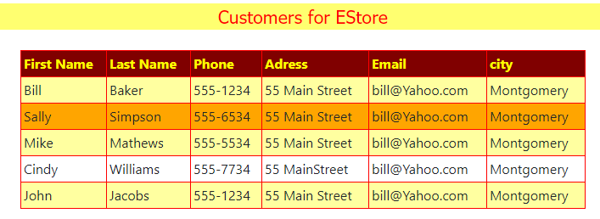

**Conclusion:**

After doing this assignment I was able to understand better how bootstrap work. I can say it is very similar to html. However, this assignment made me realize there are some differences whenever we declare things such as textboxes, radio buttons, drop downs. Also, some style features are different. Bootstrap has different pre created classes such as –success –warning !important etc.