**A Report**

**ON**

**Development of Input Processing Module for NuPAC**

BY

Name of Student ID No.

Ivanshu Kaushik 2018A8PS0520P

AT

Atomic Energy Regulatory Board, Mumbai

A Practice School Station of

**Birla Institute of Technology & Science, Pilani**

**June, 2020**

**A Report**

**ON**

**Development of Input Processing Module for NuPAC**

BY

Name of Student ID Nos Discipline

Ivanshu Kaushik 2018A8PS0520P ENI

Prepared in Partial fulfilment of the

Practice School – 1 Course No.

BITS C221

AT

Atomic Energy Regulatory Board, Mumbai

A Practice School Station of

**Birla Institute of Technology & Science, Pilani**

**June, 2020**

**ACKNOWLEDGEMENT**

I deem it a pleasure to acknowledge my sense of gratitude to my project guide Prof Prashant K Wali and Prof P Srinivasan under whom I have carried out the project work. Their incisive and objective guidance and timely advice encouraged me with constant flow of energy to continue the work.

I wish to reciprocate in full measure the kindness shown by Mr Aniket Gupta (AERB, Mumbai) who inspired me with his valuable suggestions in doing the project work

I shall remain grateful to Mr Prof Souvik Bhattacharyya, Vice Chancellor, BITS Pilani, for providing me an opportunity to do the project work with utmost concentration and dedication

Finally, I must say that no height is ever achieved without some sacrifices made at some end and it is here I owe my special debt to my parents and friends for showing their generous love and care throughout the entire period of time.

Date: 22.06.2020

Name: Ivanshu Kaushik

ID No.: 2018A8PS0520P

**Birla Institute of Technology and Science, Pilani**

**(Rajasthan)**

**Practice School Division**

**Station:** Atomic Energy Regulatory Board **Centre:** Mumbai

**Duration:** 18th May to 27th June 2010 **Date of Start:** 18th May 2020

**Date of Submission:** 25th June 2020

**Title of Project:** Development of Input Processing Module for NuPAC

**ID No:** 2018A8PS0520P

**Name:** Ivanshu Kaushik

**Discipline of Student:** Electronics and Instrumentation

**Name of Expert:** Mr. Aniket Gupta

**Designation of the expert:** Scientist at AERB

**Name of the PS 1 faculty:** Prof. Prashant K Wali

**Key Words:** NuPAC, Safety, PWR, PHWR, RELAP5 etc

**Project Areas:** Python, Programming, Computer Science

**Abstract:** Input Processing Module is an attempt to develop a module which can take inputs, and check them according to a rule file and give corresponding results.

Signature of Student Signature of PS-1 Faculty

Date: 25/06/2020 Date:

**INTRODUCTION**

As a part of the safety analysis code development programme, 1-D transient thermal hydraulic code, Nuclear Plant Analyser Code (NuPAC) is being developed. Transient thermal-hydraulic, two- phase phenomena were calculated from formulations of one-dimensional, homogeneous, equilibrium conservation equations for mass, momentum and energy.

NuPAC code is based on finite volume method and employs a semi-implicit numerical scheme for solution of governing equations. The NuPAC code has the capability to simulate closed loop, open loop and parallel flow systems. It is an indigenous replacement for the earlier used code RELAP5 (Reactor Excursion and Leak Analysis Program) which was developed at Idaho National University, United States of America.



RELAP5 (Figure 1.1)

RELAP5 was developed in early 1980’s in USA to meet the United States reactors safety needs. RELAP5 code is primarily for the PWR (Pressurised Water Reactor) type Nuclear Reactors. RELAP5-3D is a transient, two-fluid model for flow of a two-phase vapor/gas-liquid mixture that can contain non-condensable components in the vapor/gas phase and/or a soluble component in the liquid phase.

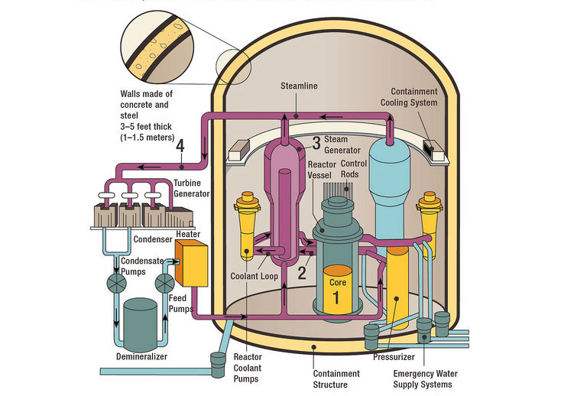

A typical PWR type Nuclear Reactor (Figure 1.2)

However, the majority of Indian reactors are PHWR (Pressurised Heavy Water) type nuclear reactors.

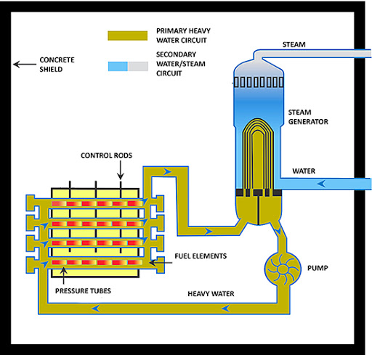

A typical PHWR type Nuclear Reactor (Figure 1.3)

So, the RELAP5 code is not directly applicable to meet the safety demands of our Indian Nuclear Reactors. The RELAP5 code used to be customised for use in PHWR type Nuclear reactors but this process was very long and inefficient. So AERB, under the banner of DAE (Department of Atomic Energy) decided to develop our own Nuclear safety simulation code called the NuPAC.

**About Atomic Energy Regulatory Board (AERB)**

The Atomic Energy Regulatory Board (AERB) was constituted on 15 November 1983 by the President of India exercising the powers conferred by Section 27 of the Atomic Energy Act, 1962 (33 of 1962) to carry out certain regulatory and safety functions under the Act. The regulatory authority of AERB is derived from the rules and notifications promulgated under the Atomic Energy Act, 1962 and the Environmental (Protection) Act, 1986. The headquarters is in Mumbai.

The mission of the Board is to ensure that the use of ionising radiation and nuclear energy in India does not cause undue risk to health and the environment.

AERB secretariat has Nine technical divisions & two supporting divisions. The heads and directors of divisions constitute the Executive Committee which meets periodically with Chairman, AERB and Executive Director, AERB to take decisions on important policy matters related to the management of the Secretariat of the Board.



AERB (Figure 2.1)

The different divisions of AERB are:

1. OPSD: Operating Plant Safety Division

2. NPSD: Nuclear Projects Safety Division

3. RSD: Radiological Safety Division

4. NSAD: Nuclear Safety Analysis Division

5. R&DD: Resources & Documentation Division

6. DRI: Directorate of Regulatory Inspection

7. DRA&C: Directorate of Regulatory Affairs & Communications

8. DRP&E: Directorate of Radiation Protection & Environment

9. SRI: Safety Research Institute, Kalpakkam

**Software Requirements and Specifications**

**3.1 Industry Perspective**

The idea behind this project is to develop a software code for input processing modules to simulate the thermal and hydraulic condition and postulated failures conditions using NuPAC.

The purpose of this project work is to provide and Input Processing Module for NuPAC which will process the inputs and validate them according to a rule file and then save the output in a way that it can be used further for stability testing, simulation and analysis of various parameters of Nuclear Power Plants. This will ensure the independence of our Nuclear Industry from using foreign technologies and relying on indigenous technologies instead. The Input Processing module makes it possible for the developers who are concerned about major safety parameters to not pay attention to inputting the files and thus ensuring an efficient and fast Safety Analysis in the Nuclear Power Plants to ensure that no accidents take place.

**3.2 User Characteristics**

The users who are making this program are trying to make use of the latest technologies so that with time this module doesn’t get outdated and the algorithm involves proficiency in the following areas:

* Python Programming Language and all the concepts of Object-oriented programming and especially abstraction methods
* List Methods and List Comprehensions, Anonymous functions, Dictionaries in Python and all the various methods involved with accessing dictionaries and using them. Loops including for loop, while loop, if loop, else loop etc.
* Different modules in Python including RegExp (re module) Itertools (itertools module) and islice method of the itertools module and use of List iterators and Iteration tools
* Use of PyCharm as IDE (Integrated Development Environment) as it provides a free development environment making it easier to code in Python
* Use of text editors like Sublime Text 3 as the input and output involve parsing, reading and writing to text files.

**3.3 Functional Requirements**

The functional requirement of this project is to develop a software code for input processing module to simulate the Thermal and Hydraulic condition of Reactor Core under Normal Operating Condition and Postulated Failure Conditions. The parameters for which this code will be tested are Temperature of Coolant, Temperature of Clad, Coolant Flow, Pressure of Coolant, Moderator Level, Neutron Flux, Power Level etc.

The developed code will be testable and user-friendly and secure for given operating parameters and to simulate the effects on reactor core.

**3.4 Performance Requirements**

The algorithm developed involves reading the input file, Parsing it and then turning the input into a Key-Value Pair. The input is nested so the Dictionary created will also be nested.

The input file is to be checked according to a set of rules which is also read as the rules file. If the input file matches all the rules and there is no error, then the input file is to be written into another file as a Key-Value Pair which can be inputted by the developers as a Module. The performance requirement is to meet the following requirements:

• Accuracy

• Consistency

• Time Response

**About PHWR type Nuclear Reactors**

A **pressurized heavy water reactor** (PHWR) is a nuclear power reactor, commonly using unenriched natural uranium as its fuel, that uses heavy water (deuterium oxide D2O) as its coolant and moderator. The heavy water coolant is kept under pressure, allowing it to be heated to higher temperatures without boiling, much as in a typical pressurized water reactor. While heavy water is significantly more expensive than ordinary light water, it yields greatly enhanced neutron economy, allowing the reactor to operate without fuel enrichment facilities (mitigating the additional capital cost of the heavy water) and generally enhancing the ability of the reactor to efficiently make use of alternate fuel cycles.

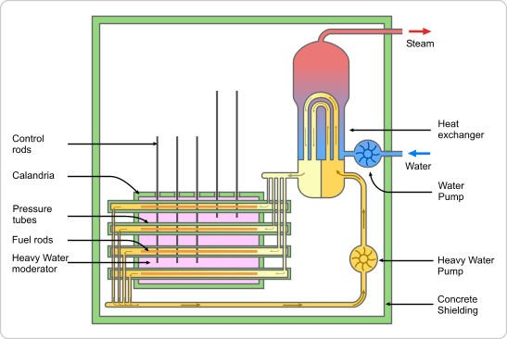

A PHWR type Nuclear Reactor (Figure 4.1)

The major components of a PHWR type Nuclear Power Plant are:

1. Reactor Building
2. Cooling Tower
3. Turbine Building
4. Auxiliary Building
5. Spent Fuel Storage Pool
6. Control Room

**4.1 Reactor Building**

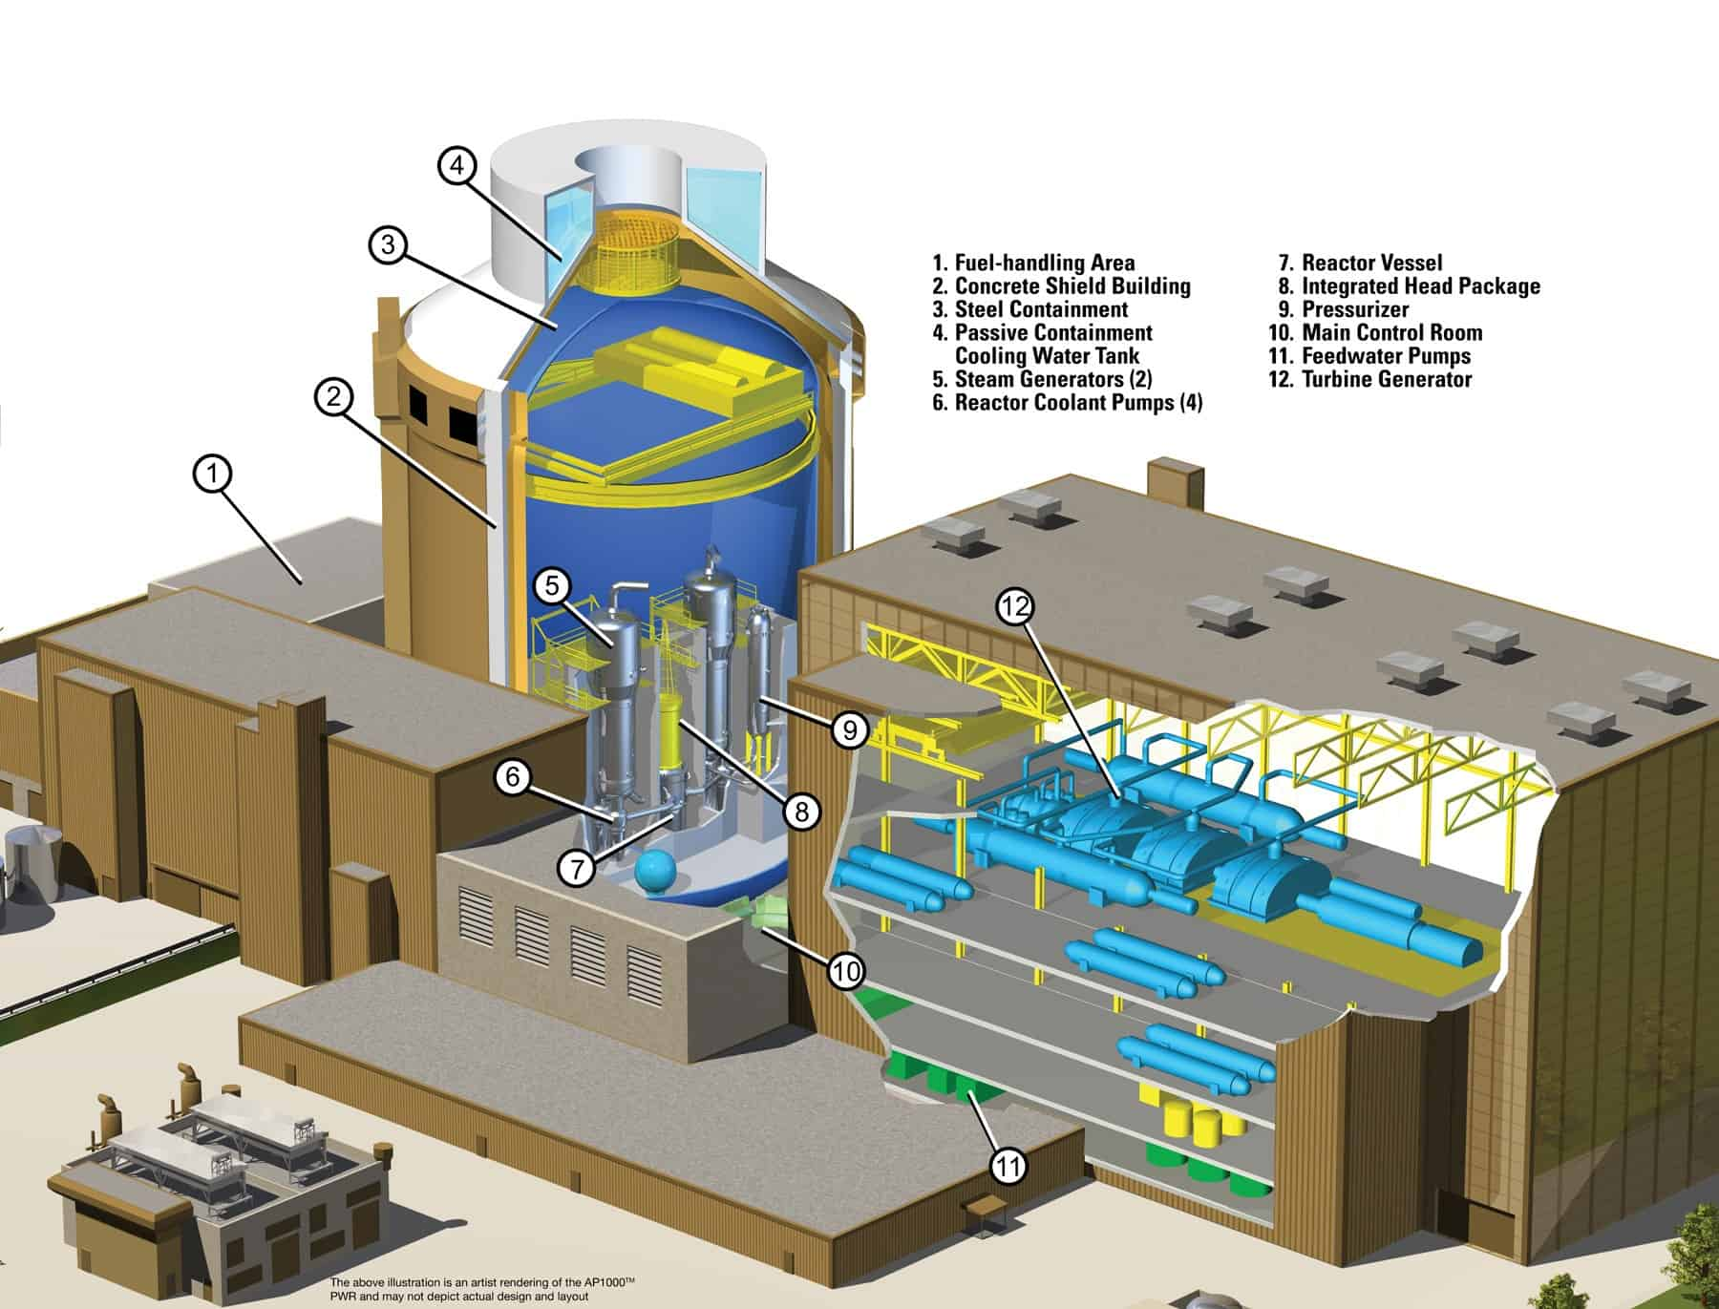

A Reactor Building (Figure 4.2)

A **reactor building** is a general term for a building that houses a reactor of some type. In particular, it often refers to a building containing a nuclear reactor. This can also be used to refer to pressure sealed buildings containing nuclear reactor, though it would be more correct to call them containment buildings**.**

A reactor building, in its most common usage, is a reinforced steel or lead structure enclosing a nuclear reactor. It is designed, in any emergency, to contain the escape of radioactive steam or gas to a maximum pressure in the range of 275 to 550 kPa (40 to 80 psi). The containment is the fourth and final barrier to radioactive release (part of a nuclear reactor's defence in depth strategy), the first being the fuel ceramic itself, the second being the metal fuel cladding tubes, the third being the reactor vessel and coolant system.

**4.2 Cooling Tower**

A Cooling Tower (Figure 4.3)

A **cooling tower** is a heat rejection device that rejects waste heat to the atmosphere through the cooling of a water stream to a lower temperature. Cooling towers may either use the evaporation of water to remove process heat and cool the working fluid to near the wet-bulb air temperature.

The process begins with a reactor pressure vessel which houses fuel assemblies. These fuel assemblies cause fission chain reactions, which release great amounts of heat. This process heats up water, which is transported to the heat exchanger. After different water is transformed into steam in a heat exchanger, it flows through a set of turbines that are attached to a steam generator, which creates energy. It then travels through a condenser, which converts it back to liquid form. The condenser acts as a reverse heat exchanger and cools the steam into water. The condenser takes in cold water and generates hot water. The cooling tower transforms the hot water back to cold 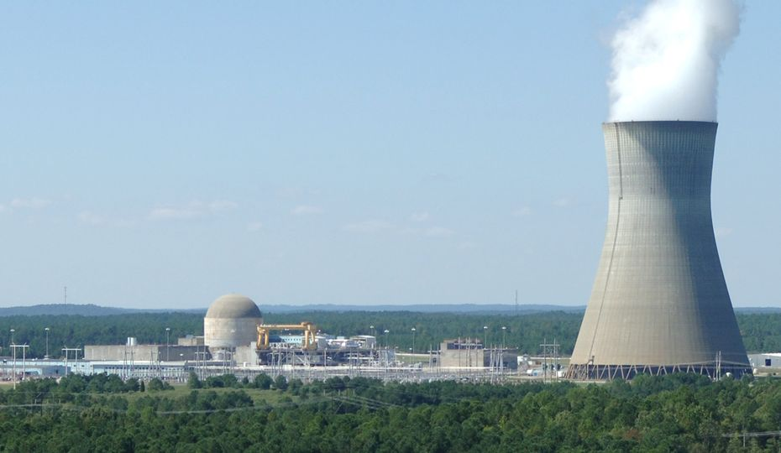water. Because there are three contained water cycles, (the primary which reacts directly with the fuel assemblies, secondary, which cools the primary, and tertiary, which cools the secondary) the water used in the condenser is not radioactive and can be released into the environment through cooling towers.

**4.3 Turbine Building**

The purpose of the steam turbine is to convert the heat contained in steam into mechanical energy. The engine house with the steam turbine is usually structurally separated from the main reactor building. It is aligned so as to prevent debris from the destruction of a turbine in operation from flying towards the reactor.

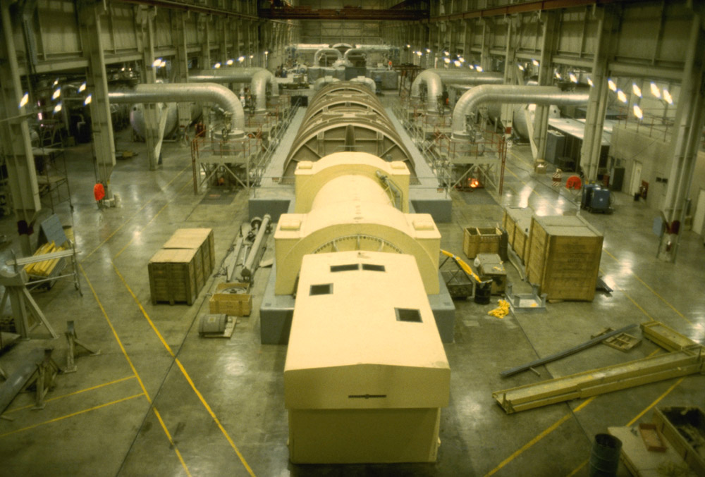

Turbine Building (Figure 4.4)

**4.4 Auxiliary Building**

A building at a nuclear power plant, which is frequently located adjacent to the reactor containment structure, and houses most of the auxiliary and safety systems associated with the reactor, such as radioactive waste systems, chemical and volume control systems, and emergency cooling water systems.

**4.5 Spent Fuel Storage Pool**

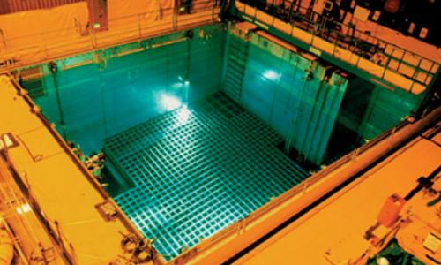

Spent fuel storage pool (Figure 4.5)

**Spent fuel pools (SFP)** are storage pools (or "ponds" - UK usage) for spent fuel from nuclear reactors. They are typically 40 or more feet (12 m) deep, with the bottom 14 feet (4.3 m) equipped with storage racks designed to hold fuel assemblies removed from reactors. A reactor's local pool is specially designed for the reactor in which the fuel was used and is situated at the reactor site. Such pools are used for immediate "cooling" of the fuel rods, which allows short-lived isotopes to decay and thus reduce the ionising radiation emanating from the rods. The water cools the fuel and provides radiological protection shielding from their radiation.

**4.6 Control Room**

A nuclear power plant control room (Figure 4.6)

Control Room in A PHWR Nuclear Power Plant Facility. Main Control Rooms. The Main Control Room in all countries is used as the main control centre in the plant. The Plant operating supervisor and senior operating personnel operate and monitor major plant equipment.

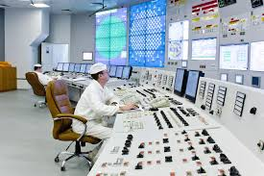

**Project Plan**

The project plan can be divided into the following major aspects:

1. Reading the Rules File
2. Reading the Input File

**5.1 Reading the Rules File**

The Rules file needs to be read and stored in a manner in which we can later retain the information and use it for validating the input file. The Rules file maybe something like:

STRU CONTAINMENT (O, BL, S, ,)  
 STRU MATE (O, BL, M, ,)  
 NAME (C, C1, S, UNIQUE AMONG MATE,)  
 ARR (C, C1, S, <EQUIDIS | VOLUME | PROGRESS | FREE>)  
 CP (C, F0, S, >0)  
 DL (C, F0, S, >0)  
 EMI (C, F0, S, >0)  
 RHO (C, F0, S, >0)  
 MESH (C, I0, S, >0)  
 FAC (C IF ARR == PROGRESS, F0, S, >0)  
 END  
  
 STRU COMP (O, BL, M, ,)  
 NAME (C, C1, M, ,)  
 PHAS (C, C1, S,<FLUID | GAS>)  
 MLMA (C, F0, S, >0 ,)  
 CDIF (C IF PHAS == GAS, F0, S, >0,)  
 CSTD (C IF PHAS == GAS, F0, S, >0,)  
 CDIS (C IF PHAS == GAS, F0, S, >0,)  
 CP (C, F0, S, <FUNCTION | R0 VALUE>)  
 DL (C, F0, S, <FUNCTION | R0 VALUE>)  
 ETA (C, F0, S, <FUNCTION | R0 VALUE>)  
 END  
  
 STRU ZONE (0, BL, M, )  
 NAME (C, C1, S, UNIQUE AMONG BLOCK ZONE )  
 MODE (C, C1, S, <NONEQUIL | EQUIL>)  
 ROOM (O, I0, S, >0 )  
 STRU GEOM (C, BL, S, )  
 VOLU (C, F0, S, >0)  
 ELEV (C, F0, S, >SELE)  
 SELE (C, F0, S, )  
 ASUM (C, F0, S, >0)  
 END  
 STRU INIT (C, BL, M, )  
 STRU COND (C, BL. M, )  
 COMP (C, C1, S, <PRES | SATUR | TEMP | AIR)  
 VALU (O, F0, S, >0)  
 UNIT (O, <C1 | C0 >, S, <BAR | C | '%'>)  
 TYPE (O, C1, S, <BAR | C | '%'>)  
 END  
 END  
 END  
 STRU CONN (O, BL, M, )  
 NAME (C, C1, S, UNIQUE AMONG BLOCK ZONE)  
 FROM (C, C1, S, VALUE SHOULD BE NAME OF ZONE)  
 TO (C, C1, S, VALUE SHOULD BE NAME OF ZONE)  
 TYPE (C, C1, S, <ATMOS_JU | RUPTURE>)  
 LEN (C, F1, S, >0)  
 SECT (C, F1, S, >0)  
 ZETE (C, F1, S, >0)  
 END  
END

Sample Rules File (Figure 5.1)

So we need to read the rules file line by line and then ensure that the way in which it is stored retains every bit of information about the rules file. For this, we create a list called bi and then we append 1 to it if we encounter the keyword ‘STRU’, -1 if we encounter ‘END’ and in all other cases we append 0 to it. So we create another list called initial_rules and we add to it the rules file line by line.

with open('rules1.txt') as rule_file:  
 for line in rule_file:  
 if not line.isspace():  
 initial_rules.append(line.strip())

Reading the Rules file line by line (Figure 5.2)

Now lets create the bi list in the manner mentioned above.

for rule in initial_rules:  
 if stru in rule:  
 bi.append(1)  
 elif end in rule:  
 bi.append(-1)  
 else:  
 bi.append(0)

Creating the bi list (Figure 5.3)

Now we create a list called sum_bi in which we add all the elements of the list bi until that corresponding element. This list contains the information about the level of nesting with the value itself being the level. For e.g. a value of 2 in sum_bi denotes that this is second level of nesting and a value of 4 shows that this is fourth level

sum_bi = []  
  
for i, b in enumerate(bi):  
 sum_bi.append(cum_sum(i, bi[:i]))

Creation of the list called sum_bi (Figure 5.4)

During the creation of the sum_bi list we have used a function called cum_sum which performs the function of summing up the values of the list bi until the corresponding element. Next we make a new list which holds all the nested components individually and ensure that the information about nesting is not lost. For that we first create a list called level_two_index which holds the indexes of when nesting starts and ends. Then we add those values to another list called initial_rules_two.

lvl_two = []  
lvl_two_index = []  
sum_bi_two = []  
  
for i, val in enumerate(initial_rules_two):  
 if sum_bi[i] == 2 and sum_bi[i - 1] == 1:  
 lvl_two_index.append(i)  
  
lvl_two_index.append(len(initial_rules_two))  
  
rules_three = []  
for i in range(len(lvl_two_index) - 1):  
 rules_three.append(initial_rules_two[lvl_two_index[i]:lvl_two_index[i + 1]])  
 sum_bi_two.append(sum_bi[lvl_two_index[i]:lvl_two_index[i + 1]])

Creating sum_bin_two list (Figure 5.5)

We finally create the final Dictionary which holds the values of all the Rules files and call it rule

rule = {}

Creating the rule dictionary (Figure 5.6)

We need to populate this dictionary with key value pairs and ensure that the nesting components are clearly visible.

for i, val in enumerate(rules_three):  
 if 3 in sum_bi_two[i]:  
 key = val[0][1]  
 for j, m in enumerate(sum_bi_two[i]):  
 if m == 3 and sum_bi_two[i][j - 1] == 2:  
 rule[lvl_one[0]][key][rules_three[i][j][1]] = {}  
 lvl_three.append(rules_three[i][j][1])

Adding key-value pairs to the dictionary rule (Figure 5.7)

Thus we can populate the dictionary in this manner. We need to repeat this step for further nesting levels as this ensures that the corresponding information about the key-value pairs is not lost

for i, val in enumerate(rules_three):  
 if 4 in sum_bi_two[i]:  
 key = val[0][1]  
 for j, m in enumerate(sum_bi_two[i]):  
 if m == 3 and sum_bi_two[i][j - 1] == 2:  
 key_one = rules_three[i][j][1]  
  
 if m == 4 and sum_bi_two[i][j - 1] == 3:  
 rule[lvl_one[0]][key][lvl_three[1]][rules_three[i][j][1]] = {}  
 lvl_four.append(rules_three[i][j][1])

for i in range(len(rule)):  
 for j in range(len(rule[lvl_one[i]])):  
 key = rules_three[j][0][1]  
 for k in range(len(rules_three[j])):  
 if k > 0 and sum_bi_two[j][k] == 3 and sum_bi_two[j][k - 1] == 3:  
 print(rules_three[j][k], k)  
 rule[lvl_one[i]][key][lvl_three[0]][rules_three[j][k][0]] = rules_three[j][k][1:]  
  
 elif k > 0 and sum_bi_two[j][k] == 4 and sum_bi_two[j][k - 1] == 4:  
 rule[lvl_one[i]][key][lvl_three[1]][lvl_four[0]][rules_three[j][k][0]] = rules_three[j][k][1:]

Making the complete rule dictionary (Figure 5.8)

Once we are done with the steps mentioned, we finally obtain a dictionary which holds all the information in a key-value pair and it looks like:

{'CONTAINMENT': {'MATE': {'NAME': ['(C,', 'C1,', 'S,', 'UNIQUE', 'AMONG', 'MATE,)'], 'ARR': ['(C,', 'C1,', 'S,', '<EQUIDIS', '|', 'VOLUME', '|', 'PROGRESS', '|', 'FREE>)'], 'CP': ['(C,', 'F0,', 'S,', '>0)'], 'DL': ['(C,', 'F0,', 'S,', '>0)'], 'EMI': ['(C,', 'F0,', 'S,', '>0)'], 'RHO': ['(C,', 'F0,', 'S,', '>0)'], 'MESH': ['(C,', 'I0,', 'S,', '>0)'], 'FAC': ['(C', 'IF', 'ARR', '==', 'PROGRESS,', 'F0,', 'S,', '>0)'], 'END': []}, 'COMP': {'NAME': ['(C,', 'C1,', 'M,', ',)'], 'PHAS': ['(C,', 'C1,', 'S,<FLUID', '|', 'GAS>)'], 'MLMA': ['(C,', 'F0,', 'S,', '>0', ',)'], 'CDIF': ['(C', 'IF', 'PHAS', '==', 'GAS,', 'F0,', 'S,', '>0,)'], 'CSTD': ['(C', 'IF', 'PHAS', '==', 'GAS,', 'F0,', 'S,', '>0,)'], 'CDIS': ['(C', 'IF', 'PHAS', '==', 'GAS,', 'F0,', 'S,', '>0,)'], 'CP': ['(C,', 'F0,', 'S,', '<FUNCTION', '|', 'R0', 'VALUE>)'], 'DL': ['(C,', 'F0,', 'S,', '<FUNCTION', '|', 'R0', 'VALUE>)'], 'ETA': ['(C,', 'F0,', 'S,', '<FUNCTION', '|', 'R0', 'VALUE>)'], 'END': []}, 'ZONE': {'GEOM': {'VOLU': ['(C,', 'F0,', 'S,', '>0)'], 'ELEV': ['(C,', 'F0,', 'S,', '>SELE)'], 'SELE': ['(C,', 'F0,', 'S,', ')'], 'ASUM': ['(C,', 'F0,', 'S,', '>0)']}, 'INIT': {'COND': {'COMP': ['(C,', 'C1,', 'S,', '<PRES', '|', 'SATUR', '|', 'TEMP', '|', 'AIR)'], 'VALU': ['(O,', 'F0,', 'S,', '>0)'], 'UNIT': ['(O,', '<C1', '|', 'C0', '>,', 'S,', '<BAR', '|', 'C', '|', "'%'>)"], 'TYPE': ['(O,', 'C1,', 'S,', '<BAR', '|', 'C', '|', "'%'>)"]}}, 'NAME': ['(C,', 'C1,', 'S,', 'UNIQUE', 'AMONG', 'BLOCK', 'ZONE', ')'], 'MODE': ['(C,', 'C1,', 'S,', '<NONEQUIL', '|', 'EQUIL>)'], 'ROOM': ['(O,', 'I0,', 'S,', '>0', ')'], 'END': []}, 'CONN': {'NAME': ['(C,', 'C1,', 'S,', 'UNIQUE', 'AMONG', 'BLOCK', 'ZONE)'], 'FROM': ['(C,', 'C1,', 'S,', 'VALUE', 'SHOULD', 'BE', 'NAME', 'OF', 'ZONE)'], 'TO': ['(C,', 'C1,', 'S,', 'VALUE', 'SHOULD', 'BE', 'NAME', 'OF', 'ZONE)'], 'TYPE': ['(C,', 'C1,', 'S,', '<ATMOS_JU', '|', 'RUPTURE>)'], 'LEN': ['(C,', 'F1,', 'S,', '>0)'], 'SECT': ['(C,', 'F1,', 'S,', '>0)'], 'ZETE': ['(C,', 'F1,', 'S,', '>0)'], 'END': []}}}

The rule dictionary having all the values in the required format (Figure 5.9)

**5.2 Reading the input file**

Just like how we read the rules file, we need to read the input file in a similar way. That is we need to ensure that we don’t lose the necessary data and we are able to execute all the required functions without any problem. The input file looks like:

STRU CONTAINMENT  
 STRU MATE  
 NAME BET1  
 ARR PROGRESS  
 CP 869.207  
 DL 1.44704  
 EMI 1.0  
 RHO 2343.32  
 MESH 9  
 FAC 4.0  
 END  
 STRU COMP  
 NAME WATER  
 PHAS FLUID  
 MLMA 18.016  
 CP FUNCTION  
 DL FUNCTION  
 ETA FUNCTION  
 END  
 STRU COMP  
 NAME N2  
 PHAS GAS  
 MLMA 28.01  
 CDIF 2.0E-5  
 CSTD 0.0  
 CDIS 0.0  
 CP FUNCTION  
 DL FUNCTION  
 ETA FUNCTION  
 END  
 STRU COMP  
 NAME STEAM  
 PHAS GAS  
 MLMA 18.016  
 CDIF .58E-4  
 CSTD 0.0  
 CDIS 0.0  
 CP FUNCTION  
 DL FUNCTION  
 ETA FUNCTION  
 END  
 STRU COMP  
 NAME H2  
 PHAS GAS  
 MLMA 2.016  
 CDIF 6.11E-5  
 CSTD 0.0  
 CDIS 0.0  
 CP FUNCTION  
 DL FUNCTION  
 ETA FUNCTION  
 END  
 STRU COMP  
 NAME O2  
 PHAS GAS  
 MLMA 32.0  
 CDIF 2.0E-5  
 CSTD 0.0  
 CDIS 0.0  
 CP FUNCTION  
 DL FUNCTION  
 ETA FUNCTION  
 END  
 STRU COMP  
 NAME CO  
 PHAS GAS  
 MLMA 28.01  
 CDIF 2.0E-5  
 CSTD 0.0  
 CDIS 0.0  
 CP FUNCTION  
 DL FUNCTION  
 ETA FUNCTION  
 END  
 STRU COMP  
 NAME CO2  
 PHAS GAS  
 MLMA 44.01  
 CDIF 2.0E-5  
 CSTD 0.0  
 CDIS 0.0  
 CP FUNCTION  
 DL FUNCTION  
 ETA FUNCTION  
 END  
 STRU ZONE  
 NAME ENVIRON  
 MODE NONEQUIL  
 ROOM 2  
 STRU GEOM  
 VOLU 1.0E8  
 ELEV 100.0  
 SELE 0.0  
 ASUM 1000000.0  
 END  
 STRU INIT  
 STRU COND  
 COMP PRESS  
 VALU 1.013  
 UNIT BAR  
 END  
 STRU COND  
 COMP SATUR  
 UNIT '%'  
 VALU 40.0  
 END  
 STRU COND  
 COMP TEMP  
 VALU 25.0  
 UNIT C  
 END  
 STRU COND  
 COMP AIR  
 TYPE REST  
 END  
 END  
 END  
  
 STRU ZONE  
 STRU GEOM  
 VOLU 5.0E4  
 ELEV 50.0  
 SELE 0.0  
 ASUM 1000.0  
 END  
 STRU INIT  
 STRU COND  
 COMP PRESS  
 VALU 1.0  
 UNIT BAR  
 END  
 STRU COND  
 COMP SATUR  
 UNIT '%'  
 VALU 40.0  
 END  
 STRU COND  
 COMP TEMP  
 VALU 23.0  
 UNIT C  
 END  
 STRU COND  
 COMP AIR  
 TYPE REST  
 END  
 END  
 END  
 STRU CONN  
 NAME V2  
 FROM C1  
 TO ENVIRON  
 TYPE ATMOS_JUN  
 LEN 0.3  
 SECT 7.2E-6  
 ZETB 5.0  
 ZETE 5.0  
 END  
 STRU CONN  
 NAME V1  
 FROM C1  
 TO ENVIRON  
 TYPE RUPTURE  
 LEN 0.3  
 SECT 1.5  
 ZETB 5.0  
 ZETE 5.0  
 DPBE 4.bar  
 DPEB 4.bar  
 END  
END

A sample input file (Figure 5.10)

So, we need to ensure that the nesting levels are ensured. Now we need to parse this input file in a similar manner to how we did it with the rule file. So, we create an initial list and add all these values to that list

with open('input_file.txt') as input_file:  
 for line in input_file:  
 if not line.isspace():  
 initial_input.append(line.strip())

Reading the input file line by line (Figure 5.11)

Now just like we did for the Rules file, we create two lists called binary and sum_one_bin. For forming the list binary, we append 1 to it if we encounter the keyword ‘STRU’, -1 if we encounter ‘END’ and 0 in all other cases. Now using a function called as cumulative_sum we sum the values of all elements of bin until the corresponding value and store it in the list sum_one_bin.

def cumulative_sum(ind, bin_list):  
 cum_sum = 0  
 for i, val in enumerate(bin_list):  
 if i <= ind:  
 cum_sum = cum_sum + val  
 else:  
 break  
 return cum_sum

The function cumulative_sum (Figure 5.12)

binary = []  
  
for number in final_input:  
 if 'STRU' in number:  
 binary.append(1)  
  
 elif 'END' in number:  
 binary.append(-1)  
 else:  
 binary.append(0)

Creating the list binary (Figure 5.13)

for bin in binary:  
 sum_one_bin.append(cumulative_sum(na, binary))  
 na += 1

Creating the list sum_one_bin (Figure 5.14)

Now we need to ensure that the input file holds all these values and can show all the necessary values inside a dictionary. We call that dictionary input and create the key value pairs so that we can check according to the rules file easily so we initialise a dictionary with the name input.

input = {}

Creating the dictionary input (Figure 5.15)

Now just like we did for the rules file, we need to append the values to the input dictionary in key-value format

for i, val in enumerate(final_input):  
 if sum_one_bin[i] == 1 and (sum_one_bin[i - 1] == 0 or i == 0):  
 temp = val.split()  
 input[temp[1]] = {}

Initialising the level one of the dictionary input (Figure 5.16)

for i in range(len(final_input_two)):  
 for j, ip in enumerate(final_input_two[i]):  
 if sum_bin_two[i][j] == 2 and sum_bin_two[i][j - 1] == 1:  
 temp = ip.split()  
 # print(temp[1])  
 if level_two[i].count(temp[1]) > 1:  
 input[level_one[i]][temp[1]] = []

Initialising the level two of the dictionary input (Figure 5.17)

for i in range(len(sum_bin_three)):  
 for j, val in enumerate(sum_bin_three[i]):  
 if 3 in val:  
 for k, s in enumerate(val):  
 if s == 3 and sum_bin_three[i][j][k - 1] == 2:  
 temp = final_input_three[i][j][k].split()  
 temp[1] = {}  
  
 input[level_one[i]][level_two[i][j]][x].append(temp[1])

Initialising the level three of the dictionary input (Figure 5.18)

for i, one in enumerate(final_input_three):  
 for j, two in enumerate(final_input_three[i]):  
 if 4 in sum_bin_three[i][j]:  
 for k, three in enumerate(sum_bin_three[i][j]):  
  
 if three == 4 and sum_bin_three[i][j][k - 1] == 3:  
 input[level_one[i]][key[1]][z][1][level_three[i][1]][temp[1]].append([])

Initialising the level four of the dictionary input (Figure 5.19)

After following the mentioned steps, we arrive at the dictionary input which has been populated with the key value pairs accordingly

{'CONTAINMENT': {'MATE': {'NAME': 'BET1', 'ARR': 'PROGRESS', 'CP': '869.207', 'DL': '1.44704', 'EMI': '1.0', 'RHO': '2343.32', 'MESH': '9', 'FAC': '4.0'}, 'COMP': [[], [], [], [], [], [], []], 'ZONE': [[{'GEOM': {}}, {'INIT': {'COND': [[], [], [], []]}}], [{'GEOM': {}}, {'INIT': {'COND': [[], [], [], []]}}]], 'CONN': [[], []]}}

A simplified version of the final value obtained after processing the input file (Figure 5.20)

**Future Work**