DOI: [assigned by editorial team]
UDC 004.932:004.94:796.352

Validation, robustness, and reliability of a markerless video-based golf-stick motion analysis

Ivan M. Syniuk¹⁾
ORCID: https://orcid.org/0009-0000-4141-0135; i.syniuk@gmail.com
Maksym V. Maksymov¹⁾
ORCID: https://orcid.org/0000-0002-7536-2570; prof.maksimov@gmail.com. Scopus Author ID: 7005088554
Oleksii M. Maksymov¹⁾
ORCID: https://orcid.org/0000-0003-2504-0853; oleksii.maksymov@op.edu.ua. Scopus Author ID: 57220057510
Karthik Iyer²⁾
ORCID: https://orcid.org/0009-0003-2520-1810; ki2406@columbia.edu
¹⁾ Odesa Polytechnic National University, 1, Shevchenko Ave. Odesa, 65044, Ukraine
²⁾ Columbia University, 116th and Broadway. New York, 10027, USA
ABSTRACT
Markerless video analysis is an attractive alternative to marker-based motion capture for golf-swing assessment because it works with ordinary cameras, yet the measurements it produces are rarely validated against an independent reference, and their robustness to real recording conditions is seldom quantified. The aim of this study is to evaluate the accuracy, robustness, and reliability of a previously described markerless video-based golf-stick motion-analysis workflow under heterogeneous recording conditions and controlled input perturbations. A reference subset of twenty-five sessions was drawn from seventy-one processed recordings by stratified sampling across camera viewpoint, frame rate, resolution, and quality grade. For each session a single annotator manually marked four swing events and about ten stick-tip control points, giving one hundred event annotations and two hundred sixty control points. Automatic event times were compared with the manual reference; geometric trajectory error was computed between processed and manually annotated stick-tip positions, with swing phase assigned from the manual events; metric sensitivity was measured under frame thinning, landmark dropout, coordinate jitter, scale perturbation, and combined degradation; and six processing variants were compared in a controlled ablation with a shared derivative definition. Event detection showed a large early bias of approximately one and seven tenths to two seconds and a median absolute error near one second, which is reported as an honest negative finding rather than as evidence of accurate timing. In contrast, stick-tip trajectory error was small over the reliably tracked backswing and downswing, with an overall median near fifteen pixels or about four centimetres, degrading only in the follow-through where tracking is lost. The smoothness index and path efficiency were the most stable metrics under perturbation and across sessions, whereas peak derivative and phase-duration metrics were highly unstable. The novelty of the work is a transparent, reference-based robustness characterization that separates trustworthy geometric measurements from unreliable event timing and exploratory derivative metrics. The practical value is a set of explicit recommendations that indicate which markerless golf-swing indicators can be used for cross-session comparison in sport-biomechanics research and virtual-reality training and which require controlled acquisition or external validation.
Keywords: markerless validation; golf swing; event detection; trajectory error; sensitivity analysis; metric robustness

For citation: Syniuk I. M., Maksymov M. V., Maksymov O. M., Iyer K. "Validation, robustness, and reliability of a markerless video-based golf-stick motion analysis". Herald of Advanced Information Technology. - [Year]. - Vol. [..]. - No. [..]. - Pp. [..-..]. DOI: [assigned by editorial team]
© Syniuk I. M., Maksymov M. V., Maksymov O. M., Iyer K., 2026
This is an open access article under the CC BY license (http://creativecommons.org/licenses/by/4.0/deed.en)
INTRODUCTION
Quantitative assessment of the golf swing supports coaching, rehabilitation, talent development, and virtual-reality training analytics. Marker-based optical motion capture provides high spatial accuracy, but it requires calibrated laboratory space, synchronized cameras, reflective markers, and trained operators, which restricts repeated field use and reduces ecological validity [1], [2]. Markerless computer-vision methods lower this barrier by estimating body and object landmarks from ordinary video, so a single smartphone recording can in principle yield stick speed, swing tempo, phase timing, and movement-quality indicators [3], [4], [5].
The convenience of markerless capture, however, does not by itself guarantee measurement validity. Monocular landmark trajectories are affected by frame-to-frame noise, missed detections, motion blur, occlusion, and apparent scale change caused by camera geometry, and differentiation amplifies these errors when speed, acceleration, jerk, and angular velocity are computed [6], [7]. A companion methodological study introduced a reproducible processing workflow that combines running median pre-filtering, a confidence-aware constant-velocity Kalman filter, Rauch-Tung-Striebel backward smoothing, trajectory despiking, bounded polynomial smoothing, and dynamic scale calibration, and it reported session-level repeatability together with diagnostic validation, sensitivity, and ablation blocks. Those diagnostics were deliberately framed as preliminary because they were not compared against an independent reference.
The open problem is therefore not the design of the pipeline but its evaluation. Before markerless swing metrics can be used for cross-session comparison, three questions must be answered with evidence: how accurately the workflow locates swing events in time, how closely the processed stick-tip trajectory matches manually annotated positions, and how stable the exported metrics remain when realistic degradations affect the input. The present study addresses these questions directly by constructing a manually annotated reference subset and using it to quantify accuracy, robustness, and reliability. A distinctive feature of the study is that it reports a clear negative finding for event timing alongside encouraging geometric-trajectory results, so that the workflow is characterized honestly rather than promoted uncritically. The overall study design is shown in Fig. 1.
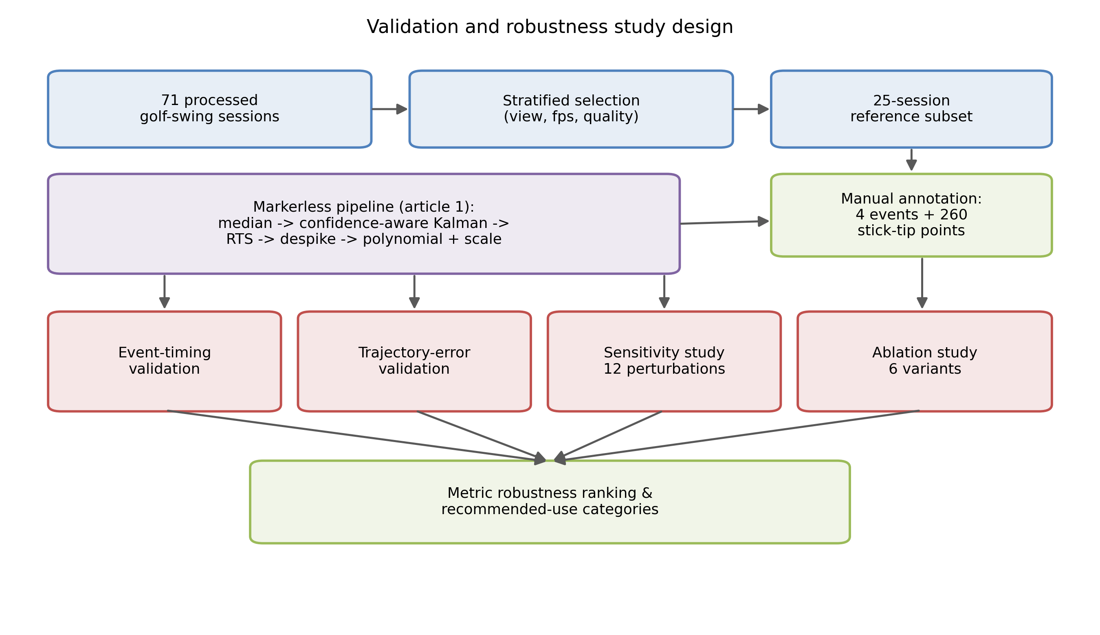
Fig. 1. Validation and robustness study design
Source: compiled by the authors
LITERATURE REVIEW AND PROBLEM STATEMENT
Kinematic analysis has long been central to sports biomechanics, describing movement timing, segment coordination, implement speed, and movement smoothness [1], [2], [8]. In golf, relevant indicators include stick speed, swing tempo, kinematic sequencing, and impact timing [9], [10], [11], [23]. These indicators are traditionally obtained with marker-based systems or, for portable field instrumentation, with wearable inertial sensors [24]; both are more cumbersome than ordinary video for routine use.
Deep-learning pose estimators such as OpenPose, BlazePose, and MediaPipe made markerless analysis practical with ordinary cameras and near-real-time inference [3], [4], [5], [25], [29]. Their accuracy nonetheless depends on camera view, lighting, motion blur, occlusion, and model confidence, and validation studies consistently warn that two-dimensional monocular projections cannot fully replace calibrated three-dimensional systems [12], [13], [26], [27], [28]. This literature establishes that a markerless workflow must be validated against an explicit reference before its measurements are trusted, and that reported error should be interpreted with respect to the specific capture conditions.
Signal conditioning is a second recurring theme. Median filtering suppresses impulse outliers [14]; Kalman filtering combines a dynamic model with noisy measurements to produce a recursive state estimate [15], [16]; and, when offline analysis is acceptable, Rauch-Tung-Striebel smoothing refines earlier estimates using later observations [17]. Polynomial smoothing of the Savitzky-Golay type reduces derivative noise while preserving local shape [18], and jerk-based smoothness metrics are widely used but must be interpreted cautiously because differentiation amplifies noise [19]. For measurement reliability, coefficient of variation, repeatability coefficient, intraclass correlation, and Bland-Altman limits of agreement are the standard tools [20], [21], [22].
Despite this background, most markerless golf-swing reports emphasize plausible trajectories and pipeline design rather than reference-based error. Three gaps remain. First, event-timing accuracy is rarely quantified against manually verified frames. Second, geometric trajectory error is rarely measured against per-frame stick-tip annotations, because no such reference normally exists. Third, metric robustness under realistic degradations, and the resulting distinction between trustworthy and exploratory metrics, is rarely reported. The problem addressed in this article is to close these gaps for the described workflow by building a manual reference subset and using it to quantify event accuracy, trajectory accuracy, sensitivity, and reliability, and then to classify each exported metric by its practical usability.
RESEARCH AIM AND OBJECTIVES
The aim of the research is to evaluate the accuracy, robustness, and reliability of a markerless video-based golf-stick motion-analysis workflow under heterogeneous recording conditions and controlled input perturbations.
The research objectives are:
1. To construct a manually annotated reference subset of swing events and stick-tip control points from a heterogeneous corpus of processed sessions.
2. To quantify event-detection accuracy for top of backswing, downswing transition, and impact against the manual reference.
3. To estimate geometric stick-tip trajectory error between the processed trajectory and manually annotated points, resolved by swing phase.
4. To evaluate the sensitivity of exported metrics to frame thinning, landmark dropout, coordinate jitter, scale perturbation, and combined degradation.
5. To compare processing variants through a controlled ablation with a shared derivative definition and time base.
6. To identify which kinematic and movement-quality metrics are robust enough for cross-session comparison and to formulate practical recommendations for their use.
MATERIALS AND METHODS
Dataset and reference subset
The corpus comprises seventy-one markerless golf-swing sessions processed with the scientific filtering profile of the workflow described in the companion methodological study. The recordings are heterogeneous: the frame-rate range is 23.98 to 60.00 frames per second, resolution ranges from below 720 p to 1080 p and above, and camera viewpoint is predominantly down-the-line with a minority of face-on recordings. To obtain a manageable yet representative reference set, twenty-five sessions were selected by stratified sampling across viewpoint, frame-rate bucket, resolution bucket, capture-speed class, and a coarse quality grade that counts the number of adverse tags (keyframe issue, motion blur, occlusion). The stratification balances easy and difficult recordings so that reported error is not dominated by a single favourable condition. Dataset and subset characteristics are summarized in Table 1.
Table 1. Dataset and reference-subset characteristics
Characteristic | Full dataset | Annotated subset
Sessions, n | 71 | 25
Camera viewpoint | dtl: 59; face_on: 10; other: 2 | dtl: 21; face_on: 3; other: 1
Capture speed class | regular: 47; slow: 23; super_slow: 1 | regular: 17; slow: 8
Frame-rate bucket, fps | 31-60: 41; <=30: 30 | 31-60: 18; <=30: 7
Resolution bucket | 1080p+: 43; <720p: 14; 720-1080p: 14 | 1080p+: 17; 720-1080p: 5; <720p: 3
Quality grade | medium: 47; good: 12; difficult: 12 | medium: 17; difficult: 4; good: 4
Club type | driver: 32; iron: 23; unknown: 16 | driver: 12; iron: 7; unknown: 6
Stick-tip control points, n | - | 260 (in 25 sessions)
Source: compiled by the authors
Manual annotation protocol
Because the corpus contains no per-frame stick-tip ground truth and its automatic keyframes are unreliable, a manual reference was created. A frame-by-frame annotation tool built on an image viewer was used to step through each selected video and record, in original video pixel coordinates, four swing events (address, top of backswing, downswing transition, and impact) and a set of stick-tip control points distributed along the visible swing arc. Clicks were captured at full resolution even when the display was downscaled, so the reference is independent of display size. A single annotator produced one annotation round, yielding one hundred event annotations and two hundred sixty stick-tip control points across the twenty-five sessions, with eight to fourteen points per session. The protocol is summarized in Table 2. A schematic annotated frame is shown in Fig. 2; a drawn schematic is used instead of a real user frame to avoid consent and privacy concerns.
Table 2. Manual annotation protocol
Protocol element | Value
Annotated sessions | 25
Swing events per session | 4 (address, top of backswing, downswing transition, impact)
Total event annotations | 100
Stick-tip control points per session | 8-14 (median 10)
Total control points | 260
Annotation tool | Frame-by-frame OpenCV viewer with original-resolution click capture
Coordinate reference | Original video pixel coordinates
Annotators / rounds | 1 annotator, round 1
Source: compiled by the authors
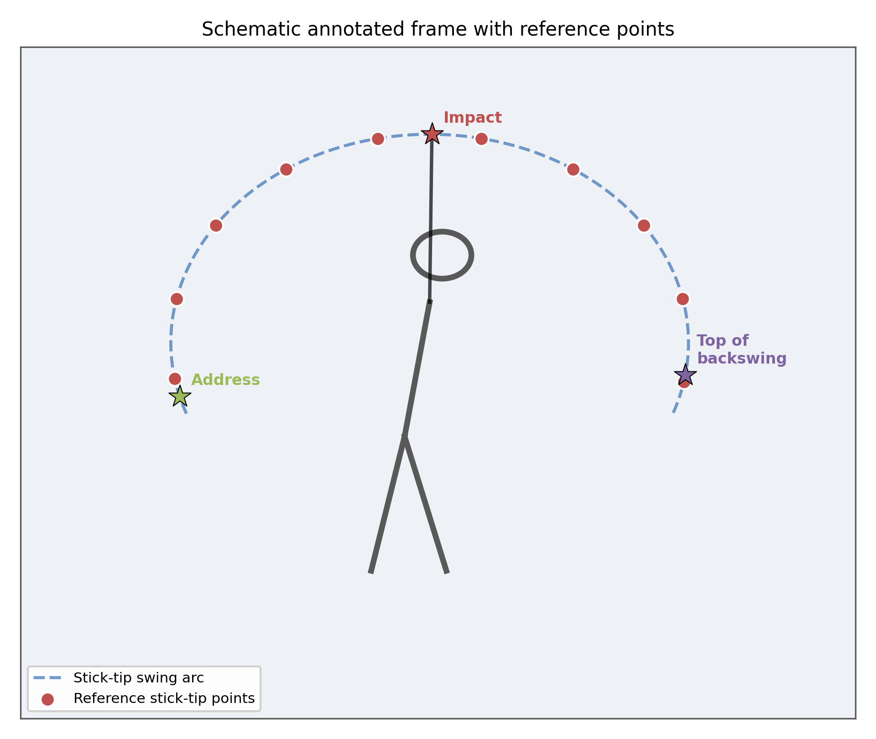
Fig. 2. Schematic annotated frame with reference stick-tip points
Source: compiled by the authors
Automatic processing
Each session was processed with the unmodified scientific profile of the workflow. The processing chain converts normalized landmarks to pixel coordinates, applies a running median filter, a confidence-aware constant-velocity Kalman filter with innovation gating, Rauch-Tung-Striebel smoothing, trajectory despiking, and bounded polynomial smoothing, and derives a per-frame pixel-to-metre scale from the detected stick length. Automatic swing events and the final smoothed stick-tip trajectory were exported for comparison with the manual reference. The pipeline itself is not re-derived here; it is the object under evaluation.
Event validation
For each session, automatic event times were compared with the manual reference times for top of backswing, downswing transition, and impact. Signed and absolute errors were computed in both milliseconds and frames. Reported statistics are the mean signed error, the median absolute error, the ninety-fifth percentile absolute error, and Bland-Altman bias and ninety-five-percent limits of agreement [22]. The signed error is defined as automatic minus reference, so a negative value indicates that the automatic event fires early.
Trajectory validation
For each manually annotated control point, the processed stick-tip position at the matching frame was retrieved and the Euclidean error was computed in pixels, in image-diagonal-normalized units, and in metres using the per-frame scale. Each point was assigned to a swing phase (backswing, transition, downswing, impact region, or follow-through) using the manual event times rather than the automatic ones, because the automatic events are biased early and would misclassify most points. Errors were summarized per phase and overall by median, upper quartile, and ninety-fifth percentile.
Sensitivity analysis
Robustness was assessed by perturbing the input of each of the seventy-one sessions and re-processing it with the same profile. Twelve scenarios were applied: frame thinning by factors of two and three; landmark dropout at five, ten, and twenty percent; zero-mean Gaussian coordinate jitter at normalized standard deviations of 0.004 and 0.008 applied to the stick landmarks; scale perturbation of plus or minus five and ten percent; and a combined degradation that stacks frame thinning, ten-percent dropout, and jitter. For each scenario and metric the signed change, percentage change, and median absolute percentage change relative to the unperturbed baseline were computed, together with a rank-stability coefficient. Metrics were classified as robust, usable, or exploratory when the median absolute change was below ten percent, below twenty-five percent, or above twenty-five percent respectively.
Ablation study
Six processing variants were reconstructed from the same raw landmarks: raw, median only, Kalman only, Kalman plus RTS, Kalman plus RTS plus despiking, and the full pipeline. To avoid the inconsistency of the earlier diagnostic ablation, all derivative metrics were computed from each variant's final trajectory with one shared derivative function and one time base. For the standalone Kalman-plus-RTS variant the textbook smoother with the process-noise term in the predicted covariance was used, because the production smoother omits that term and relies on a downstream deviation clamp that is absent when the variant is isolated; the production code was left unchanged. Reported per-variant statistics include median deviation from the raw trajectory, median root-mean-square jerk, and the median smoothness index, path efficiency, and maximum speed.
Reliability and statistical analysis
Cross-session dispersion of eleven exported metrics was summarized by the coefficient of variation and the repeatability coefficient. Because athlete and trial grouping are not encoded in the anonymized export, these statistics describe between-session heterogeneity of the corpus and are not interpreted as within-athlete test-retest repeatability; an intraclass-correlation path is provided in the analysis code for future data with explicit grouping [20], [21]. Agreement between the full pipeline and the Kalman-plus-RTS-plus-despiking variant was additionally summarized with Bland-Altman bias and limits of agreement [22]. A metric robustness ranking combined the sensitivity classification with the cross-session coefficient of variation to assign each metric to a recommended-use category.
RESEARCH RESULTS
Reference subset
All seventy-one sessions processed successfully, and the twenty-five-session reference subset preserved the heterogeneity of the full corpus across viewpoint, frame rate, resolution, and quality grade (Table 1). The manual annotation produced one hundred event annotations and two hundred sixty stick-tip control points (Table 2), which is, to our knowledge, the first per-frame stick-tip reference for this workflow.
Event-timing accuracy
Event detection was inaccurate. The median absolute timing error was 817 ms for impact, 920 ms for top of backswing, and 1000 ms for downswing transition, and the ninety-fifth percentile absolute error exceeded 4.7 s for every event (Table 3; Fig. 3). The errors were strongly biased: the mean signed error was -1730 ms for impact, -1914 ms for top of backswing, and -1987 ms for downswing transition, so the automatic events fire roughly one and seven tenths to two seconds early. The Bland-Altman plots confirm a large negative bias with wide limits of agreement that broaden as swing duration increases (Fig. 4). These values are far larger than a normal golf swing and are reported as a negative finding: the current automatic event detector requires recalibration before any timing-based claim can be made.
Table 3. Event-timing validation against the manual reference
Swing event | n | Median |error|, ms | Mean signed, ms | P95 |error|, ms
Top of backswing | 25 | 920 | -1914 | 4707
Downswing transition | 25 | 1000 | -1987 | 4893
Impact | 25 | 817 | -1730 | 4727
Source: compiled by the authors
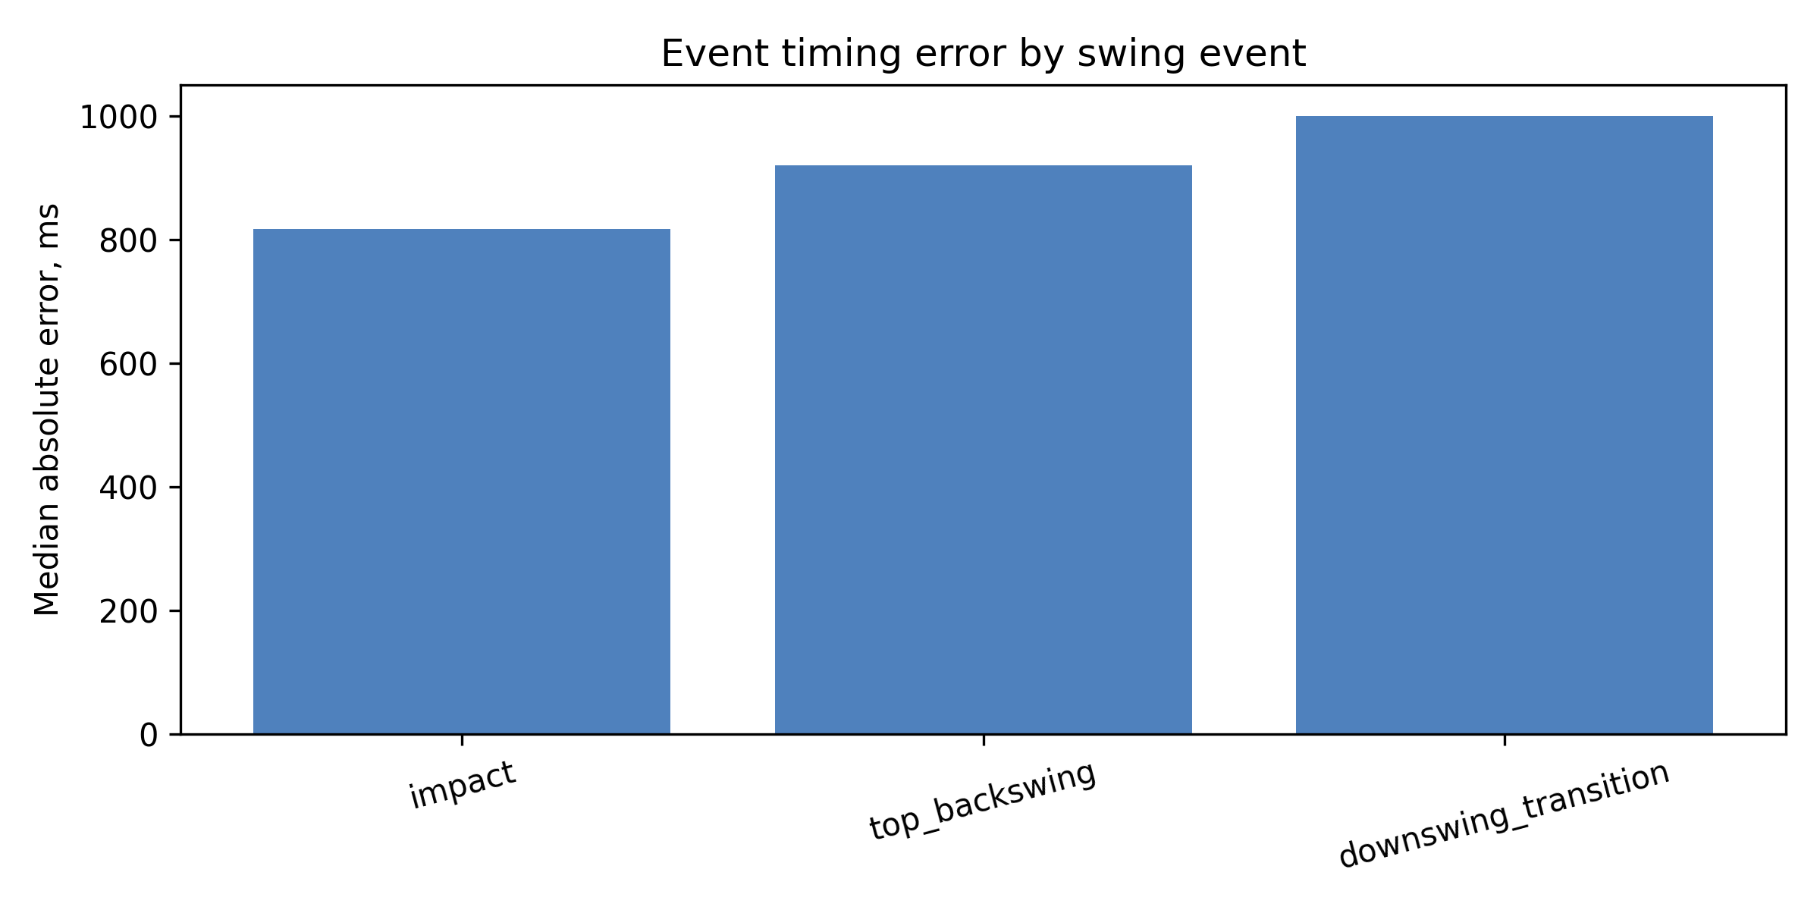
Fig. 3. Median absolute event-timing error by swing event
Source: compiled by the authors
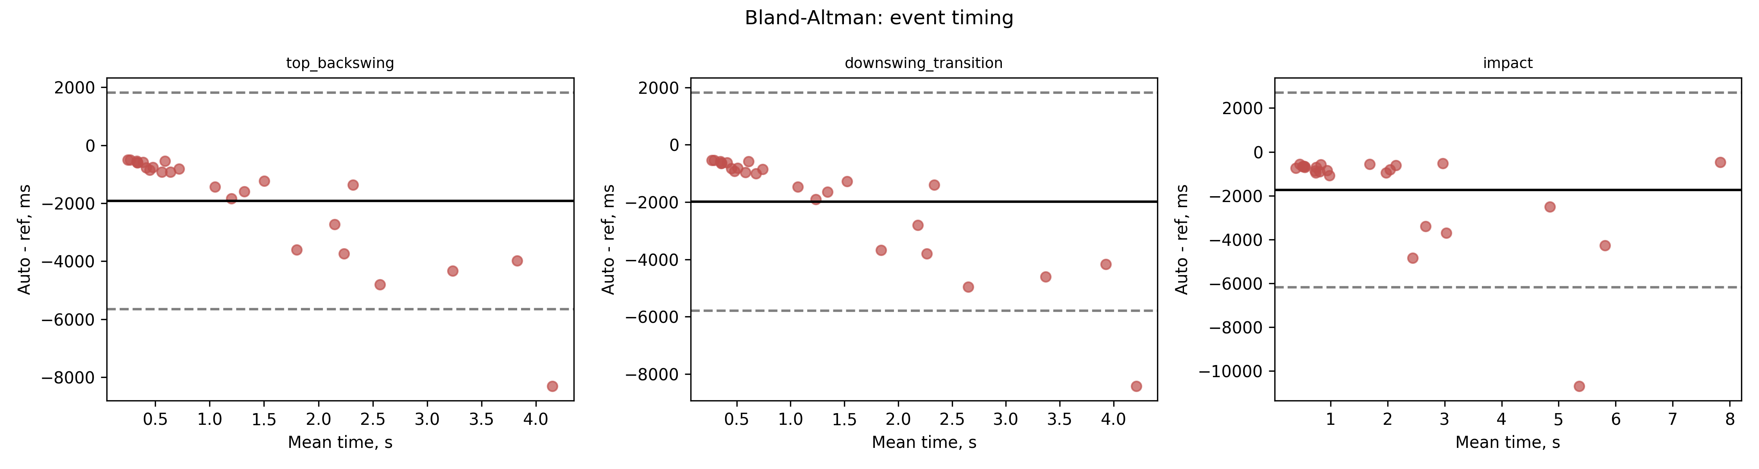
Fig. 4. Bland-Altman agreement of automatic and reference event timing
Source: compiled by the authors
Trajectory accuracy
Geometric trajectory error was, in contrast, small over the reliably tracked phases. The overall median stick-tip error was 14.9 px, corresponding to about 3.8 cm, with an upper quartile of 27.2 px (Table 4). Error was lowest in the backswing (median 12.7 px, about 3.1 cm) and downswing (median 14.5 px, about 4.2 cm) and increased in the impact region and follow-through (medians near 19 px). The ninety-fifth-percentile values are inflated by a small number of sessions in which tracking is lost after impact, which is visible as large whiskers for the downswing and follow-through phases (Fig. 5). The combination of accurate stick-tip positions with grossly inaccurate event timing indicates that the geometric trajectory is trustworthy where the tip is tracked, while the temporal segmentation is not.
Table 4. Stick-tip trajectory error by swing phase
Swing phase | Points, n | Median, px | P75, px | P95, px | Median, cm
Backswing | 105 | 12.7 | 19.9 | 45.5 | 3.1
Transition | 5 | 19.1 | 46.5 | 124.7 | 3.3
Downswing | 44 | 14.5 | 22.3 | 1589.1 | 4.2
Impact region | 59 | 19.1 | 55.3 | 237.9 | 4.5
Follow-through | 47 | 18.8 | 32.3 | 706.5 | 5.0
All phases | 260 | 14.9 | 27.2 | 265.6 | 3.8
Source: compiled by the authors
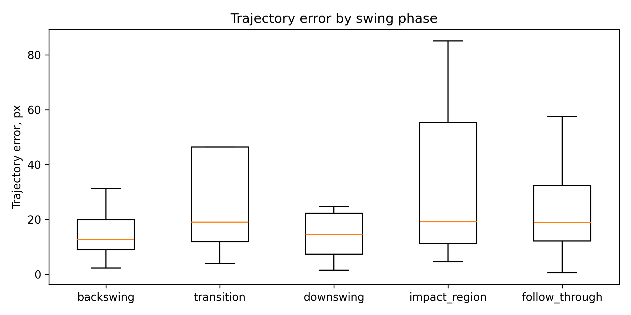
Fig. 5. Stick-tip trajectory error by swing phase
Source: compiled by the authors
Sensitivity
Metric sensitivity varied by orders of magnitude across metrics (Table 5; Fig. 6). Scale perturbation had a small and predictable effect on most metrics, with a median absolute change of one percent or less for the smoothness index and path efficiency. The smoothness index was the most stable metric under every perturbation family, with a median absolute change of about 14 percent under frame thinning, 12 percent under landmark dropout, 12 percent under jitter, and 14 percent under combined degradation. Path efficiency was the next most stable. In sharp contrast, peak derivative metrics and phase-duration metrics were highly unstable: maximum acceleration, maximum angular velocity, curvature RMS, swing tempo, and backswing peak speed frequently changed by more than 60 percent, and backswing peak speed changed by several hundred percent under jitter and combined degradation. Rank stability followed the same pattern, remaining moderate for the smoothness index and path efficiency and collapsing for the derivative metrics [30].
Table 5. Sensitivity of exported metrics to input perturbations
Metric | Frame thin., % | Dropout, % | Jitter, % | Scale, % | Combined, %
Smoothness index | 14.4 | 11.8 | 11.6 | 1.0 | 13.9
Path efficiency | 13.7 | 19.5 | 29.9 | 0.0 | 20.0
Maximum speed | 43.2 | 31.5 | 35.5 | 7.5 | 74.4
Maximum acceleration | 65.3 | 71.9 | 46.7 | 7.5 | 85.3
Maximum angular velocity | 66.1 | 4.5 | 66.0 | 0.0 | 90.2
Curvature RMS | 75.5 | 25.3 | 92.4 | 7.2 | 84.8
Swing tempo | 73.7 | 82.9 | 99.1 | 0.0 | 88.1
Backswing peak speed | 47.2 | 49.5 | 609.9 | 7.5 | 577.9
Source: compiled by the authors
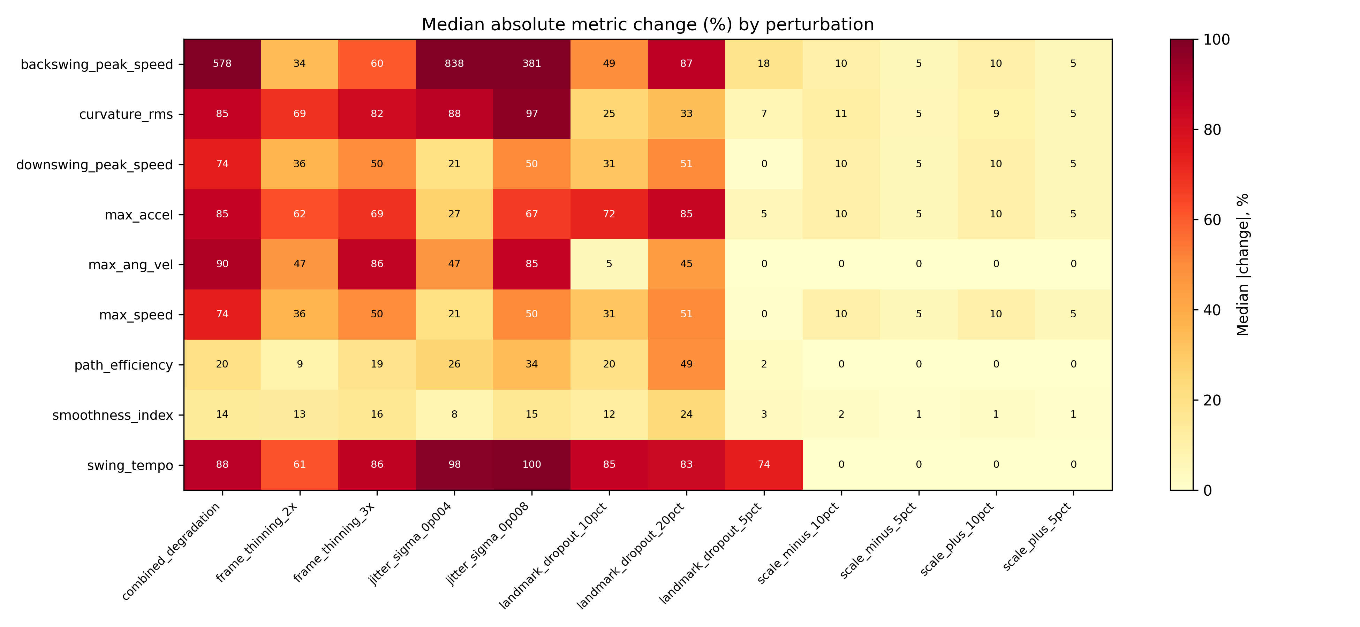
Fig. 6. Median absolute metric change by input perturbation
Source: compiled by the authors
Ablation
The controlled ablation showed the expected monotone reduction of jerk along the filtering chain when metrics are computed consistently (Table 6; Fig. 7). Median root-mean-square jerk fell from about 17300 for raw landmarks to about 4600 for the Kalman-plus-RTS variant, while the smoothness index rose correspondingly. The full pipeline deviated from the raw trajectory by a median of only about 2.3 cm, much less than the intermediate variants, because its bounded polynomial smoothing and scale handling keep the final trajectory close to the observed path while still suppressing jerk relative to raw. These results confirm that each stage contributes to trajectory regularization and that the differences between variants are consistent once a shared derivative definition is used.
Table 6. Ablation comparison of processing variants
Pipeline variant | Dev. from raw, cm | RMS jerk, m/s^3 | Smoothness | Path eff. | Max speed, m/s
Raw landmarks | 0.0 | 17334 | -8.48 | 0.086 | 50.2
Median only | 15.3 | 14448 | -8.32 | 0.096 | 41.2
Kalman only | 18.4 | 8084 | -7.82 | 0.101 | 36.1
Kalman + RTS | 15.2 | 4637 | -7.33 | 0.107 | 27.0
Kalman + RTS + despiking | 15.2 | 4637 | -7.33 | 0.107 | 27.0
Full pipeline | 2.3 | 11871 | -8.15 | 0.086 | 46.4
Source: compiled by the authors
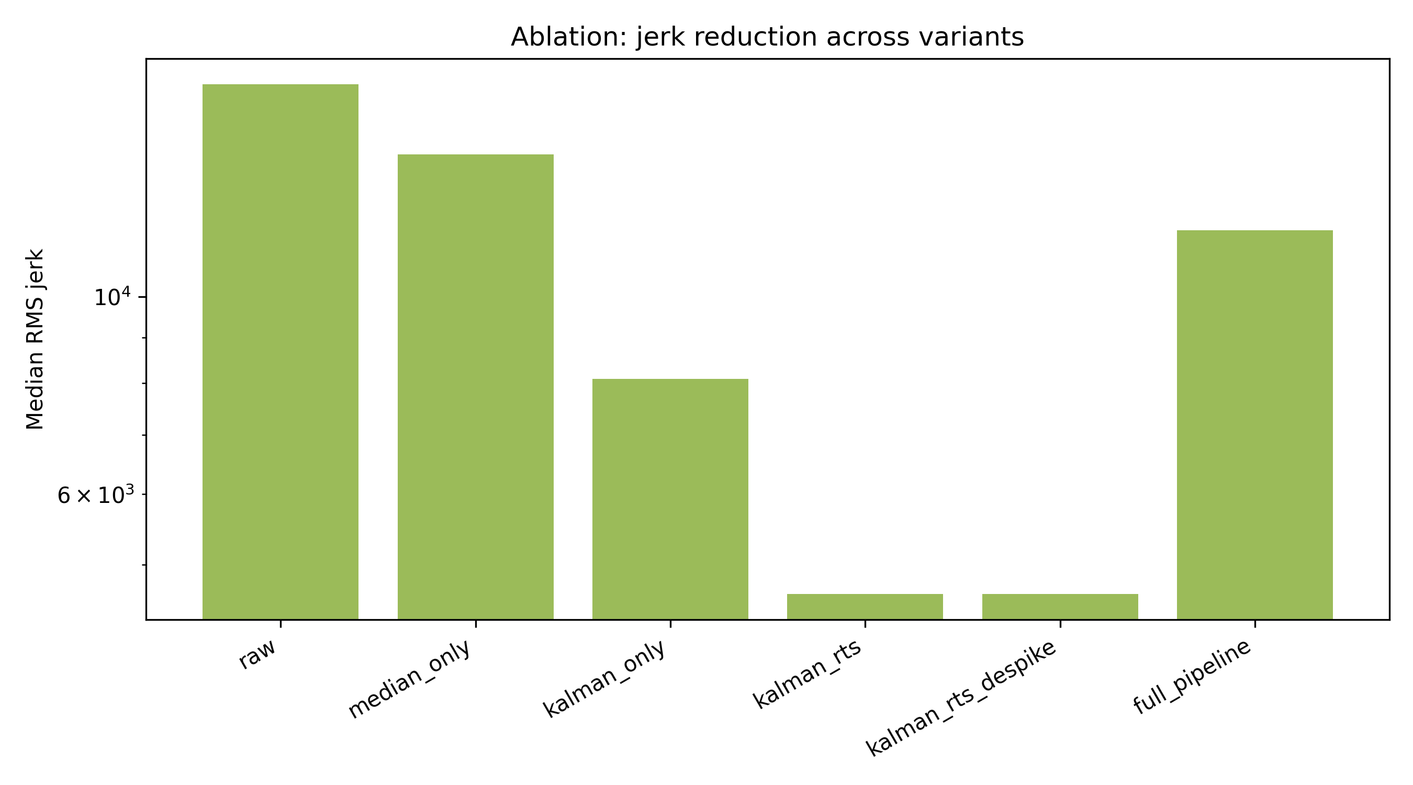
Fig. 7. Median root-mean-square jerk across processing variants
Source: compiled by the authors
Metric robustness ranking
Combining the sensitivity classification with cross-session dispersion produced a clear ranking (Table 7; Fig. 8). The smoothness index was robust in all twelve perturbation scenarios and had the lowest cross-session coefficient of variation (about 22 percent); it is recommended as robust under heterogeneous capture. Path efficiency was robust or usable in most scenarios (coefficient of variation about 36 percent) and is recommended as usable with controlled acquisition. All remaining metrics, including maximum speed, maximum acceleration, maximum angular velocity, curvature RMS, swing tempo, and the peak-speed and phase-duration metrics, were exploratory, with median changes above 25 percent and cross-session coefficients of variation above 100 percent; they should not be used for cross-session comparison without controlled acquisition and external validation.
Table 7. Metric robustness ranking and recommended use
Metric | Median |change|, % | CV, % | Recommended use
Smoothness index | 9.8 | 21.6 | Robust under heterogeneous capture
Path efficiency | 13.7 | 35.9 | Usable with controlled acquisition
Maximum angular velocity | 24.5 | 197.1 | Exploratory only
Downswing peak speed | 26.0 | 105.7 | Exploratory only
Maximum speed | 26.0 | 105.7 | Exploratory only
Curvature RMS | 29.3 | 159.5 | Exploratory only
Backswing peak speed | 41.8 | 590.2 | Exploratory only
Maximum acceleration | 44.2 | 184.5 | Exploratory only
Swing tempo | 78.4 | 129.8 | Exploratory only
Source: compiled by the authors
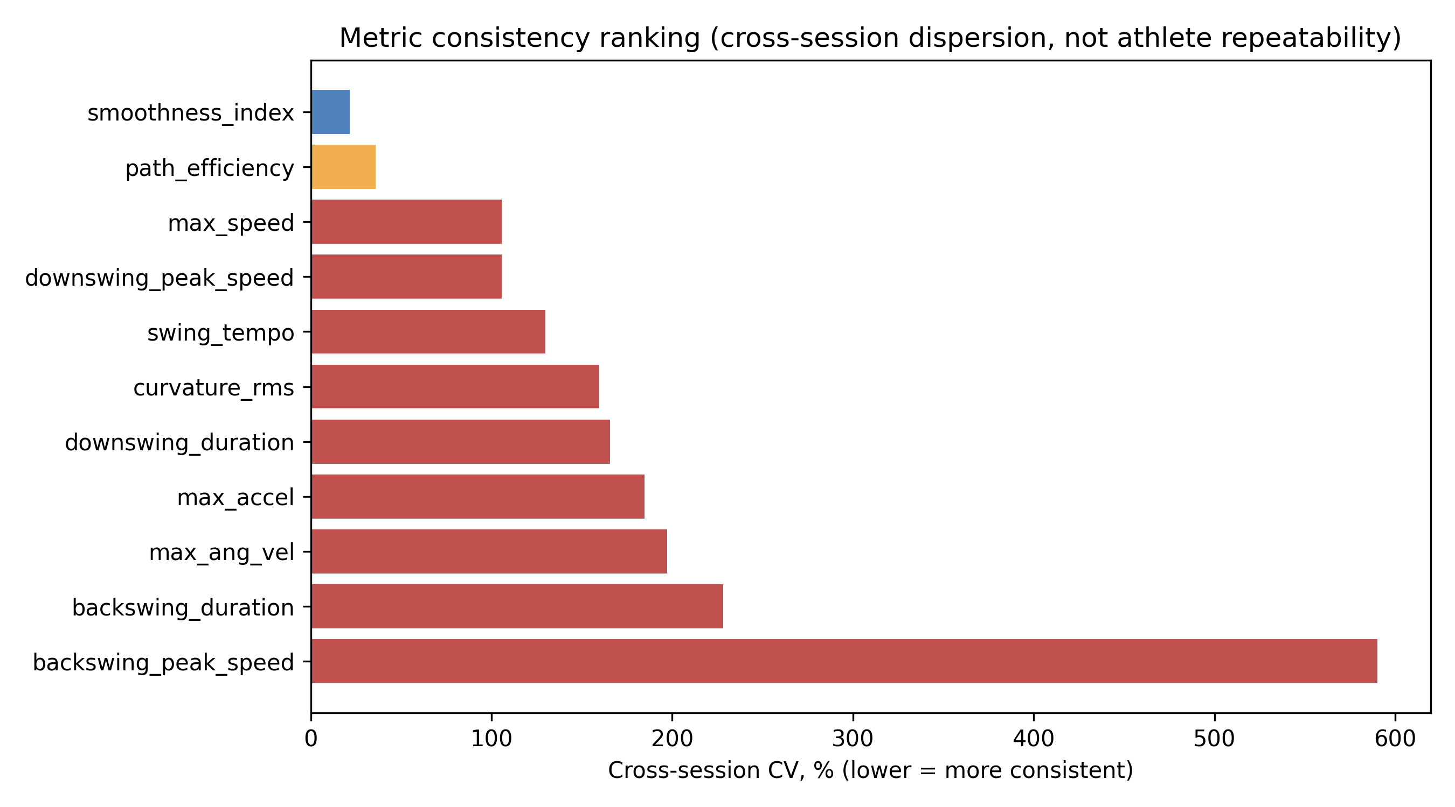
Fig. 8. Metric consistency ranking by cross-session coefficient of variation
Source: compiled by the authors
DISCUSSION OF RESULTS
The results give a differentiated picture of what the markerless workflow can and cannot measure. The strongest positive finding is geometric: where the stick tip is tracked, the processed trajectory lies within about four centimetres of manually annotated positions during the backswing and downswing, the phases that matter most for swing-path assessment. This is a meaningful accuracy level for coaching feedback and virtual-reality training, and it is supported by an explicit per-frame reference rather than by visual plausibility alone.
The strongest negative finding is temporal. Automatic event detection is biased early by roughly one and seven tenths to two seconds, with median absolute errors near one second and very wide limits of agreement. This is far too large for any timing-dependent metric, and it explains why phase-duration and tempo metrics were among the least reliable. The early bias also motivates the decision to classify trajectory points by manual rather than automatic events: had the automatic events been used, most points would have been misassigned to the follow-through and the trajectory result would have been distorted. Reporting this bias openly is more useful than suppressing it, because it identifies event detection as the single component most in need of recalibration.
The robustness analysis reconciles these findings with the earlier repeatability observations. Global movement-quality metrics, the smoothness index and path efficiency, are stable both under controlled perturbation and across heterogeneous sessions, whereas peak derivative metrics are dominated by noise that differentiation amplifies [6], [7], [19]. Scale perturbation behaves predictably, confirming that the pixel-to-metre calibration propagates linearly and does not introduce nonlinear artefacts, while frame thinning, dropout, and jitter degrade derivative metrics most, consistent with the hypothesis that temporal and high-frequency information is the first to be lost under degradation. These patterns agree with the broader markerless-validation literature, which reports that two-dimensional monocular estimates are usable for global and low-order measures but unreliable for fine temporal and high-order kinematics without controlled capture [12], [13], [26], [27], [28].
These findings translate into concrete guidance for virtual-reality training and coaching applications. A virtual-reality feedback system built on this workflow should present the smoothness index and path efficiency as primary swing-quality indicators, because they remain comparable across sessions recorded on different devices and under different conditions, and it should display stick-tip trajectory overlays for the backswing and downswing, where geometric error is small enough to be visually faithful. Conversely, timing-dependent cues such as tempo, phase durations, and event markers should be withheld or clearly flagged as approximate until event detection is recalibrated, and peak speed and acceleration values should be shown only as within-session trends rather than as absolute measurements to be compared between athletes or sessions. This selective presentation lets a training system exploit the parts of the workflow that are trustworthy while avoiding feedback that the present evidence cannot support.
Several limitations bound these conclusions. The reference was produced by a single annotator in one round, so inter-annotator reliability is not yet available; the analysis code already supports a second round and intraclass-correlation computation for future work. The corpus lacks athlete and trial grouping, so reliability is expressed as cross-session dispersion rather than test-retest repeatability. The system is monocular and two-dimensional, so out-of-plane motion and perspective distortion remain unresolved, and the metric error in metres depends on the stick-length scale assumption. Finally, the trajectory reference covers control points rather than every frame, and follow-through tracking is unreliable. None of these limitations affects the two central, reference-based conclusions: the trajectory is accurate where tracked, and the event timing is not.
CONCLUSIONS
This study evaluated a markerless video-based golf-stick motion-analysis workflow against a purpose-built manual reference and under controlled perturbations, converting the earlier diagnostic checks into a reference-based validation. A stratified twenty-five-session subset was annotated with one hundred swing events and two hundred sixty stick-tip control points and used to quantify event-timing accuracy, geometric trajectory accuracy, metric sensitivity, ablation consistency, and cross-session reliability.
The evaluation shows that the workflow measures stick-tip geometry accurately where the tip is tracked, with an overall median trajectory error of about four centimetres and best performance in the backswing and downswing, but that its automatic event detection is biased early by roughly one and seven tenths to two seconds and is not yet usable for timing. Among exported metrics, the smoothness index is robust under heterogeneous capture and path efficiency is usable with controlled acquisition, whereas peak derivative and phase-duration metrics remain exploratory.
The scientific novelty is a transparent, reference-based characterization that separates trustworthy geometric measurements from unreliable event timing and exploratory derivative metrics, including an explicitly reported negative finding for event detection. The practical value is a concrete set of recommendations that tell practitioners which markerless golf-swing indicators to trust for cross-session comparison in sport biomechanics and virtual-reality training. Future work will recalibrate event detection, add a second annotator for inter-annotator reliability, and extend the reference with athlete and trial grouping to enable intraclass-correlation and test-retest analysis.
ACKNOWLEDGMENTS
The authors thank the research supervisor and collaborators who supported the review of the manuscript and the development and evaluation of the motion-analysis workflow.

REFERENCES
1. Winter, D. A. “Biomechanics and Motor Control of Human Movement”. 4th ed. Hoboken, NJ, USA: Wiley, 2009.
2. Bartlett, R. “Introduction to Sports Biomechanics: Analysing Human Movement Patterns”. 2nd ed. London, UK: Routledge, 2007. DOI: https://doi.org/10.4324/9780203462027.
3. Cao, Z., Hidalgo, G., Simon, T., Wei, S. E. & Sheikh, Y. “OpenPose: Realtime multi-person 2D pose estimation using part affinity fields”. IEEE Transactions on Pattern Analysis and Machine Intelligence. 2021; Vol. 43, No. 1: 172–186. https://www.scopus.com/record/display.uri?eid=2-s2.0-85070219994. DOI: https://doi.org/10.1109/TPAMI.2019.2929257.
4. Bazarevsky, V., Grishchenko, I., Raveendran, K., Zhu, T., Zhang, F. & Grundmann, M. “BlazePose: On-device real-time body pose tracking”. Proceedings of the CVPR Workshop on Computer Vision for Augmented and Virtual Reality. Seattle, WA, USA. June 2020. DOI: https://doi.org/10.48550/arXiv.2006.10204.
5. Lugaresi, C., Tang, J., Nash, H., McClanahan, C., Uboweja, E., Hays, M., Zhang, F., Chang, C. L., Yong, M. G., Lee, J., Chang, W. T., Hua, W., Georg, M. & Grundmann, M. “MediaPipe: A framework for building perception pipelines”. arXiv preprint. 2019. DOI: https://doi.org/10.48550/arXiv.1906.08172.
6. Robertson, D. G. E., Caldwell, G. E., Hamill, J., Kamen, G. & Whittlesey, S. N. “Research Methods in Biomechanics”. 2nd ed. Champaign, IL, USA: Human Kinetics, 2014. DOI: https://doi.org/10.5040/9781492595809.
7. Challis, J. H. “A procedure for determining rigid body transformation parameters”. Journal of Biomechanics. 1995; Vol. 28, No. 6: 733–737. https://www.scopus.com/record/display.uri?eid=2-s2.0-0029300566. DOI: https://doi.org/10.1016/0021-9290(94)00116-L.
8. Hume, P. A., Keogh, J. & Reid, D. “The role of biomechanics in maximising distance and accuracy of golf shots”. Sports Medicine. 2005; Vol. 35, No. 5: 429–449. https://www.scopus.com/record/display.uri?eid=2-s2.0-18244376551. DOI: https://doi.org/10.2165/00007256-200535050-00005.
9. Nesbit, S. M. & Serrano, M. “Work and power analysis of the golf swing”. Journal of Sports Science and Medicine. 2005; Vol. 4, No. 4: 520–533. https://www.scopus.com/record/display.uri?eid=2-s2.0-33747125283.
10. McLaughlin, J. J. & Best, R. J. “Three-dimensional kinematic analysis of the golf swing”. In: Cochran, A. J. & Farrally, M. R. (Eds.). Science and Golf II. London, UK: E & FN Spon, 1994. p. 91–96.
11. Tinmark, F., Hellström, J., Halvorsen, K. & Thorstensson, A. “Elite golfers' kinematic sequence in full-swing and partial-swing shots”. Sports Biomechanics. 2010; Vol. 9, No. 4: 236–244. https://www.scopus.com/record/display.uri?eid=2-s2.0-79551491419. DOI: https://doi.org/10.1080/14763141.2010.535842.
12. van der Kruk, E. & Reijne, M. M. “Accuracy of human motion capture systems for sport applications: state-of-the-art review”. European Journal of Sport Science. 2018; Vol. 18, No. 6: 806–819. https://www.scopus.com/record/display.uri?eid=2-s2.0-85045751825. DOI: https://doi.org/10.1080/17461391.2018.1463397.
13. Ota, M., Tateuchi, H., Hashiguchi, T. & Ichihashi, N. “Verification of reliability and validity of motion analysis systems during bilateral squat using human pose tracking algorithm”. Gait & Posture. 2020; Vol. 80: 62–67. https://www.scopus.com/record/display.uri?eid=2-s2.0-85085754655. DOI: https://doi.org/10.1016/j.gaitpost.2020.05.027.
14. Tukey, J. W. “Exploratory Data Analysis”. Reading, MA, USA: Addison-Wesley, 1977.
15. Kalman, R. E. “A new approach to linear filtering and prediction problems”. Journal of Basic Engineering. 1960; Vol. 82, No. 1: 35–45. DOI: https://doi.org/10.1115/1.3662552.
16. Welch, G. & Bishop, G. “An introduction to the Kalman filter”. Technical Report TR 95-041. Chapel Hill, NC, USA: University of North Carolina at Chapel Hill, 2006. [Online]. – Available from: https://www.cs.unc.edu/~welch/media/pdf/kalman_intro.pdf – [Accessed: Apr. 29, 2026].
17. Rauch, H. E., Tung, F. & Striebel, C. T. “Maximum likelihood estimates of linear dynamic systems”. AIAA Journal. 1965; Vol. 3, No. 8: 1445–1450. https://www.scopus.com/record/display.uri?eid=2-s2.0-84945697750. DOI: https://doi.org/10.2514/3.3166.
18. Savitzky, A. & Golay, M. J. E. “Smoothing and differentiation of data by simplified least squares procedures”. Analytical Chemistry. 1964; Vol. 36, No. 8: 1627–1639. https://www.scopus.com/record/display.uri?eid=2-s2.0-33947453419. DOI: https://doi.org/10.1021/ac60214a047.
19. Balasubramanian, S., Melendez-Calderon, A., Roby-Brami, A. & Burdet, E. “On the analysis of movement smoothness”. Journal of NeuroEngineering and Rehabilitation. 2015; Vol. 12: 112. https://www.scopus.com/record/display.uri?eid=2-s2.0-84953214858. DOI: https://doi.org/10.1186/s12984-015-0090-9.
20. Atkinson, G. & Nevill, A. M. “Statistical methods for assessing measurement error (reliability) in variables relevant to sports medicine”. Sports Medicine. 1998; Vol. 26, No. 4: 217–238. https://www.scopus.com/record/display.uri?eid=2-s2.0-0031740657. DOI: https://doi.org/10.2165/00007256-199826040-00002.
21. Koo, T. K. & Li, M. Y. “A guideline of selecting and reporting intraclass correlation coefficients for reliability research”. Journal of Chiropractic Medicine. 2016; Vol. 15, No. 2: 155–163. https://www.scopus.com/record/display.uri?eid=2-s2.0-84963540533. DOI: https://doi.org/10.1016/j.jcm.2016.02.012.
22. Bland, J. M. & Altman, D. G. “Statistical methods for assessing agreement between two methods of clinical measurement”. The Lancet. 1986; Vol. 327, No. 8476: 307–310. https://www.scopus.com/record/display.uri?eid=2-s2.0-0022571143. DOI: https://doi.org/10.1016/S0140-6736(86)90837-8.
23. Mo, S. & Chow, D. H. K. “Segmental sequencing in golf swing and its relation to clubhead speed”. Sports Biomechanics. 2018; Vol. 17, No. 3: 429–441. https://www.scopus.com/record/display.uri?eid=2-s2.0-85029525987. DOI: https://doi.org/10.1080/14763141.2017.1371213.
24. Godfrey, A., Del Din, S., Barry, G., Mathers, J. C. & Rochester, L. “Instrumenting gait with an accelerometer: a system and algorithm examination”. Medical Engineering & Physics. 2015; Vol. 37, No. 4: 400–407. https://www.scopus.com/record/display.uri?eid=2-s2.0-84926144625. DOI: https://doi.org/10.1016/j.medengphy.2015.02.003.
25. Colyer, S. L., Evans, M., Cosker, D. P. & Salo, A. I. T. “A review of the evolution of vision-based motion analysis and the integration of advanced computer vision methods towards developing a markerless system”. Sports Medicine – Open. 2018; Vol. 4: 24. https://www.scopus.com/record/display.uri?eid=2-s2.0-85048302366. DOI: https://doi.org/10.1186/s40798-018-0139-y.
26. Wade, L., Needham, L., McGuigan, P. & Bilzon, J. “Applications and limitations of current markerless motion capture methods for clinical gait biomechanics”. PeerJ. 2022; Vol. 10: e12995. https://www.scopus.com/record/display.uri?eid=2-s2.0-85125709321. DOI: https://doi.org/10.7717/peerj.12995.
27. Needham, L., Evans, M., Cosker, D. P., Wade, L., McGuigan, P. M., Bilzon, J. L. & Colyer, S. L. “The accuracy of several pose estimation methods for 3D joint centre localisation”. Scientific Reports. 2021; Vol. 11, No. 1: 20673. https://www.scopus.com/record/display.uri?eid=2-s2.0-85117132097. DOI: https://doi.org/10.1038/s41598-021-00212-x.
28. Stenum, J., Rossi, C. & Roemmich, R. T. “Two-dimensional video-based analysis of human gait using pose estimation”. PLOS Computational Biology. 2021; Vol. 17, No. 4: e1008935. https://www.scopus.com/record/display.uri?eid=2-s2.0-85104998893. DOI: https://doi.org/10.1371/journal.pcbi.1008935.
29. Cust, E. E., Sweeting, A. J., Ball, K. & Robertson, S. “Machine and deep learning for sport-specific movement recognition: a systematic review of model development and performance”. Journal of Sports Sciences. 2019; Vol. 37, No. 5: 568–600. https://www.scopus.com/record/display.uri?eid=2-s2.0-85053196097. DOI: https://doi.org/10.1080/02640414.2018.1521769.
30. Sweeting, A. J., Cormack, S. J., Morgan, S. & Aughey, R. J. “When is a sprint a sprint? A review of the analysis of team-sport athlete activity profile”. Frontiers in Physiology. 2017; Vol. 8: 432. https://www.scopus.com/record/display.uri?eid=2-s2.0-85021858935. DOI: https://doi.org/10.3389/fphys.2017.00432.
Conflicts of Interest: The authors declare that there is no conflict of interest regarding this study, including financial, personal, authorship, or other interests that could influence the research and its results presented in this article.
Funding: This research was conducted without external financial support.
Use of generative AI tools: Substantial AI-assisted text revision was used during manuscript preparation with GPT-5.5 in Cursor, accessed on 3 May 2026. The authors remain responsible for all data, methods, interpretation, references, and final text; all generated content must be checked and corrected by the authors before submission.
Received [completed by editorial office]. Received after revision [completed by editorial office]. Accepted [completed by editorial office].
УДК 004.932:004.94:796.352

Валідація, робастність і надійність безмаркерного відеоаналізу руху ключки для гольфу за неоднорідних умов зйомки

Синюк Іван Миколайович¹⁾
ORCID: https://orcid.org/0009-0000-4141-0135; i.syniuk@gmail.com
Максимов Максим Віталійович¹⁾
ORCID: https://orcid.org/0000-0002-7536-2570; prof.maksimov@gmail.com. Scopus Author ID: 7005088554
Максимов Олексій Максимович¹⁾
ORCID: https://orcid.org/0000-0003-2504-0853; oleksii.maksymov@op.edu.ua. Scopus Author ID: 57220057510
Айєр Картік²⁾
ORCID: https://orcid.org/0009-0003-2520-1810; ki2406@columbia.edu
¹⁾ Національний університет «Одеська політехніка», просп. Шевченка, 1. Одеса, 65044, Україна
²⁾ Колумбійський університет, 116-та вулиця та Бродвей. Нью-Йорк, 10027, США
АНОТАЦІЯ
Безмаркерний відеоаналіз є привабливою альтернативою маркерним системам захоплення руху для оцінювання гольф-свінгу, оскільки працює зі звичайними камерами, проте отримані вимірювання рідко перевіряють щодо незалежного еталона, а їхню стійкість до реальних умов зйомки майже не оцінюють кількісно. Метою дослідження є оцінювання точності, робастності та надійності раніше описаного безмаркерного відеопайплайну аналізу руху ключки для гольфу за неоднорідних умов зйомки та контрольованих збурень вхідних даних. Еталонну підмножину з двадцяти п’яти сесій було відібрано із сімдесяти однієї опрацьованої сесії стратифікованою вибіркою за ракурсом камери, частотою кадрів, роздільною здатністю та класом якості. Для кожної сесії один анотатор вручну позначив чотири події свінгу та близько десяти контрольних точок кінця ключки, що дало сто анотацій подій і двісті шістдесят контрольних точок. Автоматичні часи подій порівнювали з ручним еталоном; геометричну похибку траєкторії обчислювали між опрацьованими та вручну позначеними положеннями кінця ключки, а фазу свінгу визначали за ручними подіями; чутливість метрик вимірювали за проріджування кадрів, випадання орієнтирів, координатного шуму, збурення масштабу та комбінованої деградації; шість варіантів обробки порівнювали в контрольованій абляції зі спільним визначенням похідних. Виявлення подій показало велике раннє зміщення приблизно від однієї цілої семи десятих до двох секунд і медіанну абсолютну похибку близько однієї секунди, що подано як чесний негативний результат, а не як свідчення точного хронометражу. Натомість похибка траєкторії кінця ключки була малою на надійно відстежуваних фазах бек- та даун-свінгу з медіаною близько п’ятнадцяти пікселів, або близько чотирьох сантиметрів, і зростала лише на фазі супроводу, де відстеження втрачається. Індекс плавності та ефективність траєкторії були найстабільнішими метриками за збурень і між сесіями, тоді як пікові похідні та метрики тривалості фаз були вкрай нестабільними. Новизна роботи полягає у прозорому оцінюванні робастності на основі еталона, що відокремлює достовірні геометричні вимірювання від ненадійного хронометражу подій та дослідницьких похідних метрик. Практична цінність — набір явних рекомендацій, які показники безмаркерного гольф-свінгу можна використовувати для міжсесійного порівняння у спортивній біомеханіці та тренуваннях віртуальної реальності, а які потребують контрольованої зйомки або зовнішньої валідації.
Ключові слова: валідація безмаркерних систем; гольф-свінг; виявлення подій; похибка траєкторії; аналіз чутливості; робастність метрик
Для цитування: Синюк І. М., Максимов М. В., Максимов О. М., Айєр К. «Валідація, робастність і надійність безмаркерного відеоаналізу руху ключки для гольфу». Herald of Advanced Information Technology. - [Рік]. - Т. [..]. - № [..]. - С. [..-..]. DOI: [призначається редакцією]
ABOUT THE AUTHORS
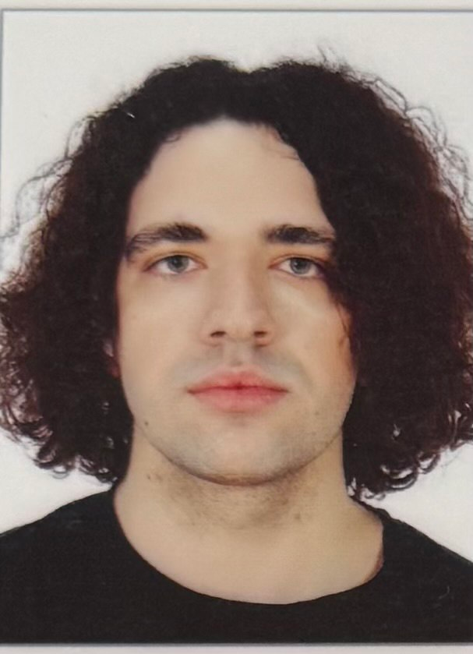 | Ivan M. Syniuk – PhD student, Department of Computer Intelligent Systems and Networks, Odesa Polytechnic National University, 1, Shevchenko Ave. Odesa, 65044, Ukraine. Author of scientific publications on markerless motion analysis, computer vision pipelines and applied biomechanics. Current PhD research focuses on the development of reproducible video-based measurement workflows for sport biomechanics and virtual-reality training applications, including signal filtering, trajectory smoothing and kinematic feature extraction.  ORCID: https://orcid.org/0009-0000-4141-0135; i.syniuk@gmail.com  Research field: markerless motion analysis; computer vision; Kalman filtering and trajectory smoothing; sport biomechanics; virtual-reality training systems  Синюк Іван Миколайович – аспірант кафедри комп’ютерних інтелектуальних систем і мереж, Національний університет «Одеська політехніка», просп. Шевченка, 1. Одеса, 65044, Україна. Сфера наукових інтересів охоплює безмаркерний відеоаналіз рухів людини та спортивного інвентарю, фільтрацію Калмана, згладжування траєкторій, кінематичні індикатори техніки виконання та застосування відеоаналітики у системах віртуальної реальності.
 | Maksym V. Maksymov – Doctor of Technical Sciences, Professor, Head of Department, Department of Computer Intelligent Systems and Networks, Odesa Polytechnic National University, 1, Shevchenko Ave. Odesa, 65044, Ukraine. Author and co-author of more than two hundred scientific publications, monographs, patents and study guides on automated control systems, intelligent measurement systems and applied data analysis. Supervises doctoral and PhD research on intelligent information systems and computer modelling of complex technical objects.  ORCID: https://orcid.org/0000-0002-7536-2570; prof.maksimov@gmail.com; Scopus Author ID: 7005088554  Research field: automation and control systems; intelligent measurement systems; data analysis and processing; computer modelling of complex technical objects; decision-support systems  Максимов Максим Віталійович – доктор технічних наук, професор, завідувач кафедри комп’ютерних інтелектуальних систем і мереж, Національний університет «Одеська політехніка», просп. Шевченка, 1. Одеса, 65044, Україна. Автор і співавтор понад двохсот наукових публікацій, монографій, патентів та навчально-методичних видань у галузі автоматизованих систем управління, інтелектуальних вимірювальних систем та аналізу даних.
[3×4 cm color photo] | Oleksii M. Maksymov – PhD in Engineering, Associate Professor, Department of Computer Intelligent Systems and Networks, Odesa Polytechnic National University, 1, Shevchenko Ave. Odesa, 65044, Ukraine. Author of scientific publications in the field of computer vision, applied signal processing and intelligent information systems. Participates in research and educational projects related to image processing, software engineering and the development of analytical pipelines for heterogeneous measurement data.  ORCID: https://orcid.org/0000-0003-2504-0853; oleksii.maksymov@op.edu.ua; Scopus Author ID: 57220057510  Research field: computer vision; digital signal and image processing; intelligent information systems; software engineering; applied machine learning  Максимов Олексій Максимович – кандидат технічних наук, доцент кафедри комп’ютерних інтелектуальних систем і мереж, Національний університет «Одеська політехніка», просп. Шевченка, 1. Одеса, 65044, Україна. Автор наукових публікацій у галузі комп’ютерного зору, цифрової обробки сигналів і зображень, інтелектуальних інформаційних систем та програмної інженерії.
[3×4 cm color photo] | Karthik Iyer – Researcher, Columbia University, 116th Street and Broadway. New York, NY 10027, USA. Conducts research on computer vision, applied machine learning and biomedical engineering, with particular interest in image-based measurement of human motion, sport biomechanics and assistive technologies. Co-author of publications on motion analysis and applied signal processing in healthcare and sport-related domains.  ORCID: https://orcid.org/0009-0003-2520-1810; ki2406@columbia.edu  Research field: computer vision; applied machine learning; biomedical engineering; image-based motion measurement; sport and rehabilitation technologies  Айєр Картік – дослідник, Колумбійський університет, 116-та вулиця та Бродвей. Нью-Йорк, 10027, США. Сфера наукових інтересів включає комп’ютерний зір, прикладне машинне навчання, біомедичну інженерію, відеоаналіз рухів людини у спортивних і реабілітаційних застосуваннях.

