DOI: [assigned by editorial team]
UDC 004.932:004.94:796.352

Markerless video-based golf-stick motion analysis using Kalman filtering and Rauch-Tung-Striebel smoothing

Ivan M. Syniuk¹⁾
ORCID: https://orcid.org/0009-0000-4141-0135; i.syniuk@gmail.com
Maksym V. Maksymov¹⁾
ORCID: https://orcid.org/0000-0002-7536-2570; prof.maksimov@gmail.com. Scopus Author ID: 7005088554
Oleksii M. Maksymov¹⁾
ORCID: https://orcid.org/0000-0003-2504-0853; oleksii.maksymov@op.edu.ua. Scopus Author ID: 57220057510
Karthik Iyer²⁾
ORCID: https://orcid.org/0009-0003-2520-1810; ki2406@columbia.edu
¹⁾ Odesa Polytechnic National University, 1, Shevchenko Ave. Odesa, 65044, Ukraine
²⁾ Columbia University, 116th and Broadway. New York, 10027, USA
ABSTRACT
Quantitative assessment of golf-stick motion is important for sport biomechanics, coaching technologies, rehabilitation, and virtual-reality training systems. Laboratory marker-based motion capture supplies high-precision data but requires specialised equipment, controlled space, and time-consuming preparation that limit field deployment and repeated use. Markerless video analysis based on deep learning landmark detectors lowers this barrier, but raw monocular landmark trajectories are affected by frame-to-frame noise, missed detections, and perspective scale variation, so they cannot be used directly as biomechanical measurements. The aim of the work is to develop and evaluate a reproducible markerless video-based workflow that turns heterogeneous golf-stick video into interpretable kinematic indicators with explicit comparison between raw, filtered, and smoothed trajectory streams. The proposed pipeline combines landmark extraction, running median pre-filtering, a constant-velocity Kalman filter with confidence-weighted measurement noise and innovation gating, Rauch-Tung-Striebel backward smoothing, local trajectory despiking with bounded polynomial smoothing, and dynamic pixel-to-metre scale calibration based on the detected stick length. From the smoothed trajectory the workflow computes speed, acceleration, jerk, local curvature, path efficiency, swing tempo, backswing and downswing durations, and a smoothness index. Repeatability is reported across seventy-one processed sessions, and an external keyframe timing diagnostic, three controlled sensitivity perturbations, and an ablation consistency check are presented as diagnostic blocks. Smoothness index and path efficiency are the most stable indicators on the present heterogeneous corpus, while peak derivative metrics are exploratory and sensitive to capture conditions. The scientific novelty is the coordinated integration of these filtering and smoothing components into a single reproducible measurement workflow with transparent stage comparison. The practical value is that the workflow can be applied to ordinary smartphone video to extract interpretable swing-quality indicators for sport-biomechanics research, coaching feedback, and virtual-reality training scenarios without specialised motion-capture infrastructure.
Keywords: markerless tracking; golf swing; Kalman filtering; trajectory smoothing; path efficiency; movement repeatability

For citation: Syniuk I. M., Maksymov M. V., Maksymov O. M., Iyer K. “Markerless video-based golf-stick motion analysis using Kalman filtering and Rauch-Tung-Striebel smoothing”. Herald of Advanced Information Technology. – [Year]. – Vol. [..]. – No. [..]. – Pp. [..–..]. DOI: [assigned by editorial team]
© Syniuk I. M., Maksymov M. V., Maksymov O. M., Iyer K., 2026
This is an open access article under the CC BY license (http://creativecommons.org/licenses/by/4.0/deed.en)
INTRODUCTION
Quantitative assessment of human movement is important for sport biomechanics, rehabilitation, coaching technologies, and virtual-reality training systems. Traditional marker-based optical motion-capture systems can provide high spatial accuracy, but their practical use requires calibrated laboratory space, several synchronized cameras, reflective markers, trained operators, and post-processing procedures [1], [2]. These requirements limit repeated field use and reduce ecological validity in sports where natural motion and rapid setup are important.
Markerless computer-vision methods reduce this barrier by estimating human body landmarks and object landmarks from ordinary video [3], [4], [5]. For golf-stick movement, such a system can track the stick tip, estimate speed and angular motion, detect swing phases, and calculate movement-quality indicators. This is relevant for virtual-reality environments because the same measurement pipeline can support feedback, session comparison, and training analytics without specialized motion-capture hardware.
However, markerless tracking does not automatically produce reliable biomechanical measurements. Raw landmark coordinates from monocular video are affected by frame-to-frame noise, missed detections, outliers caused by motion blur or occlusion, and apparent scale changes caused by camera geometry. Differentiation amplifies these errors when velocity, acceleration, jerk, and angular velocity are computed [6], [7]. Therefore, a scientific article must not only show a visually plausible trajectory. It must explain the motion-processing pipeline, define the filtering and smoothing models, compare raw and processed signals, and report which metrics are stable enough for interpretation.
The present study develops a reproducible video-based pipeline for golf-stick motion analysis. The main contribution is not a new isolated filter, but a coordinated measurement workflow that combines robust landmark handling, Kalman filtering, backward smoothing, scale adaptation, phase segmentation, and repeatability assessment. This formulation directly addresses the practical limitations observed in heterogeneous video recordings and supports further validation of the pipeline as a measurement instrument. The overall processing architecture is shown in Fig. 1.
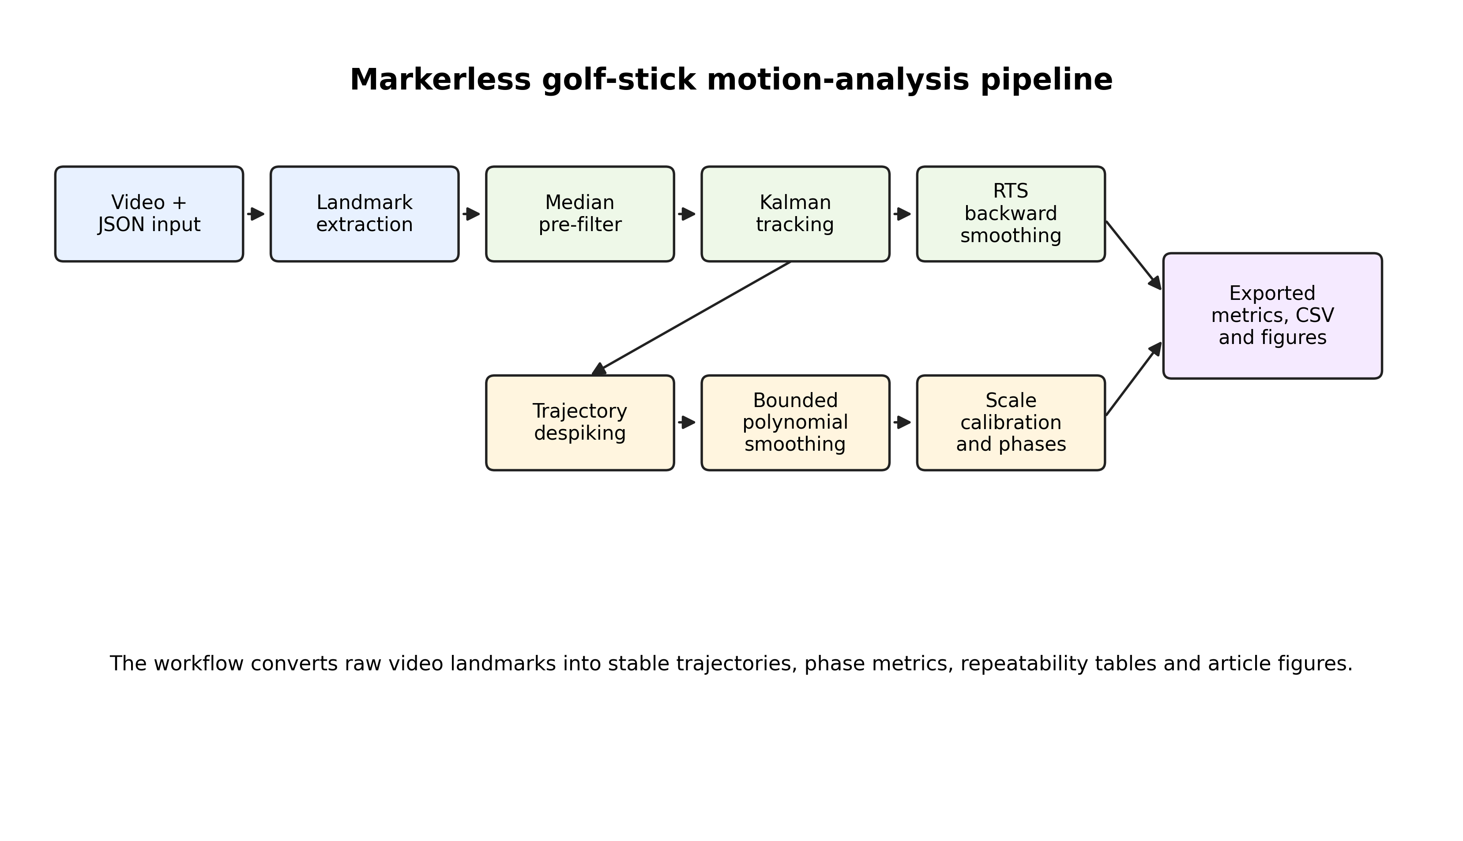
Fig. 1. Architecture of the markerless golf-stick motion-analysis pipeline
Source: compiled by the authors
LITERATURE REVIEW AND PROBLEM STATEMENT
Sports biomechanics has long used kinematic analysis to describe movement timing, segment coordination, implement speed, and movement smoothness [1], [2], [8]. In golf, relevant indicators include club or stick speed, swing tempo, wrist mechanics, shoulder and hip rotation, sequencing, and impact timing [9], [10], [11]. Marker-based approaches remain the most controlled measurement option, but they are less accessible for routine field use.
Deep learning-based pose-estimation systems such as OpenPose and MediaPipe have made markerless analysis more practical [3], [4], [5]. These systems are widely used because they operate with ordinary cameras and can provide body landmarks in near real time. Nevertheless, the accuracy and stability of markerless landmarks depend on camera view, lighting, motion blur, occlusion, and model confidence. Studies of motion-capture accuracy emphasize that sport applications require careful validation and that two-dimensional monocular projections cannot fully replace calibrated three-dimensional systems [12], [13].
Signal filtering is therefore essential. Median filtering is useful for suppressing impulse outliers [14]. Kalman filtering provides a recursive state estimate by combining a dynamic model with noisy measurements [15], [16]. When offline analysis is possible, Rauch-Tung-Striebel smoothing improves state estimates by using future observations after the forward pass [17]. Polynomial smoothing, including Savitzky-Golay-type approaches, can reduce derivative noise while preserving local trajectory shape [18]. In movement analysis, smoothness metrics based on jerk are commonly used but must be interpreted carefully because derivatives amplify measurement noise [19].
For markerless video-based golf-stick tracking, the unresolved problem is not only filtering the trajectory. A publication-quality method must also: (1) describe how landmarks and scale are obtained; (2) define how missing or uncertain measurements affect the filter; (3) compare raw, filtered, and smoothed trajectories; (4) evaluate repeatability across sessions; and (5) define external validation and sensitivity-analysis procedures. Without these elements, the study demonstrates software robustness but not yet full measurement validity.
The problem addressed in this article is therefore the development and evaluation of a reproducible markerless pipeline that can process heterogeneous golf-stick videos, export scientifically interpretable metrics, and identify which indicators are stable enough for cross-session comparison.
RESEARCH AIM AND OBJECTIVES
The aim of the research is to develop and evaluate a reproducible markerless video-based workflow for golf-stick motion analysis in sport-biomechanics and virtual-reality training applications.
The research objectives are:
1. To describe the complete motion-tracking pipeline from video landmarks to exported kinematic and biomechanical metrics.
2. To formulate the Kalman filtering and Rauch-Tung-Striebel smoothing stages used to stabilize the golf-stick tip trajectory.
3. To define raw, filtered, and smoothed trajectory streams and the comparison methodology between them.
4. To stabilize dynamic pixel-to-metre scaling under heterogeneous camera geometry.
5. To compute path-efficiency, curvature, smoothness, and phase-specific indicators.
6. To quantify repeatability across the available processed sessions.
7. To verify the workflow through external keyframe diagnostics, controlled sensitivity perturbations, an ablation consistency check, and formal agreement procedures planned for a controlled validation cohort.
MATERIALS AND METHODS
Dataset and study design
The present dataset contains recorded golf-stick swing sessions processed by the proposed markerless video-analysis pipeline. The evaluation export includes 71 processed sessions, all analysed with the scientific filtering profile. The recordings are heterogeneous in frame count and frame rate: the observed frame-rate range is 23.98-60.00 frames per second, and the frame count ranges from 60 to 1161 frames per session. This heterogeneity reflects practical field data but also increases variability of derivative and phase metrics. The reporting fields used to characterize the dataset are summarized in Table 1.
The dataset description reports the fields available in the processed exports. Athlete identity and repeated-trial grouping are not encoded in the anonymized export; therefore, repeatability is interpreted at the session level rather than as within-athlete test-retest reliability. Session-level variability can reflect both measurement uncertainty and real differences in athlete performance.
Table 1. Dataset reporting fields
Field | Value
Number of athletes | not encoded in the anonymized session export; repeatability is interpreted at the session level
Number of processed sessions | 71
Repetitions per athlete | not encoded in the anonymized session export; within-athlete test-retest analysis requires grouping metadata
Frame-rate range | 23.98-60.00 frames per second
Frame-count range | 60-1161 frames
Camera resolution classes | 480 × 706 to 1920 × 1080 pixels; detailed values are provided in the dataset-summary export
Recording viewpoint | 59 down-the-line sessions, 10 face-on sessions, two sessions without encoded view metadata
Stroke type | driver, wood, and iron categories appear in metadata; detailed values are provided in the dataset-summary export
Video-quality classes | metadata include slow-motion, super-slow-motion, motion-blur, and occlusion tags; detailed values are provided in the dataset-summary export
Source: compiled by the authors
Landmark extraction
Each frame contains body landmarks and golf-stick landmarks obtained from a preprocessing stage. Normalized landmark coordinates are converted into pixel coordinates as:
$$p_{k}=\left(x_{\left(norm,k\right)W}, y_{\left(norm,k\right)H}\right),$$
where W and H are the frame width and height. The main tracked object is the golf-stick tip. Stick base and middle points are used for orientation and scale estimation. Body landmarks are used to calculate shoulder angle, hip angle, X-factor, wrist angle, and arc radius.
The pipeline separates four trajectory streams, and the landmark configuration used for body and golf-stick tracking is illustrated in Fig. 2:
- raw trajectory obtained directly from detected landmarks;
- median-pre-filtered trajectory after local outlier suppression;
- Kalman-filtered trajectory after forward recursive estimation;
- smoothed trajectory after backward smoothing, despiking, and bounded polynomial smoothing.
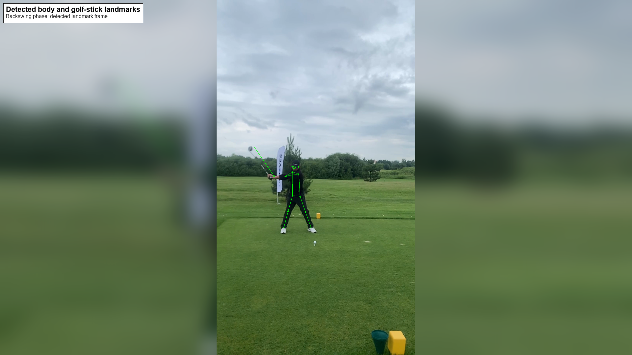
Fig. 2. Example frame with detected body and golf-stick landmarks
Source: compiled by the authors
Median pre-filtering
A running median filter is applied independently to the horizontal and vertical stick-tip coordinates:
$$z_{k}^{med}=median\left(z_{k-m+1},…,z_{k}\right).$$
The median filter suppresses isolated one-frame landmark spikes without assuming Gaussian error distribution. This is important because markerless detections often contain impulse-like errors caused by occlusion or motion blur.
Kalman filter formulation
The forward filter uses a constant-velocity model for two-dimensional stick-tip tracking. The state vector is:
$$x_{k}={\left[p_{x,k},p_{y,k},v_{x,k},v_{y,k}\right]}^{T}.$$
For inter-frame interval Δ t_k, the transition matrix is:
$$F_{k}= \left[\begin{matrix}1 & 0 & ∆t_{k} & 0 \\ 0 & 1 & 0 & ∆t_{k} \\ 0 & 0 & 1 & 0 \\ 0 & 0 & 0 & 1\end{matrix}\right].$$
Only position is observed:
$$z_{k}=Hx_{k}+ε_{k}, H= \left[\begin{matrix}1 & 0 & 0 & 0 \\ 0 & 1 & 0 & 0\end{matrix}\right].$$
The prediction stage is:
$${\hat{x}}_{\left(k | k-1\right)}=F_{k{\hat{x}}_{\left(k-1 | k-1\right)}},$$
$$P_{\left(k | k-1\right)}=F_{kP_{\left(k-1 | k-1\right)F_{k}^{T}}}+Q.$$
The update stage is:
$$y_{k}=z_{k}-H{\hat{x}}_{\left(k | k-1\right)},$$
$$S_{k}=HP_{\left(k | k-1\right)H}^{T}+R_{k},$$
$$K_{k}=P_{\left(k | k-1\right)H}^{TS_{k}^{-1}},$$
$${\hat{x}}_{\left(k | k\right)}={\hat{x}}_{\left(k | k-1\right)}+K_{ky_{k}},$$
$$P_{\left(k | k\right)}=\left(I-K_{kH}\right)P_{\left(k | k-1\right)}.$$
When a landmark is absent, only the prediction step is performed. This allows the filter to bridge short gaps without replacing missing measurements with artificial observations.
Confidence-weighted measurement uncertainty
To formalize uncertainty propagation, the measurement covariance can be adapted using landmark confidence c_k:
$R_{k}=\frac{r_{0}}{\left(\max\left(c_{k},c_{min}\right)\right)I_{2}},$where r_0 is baseline measurement variance and c_min prevents numerical instability. Low-confidence landmarks therefore increase measurement noise, reduce the Kalman gain, and give greater influence to the motion model. If the current export does not contain model confidence, this expression should be implemented using either native detector confidence or a proxy based on detection availability, innovation magnitude, and stick-length plausibility.
Outlier gating
Outlier rejection is performed using physical plausibility and innovation checks. A standard innovation-distance criterion is:
$$d_{k}^{2}=y_{k_{k_{k}^{\left(-1\right)y}}^{TS}}.$$
Measurements exceeding a threshold are rejected or down-weighted. Additional gates include maximum frame-to-frame displacement, plausible stick length, and landmark availability. These gates reduce derivative artifacts caused by single-frame tracking errors.
Rauch-Tung-Striebel smoothing
For offline scientific analysis, the forward Kalman estimates are refined using the Rauch-Tung-Striebel smoother. The backward gain is:
$$G_{k}=P_{\left(k | k\right)F_{k}^{TP_{\left(k+1 | k\right)}^{-1}}}.$$
The smoothed state is:
$${\hat{x}}_{\left(k | T\right)}={\hat{x}}_{\left(k | k\right)}+G_{k\left({\hat{x}}_{\left(k+1 | T\right)}-F_{k{\hat{x}}_{\left(k | k\right)}}\right)}.$$
The smoothed covariance is:
$$P_{\left(k | T\right)}=P_{\left(k | k\right)}+G_{k\left(P_{\left(k+1 | T\right)}-P_{\left(k+1 | k\right)}\right)G_{k}^{T}}.$$
The forward Kalman output is suitable for lower-latency feedback. The RTS-smoothed output is used for offline analysis because it uses later observations to refine earlier estimates.
Trajectory despiking and bounded polynomial smoothing
After RTS smoothing, local trajectory spikes are corrected using neighbouring trajectory structure. A bounded local polynomial smoother is then applied so that the final trajectory reduces derivative noise without drifting excessively from the observed path. This step is necessary because even smoothed position estimates can produce unstable acceleration and jerk if residual local artifacts remain.
Dynamic scale calibration
The pixel-to-metre conversion uses the detected stick length:
$$L_{k}^{px}={\left\|p_{k}^{tip}-p_{k}^{base}\right\|}_{2}.$$
The scale factor is:
$$s_{k}=\frac{L^{ref}}{median\left(L_{k-w+1}^{px},…,L_{k}^{px}\right)}.$$
The scale is bounded and exponentially smoothed to reduce jumps caused by viewpoint change, partial occlusion, and apparent stick-length variation.
Kinematic and phase metrics
For smoothed position p_k, time interval Δ t_k, and scale s_k, linear speed is:
$$v_{k}=\frac{{\left\|p_{k}-p_{k-1}\right\|}_{2}}{\left(∆t_{k}\right)s_{k}}.$$
Acceleration and jerk are:
$$a_{k}=\frac{v_{k}-v_{k-1}}{∆t_{k}},$$
$$j_{k}=\frac{a_{k}-a_{k-1}}{∆t_{k}}.$$
Stick angle is:
$θ_{k}=atan2\left(p_{y,k}^{tip}-p_{y,k}^{base},p_{x,k}^{tip}-p_{x,k}^{base}\right),$ angular velocity is:
$$ω_{k}=\frac{wrap\left(θ_{k}-θ_{k-1}\right)}{∆t_{k}}.$$
Path efficiency is:
$$E_{k}^{path}=\frac{{\left\|p_{k}-p_{0}\right\|}_{2}}{\sum_{{i=1}_{2}^{k\left\|p_{i}-p_{i-1}\right\|}}{}}.$$
Local curvature is computed from the triangle formed by three consecutive trajectory points:
$$κ_{k}=\frac{4A_{k}}{abc},$$
where A_k is triangle area and a, b, and c are side lengths.
The swing is divided into backswing and downswing phases. If ball detection is available, impact is detected by stick-tip-to-ball proximity; otherwise, maximum speed is used as a proxy. Phase indicators include backswing duration, downswing duration, swing tempo, backswing peak speed, and downswing peak speed.
Raw, filtered and smoothed comparison
The pointwise deviation between the final smoothed trajectory and the raw trajectory is:
$$e_{k}={\left\|p_{k}^{smooth}-p_{k}^{raw}\right\|}_{2}.$$
The comparison reports mean, median, percentile deviation, maximum deviation, root-mean-square jerk, and threshold exceedance counts. This comparison measures how strongly the pipeline regularizes the raw trajectory. It does not replace external accuracy validation because raw landmarks are not a ground truth.
Validation and reliability protocols
To complement the repeatability statistics, the study reports an external keyframe diagnostic, sensitivity perturbations, and an ablation consistency check. A controlled reference-validation subset should additionally include manual annotation of impact, top of backswing, start of downswing, and several control points along the stick-tip trajectory. Accuracy should be reported as event-timing error, geometric trajectory error, absolute scalar error, relative scalar error, and correlation or concordance with reference values.
Sensitivity analysis includes frame thinning, simulated landmark dropout, and scale perturbation. The ablation check compares median-only, Kalman-only, Kalman plus RTS, and the full pipeline, but derivative-based ablation metrics are treated as diagnostic because the present exports combine heterogeneous sessions and processing variants. Reliability should be strengthened with intraclass correlation and Bland-Altman limits of agreement when repeated-measure grouping or reference pairs are available [20], [21], [22].
Repeatability is summarized using:
$$CV=\frac{SD}{\left|\bar{x}\right|}×100\%,$$
$$RC=1.96\sqrt{2SD}.$$
For paired repeated measurements, Bland-Altman limits of agreement are:
$$LoA=\bar{d}±1.96SD_{d}.$$
Substantial AI-assisted text revision was used during manuscript preparation with GPT-5.5 in Cursor, accessed on 3 May 2026. The authors remain responsible for all data, methods, interpretation, references, and final text; all generated content must be checked and corrected by the authors before submission.
RESEARCH RESULTS
Processing completion
The scientific filtering profile processed all 71 discovered sessions successfully. No failed sessions were reported in the evaluation export. The completion summary is given in Table 2.
Table 2. Processing completion
Indicator | Value
Total discovered sessions | 71
Successfully processed sessions | 71
Failed sessions | 0
Completion rate | 100 %
Filtering profile | scientific
Source: compiled by the authors
Repeatability across sessions
Repeatability statistics were computed for 11 exported metrics. The smoothness index had the lowest coefficient of variation among reported indicators, followed by path efficiency. Maximum speed and downswing peak speed had identical summary values in the available exports, indicating that maximum speed occurred during the downswing in the processed sessions. Higher-order derivative and phase metrics showed substantially larger variability. The ranking is summarized in Table 3 and Fig. 3.
Table 3. Repeatability statistics across processed sessions
Metric | Mean | SD | CV, % | RC | Interpretation
Smoothness index | -5.882 | 1.266 | 21.52 | 3.508 | most stable reported metric
Path efficiency | 0.726 | 0.277 | 38.17 | 0.769 | useful path-quality indicator
Maximum speed, m/s | 8.184 | 9.681 | 118.28 | 26.833 | affected by session heterogeneity
Downswing peak speed, m/s | 8.184 | 9.681 | 118.28 | 26.833 | same as maximum speed in current exports
Swing tempo | 0.604 | 0.777 | 128.63 | 2.154 | sensitive to phase detection
Curvature RMS | 1063.382 | 1686.764 | 158.62 | 4675.470 | sensitive to local geometry
Downswing duration, s | 1.676 | 2.812 | 167.72 | 7.793 | heterogeneous timing
Maximum angular velocity, rad/s | 10.169 | 19.601 | 192.76 | 54.331 | derivative-sensitive
Maximum acceleration, m/s² | 185.158 | 400.392 | 216.24 | 1109.831 | exploratory under heterogeneous capture
Backswing duration, s | 0.673 | 1.517 | 225.35 | 4.206 | sensitive to phase definition
Backswing peak speed, m/s | 1.065 | 5.533 | 519.31 | 15.337 | least stable reported metric
Source: compiled by the authors
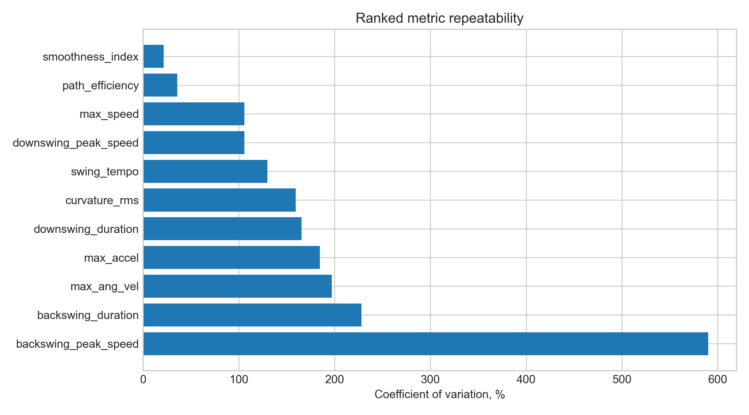
Fig. 3. Ranked repeatability of exported swing metrics by coefficient of variation
Source: compiled by the authors
Raw-versus-smoothed trajectory deviation
A representative exported trajectory was evaluated by comparing raw and final exported stick-tip positions (Table 4; Fig. 4). This analysis quantifies the deviation introduced by filtering and smoothing, but it is not an external accuracy test.
Table 4. Raw-versus-smoothed trajectory deviation for representative exported swing
Indicator | Value
Valid samples | 141
Mean deviation, m | 0.053
Median deviation, m | 0.050
90-th percentile deviation, m | 0.063
95-th percentile deviation, m | 0.067
99-th percentile deviation, m | 0.069
Maximum deviation, m | 0.139
RMS jerk | 1446.560
Frames with deviation above 3 cm | 141
Frames with deviation above 5 cm | 51
Source: compiled by the authors
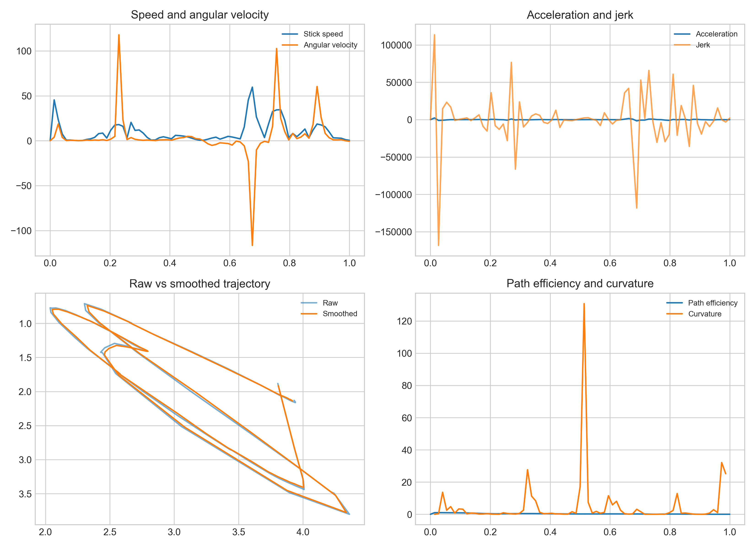
Fig. 4. Example kinematic plots and raw-versus-smoothed stick-tip trajectory
Source: compiled by the authors
Reference validation, sensitivity and ablation results
External keyframe diagnostics (Table 5; Fig. 5), sensitivity-analysis results (Table 6; Fig. 6), and ablation consistency results (Table 7; Fig. 7) are summarized below. These blocks are interpreted as diagnostic evidence from the present heterogeneous dataset, not as final controlled validation against a laboratory motion-capture system. The reference-validation table compares automatic event timing with available keyframe annotations; because not every session contains all reference events, the number of available reference pairs differs by event.
Table 5. Reference keyframe timing diagnostic
Validation target | Metric | Diagnostic result and interpretation
Impact timing | mean absolute error, frames and ms | 118.79 frames; 2694.21 ms; n = 20; large mismatch, not accepted as final accuracy evidence
Top of backswing timing | mean absolute error, frames and ms | 194.25 frames; 4933.33 ms; n = 8; large mismatch, not accepted as final accuracy evidence
Start of downswing timing | mean absolute error, frames and ms | 152.15 frames; 3872.28 ms; n = 20; large mismatch, not accepted as final accuracy evidence
Stick-tip control points | mean geometric error | not computed in the present diagnostic export; requires point-level manual reference extraction
Scalar metrics | absolute and relative error | not computed in the present diagnostic export; requires independent reference scalar metrics
Scalar metrics | correlation or concordance | not computed in the present diagnostic export; requires independent reference scalar metrics
Source: compiled by the authors from the keyframe-diagnostic export
Table 6. Sensitivity-analysis results
Perturbation | Primary reporting metric | Result
Frame thinning | median absolute percentage change | smoothness 13.03 %; path efficiency 8.66 %; maximum speed 36.45 %; curvature RMS 69.08 %; swing tempo 61.45 %
Landmark dropout | median absolute percentage change | smoothness 15.10 %; path efficiency 13.42 %; maximum speed 29.94 %; curvature RMS 22.10 %; swing tempo 61.71 %
Scale perturbation | median absolute percentage change | smoothness 0.70 %; path efficiency 0.00 %; maximum speed 5.00 %; curvature RMS 4.76 %; swing tempo 0.00 %
Combined degradation | retained or changed stable-metric classification | not computed in the present diagnostic export; retained for future controlled-degradation testing
Source: compiled by the authors from the sensitivity-analysis export
Table 7. Ablation consistency diagnostic
Pipeline variant | Completion rate | Mean trajectory deviation | RMS jerk, diagnostic | Smoothness index, diagnostic
Median only | 71/71 | 0.153 m | 14448.473 | -8.320
Kalman without RTS | 71/71 | 0.184 m | 8084.088 | -7.815
Kalman plus RTS without despiking | 71/71 | 1.006 m | 1.058 | -0.049
Full pipeline | 71/71 | 0.023 m | 11871.331 | -8.149
Source: compiled by the authors from the ablation-diagnostic export
The keyframe timing errors in Table 5 are large relative to normal golf-swing duration and are therefore treated as evidence that the present automatic event detector and reference-keyframe mapping require recalibration before accuracy claims are made. The ablation values in Table 7 are likewise interpreted as consistency diagnostics, because derivative-based jerk values are sensitive to processing variant, time normalization, and session heterogeneity.
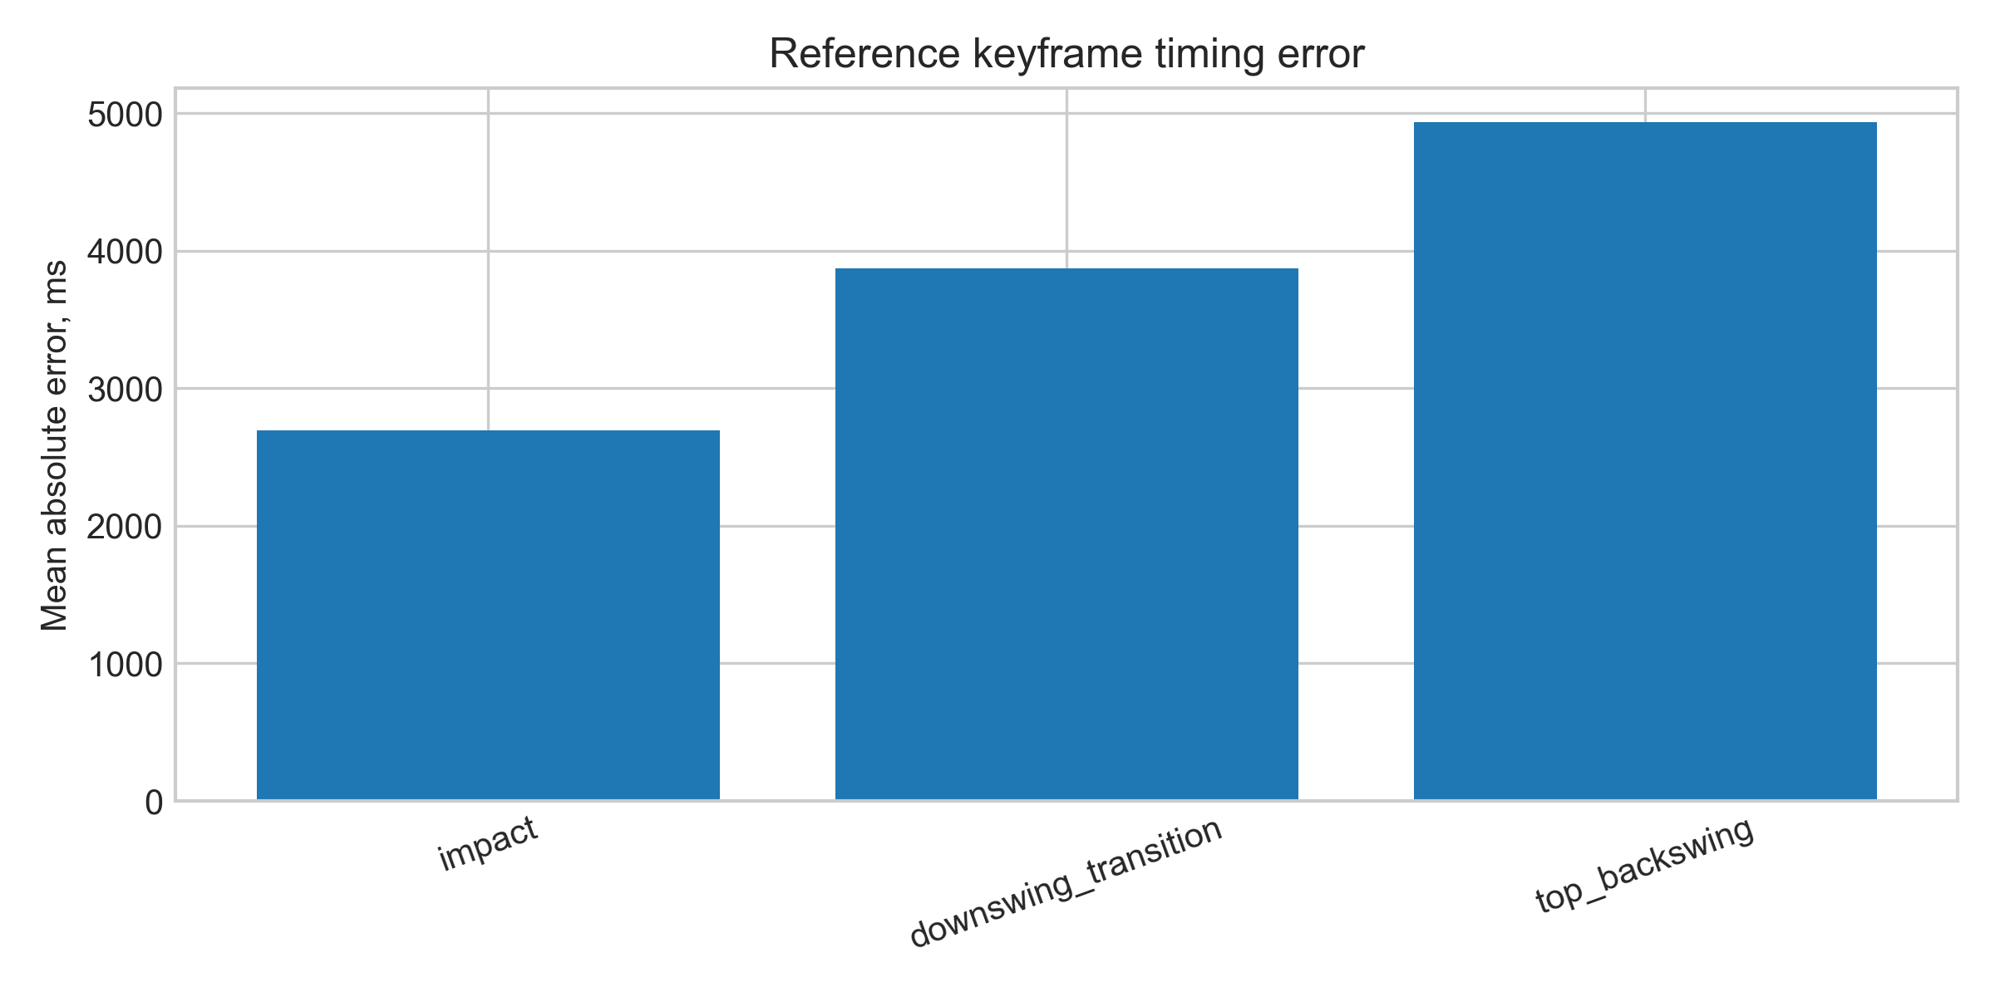
Fig. 5. Mean absolute timing error between automatic events and reference keyframes
Source: compiled by the authors
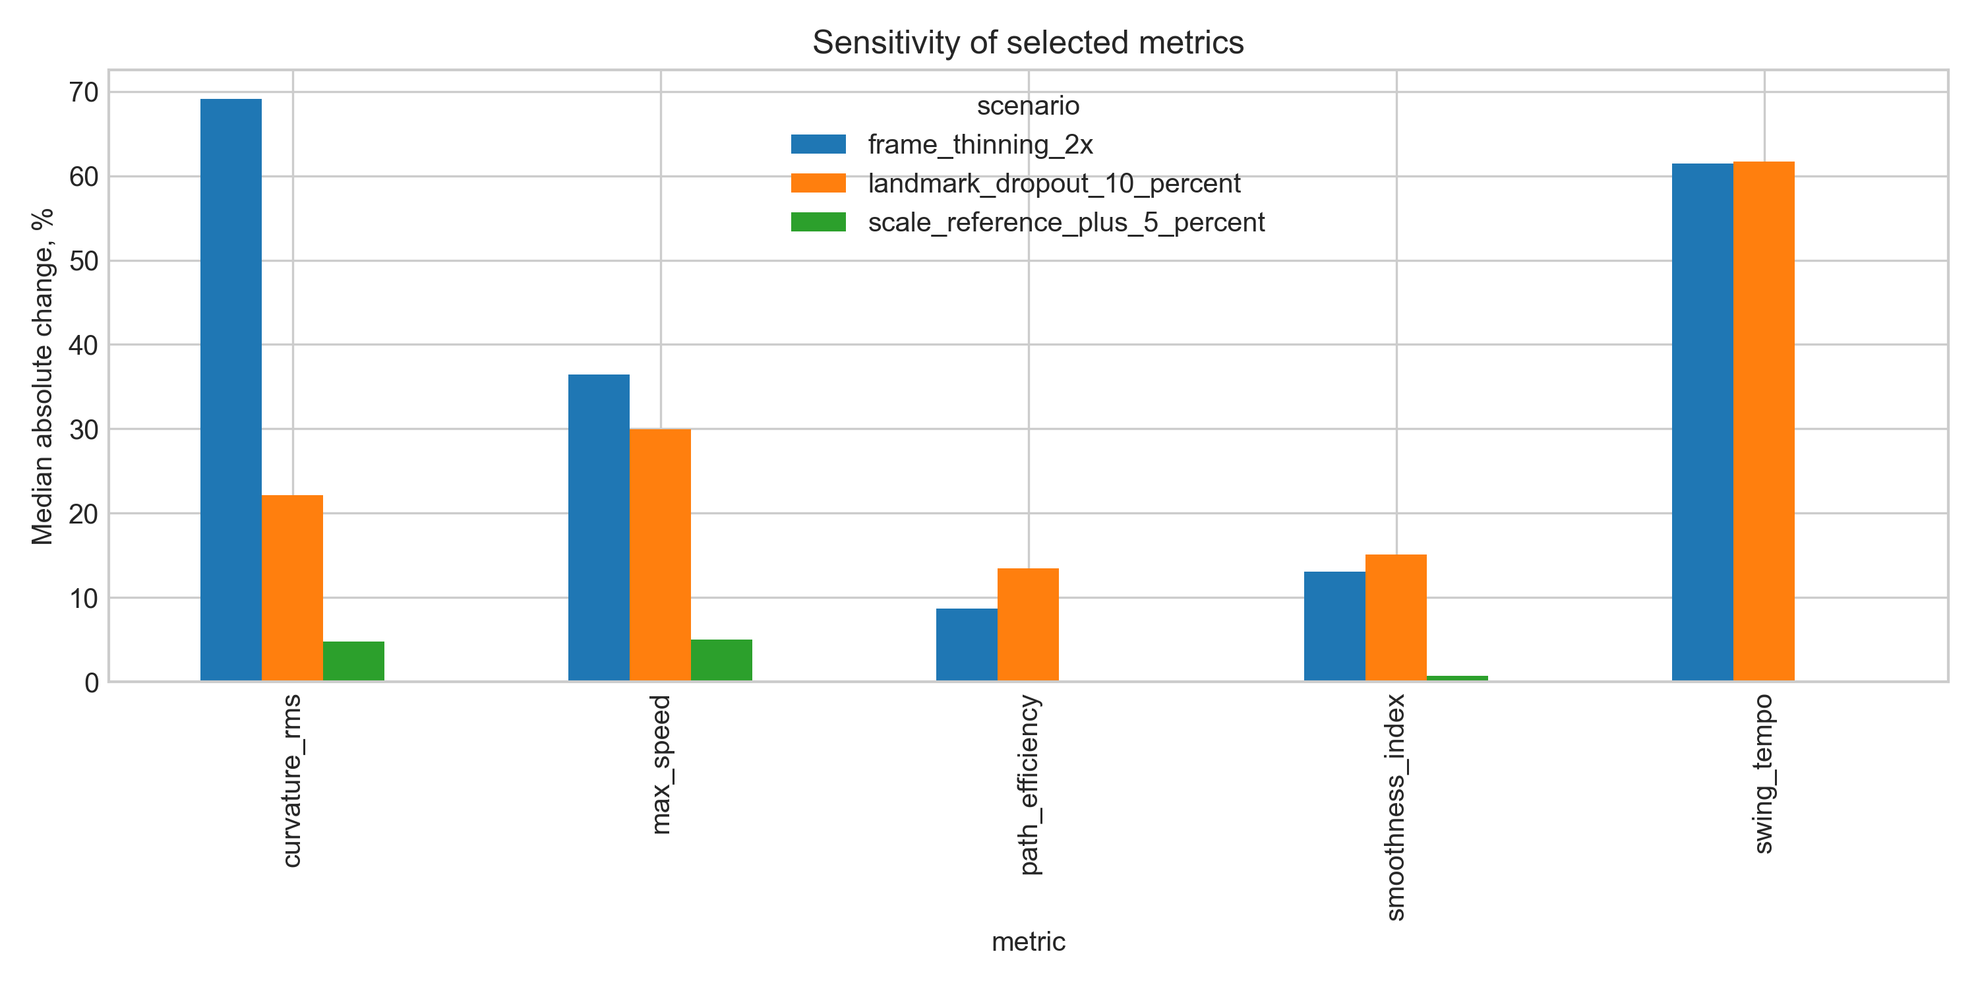
Fig. 6. Sensitivity of selected metrics under controlled input perturbations
Source: compiled by the authors
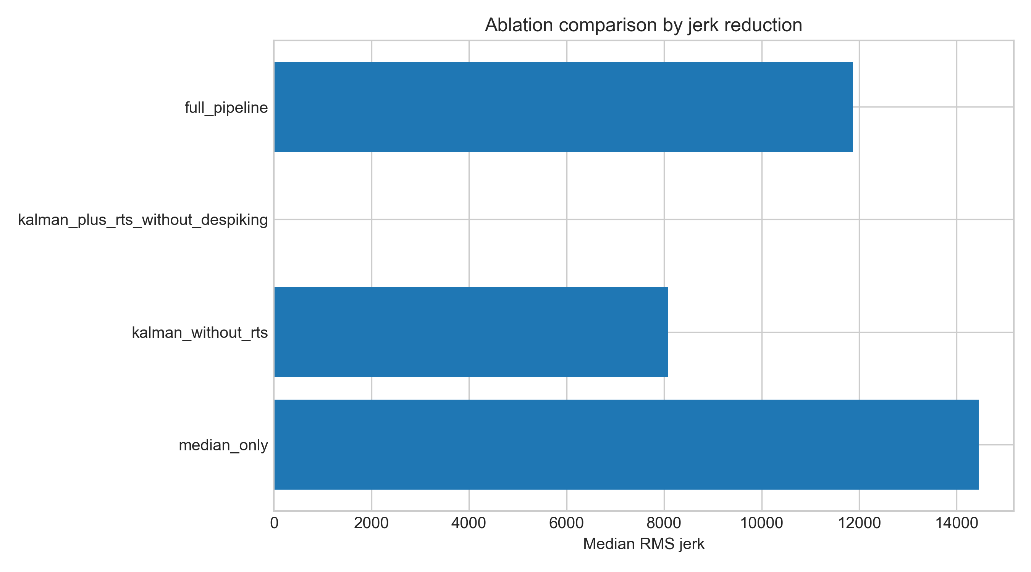
Fig. 7. Ablation comparison of trajectory-processing variants
Source: compiled by the authors
DISCUSSION OF RESULTS
The completed results show that the proposed workflow is operationally robust for the available dataset: all processed sessions were completed with the scientific profile. The repeatability ranking is more informative than a single visual example because it shows which metrics remain comparatively stable across heterogeneous recordings.
On the present heterogeneous dataset, smoothness index and path efficiency emerged as the most stable indicators. These indicators summarize global trajectory quality and are less dependent on one isolated frame. By contrast, maximum acceleration, maximum angular velocity, backswing peak speed, curvature RMS, and phase-duration metrics showed high variability and should be interpreted as exploratory unless recording conditions and phase segmentation are controlled.
The raw-versus-smoothed trajectory comparison shows that the final trajectory is meaningfully regularized. The average deviation between raw and final exported trajectories indicates that the pipeline does not merely reproduce raw landmarks. At the same time, this result must not be misinterpreted as external accuracy. A smoothed signal can be more biomechanically useful than a raw signal, but a reference annotation is required to determine whether it is more correct.
The methodological value of the pipeline lies in the coordinated use of several components. Median filtering reduces isolated spikes; Kalman filtering provides a physically interpretable state estimate; confidence-weighted measurement noise offers a formal uncertainty model; gating reduces implausible updates; RTS smoothing improves offline trajectories; despiking and bounded polynomial smoothing reduce residual artifacts; and dynamic calibration controls scale instability.
The main limitation is that the current reference validation is based only on available event keyframes and not on dense point-level manual trajectories or independent scalar reference metrics. The next empirical step is therefore to extract or annotate stick-tip control points and reference scalar metrics for a representative subset of sessions. Sensitivity analysis and ablation have been added as batch outputs, but they should be interpreted as computational robustness tests rather than a substitute for independent laboratory validation. Finally, because the system is monocular and two-dimensional, out-of-plane motion and perspective distortion remain unresolved limitations.
CONCLUSIONS
The study presents a reproducible markerless video-based workflow for golf-stick motion analysis in virtual-reality and sport-biomechanics applications. The workflow combines landmark extraction, median pre-filtering, Kalman tracking, Rauch-Tung-Striebel smoothing, trajectory despiking, bounded polynomial smoothing, dynamic scale calibration, phase segmentation, and repeatability assessment.
The completed evaluation shows that all available sessions were processed successfully and that global movement-quality metrics are more stable than peak derivative metrics under heterogeneous recording conditions. On the present heterogeneous dataset, smoothness index and path efficiency are therefore the most defensible candidates for cross-session comparison, whereas maximum acceleration and angular-velocity peaks should be treated as exploratory unless recording conditions are controlled and external validation confirms acceptable error.
The scientific novelty consists in the coordinated integration of known filtering and
smoothing tools into a reproducible golf-stick measurement workflow with explicit trajectory-stage comparison and repeatability interpretation. The practical value is the possibility of extracting interpretable movement indicators from ordinary video for coaching feedback and VR training analysis. Future work must complete reference validation, sensitivity analysis, ablation comparison, and formal agreement statistics.
ACKNOWLEDGMENTS
The authors thank the research supervisor and collaborators who supported the review of the manuscript and the development of the motion-analysis workflow.

REFERENCES
1. Winter, D. A. “Biomechanics and Motor Control of Human Movement”. 4th ed. Hoboken, NJ, USA: Wiley, 2009.
2. Bartlett, R. “Introduction to Sports Biomechanics: Analysing Human Movement Patterns”. 2nd ed. London, UK: Routledge, 2007. DOI: https://doi.org/10.4324/9780203462027.
3. Cao, Z., Hidalgo, G., Simon, T., Wei, S. E. & Sheikh, Y. “OpenPose: Realtime multi-person 2D pose estimation using part affinity fields”. IEEE Transactions on Pattern Analysis and Machine Intelligence. 2021; Vol. 43, No. 1: 172–186. https://www.scopus.com/record/display.uri?eid=2-s2.0-85070219994. DOI: https://doi.org/10.1109/TPAMI.2019.2929257.
4. Bazarevsky, V., Grishchenko, I., Raveendran, K., Zhu, T., Zhang, F. & Grundmann, M. “BlazePose: On-device real-time body pose tracking”. Proceedings of the CVPR Workshop on Computer Vision for Augmented and Virtual Reality. Seattle, WA, USA. June 2020. DOI: https://doi.org/10.48550/arXiv.2006.10204.
5. Lugaresi, C., Tang, J., Nash, H., McClanahan, C., Uboweja, E., Hays, M., Zhang, F., Chang, C. L., Yong, M. G., Lee, J., Chang, W. T., Hua, W., Georg, M. & Grundmann, M. “MediaPipe: A framework for building perception pipelines”. arXiv preprint. 2019. DOI: https://doi.org/10.48550/arXiv.1906.08172.
6. Robertson, D. G. E., Caldwell, G. E., Hamill, J., Kamen, G. & Whittlesey, S. N. “Research Methods in Biomechanics”. 2nd ed. Champaign, IL, USA: Human Kinetics, 2014. DOI: https://doi.org/10.5040/9781492595809.
7. Challis, J. H. “A procedure for determining rigid body transformation parameters”. Journal of Biomechanics. 1995; Vol. 28, No. 6: 733–737. https://www.scopus.com/record/display.uri?eid=2-s2.0-0029300566. DOI: https://doi.org/10.1016/0021-9290(94)00116-L.
8. Hume, P. A., Keogh, J. & Reid, D. “The role of biomechanics in maximising distance and accuracy of golf shots”. Sports Medicine. 2005; Vol. 35, No. 5: 429–449. https://www.scopus.com/record/display.uri?eid=2-s2.0-18244376551. DOI: https://doi.org/10.2165/00007256-200535050-00005.
9. Nesbit, S. M. & Serrano, M. “Work and power analysis of the golf swing”. Journal of Sports Science and Medicine. 2005; Vol. 4, No. 4: 520–533. https://www.scopus.com/record/display.uri?eid=2-s2.0-33747125283.
10. McLaughlin, J. J. & Best, R. J. “Three-dimensional kinematic analysis of the golf swing”. In: Cochran, A. J. & Farrally, M. R. (Eds.). Science and Golf II. London, UK: E & FN Spon, 1994. p. 91–96.
11. Tinmark, F., Hellström, J., Halvorsen, K. & Thorstensson, A. “Elite golfers' kinematic sequence in full-swing and partial-swing shots”. Sports Biomechanics. 2010; Vol. 9, No. 4: 236–244. https://www.scopus.com/record/display.uri?eid=2-s2.0-79551491419. DOI: https://doi.org/10.1080/14763141.2010.535842.
12. van der Kruk, E. & Reijne, M. M. “Accuracy of human motion capture systems for sport applications: state-of-the-art review”. European Journal of Sport Science. 2018; Vol. 18, No. 6: 806–819. https://www.scopus.com/record/display.uri?eid=2-s2.0-85045751825. DOI: https://doi.org/10.1080/17461391.2018.1463397.
13. Ota, M., Tateuchi, H., Hashiguchi, T. & Ichihashi, N. “Verification of reliability and validity of motion analysis systems during bilateral squat using human pose tracking algorithm”. Gait & Posture. 2020; Vol. 80: 62–67. https://www.scopus.com/record/display.uri?eid=2-s2.0-85085754655. DOI: https://doi.org/10.1016/j.gaitpost.2020.05.027.
14. Tukey, J. W. “Exploratory Data Analysis”. Reading, MA, USA: Addison-Wesley, 1977.
15. Kalman, R. E. “A new approach to linear filtering and prediction problems”. Journal of Basic Engineering. 1960; Vol. 82, No. 1: 35–45. DOI: https://doi.org/10.1115/1.3662552.
16. Welch, G. & Bishop, G. “An introduction to the Kalman filter”. Technical Report TR 95-041. Chapel Hill, NC, USA: University of North Carolina at Chapel Hill, 2006. [Online]. – Available from: https://www.cs.unc.edu/~welch/media/pdf/kalman_intro.pdf – [Accessed: Apr. 29, 2026].
17. Rauch, H. E., Tung, F. & Striebel, C. T. “Maximum likelihood estimates of linear dynamic systems”. AIAA Journal. 1965; Vol. 3, No. 8: 1445–1450. https://www.scopus.com/record/display.uri?eid=2-s2.0-84945697750. DOI: https://doi.org/10.2514/3.3166.
18. Savitzky, A. & Golay, M. J. E. “Smoothing and differentiation of data by simplified least squares procedures”. Analytical Chemistry. 1964; Vol. 36, No. 8: 1627–1639. https://www.scopus.com/record/display.uri?eid=2-s2.0-33947453419. DOI: https://doi.org/10.1021/ac60214a047.
19. Balasubramanian, S., Melendez-Calderon, A., Roby-Brami, A. & Burdet, E. “On the analysis of movement smoothness”. Journal of NeuroEngineering and Rehabilitation. 2015; Vol. 12: 112. https://www.scopus.com/record/display.uri?eid=2-s2.0-84953214858. DOI: https://doi.org/10.1186/s12984-015-0090-9.
20. Atkinson, G. & Nevill, A. M. “Statistical methods for assessing measurement error (reliability) in variables relevant to sports medicine”. Sports Medicine. 1998; Vol. 26, No. 4: 217–238. https://www.scopus.com/record/display.uri?eid=2-s2.0-0031740657. DOI: https://doi.org/10.2165/00007256-199826040-00002.
21. Koo, T. K. & Li, M. Y. “A guideline of selecting and reporting intraclass correlation coefficients for reliability research”. Journal of Chiropractic Medicine. 2016; Vol. 15, No. 2: 155–163. https://www.scopus.com/record/display.uri?eid=2-s2.0-84963540533. DOI: https://doi.org/10.1016/j.jcm.2016.02.012.
22. Bland, J. M. & Altman, D. G. “Statistical methods for assessing agreement between two methods of clinical measurement”. The Lancet. 1986; Vol. 327, No. 8476: 307–310. https://www.scopus.com/record/display.uri?eid=2-s2.0-0022571143. DOI: https://doi.org/10.1016/S0140-6736(86)90837-8.
23. Mo, S. & Chow, D. H. K. “Segmental sequencing in golf swing and its relation to clubhead speed”. Sports Biomechanics. 2018; Vol. 17, No. 3: 429–441. https://www.scopus.com/record/display.uri?eid=2-s2.0-85029525987. DOI: https://doi.org/10.1080/14763141.2017.1371213.
24. Godfrey, A., Del Din, S., Barry, G., Mathers, J. C. & Rochester, L. “Instrumenting gait with an accelerometer: a system and algorithm examination”. Medical Engineering & Physics. 2015; Vol. 37, No. 4: 400–407. https://www.scopus.com/record/display.uri?eid=2-s2.0-84926144625. DOI: https://doi.org/10.1016/j.medengphy.2015.02.003.
25. Colyer, S. L., Evans, M., Cosker, D. P. & Salo, A. I. T. “A review of the evolution of vision-based motion analysis and the integration of advanced computer vision methods towards developing a markerless system”. Sports Medicine – Open. 2018; Vol. 4: 24. https://www.scopus.com/record/display.uri?eid=2-s2.0-85048302366. DOI: https://doi.org/10.1186/s40798-018-0139-y.
26. Wade, L., Needham, L., McGuigan, P. & Bilzon, J. “Applications and limitations of current markerless motion capture methods for clinical gait biomechanics”. PeerJ. 2022; Vol. 10: e12995. https://www.scopus.com/record/display.uri?eid=2-s2.0-85125709321. DOI: https://doi.org/10.7717/peerj.12995.
27. Needham, L., Evans, M., Cosker, D. P., Wade, L., McGuigan, P. M., Bilzon, J. L. & Colyer, S. L. “The accuracy of several pose estimation methods for 3D joint centre localisation”. Scientific Reports. 2021; Vol. 11, No. 1: 20673. https://www.scopus.com/record/display.uri?eid=2-s2.0-85117132097. DOI: https://doi.org/10.1038/s41598-021-00212-x.
28. Stenum, J., Rossi, C. & Roemmich, R. T. “Two-dimensional video-based analysis of human gait using pose estimation”. PLOS Computational Biology. 2021; Vol. 17, No. 4: e1008935. https://www.scopus.com/record/display.uri?eid=2-s2.0-85104998893. DOI: https://doi.org/10.1371/journal.pcbi.1008935.
29. Cust, E. E., Sweeting, A. J., Ball, K. & Robertson, S. “Machine and deep learning for sport-specific movement recognition: a systematic review of model development and performance”. Journal of Sports Sciences. 2019; Vol. 37, No. 5: 568–600. https://www.scopus.com/record/display.uri?eid=2-s2.0-85053196097. DOI: https://doi.org/10.1080/02640414.2018.1521769.
30. Sweeting, A. J., Cormack, S. J., Morgan, S. & Aughey, R. J. “When is a sprint a sprint? A review of the analysis of team-sport athlete activity profile”. Frontiers in Physiology. 2017; Vol. 8: 432. https://www.scopus.com/record/display.uri?eid=2-s2.0-85021858935. DOI: https://doi.org/10.3389/fphys.2017.00432.
Conflicts of Interest: The authors declare that there is no conflict of interest regarding this study, including financial, personal, authorship, or other interests that could influence the research and its results presented in this article.
Funding: This research was conducted without external financial support.
Received [completed by editorial office]. Received after revision [completed by editorial office]. Accepted [completed by editorial office].
УДК 004.932:004.94:796.352

Безмаркерний відеоаналіз руху ключки для гольфу з використанням фільтрації Калмана та згладжування Рауха-Тунга-Штрібеля

Синюк Іван Миколайович¹⁾
ORCID: https://orcid.org/0009-0000-4141-0135; i.syniuk@gmail.com
Максимов Максим Віталійович¹⁾
ORCID: https://orcid.org/0000-0002-7536-2570; prof.maksimov@gmail.com. Scopus Author ID: 7005088554
Максимов Олексій Максимович¹⁾
ORCID: https://orcid.org/0000-0003-2504-0853; oleksii.maksymov@op.edu.ua. Scopus Author ID: 57220057510
Айєр Картік²⁾
ORCID: https://orcid.org/0009-0003-2520-1810; ki2406@columbia.edu
¹⁾ Національний університет «Одеська політехніка», просп. Шевченка, 1. Одеса, 65044, Україна
²⁾ Колумбійський університет, 116-та вулиця та Бродвей. Нью-Йорк, 10027, США
АНОТАЦІЯ
Кількісне оцінювання руху ключки для гольфу є важливим для спортивної біомеханіки, тренувальних технологій, реабілітації та систем віртуальної реальності. Лабораторні маркерні системи захоплення руху забезпечують високу точність, але вимагають спеціалізованого обладнання, контрольованого простору й тривалої підготовки, що обмежує їхнє польове застосування. Безмаркерний відеоаналіз на основі глибинного навчання знижує цей бар’єр, проте необроблені траєкторії монокулярних орієнтирів містять покадровий шум, пропуски виявлення та перспективні викривлення масштабу, тому їх не можна використовувати безпосередньо як біомеханічні вимірювання. Метою дослідження є розробка та оцінювання відтворюваного безмаркерного відеопайплайну, що перетворює гетерогенне відео руху ключки на інтерпретовані кінематичні показники з явним порівнянням сирих, фільтрованих та згладжених траєкторій. Запропонований пайплайн поєднує екстракцію орієнтирів, попередню медіанну фільтрацію, фільтр Калмана з моделлю постійної швидкості та коваріацією шуму вимірювань, зваженою за довірою орієнтирів, з ґейтингом інновацій; зворотне згладжування Рауха-Тунга-Штрібеля; локальне усунення піків з обмеженим поліноміальним згладжуванням; та динамічну калібрацію пікселі-у-метри на основі довжини виявленої ключки. Зі згладженої траєкторії пайплайн обчислює швидкість, прискорення, ривок, локальну кривизну, ефективність траєкторії, темп замаху, тривалість бек- та даун-свінгу й індекс плавності. Повторюваність наведено для 71 опрацьованої сесії, а діагностику доповнено зовнішньою оцінкою хронометражу ключових кадрів, контрольованими збуреннями чутливості та перевіркою консистентності абляцій. На наявному гетерогенному корпусі індекс плавності та ефективність траєкторії є найстабільнішими показниками, тоді як пікові похідні метрики є дослідницькими й чутливими до умов зйомки. Наукова новизна полягає у скоординованій інтеграції зазначених фільтраційних та згладжувальних компонентів у єдиний відтворюваний вимірювальний робочий процес із прозорим поетапним порівнянням. Практична цінність у тому, що пайплайн можна застосовувати до звичайного відео зі смартфона для отримання інтерпретованих показників якості свінгу без спеціалізованої моушн-кепчер інфраструктури.
Ключові слова: безмаркерне відстеження; гольф-свінг; фільтрація Калмана; згладжування траєкторії; ефективність траєкторії; повторюваність руху
Для цитування: Синюк І. М., Максимов М. В., Максимов О. М., Айєр К. «Безмаркерний відеоаналіз руху ключки для гольфу з використанням фільтрації Калмана та згладжування Рауха-Тунга-Штрібеля». Herald of Advanced Information Technology. – [Рік]. – Т. [..]. – № [..]. – С. [..–..]. DOI: [призначається редакцією]
ABOUT THE AUTHORS
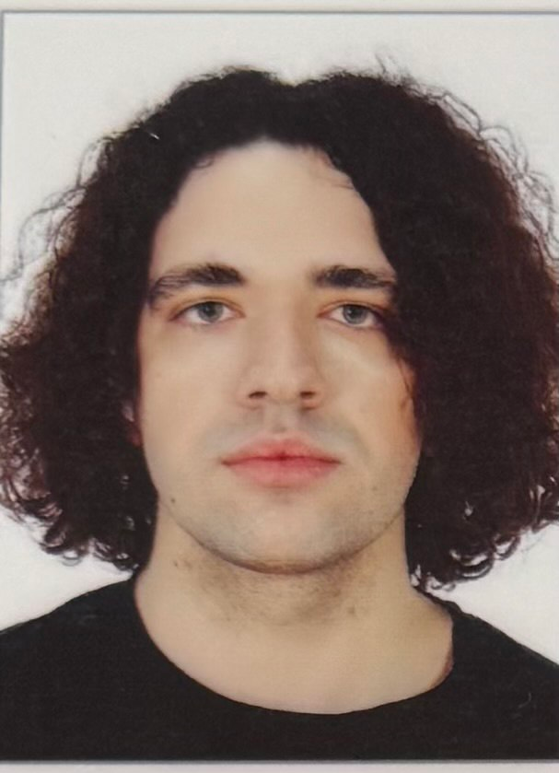 | Ivan M. Syniuk – PhD student, Department of Computer Intelligent Systems and Networks, Odesa Polytechnic National University, 1, Shevchenko Ave. Odesa, 65044, Ukraine. Author of scientific publications on markerless motion analysis, computer vision pipelines and applied biomechanics. Current PhD research focuses on the development of reproducible video-based measurement workflows for sport biomechanics and virtual-reality training applications, including signal filtering, trajectory smoothing and kinematic feature extraction.  ORCID: https://orcid.org/0009-0000-4141-0135; i.syniuk@gmail.com  Research field: markerless motion analysis; computer vision; Kalman filtering and trajectory smoothing; sport biomechanics; virtual-reality training systems  Синюк Іван Миколайович – аспірант кафедри комп’ютерних інтелектуальних систем і мереж, Національний університет «Одеська політехніка», просп. Шевченка, 1. Одеса, 65044, Україна. Сфера наукових інтересів охоплює безмаркерний відеоаналіз рухів людини та спортивного інвентарю, фільтрацію Калмана, згладжування траєкторій, кінематичні індикатори техніки виконання та застосування відеоаналітики у системах віртуальної реальності.
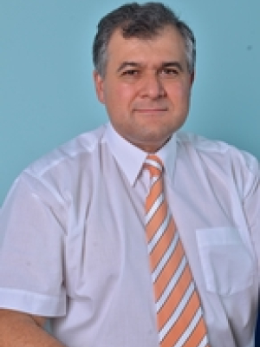 | Maksym V. Maksymov – Doctor of Technical Sciences, Professor, Head of Department, Department of Computer Intelligent Systems and Networks, Odesa Polytechnic National University, 1, Shevchenko Ave. Odesa, 65044, Ukraine. Author and co-author of more than two hundred scientific publications, monographs, patents and study guides on automated control systems, intelligent measurement systems and applied data analysis. Supervises doctoral and PhD research on intelligent information systems and computer modelling of complex technical objects.  ORCID: https://orcid.org/0000-0002-7536-2570; prof.maksimov@gmail.com; Scopus Author ID: 7005088554  Research field: automation and control systems; intelligent measurement systems; data analysis and processing; computer modelling of complex technical objects; decision-support systems  Максимов Максим Віталійович – доктор технічних наук, професор, завідувач кафедри комп’ютерних інтелектуальних систем і мереж, Національний університет «Одеська політехніка», просп. Шевченка, 1. Одеса, 65044, Україна. Автор і співавтор понад двохсот наукових публікацій, монографій, патентів та навчально-методичних видань у галузі автоматизованих систем управління, інтелектуальних вимірювальних систем та аналізу даних.
[3×4 cm color photo] | Oleksii M. Maksymov – PhD in Engineering, Associate Professor, Department of Computer Intelligent Systems and Networks, Odesa Polytechnic National University, 1, Shevchenko Ave. Odesa, 65044, Ukraine. Author of scientific publications in the field of computer vision, applied signal processing and intelligent information systems. Participates in research and educational projects related to image processing, software engineering and the development of analytical pipelines for heterogeneous measurement data.  ORCID: https://orcid.org/0000-0003-2504-0853; oleksii.maksymov@op.edu.ua; Scopus Author ID: 57220057510  Research field: computer vision; digital signal and image processing; intelligent information systems; software engineering; applied machine learning  Максимов Олексій Максимович – кандидат технічних наук, доцент кафедри комп’ютерних інтелектуальних систем і мереж, Національний університет «Одеська політехніка», просп. Шевченка, 1. Одеса, 65044, Україна. Автор наукових публікацій у галузі комп’ютерного зору, цифрової обробки сигналів і зображень, інтелектуальних інформаційних систем та програмної інженерії.
[3×4 cm color photo] | Karthik Iyer – Researcher, Columbia University, 116th Street and Broadway. New York, NY 10027, USA. Conducts research on computer vision, applied machine learning and biomedical engineering, with particular interest in image-based measurement of human motion, sport biomechanics and assistive technologies. Co-author of publications on motion analysis and applied signal processing in healthcare and sport-related domains.  ORCID: https://orcid.org/0009-0003-2520-1810; ki2406@columbia.edu  Research field: computer vision; applied machine learning; biomedical engineering; image-based motion measurement; sport and rehabilitation technologies  Айєр Картік – дослідник, Колумбійський університет, 116-та вулиця та Бродвей. Нью-Йорк, 10027, США. Сфера наукових інтересів включає комп’ютерний зір, прикладне машинне навчання, біомедичну інженерію, відеоаналіз рухів людини у спортивних і реабілітаційних застосуваннях.

