SmartNode TTL fix - test evidence
Run evidence for Home Assistant TTL generation and SmartNode validation
Run folder | C:\Users\ln20col56\Projets\ruleless-digital-twins-demo\demo-evidence\current-run-20260607-054701-ttl-fix
Run date | 2026-06-07
Workspace | C:\Users\ln20col56\Projets\ruleless-digital-twins-demo
Executive result: the missing homeassistant-ha-inferred.ttl file is now generated and present. SmartNode API, HA connection, model validation, and manual dry-run tick work. The continuous full MAPE-K loop still has a separate planner issue: it generates 0 simulation paths and then fails in MapekPlan.Plan.

Result Matrix
Area | Status | Evidence / detail
TTL generation | PASS | homeassistant-ha-inferred.ttl generated in rdt-fork-clean and copied to active repo.
FileNotFoundException | FIXED | Previous missing TTL error no longer appears in final logs.
API health/readiness | PASS | /api/health and /api/ready return HTTP 200.
HA runtime connection | PASS | POST /api/ha/connection returns Home Assistant 2025.9.3 and 99 entities.
Bindings validation | PASS | /api/model/validation returns result=PASS with HA_BINDINGS_FILE=config/ha-bindings.showcase.json.
Manual dry-run tick | PASS | /api/mapek/tick returns HTTP 200, selected scenario heat-now, executed=false.
Continuous full MAPE-K loop | FAIL | Still generates 0 simulation paths and fails with ArgumentNullException source in MapekPlan.cs:line 88.

What changed
- Copied hacvt_rdt.py, hacvt.py, and ConfigSource.py into C:\Users\ln20col56\Projets\rdt-fork-clean\models-and-rules.
- Ran the live HA RDT exporter. That export was saved as homeassistant-ha-instance.live-export.ttl for proof.
- Restored/copied the curated scenario homeassistant-ha-instance.ttl into rdt-fork-clean because the live export alone lacks simulation metadata.
- Ran the Java inference engine on the curated scenario instance and generated homeassistant-ha-inferred.ttl.
- Copied the inferred TTL into the active SmartNode workspace and relaunched SmartNode with TOKEN_HA and HA_BINDINGS_FILE.

Screenshots
Dashboard after TTL fix
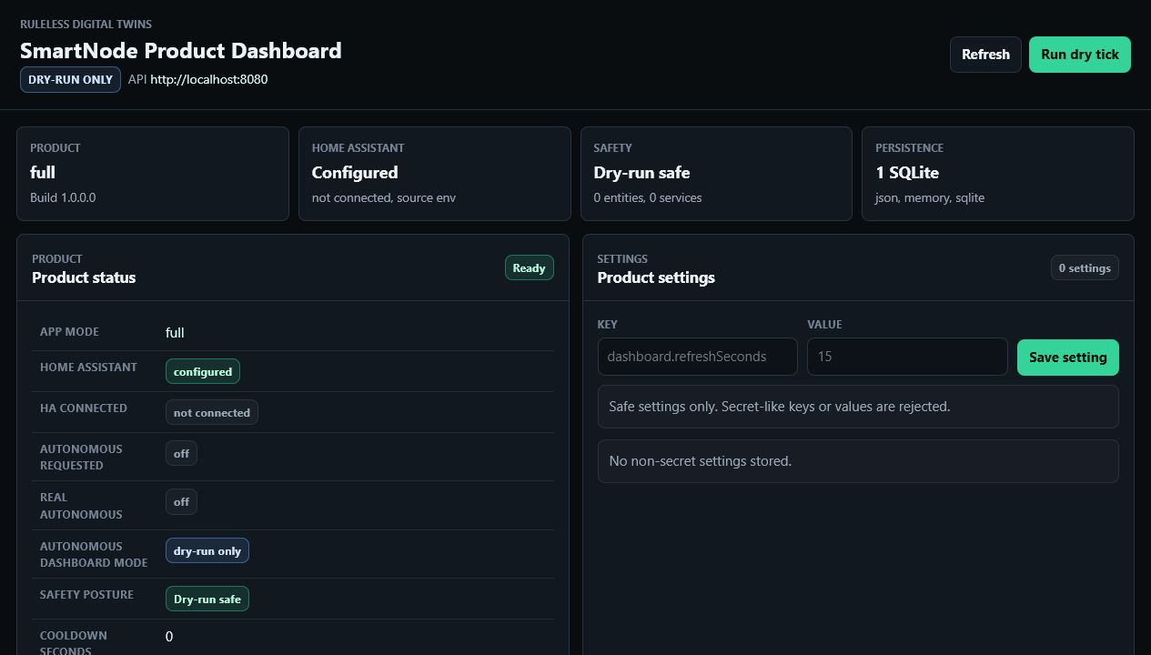
Dashboard after runtime HA connection
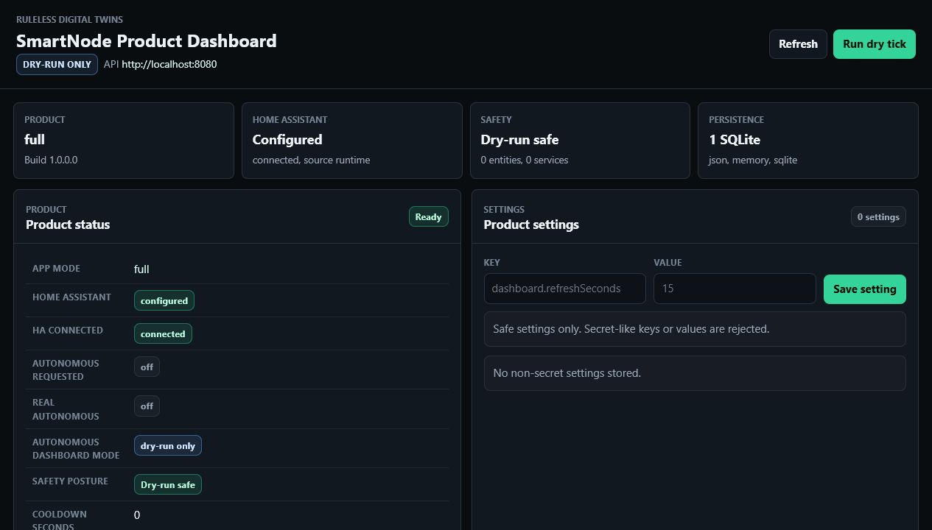
Setup page proof from first run
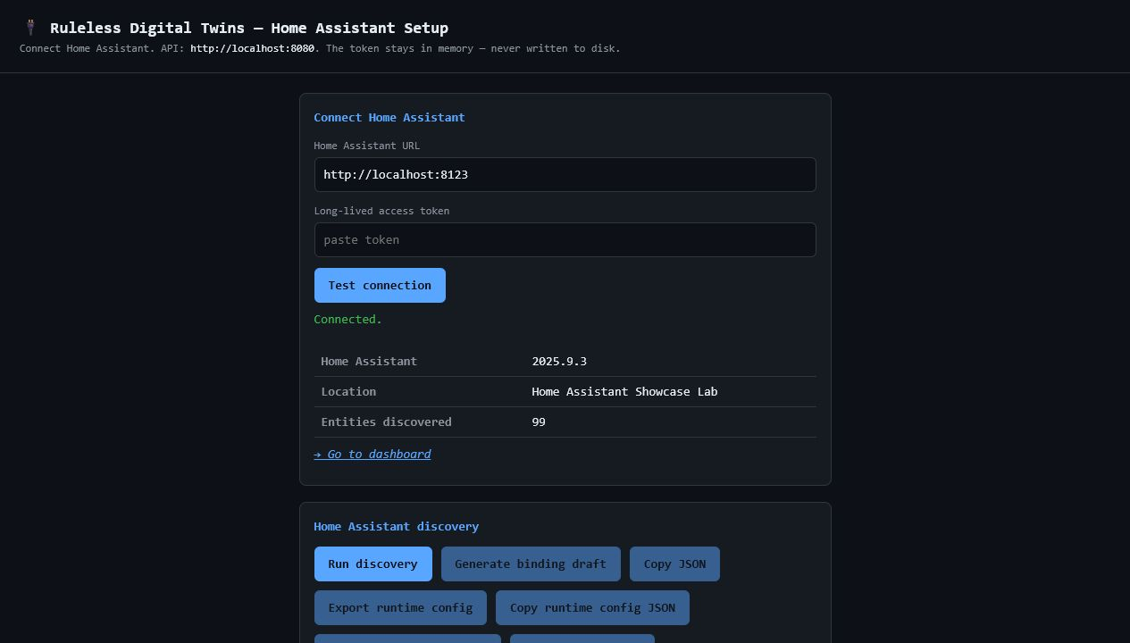
Decisions and safety proof from first run
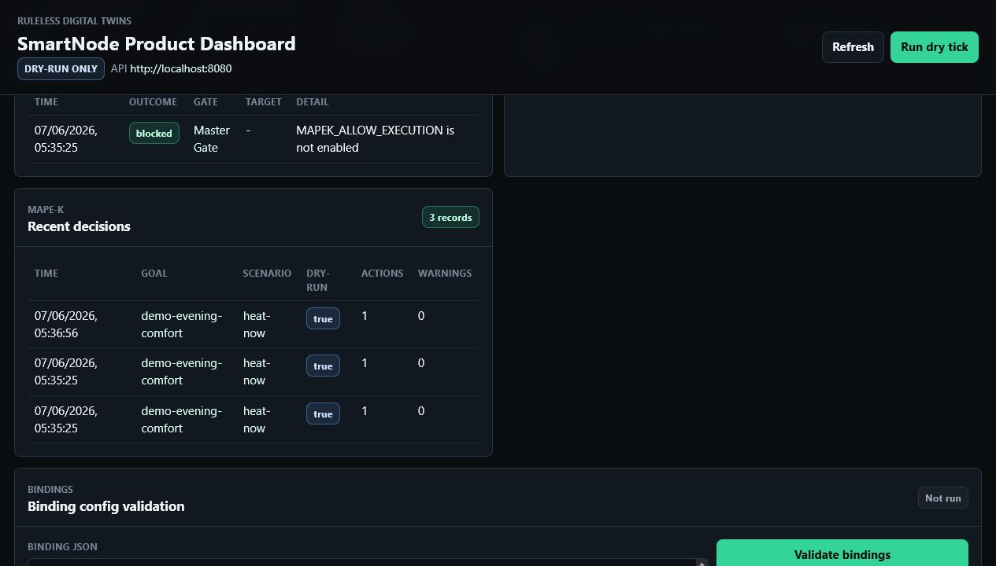

Key Log Evidence
File | Meaning
inference-engine-curated.log | 'Generated ActuationAction' ... Generated the inferred model.
api-final-model-validation.json | HTTP 200, result=PASS, sensors=8, actuators=11.
api-final-ha-connection-post.json | HTTP 200, Home Assistant 2025.9.3, entityCount=99.
smartnode-final.out.log | Generated a total of 0 simulation paths; ArgumentNullException source in MapekPlan.cs:line 88.
Conclusion: The missing TTL generation problem is handled. The remaining failure is not the missing file anymore; it is a planner/runtime issue in the continuous full MAPE-K loop after model loading.

