EGN 321 - Module 6 Assignment 6.2
Instructor Demonstration Report
Predicted Against Measured: Explain the Difference

1. Purpose and Question
This demonstration compares a deterministic temperature prediction with virtual sensor measurements from the same simulated sequence. The goal is not to force agreement. The goal is to quantify the disagreement, identify patterns, and propose evidence-based tests.
Central question: What explains the difference between what the model expected and what the instrument measured?

2. Data Used
Measured source: 1,800 timestamped virtual sensor records. The dataset deliberately includes valid readings, missing readings, rejected readings, suspicious readings, and real timestamp gaps. Prediction source: 1,800 deterministic prediction records aligned by sample number.
Measured status | Count
OK | 1747
MISSING | 33
REJECTED | 14
SUSPICIOUS | 6

3. Evidence Selection and Alignment
Only readings with sensor_status = OK and a numeric accepted_temperature_c value were used in the authoritative comparison. Missing, rejected, and suspicious rows remain in the source evidence but are excluded from the deterministic comparison. The measured and prediction files were aligned by sample_number.
Comparable points: 1,747 of 1,800. Excluded measured rows: 53.

4. Comparison Results
Metric | Result
Comparable points | 1,747
Mean signed difference (C) | 1.735
Mean absolute difference (C) | 1.735
Median signed difference (C) | 1.745
Maximum absolute difference (C) | 2.603
Minimum signed difference (C) | 0.539
Maximum signed difference (C) | 2.603
Interpretation: The measured temperature is, on average, approximately 1.73 C higher than the deterministic prediction. Because the average signed difference is positive and similar to the mean absolute difference, the disagreement appears predominantly one-sided rather than centered around zero.
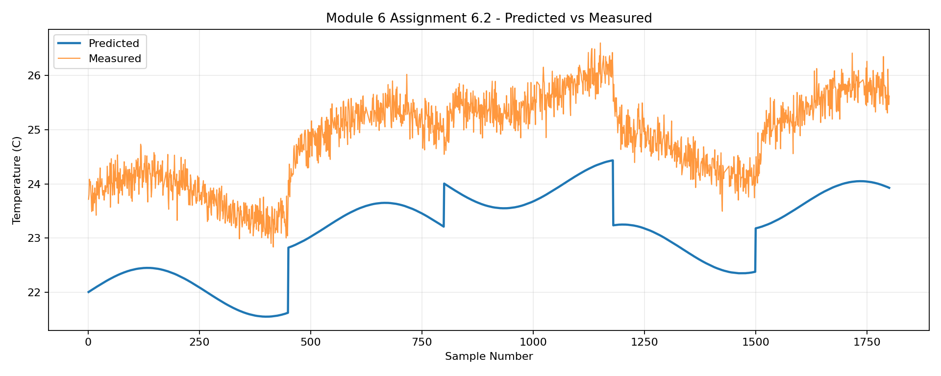
Figure 1. Predicted and measured temperature across valid comparable samples.
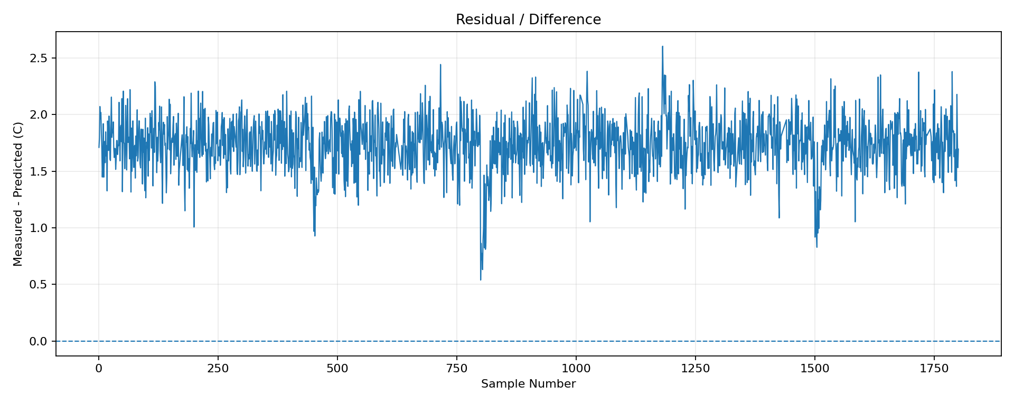
Figure 2. Residual (measured - predicted).

5. Residual Pattern by Region
Region | Comparable n | Mean signed diff. (C) | Mean abs. diff. (C)
Samples 1-450 | 440 | 1.750 | 1.750
451-800 | 340 | 1.723 | 1.723
801-1180 | 370 | 1.708 | 1.708
1181-1500 | 305 | 1.771 | 1.771
1501-1800 | 292 | 1.723 | 1.723

6. Plausible Cause 1 - Systematic Sensor or Model Offset
Hypothesis: the consistent positive residual may reflect a calibration offset in the sensor, a constant missing term in the model, or another systematic difference between the modeled and measured situations.
Evidence supporting it: residuals are predominantly positive and the overall mean signed difference is substantially above zero.
Evidence still missing: an independent reference measurement or calibration check.
Verification test: place the virtual/physical sensor and a trusted reference instrument in the same stable condition, collect paired readings, and determine whether a similar offset persists.

7. Plausible Cause 2 - Timing / Response Lag Around State Changes
Hypothesis: some disagreement around process changes may be caused by timing mismatch or sensor response lag rather than an incorrect steady-state prediction.
Evidence supporting it: the dataset contains deliberate process changes and short transient regions. A residual that changes temporarily around those transitions would be consistent with lag.
Evidence still missing: direct timing measurements showing when the modeled input changed versus when the sensor responded.
Verification test: identify each known state-change point, calculate residuals in a short window before and after the change, and compare the transient residual with the steady-state residual.

8. Effect of Missing, Rejected, and Suspicious Data
The source contains 33 missing rows, 14 rejected rows, and 6 suspicious rows. These rows were preserved but excluded from the authoritative comparison. This prevents invalid evidence from changing the residual statistics while keeping the original events available for investigation.
Important limitation: excluding problematic evidence improves the integrity of the comparison, but it may also remove information about the conditions under which the instrument fails. The status counts and source dataset should therefore be reviewed alongside the comparison results.

9. AI / Ollama Review
Ollama is used after deterministic analysis. The model receives metrics and selected evidence and may propose hypotheses, challenge conclusions, or suggest tests. It is not allowed to create missing measurements, change the deterministic prediction, or claim that a cause is proven.
Recommended AI workflow: deterministic evidence -> Ollama hypothesis review -> red-team challenge -> convert useful suggestions into deterministic tests -> document decisions in AI_LOG.md.

10. Conclusion
The comparison produced 1,747 valid comparable points. The mean signed difference was 1.735 C and the mean absolute difference was 1.735 C. The evidence supports a persistent positive disagreement, but it does not by itself prove the cause. A calibration/reference test and a transition-window timing test are appropriate next steps.

11. Assignment Submission Checklist
- Measured dataset included
- Prediction output included
- Comparison table exported
- Predicted-vs-measured plot included
- Residual plot included
- At least two plausible causes documented
- Evidence, missing evidence, and verification test documented for each cause
- README updated
- AI_LOG.md included if AI was used
- GitHub repository link ready

Appendix A - Assignment Deliverable Manifest
Required Deliverable | Supporting File
Measured sensor data | EGN321_Module6_Assignment6_2_1800_Measured.csv
Prediction output | EGN321_Module6_Assignment6_2_1800_Predictions.csv
Prediction wrapper | prediction_wrapper_demo.py
Wrapper-generated output | prediction_output_from_wrapper.csv
Comparison table | module6_predicted_vs_measured_demo.csv
Predicted-vs-measured plot | predicted_vs_measured_demo.png
Residual plot | residual_difference_demo.png
Verification tests | verification_tests_demo.py
Verification results | verification_test_results.txt
Updated README | README.md
AI log | AI_LOG.md

Appendix B - Verification Test Interpretation
Cause 1 - Systematic offset: the deterministic verification script tests whether the residual is consistently positive and large relative to its variation. A passing result supports the presence of a systematic offset pattern, but it does not prove that the sensor is miscalibrated. A trusted independent reference measurement is still required.
Cause 2 - Timing/response lag: the script shifts prediction alignment across a small range and compares mean absolute error. If a non-zero shift materially improves agreement, timing mismatch becomes more plausible. If it does not, the test weakens that explanation. Directly measuring the timing of controlled state changes remains the stronger verification method.

