НАЦІОНАЛЬНИЙ УНІВЕРСИТЕТ "ЛЬВІВСЬКА ПОЛІТЕХНІКА"

Кафедра інформаційних систем та мереж

# Звіт

до лабораторної роботи № 6

Калькулятор React

Виконав:

Студент групи КН-311

Синюк І.І.

Прийняв:

Щербак Сергій

Львів-2020

Мета: написати калькулятор на React.

import ***React***, {Component} from 'react';  
  
class KeyPadComponent extends Component {  
  
 render() {  
 return (  
 <div className="button">  
 <button name="(" onClick={e => this.props.onClick(e.target.name)}>(</button>  
 <button name="CE" onClick={e => this.props.onClick(e.target.name)}>CE</button>  
 <button name=")" onClick={e => this.props.onClick(e.target.name)}>)</button>  
 <button name="C" onClick={e => this.props.onClick(e.target.name)}>C</button><br/>  
  
  
 <button name="1" onClick={e => this.props.onClick(e.target.name)}>1</button>  
 <button name="2" onClick={e => this.props.onClick(e.target.name)}>2</button>  
 <button name="3" onClick={e => this.props.onClick(e.target.name)}>3</button>  
 <button name="+" onClick={e => this.props.onClick(e.target.name)}>+</button><br/>  
  
  
 <button name="4" onClick={e => this.props.onClick(e.target.name)}>4</button>  
 <button name="5" onClick={e => this.props.onClick(e.target.name)}>5</button>  
 <button name="6" onClick={e => this.props.onClick(e.target.name)}>6</button>  
 <button name="-" onClick={e => this.props.onClick(e.target.name)}>-</button><br/>  
  
 <button name="7" onClick={e => this.props.onClick(e.target.name)}>7</button>  
 <button name="8" onClick={e => this.props.onClick(e.target.name)}>8</button>  
 <button name="9" onClick={e => this.props.onClick(e.target.name)}>9</button>  
 <button name="*" onClick={e => this.props.onClick(e.target.name)}>x</button><br/>  
  
  
 <button name="." onClick={e => this.props.onClick(e.target.name)}>.</button>  
 <button name="0" onClick={e => this.props.onClick(e.target.name)}>0</button>  
 <button name="=" onClick={e => this.props.onClick(e.target.name)}>=</button>  
 <button name="/" onClick={e => this.props.onClick(e.target.name)}>÷</button><br/>  
 </div>  
 );  
 }  
}  
  
  
export default KeyPadComponent;

import ***React***, {Component} from 'react';  
  
class ResultComponent extends Component {  
  
  
 render() {  
 let {result} = this.props;  
 return (  
 <div className="result">  
 <p>{result}</p>  
 </div>  
 )  
 ;  
 }  
}  
  
  
export default ResultComponent;

import ***React***, { Component } from 'react';  
import './App.css';  
import ResultComponent from './components/ResultComponent';  
import KeyPadComponent from "./components/KeyPadComponent";  
  
class App extends Component {  
 constructor(){  
 super();  
  
 this.state = {  
 result: ""  
 }  
 }  
  
 onClick = button => {  
  
 if(button === "="){  
 this.calculate()  
 }  
  
 else if(button === "C"){  
 this.reset()  
 }  
 else if(button === "CE"){  
 this.backspace()  
 }  
  
 else {  
 this.setState({  
 result: this.state.result + button  
 })  
 }  
 };  
  
  
 calculate = () => {  
 var checkResult = ''  
 if(this.state.result.includes('--')){  
 checkResult = this.state.result.replace('--','+')  
 }  
  
 else {  
 checkResult = this.state.result  
 }  
  
 try {  
 this.setState({  
 // eslint-disable-next-line  
 result: (eval(checkResult) || "" ) + ""  
 })  
 } catch (e) {  
 this.setState({  
 result: "error"  
 })  
  
 }  
 };  
  
 reset = () => {  
 this.setState({  
 result: ""  
 })  
 };  
  
 backspace = () => {  
 this.setState({  
 result: this.state.result.slice(0, -1)  
 })  
 };  
  
 render() {  
 return (  
 <div>  
 <div className="calculator-body">  
 <h1>Simple Calculator</h1>  
 <ResultComponent result={this.state.result}/>  
 <KeyPadComponent onClick={this.onClick}/>  
 </div>  
 </div>  
 );  
 }  
}  
  
export default App;

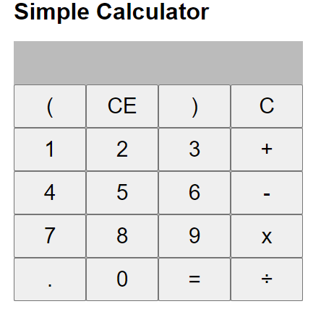

Висновок : розробив калькулятор на React.