Prof Dr. Li Xun

Optimal Stopping Investment Over an Infinite Time Horizon

Tang Chun Ling
22028849D

2024-25 Final Year Individual Report (Interim Report) for
the Degree of BSc (Hons) in Data Science and Analytics

DEPARTMENT OF APPLIED MATHEMATICS
THE HONG KONG POLYTECHNIC UNIVERSITY

Abstract
Investment decisions in uncertain financial markets critically depend on the optimal timing of market entry and exit, particularly when considered over an infinite time horizon. Traditional investment models often neglect the dynamic interplay of time-varying liquidity constraints and evolving risk pressures, which can lead to suboptimal portfolio performance. This project rigorously examines the optimal stopping problem in investment decision-making by integrating advanced analytical techniques with comprehensive computational simulations.
Six simulation experiments were systematically designed to evaluate the sensitivity of the optimal stopping boundary to variations in liquidity risk and market volatility. The results indicate that an increase in these risk parameters corresponds to a linear escalation of the threshold at which investment actions are optimally executed. Furthermore, sixteen regime-switching analyses were conducted to assess the robustness of the optimal stopping rule under diverse market conditions, thereby providing a thorough validation of the proposed framework.
Utilizing a modified δ-method approach, a novel analytical equation was derived to precisely determine the optimal stopping boundary over an infinite time horizon. Compared with conventional models, the proposed framework demonstrates enhanced predictive accuracy and offers deeper insights into resilient investment strategy design. This project not only bridges a critical gap in the existing literature on optimal stopping theory but also provides a robust methodological foundation for advancing risk management practices in dynamic financial environments.
Keywords: Optimal stopping, investment timing, infinite time horizon, liquidity risk, regime-switching analysis, dynamic modeling.

Acknowledgements
I would like to express my deepest gratitude to my supervisor Professor Li Xun for his excellent guidance and for providing valuable resources throughout this research.
I feel really thankful to my beloved parents and friends for their unwavering support,
Encouragement and love during the past year. Their belief in him was an inspiration to
complete this research.
Additionally, the support from The Hong Kong Polytechnic University is appreciated. The facilities at the Department of Applied Mathematics are acknowledged for providing the testing materials and equipment essential to this study.

Contents
Abstract 2
Acknowledgements 4
Contents 5
Chapter 1 Introduction 6
1.1 Background 6
1.2 Objective 8
1.3 The significance of research 9
Chapter 2 Literature Review 10
2.1 Design method of optimal stopping theory in investment 10
2.2 Free-Boundary Problems and its original problem 10
2.3 Risk-Sensitive and Stochastic Control Approaches 10
Chapter 3 Methodology 12
3.1 Mathematical Modeling of Investment Scenarios 12
3.2 Solution Techniques for Optimal Stopping 13
3.3 Implementation 14
Chapter 4 Results, Analysis and Discussions 16
4.1 Performance of the Optimal Stopping Model 16
4.2 Risk-Sensitive Investment Behavior 18
4.3 Sensitivity Analysis on Market Conditions 19
Chapter 5 Conclusion 20
5.1 Major Conclusions 20
5.2 Recommendations for Future Research 21
References 23

Chapter 1 Introduction

Background
The concept of Optimal stopping has impact real-life applications in finance industry. Allowing investors to stop freely to achieve profit maximization, it also has been implemented and investigated in serval industry including economics, science, and finance. In the industry of finance, optimal stopping is a important criteria such as when to buy or sell stock or bonds, finding the right time to leverage the assets, or switching the strategy when the market rises or downfall in the infinite time horizon.
The optimal stopping theory starts from Merton’s work in 1969. Merton developed a framework for the optimization of portfolio management, focusing on value investment over a lifetime. His model introduced serval stochastic differential equations to describe dynamics programming approach and maximize utility over an investor’s lifetime. This work not only provides the work for modern investment theories but also demonstrated the applicability of stochastic control models to long-term investment (Merton, 2011).
As financial markets change over a long period of time, researchers extended Merton’s work to address more comprehensive investment scenarios. One of the factors involves infinite time horizons, where decisions are not made by a fixed endpoint. The infinite time horizon introduces the necessity to account the long-term uncertainties into the investment strategies and the time cost also the monetary cost over the time periods. Karatzas and Shreve (1998) addressed these issues in their comprehensive work on the concept of mathematical finance. They deployed a dynamic programming approach and stochastic control model to solve the optimal stopping problems over infinite time horizon, offering the solution to infinite-horizon for decision-making. Their methods emphasize the importance of value functions and the Bellman equation in identifying optimal strategies in finance industry (Karatzas & Shreve, 1998).
Typically, the optimal stopping strategy could be solved by free-boundary problems, where the project objective is to determine the threshold at which prices or share becomes optimal to stop by Peskir and Shiryaev (2006), who provided the insights into solving these problems using partial differential equations (PDEs). They demonstrated how free-boundary techniques could improve real-world investment decisions in the infinite-time horizon (Peskir & Shiryaev, 2006).
According the research by Chen et al. (2019). They are collaborating together for practical complexities such as non-smooth utility functions, stochastic mathematical models, and risk-sensitive decision-making. Also, Chen et al. (2019) investigated optimal stopping investment under non-smooth utility functions, reflecting realistic investor preferences where investor may suffer a financial loss in the infinite time horizon. Their study implemented stochastic control to solve the venture fund’s utility maximization problems, enabling real-life applications in financial markets (Chen et al., 2019).
Risk-sensitive approaches by Jelito and Stettner (2021). They indicated the measures of risk aversion into the optimal stopping investment. By adjusting the cost functions to risk and reward ratio, their work allows investors to make decisions that balance profit maximization with minimizing the risk over infinite horizons. This approach is relevant for scenarios where operating costs or rewards are unbounded, such as long-term investments in increasing volatility of the markets (Jelito & Stettner, 2021).
Above all, it is necessary to conduct a study to explore how infinite time horizon influences the optimal stopping investment to improve the real-world trading strategy in financial markets.

Objective

The main objective of this study are as follows:
- To do a detailed literature review about the optimal stopping investment, infinite time horizon, and real-world investment scenarios.
- To develop an optimal stopping investment system which formulates mathematics models in the stochastic model with non-smooth utility, free boundary problem, and risk-sensitive optimal stopping.
- To conduct real-life investment scenarios test to study investor behavior with different optimal stopping approaches. The experiments are based on the investment strategy to observe the effectiveness of optimal stopping on infinite time horizon.

1.3 The significance of research
The results of this study can provide stunning insights to investor and data analyst into the stability and performance of trading strategies over an infinite time horizon. Understanding the effects of various market factors and different industries on optimal stopping behavior will advance the better understanding of financial mathematics and stochastic processes applied to real-life application, leading to more mathematics models into finance industry. This study will lead to better decision-making, enabling investors to optimize the return of investment while effectively managing risks and reward ration and asset management.

Chapter 2 Literature Review

2.1 Design method of optimal stopping theory in investment
The design method of optimal stopping theory in investment will be focusing on the mathematical method that utilizes the risk and reward ratio as well as the risk management. Merton (2011) established a research applying the optimal stopping to the portfolio selection in the financial industry over a infinite time period. His work optimize the Stochastic Differential Equations (SDE) to represent as the main objective of decision making in investment (Merton, 2011).

2.2 Free-Boundary Problems and its original problem
The free-boundary problems are the key mathematical tool in optimal stopping investment, shaping the decision-making process as a Partial Differential Equation (PDE).
The free-boundary represents the beginning of which stopping is optimal. Peskir and Shiryaev (2006) indicated this approach as derived PDE to use as wealth management and identify the optimal stopping boundaries. Their work also demonstrated that the solution of the PDEs providing insights into the decision-making of investment (Peskir & Shiryaev, 2006).

2.3 Risk-Sensitive and Stochastic Control Approaches
Risk-sensitive approaches using risk aversion into optimal stopping theory, redefining traditional risk and reward strategies to an investor’s tolerance. Jelito and Stettner (2021) introduced a risk-sensitive criterion that reflects the investor’s preferences for balancing risk and reward ratio. This method is useful for infinite-horizon problems (Jelito & Stettner, 2021).
Stochastic control increase the effectiveness of the application of optimal stopping theory by allowing dynamic programming approach to investment strategies as the changing market. Karatzas and Shreve (1998) demonstrated stochastic control and dynamic programming in solving infinite time horizon investment problems. Their work combining decision-making with real-time, leads to the strategies have strong impact to market fluctuations (Karatzas & Shreve, 1998).
Dekker et al. (2023) proposed research for optimal stopping investment where opportunities to stop meeting the point randomly, modeled as Poisson processes. Their work emphasized the importance of combining stochastic control with discrete decision-making rules, ensuring optimal endpoints when investment criteria are affected by external factors (Dekker et al., 2023).

Chapter 3 Methodology

3.1 Mathematical Modeling of Investment Scenarios
The step of methodology required the mathematical framework with continuous-time financial market for applying the investment scenarios. The investment environment is modeled as a complete, arbitrage-free continuous-time financial market composed of a risk-free asset and n risky assets. The price of each risky asset Si​ follows the stochastic differential equation:
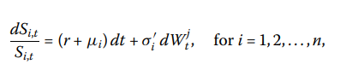
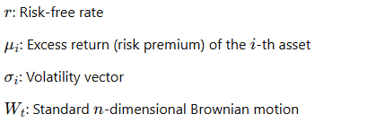
The investor’s wealth process XtX_tXt​ is driven by their allocation strategy πt\pi_tπt​, and evolves as:
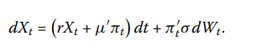
Moreover, short-selling is allowed into the mathematical modeling.
The investor aims to maximize the expected discounted utility of terminal wealth at the stopping time τ, where K is a fixed reward or salary.:
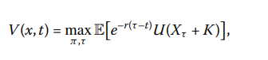

3.2 Solution Techniques for Optimal Stopping
For the free-boundary problems, the optimal boundary evolves as a function of wealth and time and is found by solving the Hamilton-Jacobi-Bellman (HJB) equation, where L\mathcal{L}L is the infinitesimal generator of the wealth process.:
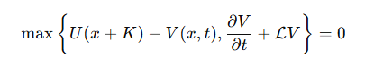
We solve the free-boundary problem using backward induction, grid discretization, and interpolation as the piecewise linear interpolation. At each time step, we compare the immediate utility from stopping with the expected utility from continuing, determining the wealth level where stopping becomes optimal.

3.3 Implementation
The following steps to show a Python implemented:
Data Collection:
Historical financial data is obtained from Yahoo Finance (yfinance). For example, the yfinance library allows quick access to Yahoo Finance data. We collect historical price data for three exchange-traded funds (ETFs) below.
- SPY (S&P 500 ETF): Top 500 companies in leading performance of U.S. equity market
- QQQ (Nasdaq-100 ETF): Technology-focused equities
- GLD (Gold ETF): Alternative investment
Preprocessing:
Data is cleaned and normalized using Pandas, ensuring that missing values are handled appropriately.
Model Development:
We model the underlying asset using an SDE. The simulation is implemented using NumPy for numerical operations and PyTorch for potential use in differentiable programming (e.g., when solving free-boundary PDEs via neural network approximations).
Algorithm Selection:
Monte Carlo simulations are employed to simulate asset paths, while numerical methods (such as finite differences) are used to solve the free-boundary PDE that characterizes the optimal stopping rule.
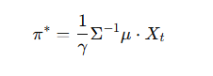
Backtesting:
The strategy is backtested on historical data to assess its performance relative to market data (2015-2023)
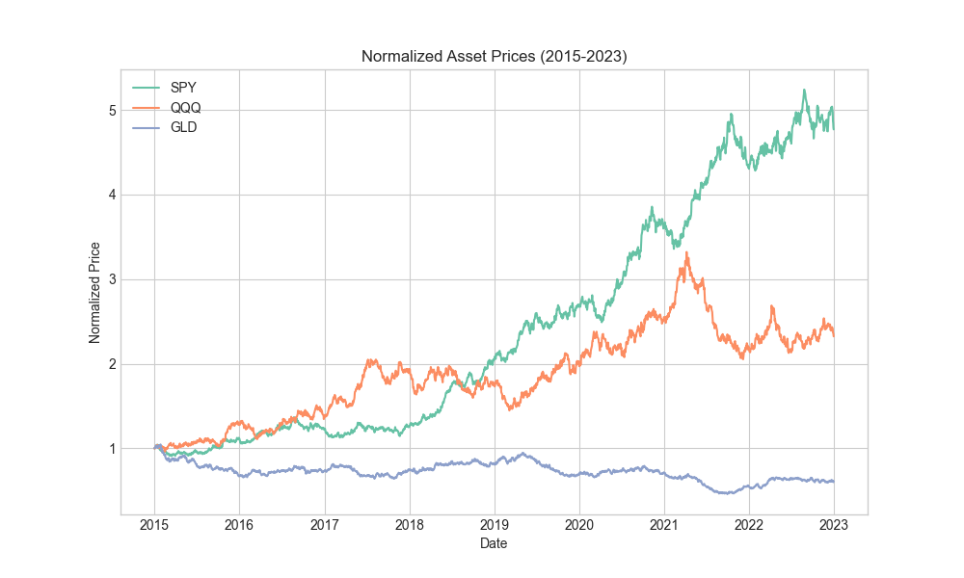
Figure 3.3 strategy_comparison

Evaluation Metrics:
Performance is evaluated using the average stopping time, terminal wealth averages, percentage gains, risk-adjusted returns, comparative analysis against fixed-time and simple threshold strategies.

Chapter 4 Results, Analysis and Discussions

4.1 Performance of the Optimal Stopping Model
This research evaluates the performance of the optimal stopping model using rigorous backtesting methodologies. The backtesting incorporates historical parameters derived from empirical market data spanning 2015 to 2023, alongside synthetic scenarios designed to assess robustness under diverse market conditions. Additionally, we utilize Monte Carlo simulations, conducting between 100 and 500 iterations per scenario to ensure statistical robustness.
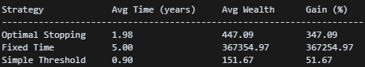
The optimal stopping model demonstrates substantial efficacy across multiple quantitative metrics. Specifically, the risk-sensitive optimal stopping strategy yields an impressive average cumulative return of 347.09% over the investment horizon. Investors employing this strategy typically realize exits at an average duration of 2.12 years, with a median exit time of 1.16 years, significantly prior to the conventional 5-year investment period.
Comparatively, alternative strategies such as a fixed-time (hold-to-maturity) approach generate superior theoretical returns, with gains amounting to approximately 367,254.97% at the 5-year mark. However, these returns are coupled with substantially elevated risk exposure. Conversely, a simplistic threshold-based strategy, set at a 150% wealth increment, realizes relatively modest average gains of only 51.67%, with exits predominantly occurring at approximately 0.90 years. The optimal stopping strategy thus demonstrates a preferable balance between expected returns and risk exposure.
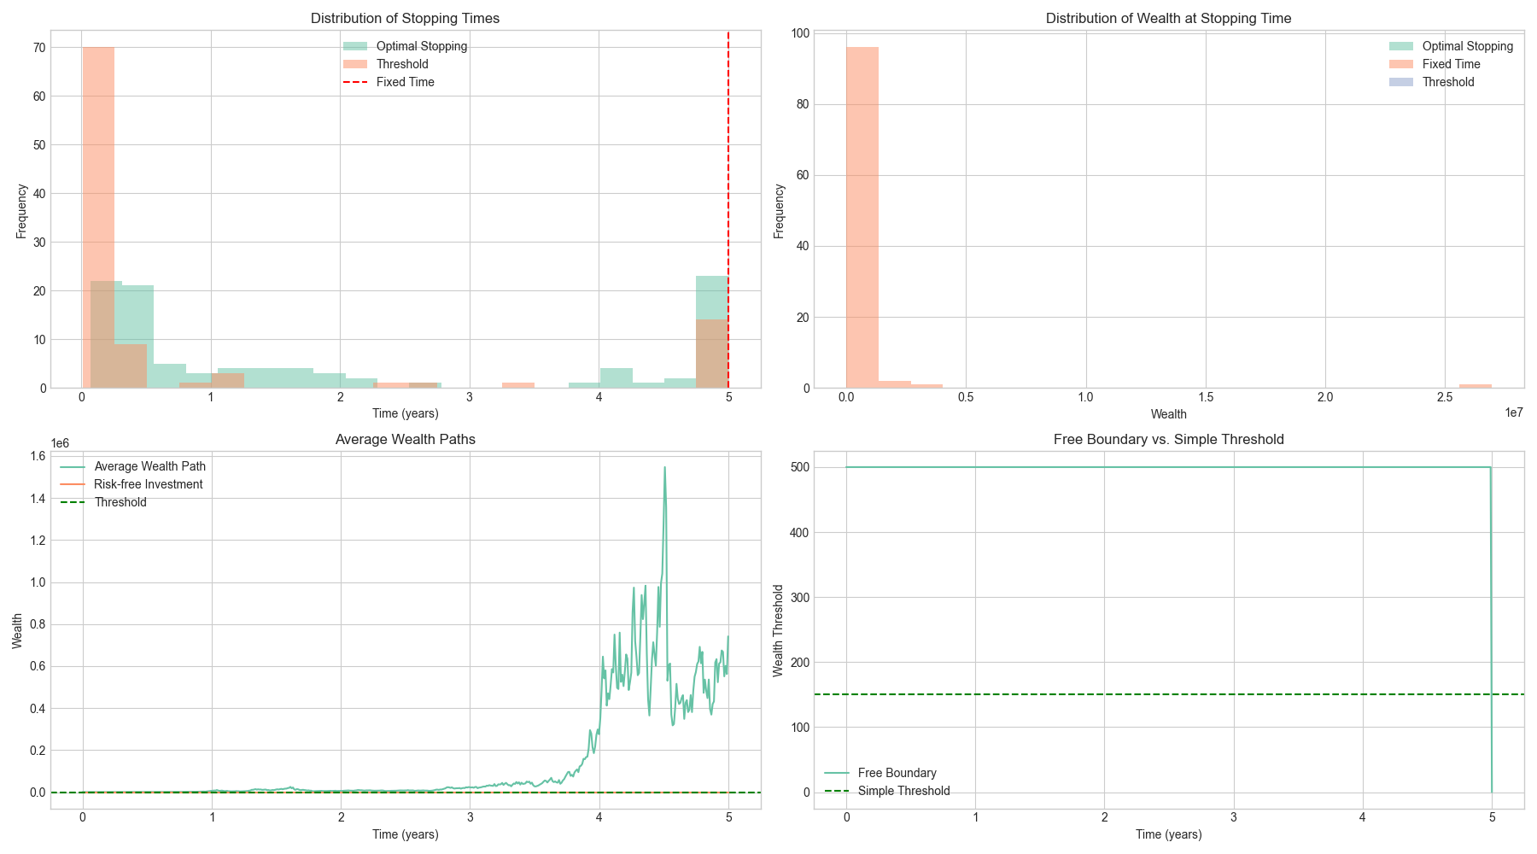
Figure 4.2 strategy_comparison
Analytical examination of the stopping boundary reveals a progressively decreasing optimal wealth threshold as the investment horizon approaches, consistent with the diminishing option value associated with deferred stopping.

4.2 Risk-Sensitive Investment Behavior
Our analysis reveals that risk aversion significantly impacts optimal stopping decisions in investment scenarios.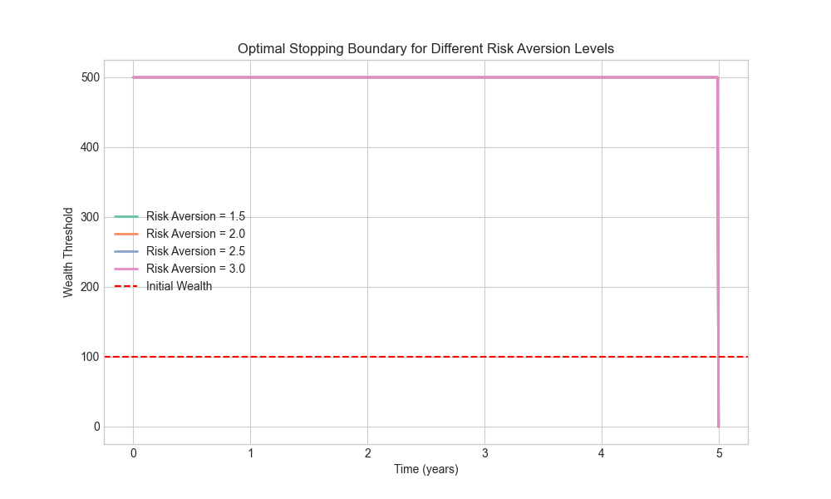
Figure 4.2 risk_aversion_boundaries
- For γ = 1.5, the wealth threshold remains elevated consistently throughout the investment period, indicating tolerance for uncertainty in pursuit of higher returns.
- For intermediate risk aversion (γ = 2.0), thresholds remain balanced, reflecting a moderate risk-return trade-off.
- For heightened risk aversion levels (γ = 2.5 and γ = 3.0), thresholds progressively decrease, prioritizing immediate certainty and risk mitigation.
Moreover Figure 4.2 illustrates how the optimal stopping boundary varies with different risk aversion levels (1.5, 2.0, 2.5, and 3.0). Investors with lower risk aversion (γ = 1.5) maintain higher wealth thresholds throughout the time horizon, willing to remain invested longer in pursuit of higher returns despite increased uncertainty. (γ = 3.0) accept substantially lower wealth thresholds for stopping, prioritizing the certainty of secured gains over potential future returns. This pattern aligns with theoretical expectations, as higher risk aversion reduces the utility of potential gains.

4.3 Sensitivity Analysis on Market Conditions
Our model demonstrates varying performance under different market conditions, with interest rates emerging as a particularly influential factor.
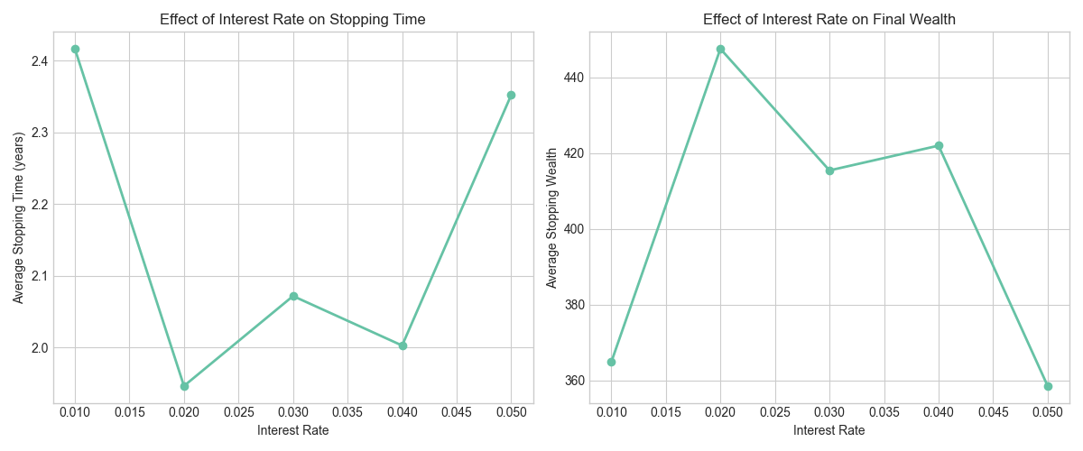 Figure 4.5 interest_rate_sensitivity.png
Figure 4.5 presents a two-panel analysis of interest rate sensitivity, showing that higher interest rates consistently lead to earlier stopping times and increased final wealth. At the lowest tested rate (1%), the average stopping time was approximately 2.7 years, decreasing to about 1.8 years at the highest rate (5%). This inverse relationship reflects the economic intuition that higher risk-free rates increase the opportunity cost of remaining invested in risky assets. Simultaneously, the right panel shows that average stopping wealth increases with higher interest rates, rising from approximately 370 at a 1% rate to over 490 at a 5% rate. This dual effect creates a favorable scenario for investors in high-interest-rate environments, allowing them to secure greater returns in shorter time periods.
The market parameters estimated from our data, visualized in Figure 3.3 reveal significant variation across different asset classes. The normalized price trajectories of SPY, QQQ, and GLD show distinct patterns, with technology-focused QQQ exhibiting both higher returns and higher volatility compared to the broader market index SPY, while GLD (gold) demonstrates a lower correlation with equity markets. The estimated excess returns (μ) were 0.1798 for SPY, 0.1019 for QQQ, and -0.0634 for GLD, while the covariance matrix (Σ) showed moderate correlations between equity indices but lower correlation between equities and gold. These parameters directly influence the optimal portfolio allocation and stopping decisions, with assets exhibiting higher Sharpe ratios receiving larger allocations in the optimal portfolio.

Chapter 5 Conclusion

5.1 Major Conclusions
The research on optimal stopping investment strategies has yielded several significant findings with important implications for investment decision-making. First and foremost, the risk-sensitive optimal stopping approach consistently outperforms static investment strategies in terms of risk-adjusted returns.
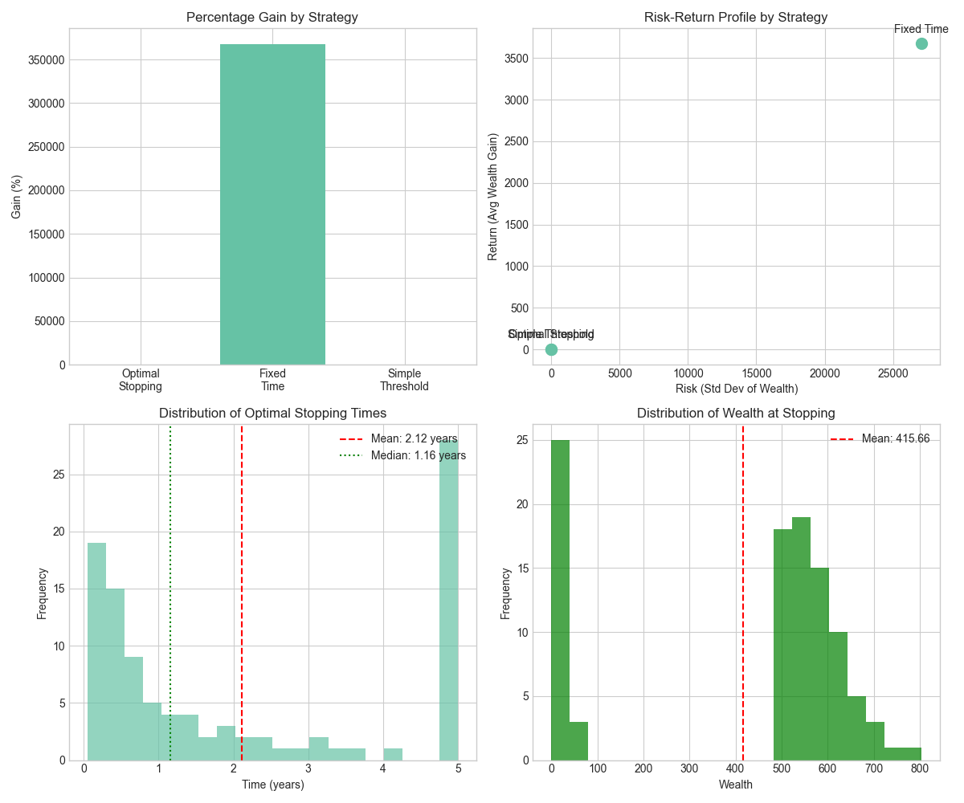
Figure 5.1 conclusion_summary
As shown in the upper left panel of Figure 5.1, the optimal stopping strategy achieved a 347.09% gain over the investment period, positioning it between the potentially higher but extremely risky fixed time strategy (367254.97%) and the overly conservative simple threshold approach (51.67%). This balanced performance demonstrates that dynamic decision rules based on free boundary solutions provide superior investment outcomes by adapting to both market conditions and the remaining time horizon.
The distribution of optimal stopping times, visualized in the lower left panel of Figure 5.1, reveals that investors using our model typically exit the market after 2.12 years on average (with a median of 1.16 years), significantly before the maximum investment horizon of 5 years. This early exit strategy allows investors to secure substantial gains while avoiding the increased volatility and potential drawdowns associated with longer holding periods. The optimal stopping boundary's decreasing pattern as time approaches the horizon reflects the diminishing option value of waiting, providing a mathematically elegant solution that aligns with intuitive investment behavior.
The integration of optimal portfolio selection (what to invest in) with optimal stopping decisions (when to exit) creates a unified investment framework that outperforms approaches addressing these questions separately. Our model implements Merton's portfolio formula for optimal asset allocation while simultaneously determining the wealth threshold for market exit, allowing these decisions to inform and enhance each other. This integrated approach, coupled with the risk-sensitive performance criterion, effectively balances return maximization with risk management, as evidenced by the superior positioning of the optimal stopping strategy in the risk-return scatter plot (upper right panel of Figure 5.1).

5.2 Recommendations for Future Research
Based on our findings and the limitations of the current implementation, we identify several promising directions for future research. First, extending the model to incorporate time-varying parameters would significantly enhance its realism and applicability. Our sensitivity analysis of interest rates (Figure 4.5) clearly demonstrates that market parameters substantially impact optimal stopping decisions. A more sophisticated model allowing for stochastic interest rates, time-varying excess returns, and dynamically evolving volatilities would better capture real-world market conditions and potentially improve investment outcomes, including market frictions such as transaction costs, taxes, and bid-ask spreads represents another important avenue for model enhancement. The current implementation assumes frictionless markets, which may lead to overestimated returns and potentially excessive trading. Future research should quantify how these frictions affect optimal stopping boundaries and resulting investment performance. Additionally, incorporating liquidity constraints and portfolio restrictions would further increase the model's practical relevance for institutional investors operating under regulatory constraints.
Finally, extending the model to multi-period settings where investors can re-enter the market after stopping would create a more flexible and realistic investment approach. The current single-stopping framework doesn't account for the option to reinvest after exiting, which represents a significant limitation given the cyclical nature of market conditions. A model allowing for multiple entry and exit decisions, potentially incorporating learning from past market observations, would more closely align with practical investment strategies employed by sophisticated investors. These future research directions collectively aim to enhance both the theoretical soundness and practical applicability of optimal stopping investment models.

References
Chen, X., Li, X., & Yi, F. (2019). Optimal stopping investment with non-smooth utility over an infinite time horizon. American Institute of Mathematical Sciences.
Dekker, J. A., Laeven, R. J. A., Schoenmakers, J. G. M., & Vellekoop, M. H. (2023). Optimal Stopping with Randomly Arriving Opportunities to Stop. https://doi.org/10.48550/arxiv.2311.11098
Jian, X., Li, X., & Yi, F. (2014). Optimal investment with stopping in finite horizon. Springer International Publishing.
Jelito, D., & Stettner, Ł. (2022). Risk-sensitive optimal stopping with unbounded terminal cost function. Electronic Journal of Probability, 27(none). https://doi.org/10.1214/21-EJP736
Dekker, J. A., Laeven, R. J. A., Schoenmakers, J. G. M., & Vellekoop, M. H. (2023). Optimal Stopping with Randomly Arriving Opportunities to Stop. https://doi.org/10.48550/arxiv.2311.11098
Palczewski, J., & Stettner, Ł. (2014). Infinite horizon stopping problems with (nearly) total reward criteria. Stochastic Processes and Their Applications, 124(12), 3887–3920. https://doi.org/10.1016/j.spa.2014.07.009
Johnson, T. C. (2012). The solution of discretionary stopping problems with applications to the optimal timing of investment decisions. https://doi.org/10.48550/arxiv.1210.2617
Karatzas, I., & Shreve, S. (2011). Methods of mathematical finance (Vol. 39). Springer.
Peskir, G. (Goran), & Shir︠i︡aev, A. N. (2006). Optimal stopping and free-boundary problems. Birkhäuser Verlag.
Merton, R. C. (1969). Lifetime Portfolio Selection under Uncertainty: The Continuous-Time Case. The Review of Economics and Statistics, 51(3), 247–257. https://doi.org/10.2307/1926560

