**Files Locations**

The git is located at

<https://github.com/ivantay2003/BDD_Cucumber>

The video on how to use this is at

<https://youtu.be/R7IEIv8fxHk>

Test Scenarios Spec is in the doc folder with this filename

TestScenarios.xlsx

Cucumber BDD Gherkin Spec is in the doc folder with this filename

Gherkin.xlsx

**TestNG**

Test Scenarios (Page Object models) TestNG files in main:

Scenario1.xml

Scenario2.xml

Scenario3.xml

Cucumber files TestNG files in main:

Cucumber_Scenarios.xml

Cucumber_Scenario1.xml

Cucumber_Scenario2_1.xml

Cucumber_Scenario2_2.xml

Cucumber_Scenario2_3.xml

Cucumber_Scenarios.xml execute ALL the test case

**Test scenario files**

src/test/java/SGDigitalTest/

**Cucumber BDD runner files**

src/test/java/cucumber

**Prerequisite**

This is developed in Eclipse with maven and cucumber plugin. All libraries will be call from pom.xml

**Steps**

* Clone from the github
* Open your Eclipse
* Import it as Maven -> Existing Maven Projects (IMPORTANT. The project will be corrupted if you import it as other existing projects beside Maven)
* Go to pom.xml -> Clean
* Go to pom.xml -> Install

Execute test case in command prompt / terminal

**Test Scenarios (Page Object Models)**

Test Scenario 1 : *mvn test -P scenario1*

Test Scenario 2 : *mvn test -P scenario2*

Test Scenario 3 : *mvn test -P scenario3*

**Cucumber Gherkin (BDD)**

BDD User Scenario 1 : *mvn test -P cucumber1*

BDD User Scenario 2_1 : *mvn test -P cucumber2_1*

BDD User Scenario 2_2 : *mvn test -P cucumber2_2*

BDD User Scenario 2_3 : *mvn test -P cucumber2_3*

BDD User Scenario 1, 2_1, 2_2 & 2_3 : *mvn test -P cucumber*

**Highlight in red Test Scenario 3 and BDD User Scenario 2_3 will fail as it does not meet User Acceptance criteria 2.2**

**Defects**

**Defect 1**

When input special characters example ‘@#”, the filter input does not ignore nor clear.

Symptom 1 : The job results change when input special characters. It should not and ignore

Symptom 2 : The filter field does not clear

1. These 2 symptoms go against Acceptance Criteria 2.2 – “Any special characters that will be entered in the filter field will be ignored/cleared.

This is caught in following automation tests :

Test Scenario – TestScenario3

BDD Cucumber – User Scenario 2_3

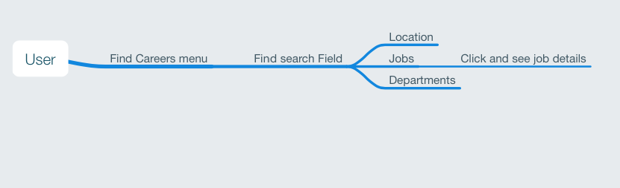

Mind mapping on high level features