URL :

http://automationpractice.com/

**Task #1:**​ Create Automation Script for Sign-Up Process **Step 0:**​ Launch Site and access the ‘Sign-In’ section

page1image3715984

**Step 1:** ​Create a new account  
(Please note that your script should be written in such a way that a new unique account is created on each test run)

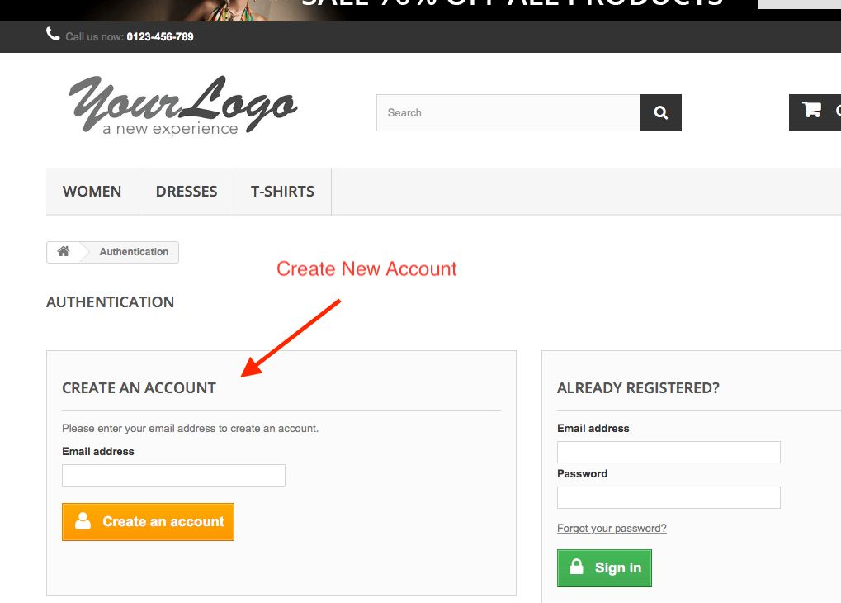

**Step 2:**​ Supply Details and confirm sign-up process was successful.

**Task #2:**​ Login Process  
A) WriteatestplanandtestcasesfortestingtheLoginsectionofthetestsite,foundinthe

same location as in Step 1 of Task 1.  
B) AutomatethetestcasesyouhavecreatedinTask2(A)