**ArticlesManager**

The project provides an easy and convenient way to manage articles for the particular user. Project consists of two microservices: API written in Ruby on Rails and UI written in Angular. UI uses Single-page application pattern. PostgreSQL is responsible for data storage. Deployment tools include Docker and AWS.

**User roles:** Guest, User

|  |  |
| --- | --- |
| **Role** | **Description** |
| Guest | User that isn't logged in, can register and log in. |
| User | Logged in user, can view articles list, add/update/delete article, view detail information about the article, filter articles. |

**Use case diagram**

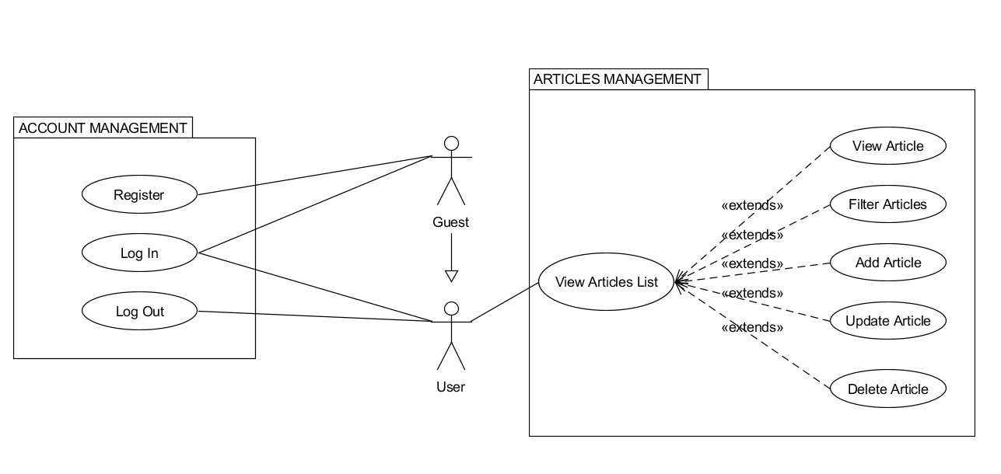

**Sequence diagram  
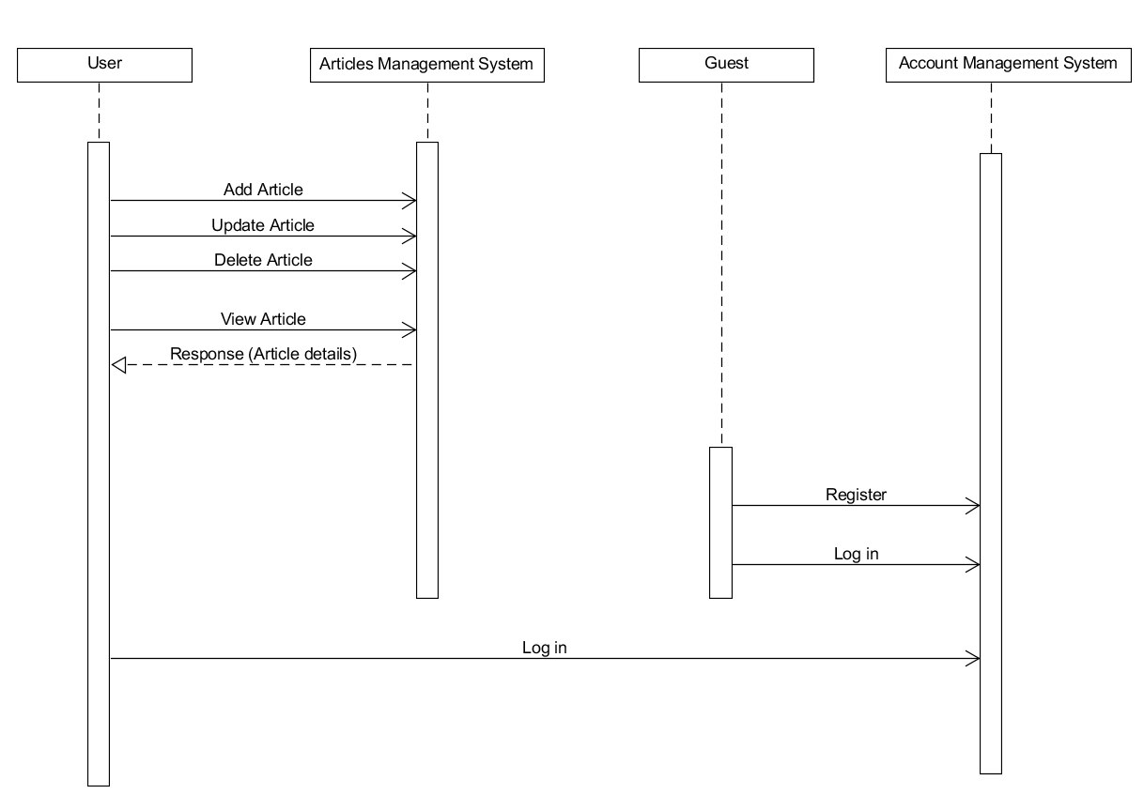**

**Database diagram**

