**CEE598 | CRN 47548**

**VISUAL SENSING FOR CIVIL INFRASTRUCTURE ENGINEERING AND MANAGEMENT**

SPRING 2015

Assignment 3

Object Detection

DUE DATE: THURSDAY APRIL 14th, 3:30 PM

*Instructor:*

**Prof. Mani Golparvar-Fard**

***Office Hours:***Tue & Thu 5:00 pm – 6:00 pm or by appointment

***Office:***3129D, Newmark Civil Engineering Lab

***E-mail:***[mgolpar@illinois.edu](mailto:mgolpar@illinois.edu)

*Teaching Assistants:*

**Jacob Lin** jlin67@illinois.edu

**Mahmoud (Mo) Hmaidi** hmaidi2@illinois.edu

**Wilfredo (Wil) Torres** trrscld2@illinois.edu

**Lectures: Tue & Thu, 3:30 PM – 4:45 PM**

* Please see the Schedule of Sessions for details on location.

##### Notes:

1. This is an **INDIVIDUAL** assignment. You can only **discuss concepts** with others. **No other discussions are allowed. DO NOT COPY answers from any sources such as Internet or Past Assignments.**

##### If you have a problem or question after reading the assignment and the tutorial, please contact us at [CEE320INSTRUCTORS@LISTSERV.UIUC.EDU](mailto:CEE320INSTRUCTORS@LISTSERV.UIUC.EDU). Remember that you cannot send attachments. If you MUST to send attachments, please send it all the instructors.

##### Notes:

1. This is a **TWO-PERSON** assignment. You can work in larger groups, but turn in your team solutions and indicate collaborators. Do not use code from the Internet. Upon completion, upload a zip file of your submission (together with the code) to [cee598spring2017@gmail.com](mailto:cee598spring2017@gmail.com). For more information about submission, please look into the course syllabus.

##### If you have a problem or question after reading the assignment, please post your questions on the “Piazza”. In case of confidentiality issues, email the instructor.

##### Notes:

1. This is an **INDIVIDUAL** assignment. You can only **discuss concepts** with others. **No other discussions are allowed. DO NOT COPY answers from any sources such as Internet or Past Assignments.**

##### If you have a problem or question after reading the assignment and the tutorial, please contact us at [CEE320INSTRUCTORS@LISTSERV.UIUC.EDU](mailto:CEE320INSTRUCTORS@LISTSERV.UIUC.EDU). Remember that you cannot send attachments. If you MUST to send attachments, please send it all the instructors.

##### Notes:

1. This is an **INDIVIDUAL** assignment. You can only **discuss concepts** with others. **No other discussions are allowed. DO NOT COPY answers from any sources such as Internet or Past Assignments.**

##### If you have a problem or question after reading the assignment and the tutorial, please contact us at [CEE320INSTRUCTORS@LISTSERV.UIUC.EDU](mailto:CEE320INSTRUCTORS@LISTSERV.UIUC.EDU). Remember that you cannot send attachments. If you MUST to send attachments, please send it all the instructors.

##### Notes:

1. This is an **INDIVIDUAL** assignment. You can only **discuss concepts** with others. **No other discussions are allowed. DO NOT COPY answers from any sources such as Internet or Past Assignments.**

##### If you have a problem or question after reading the assignment and the tutorial, please contact us at [CEE320INSTRUCTORS@LISTSERV.UIUC.EDU](mailto:CEE320INSTRUCTORS@LISTSERV.UIUC.EDU). Remember that you cannot send attachments. If you MUST to send attachments, please send it all the instructors.

##### Notes:

1. This is an **INDIVIDUAL** assignment. You can only **discuss concepts** with others. **No other discussions are allowed. DO NOT COPY answers from any sources such as Internet or Past Assignments.**

##### If you have a problem or question after reading the assignment and the tutorial, please contact us at [CEE320INSTRUCTORS@LISTSERV.UIUC.EDU](mailto:CEE320INSTRUCTORS@LISTSERV.UIUC.EDU). Remember that you cannot send attachments. If you MUST to send attachments, please send it all the instructors.

##### Notes:

1. This is an **INDIVIDUAL** assignment. You can only **discuss concepts** with others. **No other discussions are allowed. DO NOT COPY answers from any sources such as Internet or Past Assignments.**

##### If you have a problem or question after reading the assignment and the tutorial, please contact us at [CEE320INSTRUCTORS@LISTSERV.UIUC.EDU](mailto:CEE320INSTRUCTORS@LISTSERV.UIUC.EDU). Remember that you cannot send attachments. If you MUST to send attachments, please send it all the instructors.

##### Notes:

1. This is an **INDIVIDUAL** assignment. You can only **discuss concepts** with others. **No other discussions are allowed. DO NOT COPY answers from any sources such as Internet or Past Assignments.**

##### If you have a problem or question after reading the assignment and the tutorial, please contact us at [CEE320INSTRUCTORS@LISTSERV.UIUC.EDU](mailto:CEE320INSTRUCTORS@LISTSERV.UIUC.EDU). Remember that you cannot send attachments. If you MUST to send attachments, please send it all the instructors.

##### Notes:

1. This is an **INDIVIDUAL** assignment. You can only **discuss concepts** with others. **No other discussions are allowed. DO NOT COPY answers from any sources such as Internet or Past Assignments.**

##### If you have a problem or question after reading the assignment and the tutorial, please contact us at [CEE320INSTRUCTORS@LISTSERV.UIUC.EDU](mailto:CEE320INSTRUCTORS@LISTSERV.UIUC.EDU). Remember that you cannot send attachments. If you MUST to send attachments, please send it all the instructors.

# Assignment 3 – Object Recognition

##### Introduction[1]

The purpose of this assignment is to practice object recognition. Answer the following questions and explain your solution in detail. Remember that code is not an explanation.

This problem particularly explores the Lowe-style object instance recognition (David G. Lowe, **"Distinctive image features from scale-invariant keypoints,"** International Journal of Computer Vision, 60, 2 (2004), pp. 91-110.). It is highly recommended to use the included MATLAB source code and data.

##### Object Instance Recognition



**Figure 1.** Figure for part 2B.

1. Given a keypoint descriptor ***g*** from one image and a set of keypoint descriptors from a second image ***f****1,...,****f****n*, write the algorithm and equations to determine which keypoint in ***f****1,...,****f****n* (if any) matches ***g***. (25%)
2. Suppose that you have matched a keypoint in the object region to a keypoint in a second image (see Figure 1B above). Given the object bounding box center , width, and height *(x1, y1, w1, h1)* and the position, scale, and orientation of each keypoint (*u1,v1,s1,θ1; u2,v2,s2, θ2*), show how to compute the predicted center position, width, height, and relative orientation of the object in image 2. (25%)
3. **Implementation**. Use the stop sign in stop1.jpg (stopim1) with coordinates ([*x1 y1 x2 y2*] = [76 26 287 236]) as a training example. Match keypoints in the other four images and recover the position, scale, and orientation of the objects. A rough result is ok – it is not necessary to perform a subsequent geometric verification or refinement step (25%).
4. Describe your algorithms to match keypoints and to use the matched points to localize the objects. Where applicable, you may refer to your solutions in parts A and B. Explain any design decisions. Use the same code and parameters for all four images. If you are not able to localize the objects (this could happen in stopim2 and stopim5), explain what makes these cases difficult. For each image, include figures that show the corresponding keypoints and the detected objects (code is included to do this). (25%)
5. The supplemental folder (objrecognition) contains the following:

* Five images (stop1.jpg, stop2.jpg, stop3.jpg, stop4.jpg, stop5.jpg)
* SIFT descriptors and keypoints for each image (A3.mat). The SIFT keypoints were created using the code here: <http://www.vlfeat.org/~vedaldi/code/sift.html>. For each keypoint, the four coordinates are x, y, scale, and orientation, (in order).
* You can also use different algorithms (e.g., SURF) in computer vision toolbox from Mathworks, and compare the results of object recognition. (10% Bonus)
* A function (matchObject.m) that outlines the recognition process and includes code to display matches and results. You need to write the functions to match keypoints and recover likely object position/size/orientation.

Here is an example of the output for one of the images (stop3 and stop5):

* + matchObject(stop{1}, sift_desc{1}, keypt{1}, obj_bbox, stop{3}, sift_desc{3}, keypt{3});

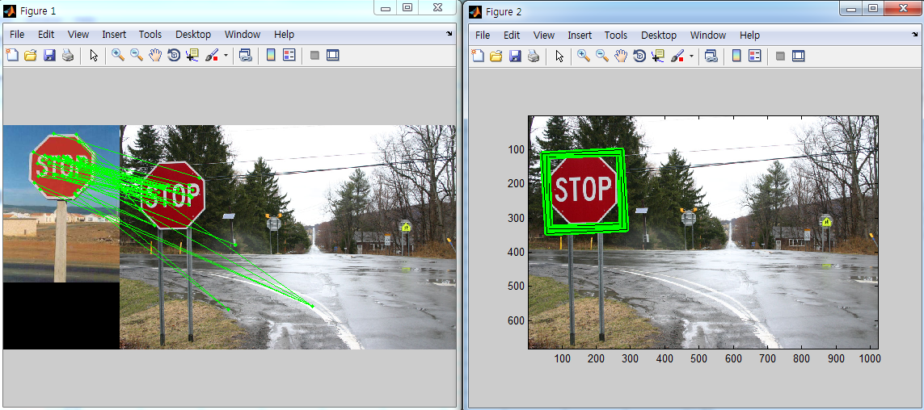

* + matchObject(stop{1}, sift_desc{1}, keypt{1}, obj_bbox, stop{5}, sift_desc{5}, keypt{5});

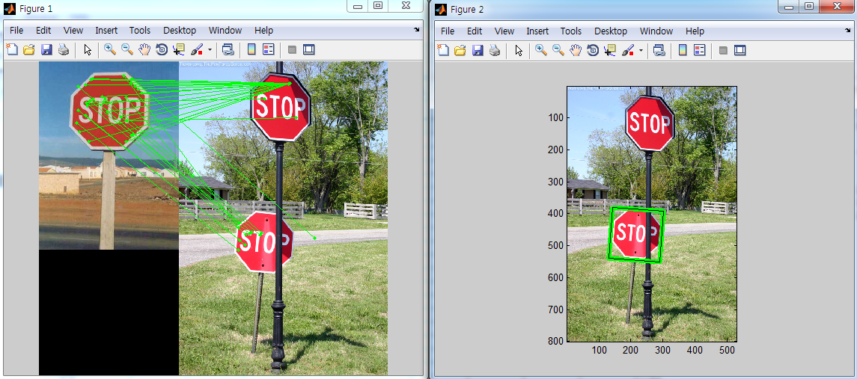

##### Submissions (100% + 10% Bonus)

Zip all your files **including a summary of your answers and figures** and submit your assignment as A2_ yourNetID1_yourNetID2.zip to [cee598spring2017@gmail.com](mailto:cee598spring2017@gmail.com). Please, feel free to refer to a lot of useful MATLAB tools and tutorials posted on the course website

<http://courses.engr.illinois.edu/cee598vsc/>.

1. This assignment is adapted from the work of Prof. Derek Hoiem at University of Illinois, Urbana-Champaign. Examples used are Courtesy of Prof. Hoiem.