
Evaluating Circular Design as a System Transition:
A System Dynamics Analysis of Success and Failure Conditions

Author One  Organization  Street Address  City, Province, Postal  author.one@email.com | Author Two  Organization  Street Address  City, Province, Postal  author.two@email.com | Author One  Organization  Street Address  City, Province, Postal  author.three@email.com
Author Four  Organization  Street Address  City, Province, Postal  author.four@email.com | Author Five  Organization  Street Address  City, Province, Postal  author.five@email.com | Author Six  Organization  Street Address  City, Province, Postal  author.six@email.com

Copyright © 2025 by the author(s). Permission granted to INCOSE to publish and use.

Abstract
Circular design is widely promoted as a strategy for reducing environmental impacts in high-volume consumable product systems, yet firms remain uncertain about its economic implications. This paper develops a system dynamics model that integrates cost learning, material recovery, design improvement, customer satisfaction, demand elasticity, and profit-optimizing price behavior. A linear business-as-usual (BAU) configuration is compared with circular design systems initiated under identical market and operational conditions. Results show that circularity does not produce a single characteristic outcome but instead exhibits varying performance regimes depending on the strength of the interaction of learning, recovery, customer value, and reinvestment feedback loops. Strong circular design significantly outperforms BAU across economic and environmental metrics, while moderate capability delivers meaningful, pronounced gains. Notably, even weak circular design, though initially underperforming, eventually surpasses the BAU system as reinforcing mechanisms mature. These findings demonstrate that circular design is inherently advantageous and becomes increasingly superior when key system capabilities evolve sufficiently to activate reinforcing feedback. This study contributes to the scientific community by providing a generic system dynamics model for the circular economy that can serve as a reusable blueprint that can be adapted to real-world use cases across different industries.

Keywords
Circular Design, System Dynamics Modeling, Sustainable Systems, Systems Engineering.

Introduction
The accelerating adoption of circular economy (CE) principles reflects growing recognition that linear “take–make–dispose” systems are environmentally unsustainable and economically fragile (Ellen MacArthur Foundation, 2015). This challenge is especially acute in high-volume consumable product systems, where material throughput is rapid, customer expectations are demanding, and disposal externalities are significant. Food and beverage packaging exemplifies this tension: it is globally pervasive, short-lived, a major contributor to municipal waste, and technically well suited for reuse, refill, and material recovery strategies (Geyer et al., 2017). Despite strong policy interest and technological advances, firms continue to report uncertainty regarding the economic viability of circular design (CD). Much CE research emphasizes environmental outcomes, while comparatively little work rigorously examines the dynamic economic behavior of firms transitioning from linear to circular operating models (Geissdoerfer et al., 2020).
From a Systems Engineering perspective, this transition represents a fundamental shift in system architecture. Linear models function as open-loop systems, whereas circular designs operate as closed-loop, tightly coupled systems in which products, users, and recovery infrastructure form an interconnected system of systems. This architectural shift introduces dynamic complexity—feedback, delays, and nonlinear responses—that makes intuition an unreliable guide for predicting performance. System dynamics is therefore well suited to analyze circular design, as it captures lifecycle behavior driven by endogenous structure rather than static assumptions.
This paper develops a system dynamics model examining the economic and environmental trajectories of a firm producing short-lived consumable goods under two strategic archetypes: business-as-usual (BAU) and circular design (CD). The model integrates cost learning, material recovery, customer satisfaction, product performance, and price–volume elasticity, allowing prices to be updated annually to maximize profit under stable market expectations. Unlike much prior CE and SD work, which treats prices as fixed, exogenous, or cost-plus variables (Sterman, 2000; Bocken et al., 2016; Linder & Williander, 2017), this model endogenizes demand as a function of price and elasticity and incorporates an explicit profit-maximizing pricing mechanism grounded in microeconomic theory (Marshall, 1920; Varian, 1992).
A central contribution is the explicit representation of CD execution quality. Rather than treating circularity as binary, the model distinguishes among three endogenous performance regimes—CD-Weak, CD-Moderate, and CD-Strong—reflecting differing levels of capability and investment. Results show that all circular configurations outperform BAU over the long term, but with markedly different trajectories. Strong circular design generates rapid, self-reinforcing gains in profitability and emissions reduction; Moderate capability yields meaningful but less transformative improvements; and even Weak circular design ultimately surpasses BAU, though with slower progress and reduced benefit. These differences arise from the strength and timing of reinforcing feedback loops rather than from exogenous performance assumptions.
The model addresses five research questions: when circular design outperforms BAU economically; which reinforcing structures enable or constrain success; how price elasticity shapes profitability; which capability thresholds govern system evolution; and which parameters most strongly influence long-term outcomes. The contribution is twofold: it positions circular design as a strategic economic architecture rather than solely an environmental intervention, and it provides systems engineers with a dynamic explanation for why circular initiatives succeed or fail in practice.
The remainder of the paper is structured as follows. Section 2 reviews relevant background; Section 3 presents the modeling approach; Section 4 reports scenario results; Section 5 analyzes sensitivity; Section 6 synthesizes circular design essentials; and Section 7 concludes.

Background
The circular economy has emerged as a strategy for reducing waste and improving resource productivity by shifting from linear patterns of extraction, production, use, and disposal toward systems that retain materials and value through reuse, remanufacturing, and recycling. Foundational work from the Ellen MacArthur Foundation (2015) and subsequent research, such as Geissdoerfer et al. (2017), has expanded the concept of circularity into a broader design and systems philosophy. While its environmental rationale is widely recognized, firms continue to question whether circular strategies can be economically viable, particularly in consumer markets with short product lifetimes and high price sensitivity.
Food and beverage packaging clearly illustrates this challenge. Packaging constitutes one of the largest global material flows, has extremely short use cycles, and contributes substantially to municipal waste. It is also well suited for circular approaches—such as refillable formats, high-quality recycling, and improved recovery systems—yet firms face pressure to deliver convenience and low prices. Prior studies (Linder & Williander, 2017; Bocken et al., 2016) show that many companies hesitate to invest in circularity because the economic impacts remain uncertain. These tensions highlight the need for models that move beyond qualitative propositions and instead capture the dynamic conditions under which circular strategies succeed or fail.
Circular design requires more than improving a specific package or material. It involves coordinated change across recovery processes, distribution and reverse logistics, cost-reduction mechanisms, customer experience, and sustained reinvestment. Circular systems depend on organizational learning, operational adaptation, and evolving customer preferences. Research shows that circularity embeds reinforcing and balancing feedback structures: as recovery improves, reclaimed materials reduce costs and accelerate adoption; when recovery remains weak, circular products may become more expensive and fail to gain traction. These endogenous dynamics make circular design a natural systems problem and well-suited to system dynamics modeling (Sterman, 2000).
A major determinant of circular performance is cost reduction through learning. Learning effects, documented across manufacturing and technology sectors (Argote & Epple, 1990; Nemet, 2006), reduce production costs as cumulative output grows. In circular systems, learning extends to recovery operations, reverse logistics, sorting and cleaning processes, and customer-facing activities. Because cost declines reinforce competitive pricing and adoption, learning becomes central to the economic viability of circular products.
Customer adoption plays an equally important role. Studies such as Van Loon et al. (2020) show that refill and reuse programs succeed only when they deliver meaningful value and convenience. Many circular initiatives falter because customers are reluctant to modify established behaviors. From an economic perspective, price elasticity is critical. Originating with Marshall (1920) and formalized by Varian (1992), elasticity theory explains why firms in competitive consumable markets cannot rely on cost-plus pricing. Prices must adapt to expected demand responses. This study, therefore, integrates a price–volume optimization mechanism to reflect realistic firm behavior.
Consumable systems such as packaging offer an appropriate domain for analyzing circular transitions because they involve high material throughput, rapid usage cycles, and significant environmental externalities. Their short lifetimes allow circular interventions to manifest quickly, making them sensitive to changes in design, recovery capability, customer incentives, and pricing. These characteristics also generalize across many consumable product categories.
The interplay among learning, material recovery, customer satisfaction, demand elasticity, and investment strategies creates complex, time-dependent behavior that static economic models cannot capture. A system dynamics approach enables exploration of reinforcing loops, delays, and threshold effects. Such modeling is essential for identifying when circular design can outperform business-as-usual and the conditions under which it may fail to deliver anticipated benefits.

Modeling Approach and System Architecture

Methodology
The study employs a system dynamics approach to examine how a producer of short-lived consumable goods performs under two strategic configurations: a business-as-usual (BAU) linear system in which materials flow from extraction to disposal, and a circular design (CD) system incorporating material recovery, reinvestment, customer incentives, and ongoing performance improvement. The methodology highlights how cost trajectories, pricing, customer adoption, and operational capabilities interact over time.
To rigorously evaluate system performance, we defined key outputs as Measures of Effectiveness (MOEs). In this context, Profit serves as the primary economic MOE, validating the system's viability for the business stakeholder, while Cumulative CO2 Reduction serves as the environmental MOE, addressing regulatory and societal stakeholder needs. By tracking these MOEs dynamically, we move beyond simple technical performance measures (TPMs) to assess whether the system delivers actual value to its intended stakeholders over time.
The model was developed using the standard system dynamics cycle. Initial causal diagrams identified how structure influences behavior and informed the construction of a quantitative stock-and-flow model implemented in a spreadsheet for transparency and ease of scenario testing. Dynamics are simulated quarterly and aggregated annually to reflect common business decision cycles.
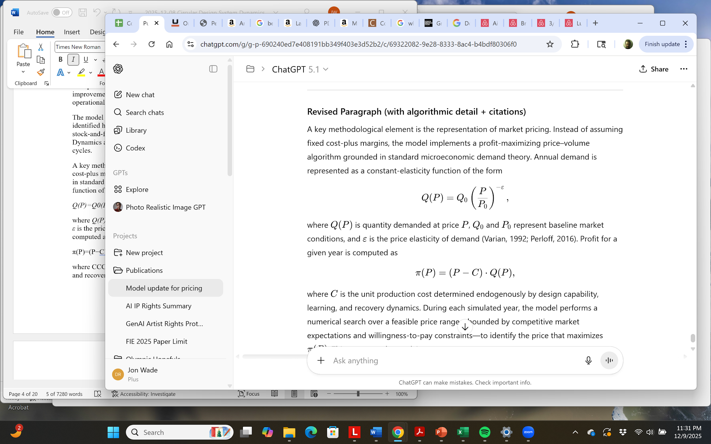
A key methodological element is the representation of market pricing. Instead of assuming fixed cost-plus margins, the model implements a profit-maximizing price–volume algorithm grounded in standard microeconomic demand theory. Annual demand is represented as a constant-elasticity function of the form
(1)

where Q(P) is quantity demanded at price P, Q₀​ and P_{0​} represent baseline market conditions, and ε is the price elasticity of demand (Varian, 1992; Perloff, 2016). Profit for a given year is computed as
(2 (2)

where C is the unit production cost determined endogenously by design capability, learning, and recovery dynamics. During each simulated year, the model performs a numerical search over a feasible price range, bounded by competitive market expectations and willingness-to-pay constraints, to identify the price that maximizes π(P). This corresponds to solving
(3)
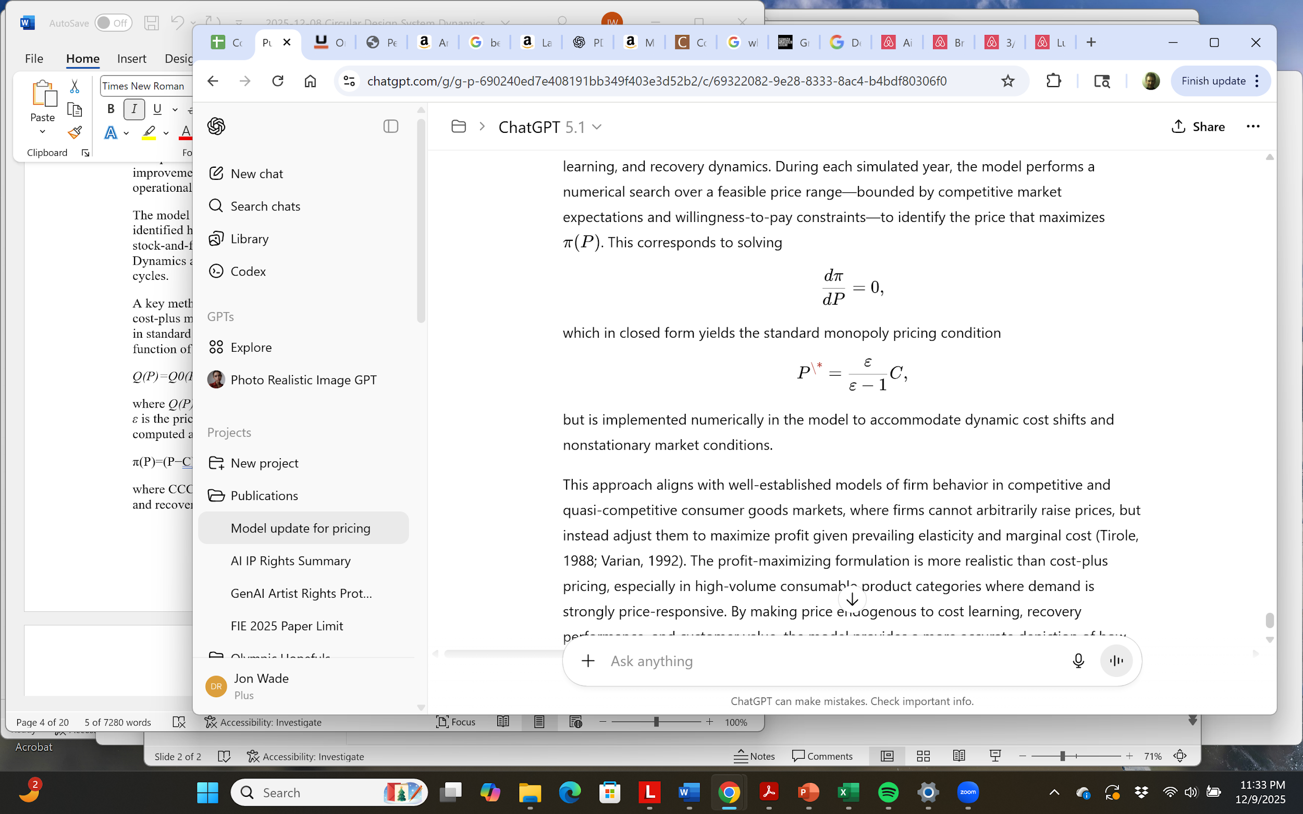
which in closed form yields the standard monopoly pricing condition
(4)
but is implemented numerically in the model to accommodate dynamic cost shifts and nonstationary market conditions.
This approach aligns with well-established models of firm behavior in competitive and quasi-competitive consumer goods markets, where firms cannot arbitrarily raise prices but instead adjust them to maximize profit given prevailing elasticities and marginal costs (Tirole, 1988; Varian, 1992). The profit-maximizing formulation is more realistic than cost-plus pricing, especially in high-volume consumable product categories where demand is strongly price-responsive. By making price endogenous to cost learning, recovery performance, and customer value, the model provides a more accurate depiction of how circular design influences profitability and market behavior over time.
The CD scenario includes endogenous mechanisms absent from BAU. Material recovery depends on design choices, customer behavior, and operational capability. As recovery improves, a larger share of inputs comes from low-cost recovered material, reducing production cost and influencing optimized price. The model also represents design improvement as a reinforcing process: R&D investment enhances product performance, reduces material intensity, and raises customer satisfaction. Higher satisfaction increases adoption and recovery volumes, strengthening feedback loops that determine whether the system evolves toward high or low performance.
The BAU baseline represents a stable linear system in which cost reductions arise only from modest learning effects. No recovery loop is present; all inputs come from virgin production, and customer satisfaction remains largely constant. This configuration serves as a counterfactual against which circular performance can be evaluated.
To explore how circular effectiveness influences behavior, the model varies the strength of key mechanisms: learning rate, recovery effectiveness, design improvement rate, customer incentives, and R&D reinvestment. Circular design is thus treated not as a single configuration but as a continuum of capabilities. Three characteristic behaviors emerge: a high-capability system that outperforms BAU across economic and environmental metrics; a medium-capability system that is competitively superior; and a low-capability system that remains competitive.
Simulations begin in 2025 and run for ten years using identical initial stocks, elasticity assumptions, time steps, and aggregation structures. This ensures that differences arise solely from system architecture rather than exogenous factors. The methodology, therefore, reveals not only whether circular design can outperform business-as-usual, but also why certain configurations may succeed while others fail.
The utility of any simulation model depends on its veracity. Verification focused on ensuring the model structure correctly represented the physical and economic logic; this included dimensional consistency checks to ensure all units of measure (e.g., currency, mass, time) were mathematically valid. In addition, the model was developed in Vensim, exported to Excel, and the results were compared for equivalence. Validation was accomplished though a qualitative review of the results to ensure that they made physical sense with respect to published results.
Validation addressed whether the model is an accurate representation of the real-world system for its intended purpose. We conducted extreme condition tests, such as setting price elasticity to zero or recovery capability to 100%, to ensure the system generated robust, logically consistent behavior even at the boundaries of operation. These tests confirm that the divergent behaviors observed in the scenarios are genuine structural consequences, not artifacts of numerical errors.

Causal Loop Structure
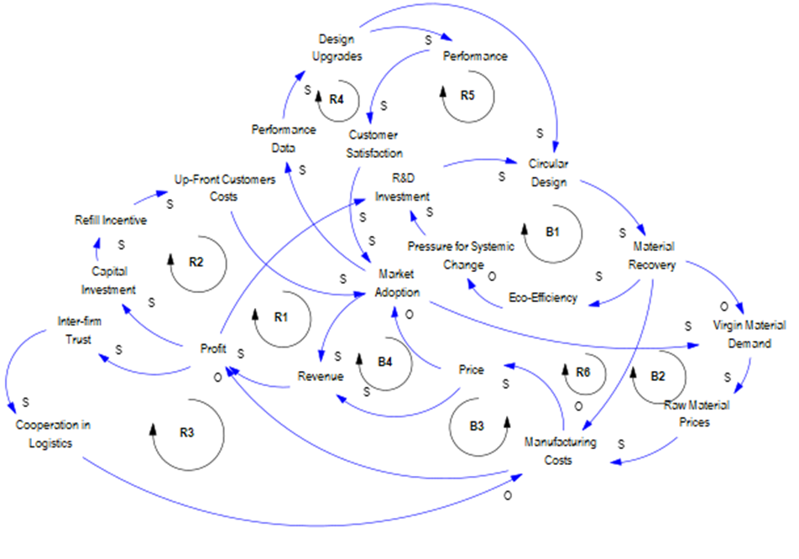
The dynamic behavior of both business-as-usual and circular design systems arises from interacting feedback loops linking production costs, material flows, customer adoption, product performance, and reinvestment decisions. As shown in Figure 1, these loops form the conceptual foundation for the quantitative model and clarify why scenarios diverge over time and why circular design can either succeed significantly or may fail under certain parameter conditions.

Figure 1. Causal loop diagram (CLD)
The first group of loops concerns the evolution of cost structures. In both systems, lower unit production costs improve profitability and expand resources available for capability development. In circular design, however, cost reduction depends not only on manufacturing efficiencies but also on the increasing share of material supplied through recovery. As recovery grows, reliance on virgin inputs declines and marginal production costs fall. These lower costs feed into the annual price optimization step, enabling more competitive pricing in elastic markets. Higher demand increases production volume, accelerating cumulative learning and further reducing costs. Together, these interactions form a reinforcing cost–recovery–demand loop that underpins the high performance observed in the stronger circular
A second reinforcing structure links product performance to customer satisfaction. Circular design reinvests a portion of profits into research and development, improving durability, reducing material intensity, and enhancing the usability of refill and recovery systems. As performance improves, customer satisfaction rises, stimulating adoption. Higher adoption increases the flow of materials returned for recovery, strengthening the cost-reduction loop above. When circular capabilities reach sufficient strength, this performance–satisfaction–recovery loop becomes a powerful reinforcing mechanism that accelerates divergence from business-as-usual trajectories.
A third loop centers on customer participation in recovery processes. Engagement is essential because the volume and quality of recovered material depend not only on technical capability but also on behavioral compliance, such as returning packaging or refilling containers. The model posits that customer satisfaction is a factor influencing participation. When customers perceive the circular offering as convenient and valuable, recovery increases, reducing costs and reinforcing system performance. When participation lags, recovery stagnates, creating a behavioral bottleneck that limits economic and environmental benefits. Customer experience and operational effectiveness thus work jointly to shape system outcomes.
Not all loops are reinforcing. Several balancing loops moderate growth tendencies. If production costs decline too slowly or customer satisfaction remains low, price optimization may require lowering prices to sustain demand. Although increased sales can temporarily boost recovery volumes, narrower margins reduce the resources available for reinvesting in design or recovery capability. This can trap a circular system in a low-investment, low-recovery equilibrium. Likewise, if recovery capability remains underdeveloped, increases in demand do not translate into proportional increases in recovered material. Cost advantages fail to materialize, and circular design may not outperform the business-as-usual alternative.
These feedbacks show that circular design is not driven by a single reinforcing mechanism but by multiple interacting structures that may amplify or constrain each other. Success depends on achieving sufficient learning, recovery performance, and customer satisfaction for reinforcing loops to dominate balancing constraints. Failure to reach these thresholds may lead to a lack of competitiveness. The causal structure thus helps explain why circularity is often promoted as transformative yet yields mixed results: modest weaknesses in design, customer experience, or recovery operations can prevent the system from realizing its theoretical benefits.
The business-as-usual model provides a useful contrast. Without recovery or major design improvements, cost reductions arise primarily from incremental learning. Customer satisfaction remains relatively stable, and no additional reinforcing structures emerge. Consequently, business-as-usual produces stable, predictable behavior—neither collapsing nor achieving the gains available in strong circular design scenarios. This stability makes it a practical baseline for evaluating economic and environmental performance.
Together, these causal relationships underscore two central insights. First, circular design can achieve superior long-term performance, but only when reinforcing processes surpass the balancing constraints imposed by cost, customer behavior, and investment limits. Second, circular design may be limited in its competitive advantage over business-as-usual when reinforcing processes fail to activate. These insights shape the quantitative model and guide the interpretation of the scenario results that follow.

Stock and Flow Structure
The system’s quantitative behavior emerges from a stock-and-flow model that translates earlier causal relationships into explicit material, financial, and performance dynamics. The model tracks how design capability, recovery capacity, customer satisfaction, cost structure, and retained earnings evolve over time. These accumulations, shaped by inflows and outflows, generate the long-term trajectories observed in the simulations. We translated the qualitative loops into a stock-and-flow model (first-order differential equations) in which key stocks change via explicit inflows/outflows. Due to space limitations, we cannot include the model in this paper; interested readers can obtain it upon request from the authors. The model has about 50 parameters, based on literature and industry data (Github, 2025).
A central stock is design capability, representing accumulated knowledge, refinements, and operational improvements arising from research and development. Inflows reflect the rate of design improvement, driven by R&D spending and the system’s learning potential. When profits rise, more resources become available for improvement; when profits decline, capability growth slows. Outflows represent the natural erosion of design advantages due to obsolescence or diminishing performance. Together, these dynamics allow circular design capability to strengthen gradually or stagnate depending on financial performance.
A second major stock is recovery capability, representing accumulated investment and operational maturity in reclaiming materials. Inflows depend on investment levels, customer participation, and process learning, while outflows reflect operational losses such as contamination or underutilization. Recovery capability determines the fraction of material supplied from recovered rather than virgin sources, linking physical circularity directly to economic outcomes because recovered materials have a lower effective cost once infrastructure matures.
Production cost is not a stock but a dynamic variable shaped by these capabilities. As design improves, production becomes less material-intensive or more efficient. As recovery capability grows, a larger share of input material is supplied at lower cost. Cumulative manufacturing experience, modeled through a learning function, further reduces cost as production volume increases. These interactions produce cost trajectories that diverge sharply between business-as-usual and circular design scenarios.
Customer satisfaction is another stock that accumulates positive experiences and declines during periods of poor performance. Satisfaction improves when design capability enhances usability or convenience, and when customers perceive economic value through competitive pricing, refill, and recovery incentives. Dissatisfaction enters through delays, inferior performance, or inconvenience. Satisfaction shapes adoption, which determines both unit sales and the volume of material available for recovery.
Retained earnings function as a financial stock that accumulates profit over time. Positive earnings increase resources available for investment in design and recovery capability, while negative earnings constrain improvement and may trap the firm in a low-performance state. Profit is computed as revenue minus production cost and overhead, and revenue depends on the optimized price and units sold. The annual price optimization step selects the price that maximizes earnings given current cost and demand elasticity.
Additional flows include units sold, recovered material volume, and virgin material requirements. Units sold depend on demand shaped by price, satisfaction, and market potential. Recovery flow depends on recovery capability and return rates. Virgin material flow equals production requirements minus recovered material availability. Environmental performance is computed by multiplying these flows by emissions factors and aggregating over time.
These interacting stocks and flows create a system in which improvements in design, recovery capability, and customer satisfaction reinforce one another—but only when financial performance supports sustained investment. When costs remain high or adoption stagnates, reinforcing mechanisms fail to activate, leaving the system in a low-performance regime. The business-as-usual case lacks these additional capability stocks and thus exhibits more stable and predictable behavior.
By capturing both material and economic dimensions, the stock-and-flow structure provides a foundation for understanding how the business-as-usual and circular scenarios diverge. The next section presents simulation results that illustrate how these structural differences manifest in units sold, profitability, material recovery, and greenhouse gas emissions.

Results
The simulation examines how a linear business-as-usual (BAU) system and three circular design configurations, Circular-Weak, Circular-Moderate, and Circular-Strong, evolve over a ten-year period beginning in 2025. All scenarios operate under identical market conditions, demand elasticity, pricing logic, and initial stock values. Differences in behavior arise solely from the strength of circular mechanisms such as learning, recovery improvement, design refinement, customer incentives, and reinvestment.
Results, shown in Figures 2 – 7, are reported in annual aggregates to reflect decision cycles typical of consumer-goods firms.
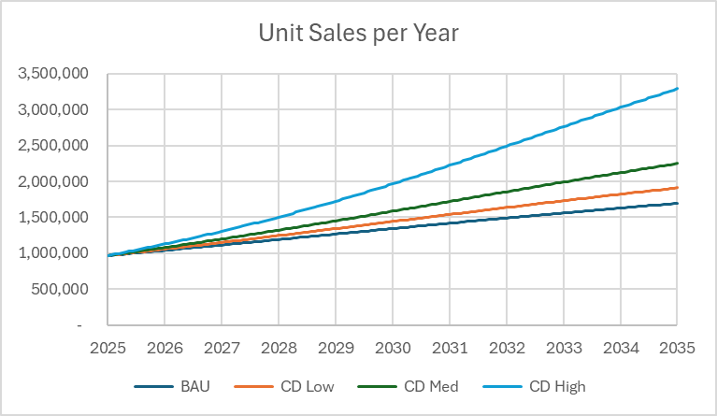
Figure 2. Unit Sales Comparison

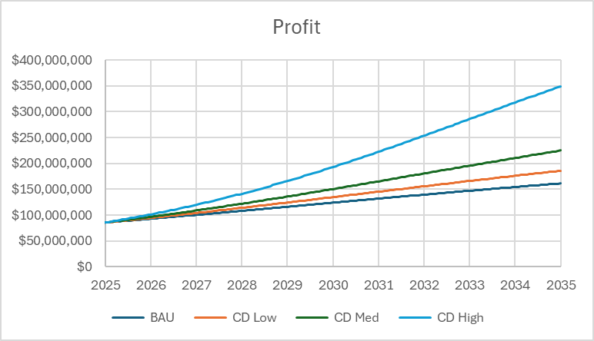
Figure 3. Profit Comparison

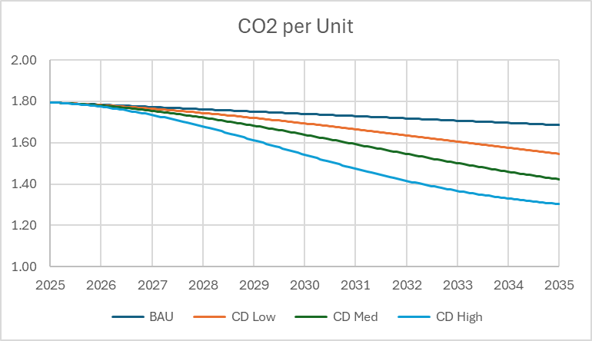
Figure 4. CO2 per Unit Comparison

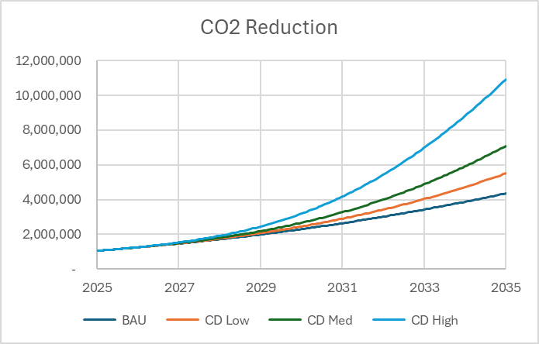
Figure 5. Cumulative CO2 Savings

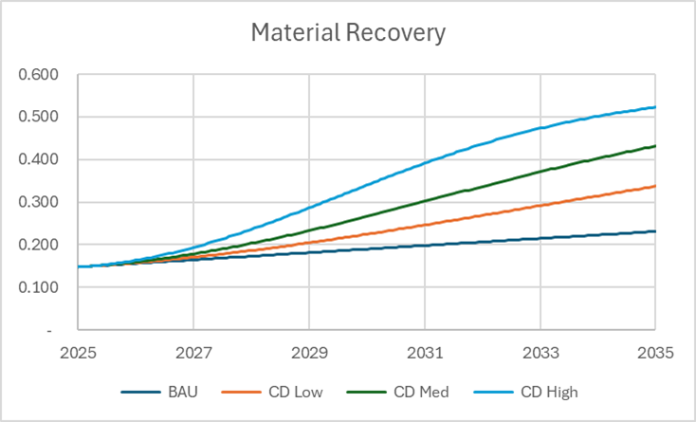
Figure 6. Material Recovery Comparison

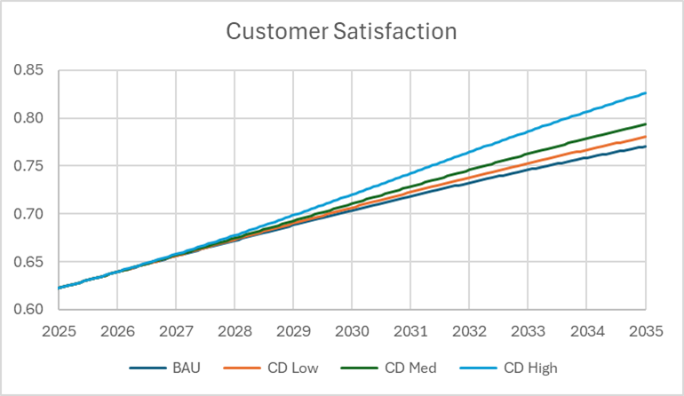
Figure 7. Customer Satisfaction Comparison

Baseline Scenario
Under BAU, production and financial performance follow a stable linear trajectory shaped by incremental learning effects. Unit sales and profits evolve gradually over the simulation horizon, with modest cost reductions driven by cumulative production experience. Because all material inputs are virgin-sourced and no recovery loop is present, emissions per unit decline only marginally over time, and cumulative CO₂ emissions increase in proportion to output. The BAU case therefore provides a predictable reference trajectory against which the structural effects of circular design can be evaluated.

Circular Design Scenarios
The three circular scenarios produce distinct trajectories that reflect different levels of capability development, but all three outperform the BAU case economically and environmentally over the full simulation horizon.

Circular-Strong (High Capability)
Circular-Strong represents the most capable configuration of the circular system. Unit sales remain substantially higher than BAU throughout the simulation and increase rapidly over time. Production cost per unit falls sharply due to improvements in design capability and increased availability of recovered material. Profits grow substantially faster than in any other scenario and remain the highest among all configurations throughout the simulation. Cumulative CO₂ reduction relative to BAU accelerates throughout the simulation horizon. Circular-Strong dominates across all economic and environmental performance measures

Circular-Moderate (Medium Capability)
Circular-Moderate achieves consistent improvements in production cost, demand, and emissions, remaining superior to BAU throughout the simulation, though improving more slowly than Circular-Strong. Unit sales and profits increase steadily over time, consistently exceeding BAU while remaining below the Circular-Strong trajectory.
CO₂ per unit declines steadily over time, and cumulative CO₂ reduction remains between the Circular-Weak and Circular-Strong trajectories. Circular-Moderate performs strongly relative to BAU across all outcome metrics and achieves substantial environmental gains, though without the transformative acceleration observed in Circular-Strong.

Circular-Weak (Low Capability)
Circular-Weak produces slower improvement but still surpasses BAU in economic and environmental outcomes. Profits rise steadily over the simulation horizon, exceeding BAU throughout while remaining below the Moderate and Strong trajectories.
CO₂ intensity declines steadily over time, and cumulative CO₂ reduction increases continuously relative to BAU. Recovery capability and customer satisfaction both improve gradually over the simulation horizon.
Although its improvements are more gradual than in the other circular scenarios, Circular-Weak outperforms BAU across all outcome metrics throughout the simulation.

Comparative Performance Summary
Across all three capability levels, clear performance gradients emerge. Unit sales in all circular scenarios exceed those of BAU, with higher capability producing greater sustained sales volume. Profitability improves under all circular configurations, overtaking BAU early and widening as circular capability strengthens. CO₂ intensity declines progressively with circular capability, with the strongest configuration achieving the most pronounced per-unit reductions. Cumulative CO₂ reduction relative to BAU increases monotonically with capability, with Weak, Moderate, and Strong configurations forming clearly separated performance bands. Material recovery capability strengthens with increasing circular maturity, while customer satisfaction improves steadily in all circular scenarios and remains comparatively flat under BAU.
Taken together, these results demonstrate that circular design, when implemented at any meaningful capability level, consistently outperforms a linear system over the simulation horizon. Differences among Weak, Moderate, and Strong scenarios reveal how the strength of circular capabilities shapes system evolution and long-term outcomes. These performance contrasts motivate a closer examination of the structural drivers, which are explored in the following sensitivity analysis.

Sensitivity Analysis
The results in Section 4 show that circular design performance varies substantially with capability level. To understand which structural mechanisms most strongly influence these outcomes, a targeted sensitivity analysis was conducted on the parameters that govern learning, recovery, customer incentives, reinvestment, and the translation of design improvements into operational performance. These parameters shape the reinforcing feedback loops that ultimately determine whether circularity evolves into a Weak, Moderate, or Strong trajectory.
The analysis evaluates how a ±20% change in each parameter relative to the Circular-Moderate (baseline) configuration affects profit in the final year of the simulation. This provides insight into the leverage each mechanism exerts over long-term economic performance and the conditions under which circular design is most likely to surpass or lag behind the business-as-usual system.

Overview of Sensitivity Results
The sensitivity analysis shows that although multiple mechanisms contribute to system evolution, a small number of parameters exert dominant influence. In particular, learning rate and customer incentives for reuse produce the largest positive and negative deviations in long-term profit. These parameters directly control access to the reinforcing loops that reduce cost, increase demand, expand recovery, and support continued reinvestment.
Other parameters, such as recovery gain and the R&D investment fraction, also shape system behavior, but their influence is conditional on the strength of learning and customer incentives. Circular design capability is therefore not determined by any single mechanism but by a coordinated set of reinforcing processes—some of which are far more consequential than others. A tornado chart summarizing these effects is shown in Figure 8.
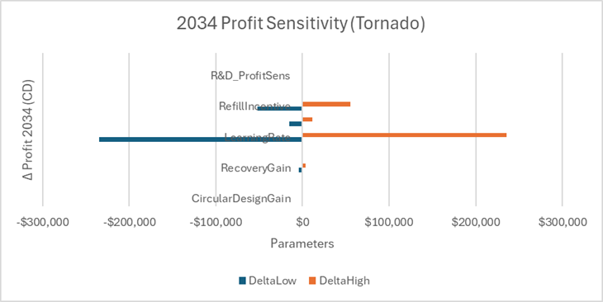
Figure 8. Profit Sensitivity Comparison

Learning Rate
The learning rate parameter determines how quickly production costs decline as cumulative output increases and as design improvements reduce material intensity. Because cost reduction influences both price competitiveness and profitability, the learning rate is the single most important determinant of circular system performance.
A 20% decrease in learning rate significantly weakens the reinforcing cost–demand–production loop. Cost reduction slows, optimized price does not fall enough to stimulate market expansion, and cumulative volume never reaches levels required for high learning-induced efficiency gains. Profitability in year ten drops sharply, and although circular design still outperforms BAU in the long run, the performance gap narrows substantially.
Conversely, a 20% increase in learning rate accelerates the activation of reinforcing loops. Costs decline more quickly, demand grows faster, and profits rise earlier in the simulation horizon. In this case, even the Circular-Moderate scenario begins to resemble the Strong configuration's behavior. Learning rate, therefore, determines not only the magnitude of improvement but also the timing at which circular design begins to diverge from linear alternatives.
This centrality of learning rate is consistent with empirical findings across manufacturing and technology sectors: capability development—not initial configuration—often determines long-term competitive advantage.

Customer Incentives
The strength of customer incentives for refill or return has the second-largest influence on system outcomes. This parameter directly affects customer participation in circular behaviors, and therefore governs both adoption and recovery performance.
When incentive strength is reduced, fewer customers return packaging or engage with refill systems. Recovery volumes remain low, leaving production heavily reliant on high-cost virgin materials. Because recovery is also a key input to customer satisfaction in the model, weak incentives reduce satisfaction and dampen demand growth. Profitability in the final year declines noticeably under the –20% case.
When incentives are strengthened by 20%, the system moves more quickly into a positive recovery–cost–demand feedback cycle. Recovered material volumes increase, customer satisfaction rises, cost declines accelerate, and the system approaches the dynamics seen in the Strong circular scenario.
Because customer behavior simultaneously influences both economic and environmental performance, incentives are a pivotal mechanism for enabling circular outcomes.

Recovery Gain
Increasing the recovery gain parameter improves the rate at which recovery capability matures. A stronger recovery gain increases the fraction of material returned by customers, reduces virgin material demand, and accelerates cost reduction. However, its influence is moderately strong rather than dominant.
A 20% reduction in recovery gain slows the transition from virgin-dominated production to recovered material inputs. Costs remain higher for longer, which in turn delays price competitiveness and limits the learning benefits associated with higher demand. Profitability in the final year falls, though the effect is less severe than for equivalent changes in learning rate or incentive strength.
Importantly, the effectiveness of recovery gain depends on customer participation and learning-driven cost dynamics. High recovery gain produces substantial benefits only when customers return enough material and when cost reductions can translate into price improvements. This conditional dependence explains why recovery gain ranks below learning rate and customer incentives in the sensitivity hierarchy.

Investment Fraction
The investment fraction, which determines how much profit is reinvested into design and operational improvement, meaningfully shapes circular system performance but does not exert the same level of leverage as the previous parameters.
Reducing the investment fraction slows the advancement of design capability, thereby moderating material efficiency improvements and customer satisfaction gains. This in turn dampens recovery participation, demand growth, and long-term profitability.
Increasing the investment fraction accelerates these processes, but the effect is smaller than that of equivalent increases in the learning rate or customer incentives. The analysis suggests that reinvestment is a necessary enabling condition rather than a primary driver. It sustains improvement but does not independently determine whether reinforcing loops activate.

Circular Design Gain
The circular design gain parameter controls how effectively improvements in design capability translate into operational performance and customer value. Variations in this parameter produce relatively small changes in long-term profit—much smaller than those generated by learning rate or customer incentives.
A higher design gain improves customer satisfaction and incremental material efficiency, but because it does not directly influence cost learning or recovery flow, its systemwide impact remains modest. Still, design gain plays a supporting role in strengthening satisfaction and participation in recovery, underscoring that design refinement contributes to circular success even if it is not the dominant driver.

Summary
The sensitivity analysis identifies a clear hierarchy of influence:
- Learning rate is overwhelmingly the strongest driver.
- Customer incentives exert major influence through both adoption and recovery.
- Recovery gain strengthens material circularity but depends on customer behavior and learning.
- Reinvestment rate supports system evolution but is not itself a trigger for performance transformation.
- Design gain shapes satisfaction and efficiency, but has limited leverage on long-term profit.
Together, these findings show that circular system performance depends on a subset of highly influential mechanisms. If learning rate or customer incentives are insufficient, the system struggles to activate reinforcing loops—even when other parameters are favorable. Conversely, when learning and incentives are strong, circular design rapidly outperforms BAU even under relatively weak recovery or reinvestment conditions. These insights help explain why real-world circular initiatives vary widely in their outcomes, and they provide a foundation for the principles synthesized in the next section.

Insights and Implications
The simulation and sensitivity analysis make clear that circular design performance emerges from a tightly coupled system of reinforcing mechanisms rather than from isolated technical interventions. The model shows that learning capability, customer value, recovery performance, and reinvestment collectively determine whether circularity evolves into a Weak, Moderate, or Strong trajectory. These elements interact to create—or suppress—the conditions that allow circular systems to outperform business-as-usual. Understanding their interplay is essential for interpreting both the simulation outcomes and their broader implications.
A central insight is the decisive role of learning. Across all scenarios, the rate of learning exerts the strongest influence on long-term performance. Learning reduces production cost by improving material efficiency, refining processes, and enabling better design. Lower costs improve price competitiveness, which increases demand and accelerates cumulative experience, leading to further cost reductions. This reinforcing cycle is the primary mechanism that enables the Strong circular case to scale rapidly and surpass the linear baseline. When the learning rate is low, however, cost reductions are insufficient to influence price or adoption, and the system behaves much like a conventional linear model. Circularity under these conditions does not activate its intended reinforcing dynamics. Thus, learning is more than a contributor to circular performance; it is the catalyst that makes other improvements meaningful.
Customer value plays a similarly critical role. In the model, customer satisfaction influences both adoption and recovery participation. When customers perceive the circular product as convenient, reliable, and economically attractive, adoption increases, and recovery volumes rise. Higher adoption stimulates learning, while higher recovery reduces production costs, reinforcing the same loop that accelerates system performance. Conversely, when customer incentives or user experience are weak, adoption and recovery remain limited, even if the technical components of circular design improve. This behavioral dimension explains why many real-world refill and reuse initiatives struggle despite strong environmental motivations. The model shows that customer value must be embedded in the system architecture if circularity is to succeed.
Material recovery capability is likewise a structural enabler of circular performance. Recovery determines the extent to which reclaimed materials can substitute for virgin inputs at scale, thereby reducing cost and environmental impact. As recovery capability matures, the system gains access to lower-cost material flows, reinforcing cost reduction, supporting price competitiveness, and improving customer value. When recovery capability remains weak, however, virgin materials continue to dominate production, and circularity behaves like a linear model with additional overhead. Recovery alone cannot make the system circular, but it is essential for allowing cost advantages and environmental benefits to accumulate once learning and customer adoption are sufficiently strong. In this sense, recovery capability functions as a hinge variable: success depends not only on its absolute level but on its alignment with other mechanisms.
Reinvestment in design capability forms another important dimension of circular performance. Regular investment is necessary to improve material efficiency, enhance product usability, and maintain customer relevance. Although reinvestment is not as influential as learning or customer incentives, it is essential for sustaining momentum. Without ongoing investment, design improvements stagnate, customer satisfaction declines, and the system may fail to reach thresholds where reinforcing feedback can take hold. Circularity is therefore best understood as a dynamic process of capability development rather than a one-time shift in material flows.
Together, these mechanisms exhibit strong nonlinear behavior. The model shows that circular systems possess performance thresholds separating low-, moderate-, and high-performing regimes. Below these thresholds, reinforcing loops do not fully activate, and the system does not gain a significant competitive advantage. Above them, cost declines, demand increases, and recovery improves in mutually reinforcing ways. These thresholds explain both the heterogeneity of circular outcomes in practice and the significant benefits observed when circular systems begin to scale. They also clarify why even weak circular configurations in the model eventually outperform business-as-usual: although the reinforcing loops activate slowly, they still operate once underlying capabilities accumulate to sufficient levels. The magnitude and timing of benefits differ, but the structural mechanisms remain the same.
These insights have important implications for firms. Circularity should not be evaluated as a marginal cost-benefit decision or as a stand-alone design intervention. Instead, it should be treated as a systemic capability architecture that requires coordinated investment in learning systems, customer experience, recovery infrastructure, and design improvements. Firms that attempt circularity without strengthening these capabilities are unlikely to unlock the reinforcing dynamics needed for competitive performance. Those that build these capabilities in parallel can achieve strong economic and environmental performance, as seen in the Strong circular case.
Policymakers also play a role in shaping these outcomes. Policies that focus solely on recycling infrastructure or material regulations address only one dimension of circularity. The model suggests that policy interventions are most effective when they simultaneously support innovation, customer participation, and recovery capability. Incentives that reduce the burden of learning investments, improve the convenience of circular products, or expand recovery capacity can help systems cross the thresholds required for reinforcing loops to dominate. Integrated policy approaches are therefore more likely to yield durable circular transitions.
For systems engineers, the study demonstrates the importance of feedback-focused modeling in evaluating complex system transitions. The observed performance regimes emerge from internal structure rather than external assumptions, underscoring the value of dynamic modeling for revealing nonlinearities and dependencies that static methods cannot detect. The results reinforce the systems engineering perspective that capability development is iterative, contingent, and shaped by emergent interactions.
In summary, the integrated analysis shows that circular design succeeds when learning, customer value, recovery capability, and reinvestment develop in concert, forming a coherent system that reinforces its own improvement. When any of these elements is insufficient, the system may remain stable but fail to achieve meaningful economic or environmental benefits. Circularity, therefore, must be approached as a system architecture choice, one that requires alignment across technical, behavioral, and operational domains and must be managed as an evolving capability rather than a static configuration to realize its full potential.

Conclusions
This study used a system dynamics model to investigate how circular design strategies perform relative to a business-as-usual linear production system for high-volume consumable goods. By integrating cost learning, recovery capability, customer satisfaction, design improvement, and a realistic price–volume optimization mechanism, the model demonstrates that circular performance emerges from interacting feedback loops rather than the consequence of any single design intervention. These interactions create three characteristic performance regimes—Weak, Moderate, and Strong circular design—that reveal how sensitive circularity is to underlying system capabilities.
A major insight is that circular design is not automatically superior to business-as-usual. Its advantages materialize only when several systemic conditions align. When learning occurs rapidly, when customers experience clear value, and when recovery systems supply reliable material flows, circularity activates reinforcing loops that reduce costs, expand demand, improve profitability, and sharply reduce emissions. The Strong circular configuration achieves this behavior early and decisively, consistently outperforming the linear baseline across economic and environmental dimensions.
More surprisingly, even Weak circular configurations, those with significantly reduced capability, eventually surpass business-as-usual over the modeled decade. Although the benefits appear later and grow more slowly, the model shows that once recovery, learning, and customer experience reach sufficient levels, positive feedback begins to dominate. This finding challenges the assumption that circularity must be executed perfectly to be beneficial. Instead, the results indicate that early-stage circular systems may underperform temporarily but still evolve into economically and environmentally advantageous states if foundational mechanisms continue to mature. Circularity requires patience, coordination, and sustained capability development—not perfection at the outset.
The sensitivity analysis highlights which levers matter most. Learning rate consistently exerts the strongest influence on profitability and adoption, underscoring its role as the engine of circular improvement. Customer incentives for refill and recovery also play a critical role by determining whether recovered material volumes grow quickly enough to influence cost structure and price competitiveness. Recovery capability amplifies these mechanisms by reducing dependence on virgin inputs, while reinvestment supports the continuous design improvement required to maintain customer satisfaction and material efficiency. Together, these parameters define the threshold conditions that separate weak, moderate, and strong system trajectories.
The implications extend beyond the modeled domain. For firms, the analysis emphasizes that circular design should be approached as a long-term systems architecture decision requiring deliberate development of learning processes, customer value propositions, recovery infrastructure, and reinvestment strategies. Circularity is not a marginal feature added to a linear system but a transformation of the system’s feedback structure. For policymakers, the results underscore the importance of interventions that strengthen learning, facilitate customer participation, and expand recovery capability—factors that often matter more than material substitution mandates alone. For systems engineers, the study illustrates the value of dynamic modeling in revealing nonlinearities, emergent behavior, and the structural conditions necessary for successful system transitions.
Traditional policy often focuses on low-leverage interventions, such as mandating specific recycling percentages (changing a parameter) or subsidizing equipment (changing a buffer). However, our "Circular-Strong" scenario demonstrates that success depends on creating a self-reinforcing system where the goal shifts from "maximizing throughput" (linear) to "maximizing value retention" (circular). For practitioners, this implies that Circular Design is not merely a technical challenge of material substitution, but a System Architecture challenge. It requires designing information flows—such as customer incentives and performance data—that close the feedback loops, effectively moving the leverage point from weak parameter adjustments to strong structural change.
In conclusion, circular design has the potential to achieve economic and environmental performance that exceeds business-as-usual, even when initial capabilities are modest, but only when it is framed and implemented as a coherent system of reinforcing mechanisms. The transition from linear to circular production is not guaranteed; it depends on the system crossing critical thresholds in learning, recovery, and customer value. Understanding and designing for these threshold dynamics is essential for creating circular systems that are resilient, scalable, and capable of generating sustained value.

References
Argote, L., & Epple, D. (1990). Learning curves in manufacturing. Science, 247(4945), 920–924. https://doi.org/10.1126/science.247.4945.920
Bocken, N. M. P., Short, S. W., Rana, P., & Evans, S. (2014). A literature and practice review to develop sustainable business model archetypes. Journal of Cleaner Production, 65, 42–56. https://doi.org/10.1016/j.jclepro.2013.11.039
Bocken, N. M. P., de Pauw, I., Bakker, C., & van der Grinten, B. (2016). Product design and business model strategies for a circular economy. Journal of Industrial and Production Engineering, 33(5), 308–320. https://doi.org/10.1080/21681015.2016.1172124
Braungart, M., McDonough, W., & Bollinger, A. (2007). Cradle-to-cradle design: Creating healthy emissions – a strategy for eco-effective product and system design. Journal of Cleaner Production, 15(13–14), 1337–1348. https://doi.org/10.1016/j.jclepro.2006.08.003
Ellen MacArthur Foundation. (2015). Towards a circular economy: Business rationale for an accelerated transition. Ellen MacArthur Foundation.
Geissdoerfer, M., Savaget, P., Bocken, N. M. P., & Hultink, E. J. (2017). The circular economy: A new sustainability paradigm? Journal of Cleaner Production, 143, 757–768. https://doi.org/10.1016/j.jclepro.2016.12.048
Geissdoerfer, M., Pieroni, M. P. P., Pigosso, D. C. A., & Soufani, K. (2020). Circular business models: A review. Journal of Cleaner Production, 277, 123741.
Geyer, R., Jambeck, J. R., & Law, K. L. (2017). Production, use, and fate of all plastics ever made. Science Advances, 3(7), e1700782..
Korhonen, J., Honkasalo, A., & Seppälä, J. (2018). Circular economy: The concept and its limitations. Ecological Economics, 143, 37–46. https://doi.org/10.1016/j.ecolecon.2017.06.041
Linder, M., & Williander, M. (2017). Circular business model innovation: Inherent uncertainties. Business Strategy and the Environment, 26(2), 182–196. https://doi.org/10.1002/bse.1906
Marshall, A. (1920). Principles of economics (8th ed.). Macmillan.
Nemet, G. F. (2006). Beyond the learning curve: Factors influencing cost reductions in photovoltaics. Energy Policy, 34(17), 3218–3232. https://doi.org/10.1016/j.enpol.2005.06.020
Perloff, J. M. (2016). Microeconomics (8th ed.). Pearson.Sterman, J. D. (2000). Business dynamics: Systems thinking and modeling for a complex world. McGraw-Hill.
Sterman, J. D. (2000). Business Dynamics: Systems Thinking and Modeling for a Complex World. McGraw-Hill.
Tirole, J. (1988). The Theory of Industrial Organization. MIT Press.
Van Loon, P., Diener, D., & Harris, S. (2020). Consumer acceptance and adoption of reusable packaging: A systematic review and conceptual framework. Journal of Industrial Ecology, 24(3), 593–609. https://doi.org/10.1111/jiec.12989
Varian, H. R. (1992). Microeconomic analysis (3rd ed.). W. W. Norton.

Biography
 | Author Name  Provide a short biography of the author. Provide a short biography of the author. Provide a short biography of the author.
 | Author Name  Provide a short biography of the author. Provide a short biography of the author.
 | Author Name  Provide a short biography of the author.

