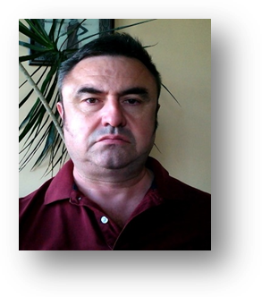
Contact details
Phone: +359 898 766 147
E-mail: ivanyordanov67@gmail.com
Address: Sofia, Mydren str. №27

Ivan Georgiev Yordanov
11.08.1967

EDUCATION

06/01/2018 – 03/11/2019
Software University
Major: Internal Program ‘Software engineering’

01/09/1985 – 30/08/1989
Military Academy ‘Georgi Dimitrov’
Level: Master’s degree
Major: Engineer of geodesy, cartography and photogrammetry

01/09/1981 – 01/09/1985
Mathematics High School

WORK EXPERIENCE

01/01/2012 - Present
Owner/Manager
Shops - OBOROT Ltd

25/02/2005 – Present
Owner/ Manager
Real Estate Agency ‘Slavia Estate Ltd.’
Duties and responsibilities:
- Recruitment
- Team structuring and building
- Allocation of daily liabilities
- Client meetings
- Organizing and conducting real estate deals

01/09/2003 – 25/02/2005
Manager
Real Estate Agency ‘Olimp - UV’

01/09/1989 – 30/06/2003
Officer in the ranks of the Bulgarian Army

SKILLS, ACIVITIES, PRACTICE

Job acquired skills
- Working under pressure
- Analytical skills
- Adaptability
- Creativity
- Customer relations

Organizational Skills
- Team working
- Leadership
- Planing
- Prioritization

Social Skills and Competences
- Open minded
- Eager learner
- Good listener
- Collaborative skills

Languages
- Bulgarian (native)
- English (intermediate)
- Serbian (advanced)
- French (beginner)
- Russian (intermediate)

Hobbies
- Reading books
- Socializing wih friends and family
- Long walks in the nature with my dog
- Coding

Driving Licence
B, C

