

**(Annexure A) Title Page**

# PROJECT REPORT

## On

**CURRENCY CONVERTER**

## COMPUTER SCIENCE AND ENGINEERING

**B.E. Batch-2018**

**in**

**December-2020**



|  |  |
| --- | --- |
| **Under the Guidance of:** | **Submitted By:** |
| *Dr. Ashutosh Kumar Dubey* | **Prateek Bhambri** |
| *Ms. Ravita Chahar* | **Id. No.- 1811981227** |
|  | **Varun Malhotra** |
|  | **Id. No.- 1811981342** |
|  | **Sawan Sood** |
|  | **Id. No.- 1811981282** |

**DEPARTMENT OF COMPUTER SCIENCE & ENGINEERING**

**CHITKARA UNIVERSITY**

**HIMACHAL PRADESH**

**(Annexure –B)**

**CERTIFICATE**

This is to be certified that the project entitled “Currency Converter” has been submitted for the Bachelor of Computer Science Engineering at Chitkara University, Himachal Pradesh during the academic semester July 2020-December 2020 is a bonafide piece of project work carried out by “Prateek Bhambri (1811981227), Varun Malhotra (1811981342), Sawan Sood(1811981282)” towards the partial fulfillment for the award of the course Professional Practices-Python for Data Science (CS254E) under the guidance of “Ms. Ravita Chahar” and supervision.

### **Signature of Project Guide**

**:**

Ms. Ravita Chahar

(Head of Department of Computer Science)

**CANDIDATE’S DECLARATION**

We, **Prateek Bhambri (1811981227), Varun Malhotra (1811981342), Sawan Sood (1811981282),** B.E.-2018 of the Chitkara University, Himachal Pradesh hereby declare that the “Professional Practices-Python for Data Science (CS254E)” Report entitled **“Currency Converter”** is an original work and data provided in the study is authentic to the best of our knowledge. This report has not been submitted to any other Institute for the award of any other course.

|  |  |  |
| --- | --- | --- |
| **Sign. of Student 1** | **Sign. of Student 2** | **Sign. of Student 3** |
| Prateek Bhambri | Varun Malhotra | Sawan Sood |
| ID No-1811981227 | ID No- 1811981342 | ID No- 1811981282 |

### **Place: Date:**

**1. ABSTRACT**

* **Currency converter** is a tool used to convert one country’s currency to another.
* In this project by the knowledge of usage of currency converter a program is designed in python language.
* In finance, an exchange rate between two currencies is the rate at which one currency will be exchanged for another.
* It is a useful tool which gives us the value of certain amount of one currency to be converted in to a different currency.
* It is also regarded as the value of one country’s currency in terms of another currency.
* In this project we are going to display a web window in which currency options are given and the conversion value is displayed in the next window.
* In this Currency Converter, it is going to display a page where you can choose to display the converter or the exchange rate of one currency with all other currencies.
* It provides an easy conversion of currency values based on present-day exchange rates.
* Different countries use different currency, and there is daily variation in these currencies relative to one another. Those who transfer money from one country to another (one currency to another) must be updated with the latest currency exchange rates in the market.
* Such software can be used by any user, but it is mainly useful for business, shares, and [finance](https://www.codewithc.com/finance-management-system-project-vb-net/) related areas where money transfer and currency exchange take place on a daily basis.
* Currency converter project is built keeping this thing in mind. It is simply a calculator. In this software, there is regular update about currency of every country by which it displays present currency market value and conversion rate.

**(Annexure -D )**

**ACKNOWLEDGEMENT**

It is our pleasure to be indebted to various people, who directly or indirectly contributed in the development of this work and who influenced our thinking, behavior and acts during the course of study.

We express our sincere gratitude to all for providing an opportunity to undergo “Professional Practices-Python for Data Science”- Project as the part of the curriculum.

We are thankful to “***Ms. Ravita Chahar***” for her support, cooperation, and motivation provided to us during the training for constant inspiration, presence and blessings.

We also extend our sincere appreciation to ***“Ms. Ravita Chahar and Dr. Ashutosh Kumar Dubey”*** who provided his/her valuable suggestions and precious time in accomplishing our project report.

Lastly, we would like to thank the almighty and our parents for their moral support and friends with whom we shared our day-to day experience and received lots of suggestions that improve our quality of work.

|  |  |  |
| --- | --- | --- |
| **Prateek Bhambri** | **Varun Malhotra** | **Sawan Sood** |
| **ID No- 1811981227** | **ID No- 1811981342** | **ID No- 1811981282** |

Table of Contents

**1 Abstract/Keywords 4**

**2 Introduction7**

2.1 Background7

2.2 Problem Statement8

**3 Software and Hardware Requirement Specification**9

3.1 Methods9

3.2 Requirements to run the application9

**4 Database Analyzing10**

**5 Program’s Structure Analyzing and GUI Constructing (Project Snapshots)11**

**6. Code-Implementation13**

**7. Limitations**1**4**

**8. Conclusion15**

**9. Future Scope16**

**10. References17**

**2.INTRODUCTION**

The *currency converter* will return what the conversion multiple is. The conversion multiple means 1 USD is equal to 74 INR. The currency converter service will convert one currency to another. Suppose the currency converter service wants to convert 100 USD to INR. So, it will convert the specified amount and provide the required output.

**2.1 Background:**

The staffs who work at places like money exchange offices have to distinguish between different types of currencies and convert them to other currencies and that is not an easy job. They have to remember the symbol of each currency. This may result into wrong recognition, so they need an efficient and fool proof system to aid in their work. The aim of our system is to help people who need to recognize different currencies, and be able to convert them to another currency using a known exchange rate. With development of modern banking services, automatic methods for paper currency recognition become important in many applications such as vending machines. It is very difficult to count different denomination notes in a bunch. This project proposes an image processing technique for paper currency recognition and conversion. The extracted region of interest (ROI) can be used with Pattern Recognition and Neural Networks matching technique. Image Processing involves changing the nature of an image in order to improve its pictorial information for human interpretation. There are various techniques for recognition that involve texture, pattern or colour based. We use digital image processing techniques to find region of interest, after that Neural Network and Pattern Recognition Technique is used for matching the pattern. A number of methods for banknote classification

have been proposed. Template matching is often used as a simple method to classify

banknotes. However, new template or matching rules are required for new bill types. An effective way to overcome the problem is to extract features from bill images representing unique characteristics of bill data. After studying different currencies and considering the availability, we have chosen 5 currencies to work on for this project. The chosen currencies are Indian Rupees (INR), Australian Dollar (AUD), Euro (EUR), Nigerian Naira (NGN) and US Dollar (USD).

In another research work, a simple statistical test is used as the verification step, where univariate Gaussian distribution is employed, in another technique

for paper currency recognition, three characteristics of paper currencies including

size, colour and texture are used in the recognition.

After studying the previously used methods for currency recognition, we can see

that most of these methods/algorithms use Artificial Neural Networks

**2.2 Problem statement:**

* Currently, human is needed to recognize the amount of the currency and to convert it manually. This is stressful especially to people who aren’t so smart in calculations. So, this project is developed to replace human power to recognize the amount of the currency.
* Currency Recognition and converter system is implemented to reduce human  
  power to automatically recognize the amount of currency and convert it into the other currency without human supervision.
* Currency conversion is of practical use to tourists who travel abroad, to businesses who do business overseas or are involved in imports and exports.
* Currency conversion is also useful for forex traders, offering the ability to track changes in exchange rate valuations in real time. even when not at the trading desk.

**3.SOFTWARE & HARDWARE REQUIREMENT SPECIFICATION**

**3.1 Methods:**

Language- Python

Libraries- Tkinter, Forex-python

GUI- Tkinter

API- Forex-python

**3.2 Requirements to run the application:**

Modern Operating System:

* Windows 7,8 or above
* Mac OS X 10.11 or higher, 64-bit
* Linux: RHEL 6/7, 64-bit (almost all libraries also work in Ubuntu) x86 64-bit CPU (Intel / AMD architecture)

RAM: 4GB

HDD: 5GB free disk space

**4.DATABASE ANALYZING**

* Forex Python is a Free Foreign exchange rates and currency conversion. Features: List all currency rates. Bitcoin price for all currencies.
* Converting amount to Bitcoins. Get historical rates for any day since 1999.
* Conversion rate for one currency (ex; USD to INR). Convert amount from one currency to other (‘USD 10$’ to INR). Currency symbols. Currency names.
* In th GUI of Currency Converter we have three inputs of which the first is the amount to be converted and the second input is the currency which is going to be converted and the third input is the currency in the above amount is being converted into. Then we have two buttons Convert and Clear All.
* Convert button converts the currency from one to another once the button is pressed and the other Clear All button clears all the entries which were inputted by the user itself.
* When the convert button is pressed the converted amount as well as the Currency Name displays on the GUI/App.

**5.PROGRAM’S STRUCTURE ANALYZING AND GUI**

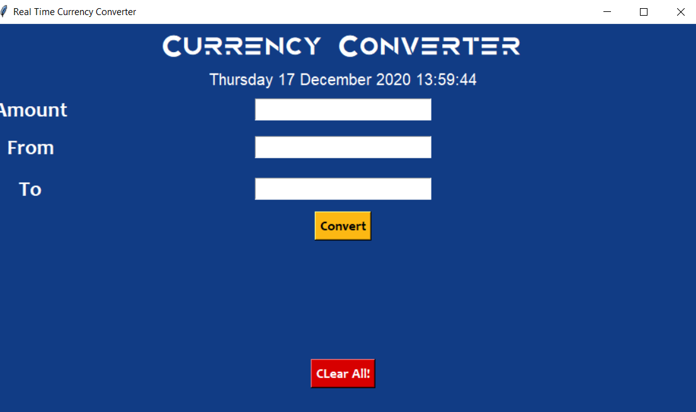

**Project Snapshot 1: Home page**

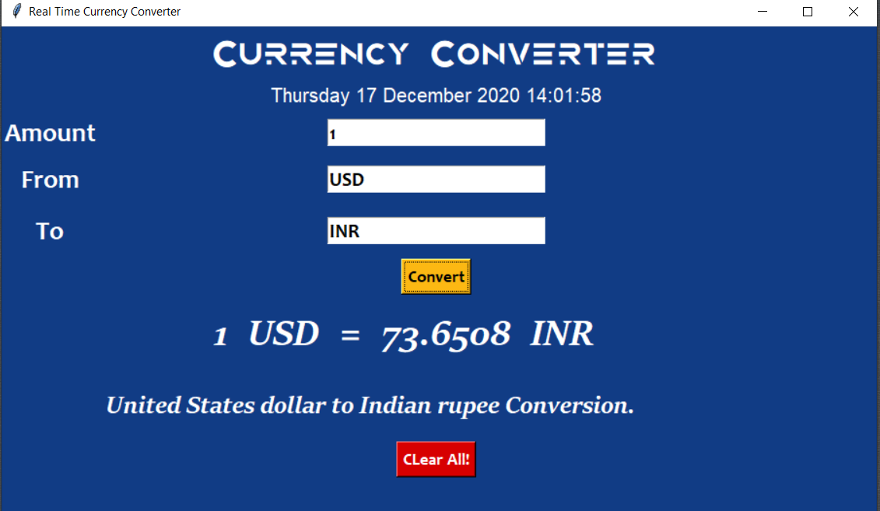

**Project Snapshot 2: Input by user, Processed by code and return respective output**

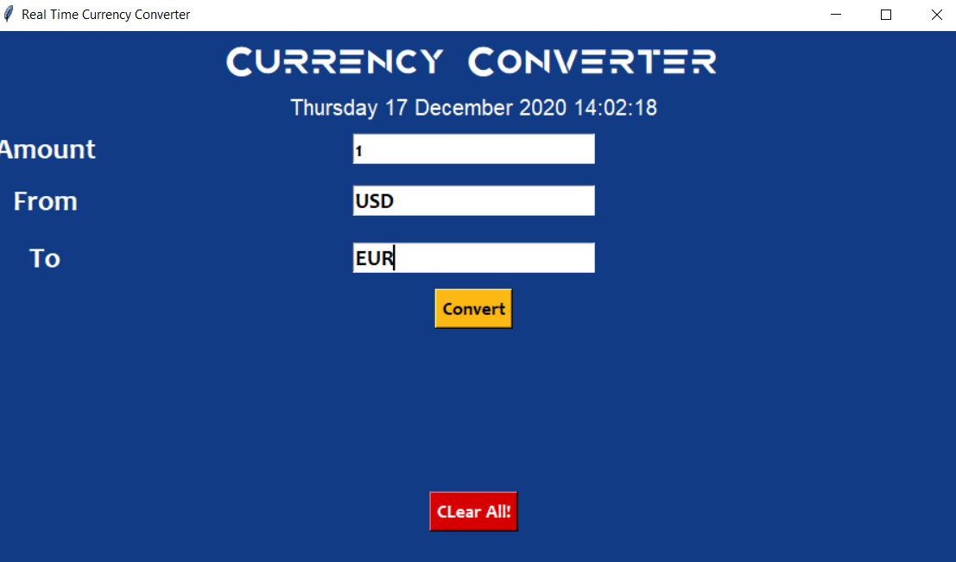

**Project Snapshot 3**

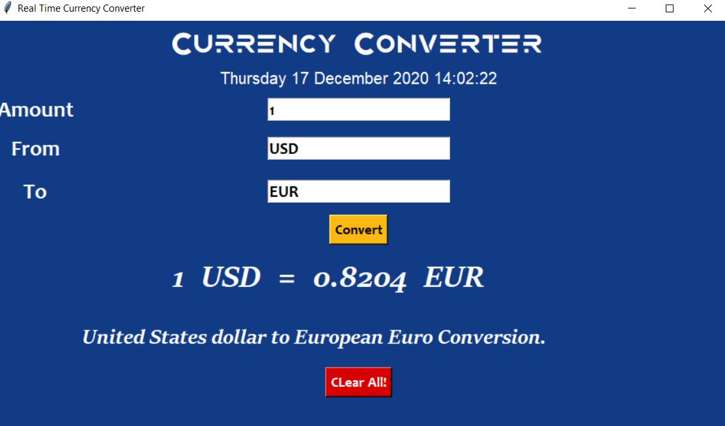

**Snapshot 4**

**6.CODE IMPLEMENTATION**

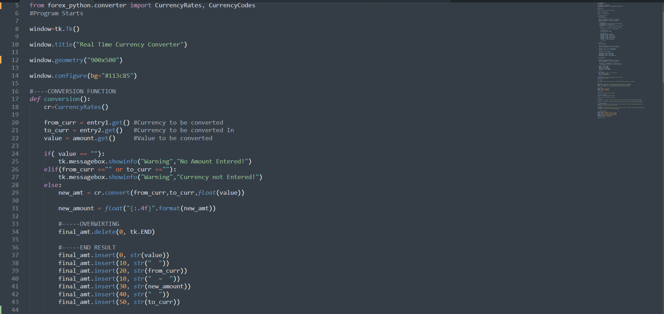

**7.LIMITATIONS**

The major limitation of this thesis is during the actual software development. The source code for image recognition was difficult to obtain as Php programming language don’t have much support for image recognition.

Also due to lack of enough money, time and confidentiality of information, system developed convers all aspect of money conversion and few aspects of currency recognition.

Not all currencies can be exchanged or converted for other currencies. There are few countries having monetary policies that restrict the convertibility of their currencies. Currency exchange is essential in a global economy and is important for international commerce. A currency that is inconvertible has significant barriers to trade and tourism.

Some brokers may not handle the currency exchange for a contract for differences (CFD). During settlement in CFD futures contract arrangements, cash payments play as a substitute for the delivery of the asset.

**8.CONCLUSIONS**

Currency converter that the people are using, they will always find ways to get the highest possible profits out of the exchanges. To those who are going to travel, it is a wise thing to check the different foreign exchange options they have beforehand.

Therefore, currency converter is developed and is used for knowing the currency’s value.

It can be further developed by including more currency options, and by shown currency value tables for user.

**9.FUTURE SCOPE**

The scope of this project is to develop a currency recognition and converter system by using image processing and neural network. In other to implement this system we have to use MATLAB Toolbox to achieve the objectives of the project.

The system will be able to recognize the currency amount, integrate hardware and software, extract the data from the currency image by using digital image processing toolbox, accept and store an exchange rate for conversion between

currencies.

It will be useful to every organization that deals with money, it will help in easy conversion of money to another. It will be of immense help to bureau de change as it will ease the task of currency recognition and conversion. This work is also significant to scholars who needs to make research about currency recognition and conversion.

**10.REFFERENCE**

* <https://www.youtube.com/watch?v=SK9NBuqg-ls&lsit=PLkndiRtQST7fwn4rpqClo97BLHvR&ab_channel=PyPowerProjects>
* <https://www.youtube.com/watch?v=AyoK9XMg9qM&ab_channel=CIDAnEducationHub>
* <https://data-flair.training/blogs/currency-converter-python/>
* <https://www.geeksforgeeks.org/python-real-time-currency-convertor-using-tkinter/>