**Report generator**

1. **Top 10 under-utilised Ad campaigns:**

Query:

select

t3.campaignID as campaignID,

t3.category as category,

t3.click as click,

t3.acquisition as acquisition,

t3.view as view,

round(t3.expenditure / t3.totalbudget * 100,5) as budgetUtilization

from

(

select

t1.campaign_id as campaignID,

t2.category as category,

t1.click as click,

t1.acquisition as acquisition,

t1.view as view,

t1.expenditure as expenditure,

t2.budget as remainingBudget,

t1.expenditure + t2.budget as totalBudget

from

(

select

feedback.campaign_id as campaign_id,

sum(feedback.view) as view,

sum(feedback.click) as click,

sum(feedback.acquisition) as acquisition,

sum(feedback.expenditure) as expenditure

from capstone.adsfeedback as feedback

group by feedback.campaign_id

) as t1

inner join capstone.ads as t2

on t1.campaign_id = t2.campaignid

) as t3

order by budgetUtilization;

1. **Top 10 spending Ad campaigns:**

Query:

select

t3.campaignID as campaignID,

t3.category as category,

t3.click as click,

t3.acquisition as acquisition,

t3.view as view,

round(t3.expenditure / t3.totalbudget * 100,5) as budgetUtilization

from

(

select

t1.campaign_id as campaignID,

t2.category as category,

t1.click as click,

t1.acquisition as acquisition,

t1.view as view,

t1.expenditure as expenditure,

t2.budget as remainingBudget,

t1.expenditure + t2.budget as totalBudget

from

(

select

feedback.campaign_id as campaign_id,

sum(feedback.view) as view,

sum(feedback.click) as click,

sum(feedback.acquisition) as acquisition,

sum(feedback.expenditure) as expenditure

from capstone.adsfeedback as feedback

group by feedback.campaign_id

) as t1

inner join capstone.ads as t2

on t1.campaign_id = t2.campaignid

) as t3

order by budgetUtilization desc;

1. **Total expenditure and click-through rates (CTR) of Ad campaigns**

Query:

select

feedback.campaign_id as campaign_id,

round(sum(feedback.click) / sum(feedback.view),6) as CTR,

round(sum(feedback.expenditure),6) as expenditure

from capstone.adsfeedback as feedback

group by feedback.campaign_id;

1. **Top five interactive (highest CTRs) age groups**

Query:

select

t1.ageRange as age_group,

sum(t1.CTR) as CTR

from

(

select

feedback.campaign_id as campaignID,

feedback.target_age_range as ageRange,

feedback.click / feedback.view as CTR

from capstone.adsfeedback as feedback

) as t1

group by t1.ageRange

order by CTR desc;

Bar Chart:

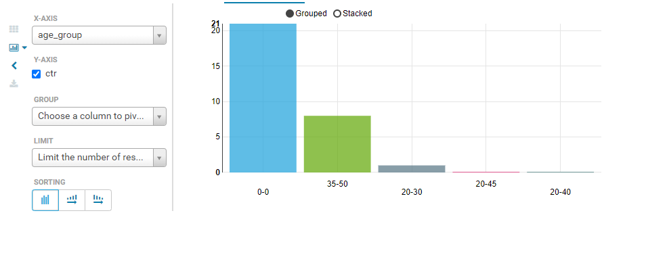

Note: “0-0” group is considered as any age group can interact.

1. **Top five interactive locations**

Query:

select

t1.location as location,

sum(t1.CTR) as CTR

from

(

select

feedback.campaign_id as campaignID,

feedback.target_location as location,

feedback.click / feedback.view as CTR

from capstone.adsfeedback as feedback

) as t1

group by t1.location

order by CTR desc

limit 5;

Bar Chart:

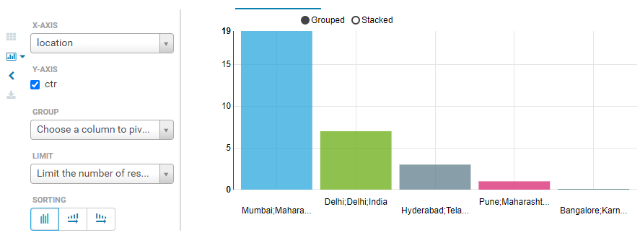

1. **Top interactive gender**

Query:

select

t1.gender as gender,

sum(t1.CTR) as CTR

from

(

select

feedback.campaign_id as campaignID,

feedback.target_gender as gender,

feedback.click / feedback.view as CTR

from capstone.adsfeedback as feedback

) as t1

group by t1.gender

order by CTR desc;

Bar Chart:

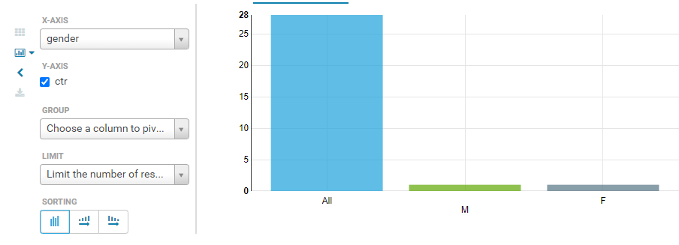

1. **Top interactive income buckets**

Query:

select

t1.income_bucket as income_bucket,

sum(t1.CTR) as CTR

from

(

select

feedback.campaign_id as campaignID,

feedback.target_income_bucket as income_bucket,

feedback.click / feedback.view as CTR

from capstone.adsfeedback as feedback

) as t1

group by t1.income_bucket

order by CTR desc;

Bar Chart:

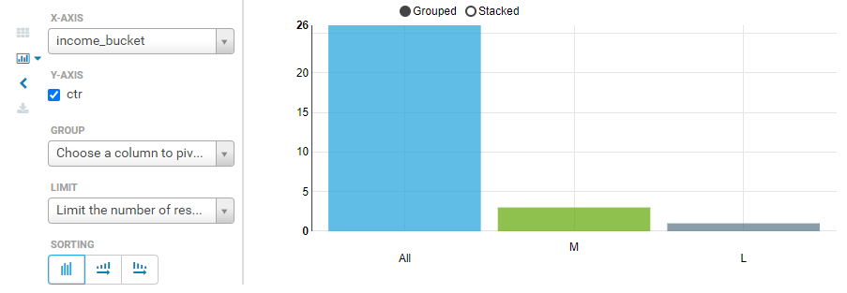

1. **Top five interactive device types**

Query:

select

t1.device_type as device_type,

sum(t1.CTR) as CTR

from

(

select

feedback.campaign_id as campaignID,

feedback.target_device_type as device_type,

feedback.click / feedback.view as CTR

from capstone.adsfeedback as feedback

) as t1

group by t1.device_type

order by CTR desc;

Bar Chart:

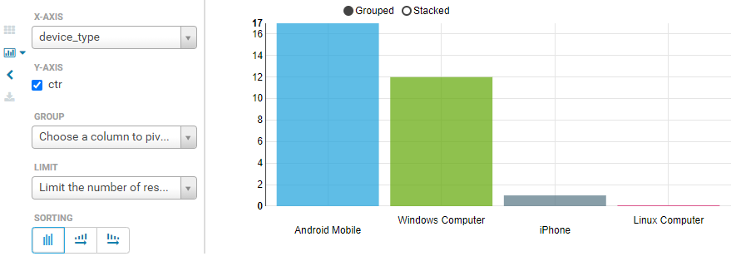

1. **Top 10 spending Ad categories**

Query:

select

t2.category as category,

round(sum(t1.expenditure),6) as expenditure

from capstone.adsfeedback as t1

inner join capstone.ads as t2

on t1.campaign_id = t2.campaignid

group by category

order by expenditure desc

limit 10;

Bar Chart:

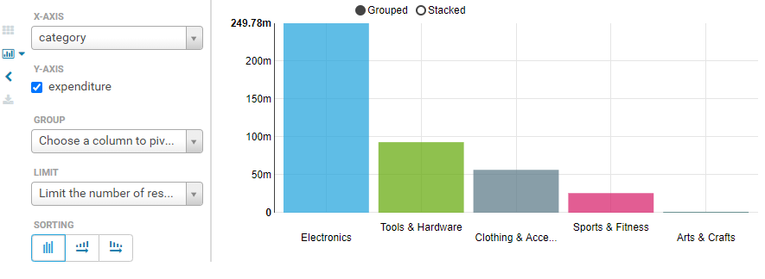

1. **Highest price differences in CPM during auctions**

Query:

select

t1.request_id as request_id,

t2.cpm -t1.auction_cpm as difference

from capstone.adsfeedback as t1

inner join capstone.ads as t2

on t1.campaign_id = t2.campaignid

order by difference desc;