**Practical - 4**

**Objective – 1: Extract Numbers.**

**Output Screenshot:**

**Test Case-1:**

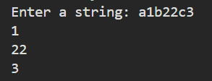

**Test case-2:**

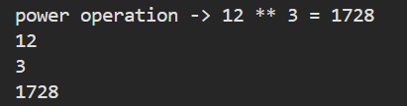

**Test case-3:**

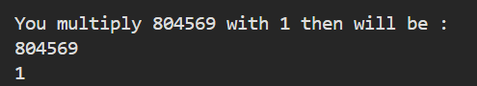

**Objective – 2: Replace “charusat” with “university”**

**Test case-1:**

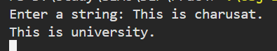

**Test case-2:**

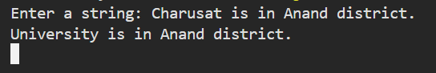

**Test case-3:**

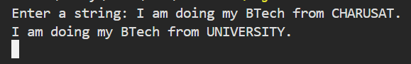

**Test case-4:**

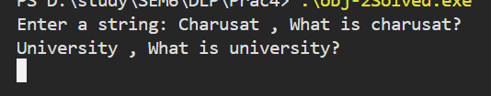

**Test case-5:**

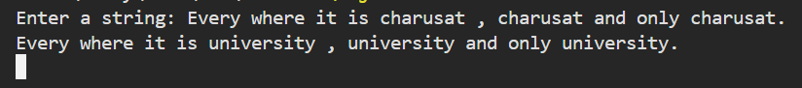

**Objective – 3: Count characters, words and Lines**

**Test Case-1:**

**Input:**

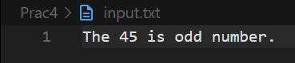

**Output:**

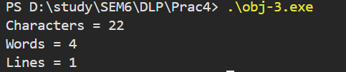

**Test Case-2:**

**Input:**

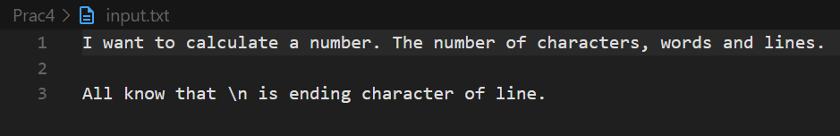

**Output:**

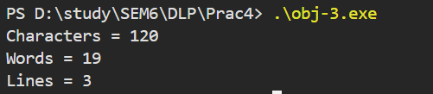

**Test Case-3:**

**Input:**

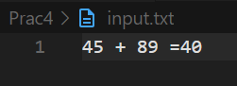

**Output:**

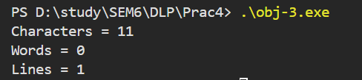

**Objective – 4: Validate Password**

**Test Case – 1:**

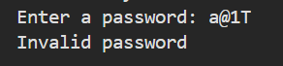

**Test Case – 2:**



**Test Case – 3:**

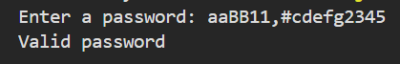

**Test Case – 4:**



**Test Case – 5:**



**Test Case – 6:**



**Test Case – 7:**

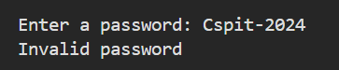

**Test Case – 8:**

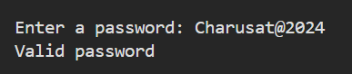

**Test Case – 9:**



**Test Case – 10:**

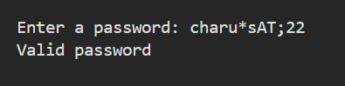

**Obj-Extra: Count characters, words, lines, whitespace/tabspace, special character, number.**

**Test Case – 1:**

**Input:**

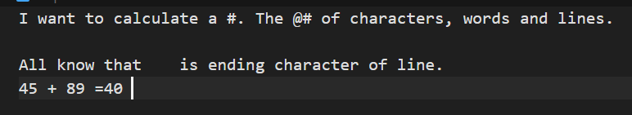

**Output:**

