Style Transfer with Pre-trained Models

ABSTRACT

1.Project Purpose:

"To explore and implement neural style transfer techniques using pre-trained deep learning models. This project aims to leverage the expressive power of convolutional neural networks (CNNs) to transfer artistic styles between images, enhancing creativity in digital content generation and exploring the intersection of art and technology."

2.Concept:

1. Input Images (Content and Style):

- Content Image: This is the base image on which the style of another image will be applied. It contains the subject matter that you want to retain in the final stylized image.

- Style Image: This image provides the artistic style you want to transfer onto the content image. It typically features textures, colors, and patterns characteristic of a particular artistic style or image.

2. Pre-trained CNN (e.g., VGG):

- Choice of Model: Use a pre-trained convolutional neural network (CNN) like VGG (Visual Geometry Group) that has been trained on large datasets for image classification tasks. These models are effective because they have already learned to extract meaningful features from images.

3. Feature Extraction Layers:

- Feature Maps: Deep CNNs consist of multiple layers that progressively extract hierarchical features from input images. In style transfer, the deeper layers capture higher-level features like textures and shapes, which are crucial for transferring style.

4. Style and Content Loss Calculations:

- Gram Matrix for Style Loss: Calculate the style loss by comparing the Gram matrices (which capture correlations between feature maps) of the style image and the output image at selected layers. This measures how well the texture and patterns of the style image are transferred.

- Mean Squared Error for Content Loss: Compute the content loss as the mean squared error between the feature maps of the content image and the output image at chosen layers. This ensures that the content of the original image is preserved.

5. Optimization Process (Gradient Descent):

- Iterative Optimization: Start with a random noise image or a copy of the content image and iteratively adjust it to minimize both the content and style losses. This involves using gradient descent to update the pixel values of the output image in the direction that reduces the overall loss.

6. Output Image:

- Result of Style Transfer: The final output image is the result of applying the style of the style image to the content of the content image. It synthesizes the content structure with the textures, colors, and patterns of the style image, producing a visually appealing stylized image.

**FLOW CHART**

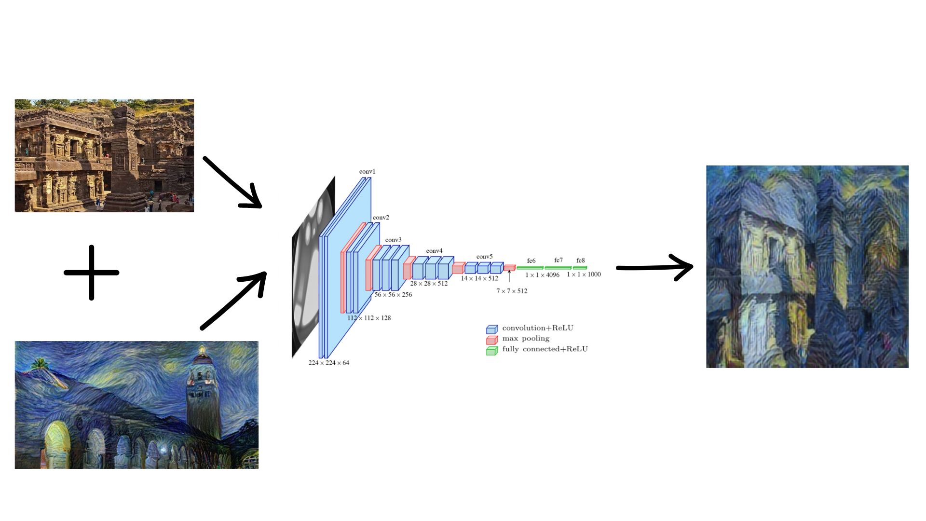

**BLOCK DIAGRAM**

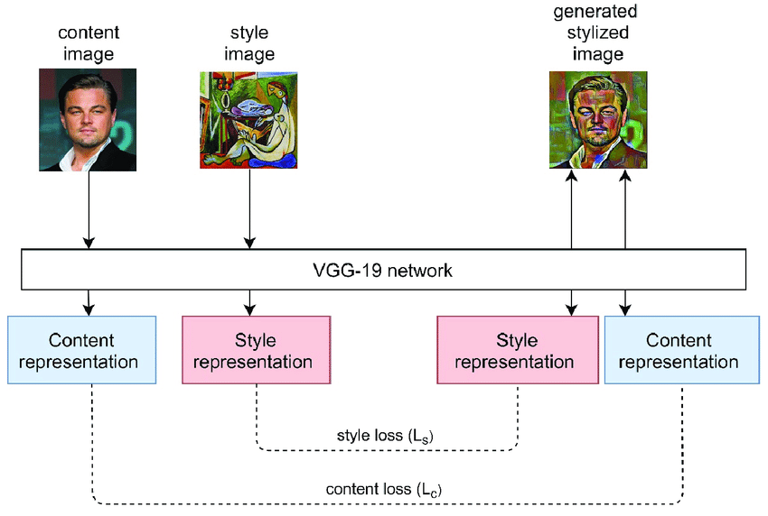

**NEURAL STYLE TRANSFER MODEL ARCHITECTURE**

