# Exam: DOB (2021.04) - 2021.07.03

### Main goal

You are expected to utilize all studied products and technologies (**VirtualBox**, **Vagrant**, **Ansible**, **Jenkins**, **Nagios**, and **Docker**) and create an infrastructure with **three or four** hosts (you decide based on resource availability). The **emphasis** should be on **features** usage **demonstration** versus optimal solution

The goal is to have the whole **infrastructure** as a **file** or **set** of **files**. Then on top of it to create an **automated** **build** **process** which will check every **two** minutes with the **source control system** and if there is a change in the project then all related images should be **re-build** and **re-run**

Your solution may look like

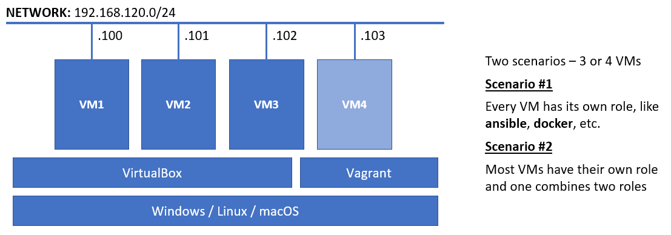

**All** **hosts** should be **provisioned** and **configured** in an automated fashion by utilizing **both** **Vagrant** and **Ansible**

**Nagios** should be used to **monitor** the **hosts** (by **ping** ONLY) and the set of running **containers**

Project URL: [**https://github.com/shekeriev/dob-2021-04-exam.git**](https://github.com/shekeriev/dob-2021-04-exam.git)

Project will auto-update every 5 minutes

### Rules

Be sure to **follow** the **naming** **conventions** specified in the checklist and in project source files

The tasks execution order should not be derived from the order in which they are listed below. Please note that there are tasks that depend on the successful completion of one or more other tasks

If there are any manual steps you must describe them in a complementary document. Don’t forget to include some pictures of the important (according to you) steps and of the **end result** as well

### Tasks

#### VirtualBox and Vagrant (12 pts)

* (T101, 2 pts) Infrastructure with **three** or **four** machines
* (T102, 2 pts) All hosts named according to the following convention:
  + For hosts with a single role, for example a dedicated **Nagios** host - **nvm.dob.exam**
  + For hosts with a combined role, for example **Ansible** and **Jenkins** - **ajvm.dob.exam**
  + In general, you must concatenate the *first letter of the role* (or roles) and the string *vm.dob.exam*
* (T103, 2 pts) All hosts in a dedicated network - **192.168.120.0/24**
* (T104, 2 pts) All necessary ports forwarded to the corresponding ports on the host machine, starting from **8000**. For example, **Jenkins** 8080 => **8000** on the host, **Nagios** 80 => **8001** on the host, and so on
* (T105, 4 pts) At least one host provisioned with the help of **Vagrant** and shell (inline or external) script

#### Ansible (12 pts)

* (T201, 3 pts) Installed and working **Ansible** with custom created inventory (either manually or automatically)
* (T202, 4 pts) Provisioned at least one host
* (T203, 3 pts) Create and use at least one own role
* (T204, 2 pts) Install and apply at least one 3rd party role

#### Jenkins (16 pts)

* (T301, 3 pts) Working base installation of **Jenkins** with configured administrator user
* (T302, 1 pts) Additional (at least one) plugins installed and enabled
* (T303, 2 pts) Added credentials - user and password (for the **vagrant** user)
* (T304, 3 pts) Added slave (agent) node (the **Docker** host)
* (T305, 5 pts) Project for building the images and running the containers out of the **GitHub** repository
* (T306, 2 pts) Schedule to check for changes on every two minutes

#### Nagios (12 pts)

* (T401, 3 pts) Working base installation of **Nagios** with configured administrator
* (T402, 3 pts) **NRPE** plugin installed and configured (where applicable, for example on the **Docker** host)
* (T403, 3 pts) Monitor all hosts with **ping** (service)
* (T404, 1 pts) Individual services (named after the containers) to monitor every container
* (T405, 2 pts) Service group named **CONT** to include all individual container services

#### Docker (8 pts)

* (T501, 2 pts) Create a dedicated network (**dob-network**) for the containers
* (T502, 2 pts) Run and attach the containers to the dedicated network
* (T503, 3 pts) Working containerized application as expected
* (T504, 1 pts) Application reachable on the host (via port forwarding)