# Lab: SOLID Principles and Design Patterns

This goal of this lab is to practice some of the most well-known **design patterns**. You are given several broken projects with misuse of OOP - your task is to refactor the code (or rewrite it from scratch) by applying a suitable design pattern.

### Creational Patterns

## Web Scraper

Pattern: **Singleton**

You are given a **WebPageRepository** class that stores web page URL addresses. Your task is to implement the singleton design pattern. Ensure that the class:

* Cannot be instantiated from outside
* Cannot be inherited
* Is thread-safe (see **Double-null check** pattern)

The code below should download the HTML content of all web addresses stored in the repository.

|  |
| --- |
| **Sample Source Code** |
| **var repository = WebPageRepository.Instance;**  **var downloader = new Downloader();**  **while (!repository.IsEmpty)**  **{**  **var url = repository.Remove();**  **downloader.Download(url, GenerateFileNameFromUrl(url));**  **}** |

## Tank Manufacturer

Pattern: **Factory Method**

Write a program with several factories for manufacturing **tanks**. The following factories should be supported:

* **German** factory - manufactures a **Tiger** tank, with speed **4.5** and damage **120**
* **Russian** factory - manufactures a **T 34** tank, with speed **3.3** and damage **75**
* **American** factory - manufactures a **M1 Abrams** tank, with speed **5.4** and damage **120**

Steps:

1. Define an abstract factory with a **CreateTank()** method
2. Define concrete factories with concrete implementations of that method (e.g. **GermanTankFactory** creates a **Tiger** tank)
3. Use the concrete factories interchangeably in the code

|  |  |
| --- | --- |
| **Sample Source Code** | **Sample Output** |
| **TankFactory tankFactory = new GermanTankFactory();**  **// tankFactory = new RussianTankFactory();**  **// tankFactory = new AmericanTankFactory();**    **var tank = tankFactory.CreateTank();**  **Console.WriteLine(tank);** | **-Tank**  **...Model: Tiger**  **...Speed: 4.50**  **...Damage: 120** |

### Structural Patterns

## DOM Builder

Pattern: **Composite**

Write a program that allows building complex **tree**-like structures with DOM elements.

Steps:

1. Create an **Element** class that holds a **type** and a **collection of its children**
2. Define **Add()** and **Remove()** methods for adding/removing children - add validation for null
3. Define a **Display()** method that renders the current element and all its children elements
4. Create a constructor that accepts **type** + an arbitrary number of **elements**

|  |  |
| --- | --- |
| **Sample Source Code** | **Sample Output** |
| **Element html =**  **new Element("html",**  **new Element("head"),**  **new Element("body",**  **new Element("section",**  **new Element("h2"),**  **new Element("p"),**  **new Element("span")),**  **new Element("footer")));**  **File.WriteAllText("index.html", html.Display());** | **<html>**  **<head>**  **</head>**  **<body>**  **<section>**  **<h2>**  **</h2>**  **<p>**  **</p>**  **<span>**  **</span>**  **</section>**  **<footer>**  **</footer>**  **</body>**  **</html>** |

## RPG

Pattern: **Bridge**

Write a simple RPG Game where there are **characters** and **weapons**. The game is simple - each character can have **one weapon** at a time. Implement a **Mage** and a **Warrior** as characters. Implement a **Sword** and an **Axe** as weapons. Any character should be able to use any weapon.

Steps:

1. Create an abstract class **Character**
2. Create an abstract class **Weapon**
3. A **character** should receive an abstract **Weapon** (through dependency injection)

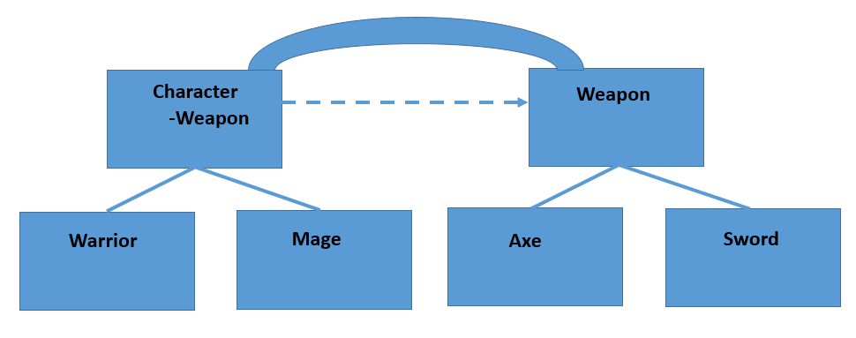

## Reaper Invasion

Pattern: **Flyweight**

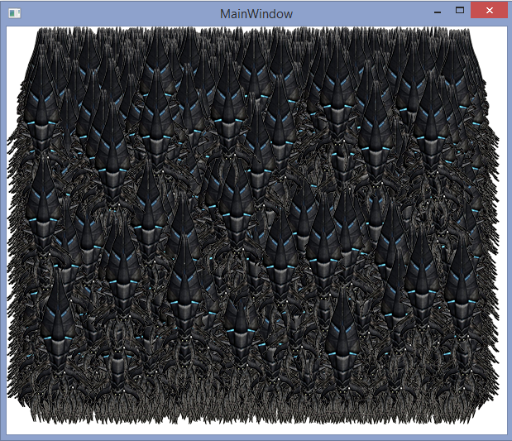You are given a working **WPF application** that renders **10000 Reaper images** on the screen. However, its performance is quite **poor** (takes at least 10 seconds to draw everything).

Your task is to study the application, **pinpoint the bottleneck** and apply the **Flyweight Design Pattern** in order to optimize its performance.

**Hint**: Look for places where a **heavy operation** is performed **too often unnecessarily**.

### Behavioral Patterns

## C# Compiler

Pattern: **Strategy**

You are given a **simple API** for **compiling C# code** **strings** at runtime. The process is as follows:

* Preprocess - prepares the code for compilation by performing **validations**
* Compile - compiles the code to **Intermediate Language (IL)**
* Execute - begins program execution from **IL** to **machine instructions**

Your task is to open the **Preprocess** step for extension by **leaving the user to decide** what sort of **validation** should be made. **Tip**: Use **Dependency Injection**.

Steps:

1. Edit the **CSharpCompiler** constructor so that it receives a **strategy** from outside (through dependency injection). The strategy will be used during the preprocess step.
2. Create an interface that defines a strategy - e.g. **ICodeValidationStrategy** with a **Validate()** method
3. Create concrete validation strategies:
   * Validates if the code is at least 20 characters long
   * Validates if no "**using System.Net**" reference is contained in the code string

**CompilationException** with a proper message should be thrown if validation fails.

1. The validation strategy should be **optional**. Ensure **NullReferenceException** is never thrown.

|  |
| --- |
| **Sample Source Code** |
| **ICodeSyntaxValidationStrategy codeValidationStrategy = new CodeLengthValidator();**  **// codeValidationStrategy = new SystemNetValidator();**  **var compiler = new CSharpCompiler(codeValidationStrategy);**  **compiler.Compile(code);**  **compiler.Execute(EntryClassName);** |

## Skyrim

Pattern: **Observer**

You're in Skyrim - there are **dragons** and **warriors**. Warriors fight dragons and whenever a dragon dies, it drops an item (such as a sword) to all warriors.

You are given ready classes for **Dragon** and **Warrior**. Apply the Observer pattern so that when a dragon dies (its **health** falls below **0**) all warriors **attached** to it receive a Sword item in their inventories.

The dragon is the subject (i.e. the "event" the warriors will be listening to and his death will trigger that event). As such, it should keep a list of all observers of that event.

Steps:

1. Create an interface **IDragonDeathObserver** with method **Update(Weapon weapon)**
2. The warriors should implement that interface and add the received weapon whenever they are updated of a dragon's death
3. The dragon itself should hold a list of all warriors and offer methods **Attach()** and **Detach()** for adding/removing listeners.
4. Add a **Notify()** method to the dragon. Whenever his health falls below **0**, the method should be called and all attached observers should be updated with the dropped item.

|  |
| --- |
| **Sample Source Code** |
| **foreach (var warrior in warriors)**  **{**  **dragon.Attach(warrior);**  **}**  **// Nothing happens**  **dragon.HealthPoints -= 20;**  **// Nothing happens**  **dragon.HealthPoints -= 10;**  **// Dragon dies**  **dragon.HealthPoints -= 90;** |

* Implement the Observer pattern using **events**.

## Customer Service

Pattern: **Visitor**

You are given a **repository** of customers. **Customers** have **name**, **discount** and keep all the **purchases** they have made. When accessing customers from the repository, you might want to make changes to them (e.g. raise the discount of all premium customers).

Apply the Visitor pattern so you can make changes to the customers on the fly. Create visitors for the following operations:

* Raise discount of all **premium customers** by **5%**
* Give out free "**SteamOp**" purchases to **all customers**

Steps:

1. Create an interface **ICustomerVisitor** with a **Visit(Customer customer)** method.
2. Add an **Accept()** method in the **Customer** class that accepts a visitor and tells him to visit the current instance.
3. Create concrete visitors for the above described operations:
   * **FreePurchaseVisitor** - adds a free purchase of an item to the visited customer
   * **DiscountRaiseVisitor** - adds 5% discount to visited customer
4. Use the **DiscountRaiseVisitor** to increase all premium customers' discount
5. Use the **FreePurchaseVisitor** to give all customers' a free SteamOp