## Problem 4 – The Mandarin Bird

You are given an unresponsive Web site (**HTML** + **CSS** + images). Your task is to **make the site responsive**. The site layout should change according to the browser viewport / screen size. You need to implement 2 layouts: **1200px >=** **width > 730px** , **730px >=** **width >= 500px**. The figures below represent these 3 layouts:

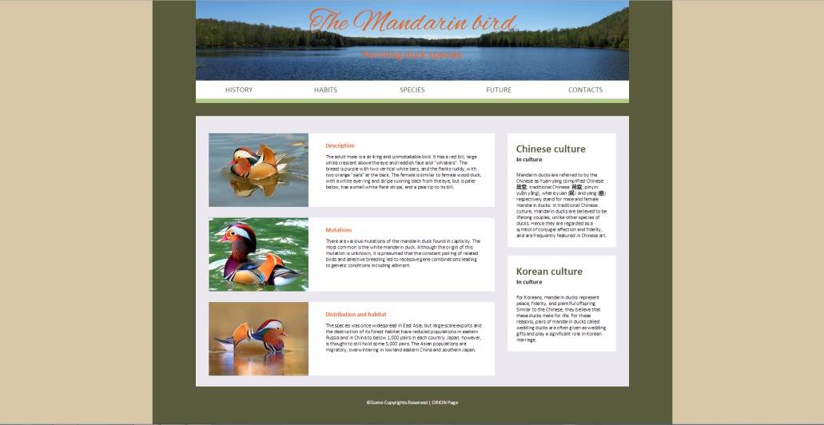

### D:\PAST\SOFTUNI\WEB FUNDAMENTALS\WEB FUNDAMENTALS\WEB FUNDAMENTALS\WEB FUNDAMENTALS\EXAMS\NEW\Exam_02\Problem_4_The_Mandarin_Bird\ScreenShots\Medium.jpg D:\PAST\SOFTUNI\WEB FUNDAMENTALS\WEB FUNDAMENTALS\WEB FUNDAMENTALS\WEB FUNDAMENTALS\EXAMS\NEW\Exam_02\Problem_4_The_Mandarin_Bird\ScreenShots\Small.jpg

### Input

You are given the unresponsive site as HTML + CSS + images.

### Output

The output should be valid HTML5 + CSS3 + images that implement the above responsive site.

### Constraints

* You are free to change the HTML and CSS, as well as use external frameworks like Bootstrap.
* Pixel-perfect implementation is not required.
* The site should open correctly in Chrome 38.