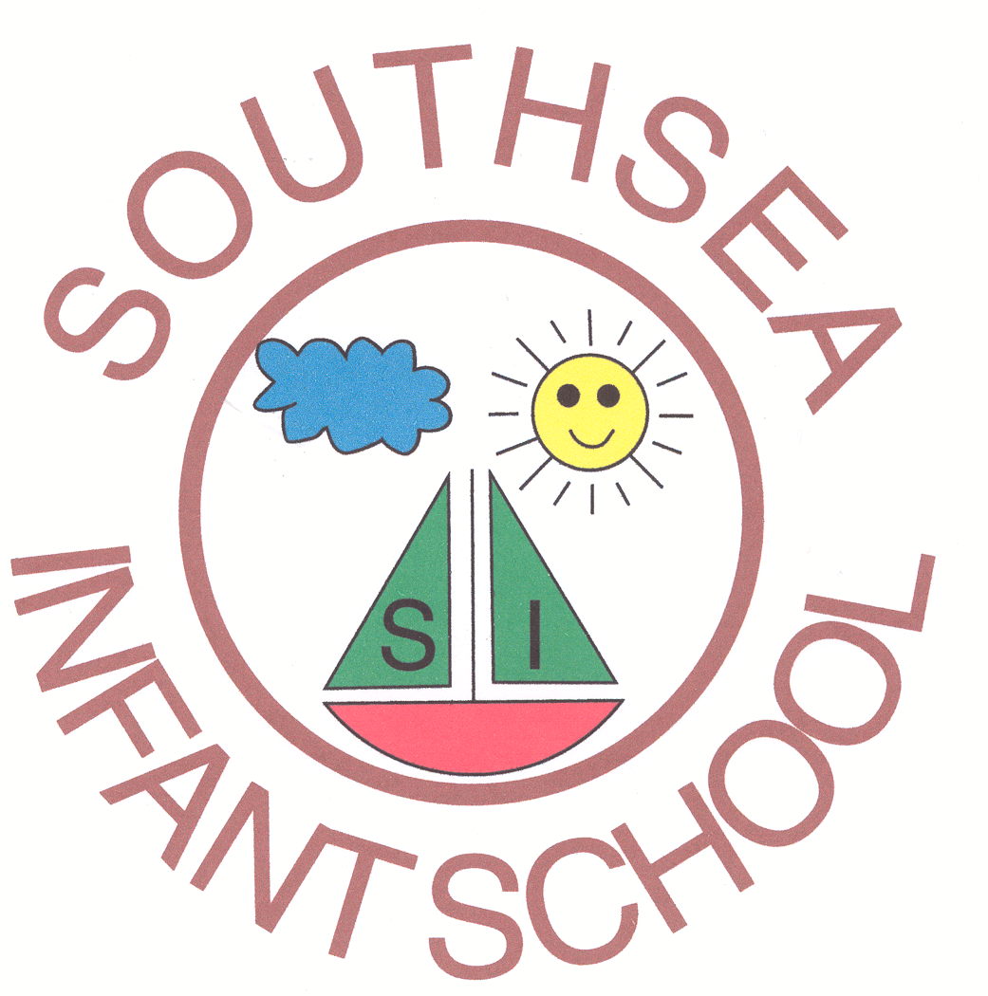
ABOUT SOUTHSEA INFANT SCHOOL

Southsea Infant School caters for children from 4-7 years. It is located in the south of Portsmouth in a traditional Victorian building. The number on roll is currently 187. There are six mainstream classes containing two parallel classes in Yr R, 1 and 2.

In addition there is a Language Unit attached to mainstream school which contains eight children all of whom have statements of educational needs. The children are included in mainstream activities as appropriate.

At the present time approximately 35% of NOR are from ethnic minority backgrounds. A total of 23 languages apart from English are currently represented with Bengali speakers being the largest group.

The number on roll is subject to significant fluctuation and the socio-economic characteristics of each year group can vary quite radically.
The school offers a wide range of out of school activities and facilities for the community.

The staff are a very friendly hard working team and staff development is seen as an important aspect of school life. Safeguarding of children is of paramount importance at all times.

The Administrative team consists of Admin Manager/Finance Officer (part time, Admin Officer and Admin Assistant.

The school is rated ‘good’ by OFSTED.

