
PAGES 1-4 TO BE RETAINED BY TRADER

BULL RING RAG AND OPEN MARKETS

INFORMATION PACK AND APPLICATION FORM

The Bull Ring Rag Market is famous for the extensive range of materials available in addition to a bewildering array of other merchandise.

The Bull Ring Open Market provides 130 purposely designed and manufactured stalls including stalls around the Bull Ring Rag Market, providing a lively and attractive street scene.

The Markets are full of character, colour and charm. They have excellent goods, quality service, bargains and much more.

The Bull Ring Open Market is open from 9am until 5pm every Tuesday to Saturday (5.30pm close on Saturdays).

The Bull Ring Rag Market is open from 9am until 5pm every Tuesday, Thursday, Friday and Saturday (5.30pm close on Saturdays).

For further information on how to apply for a casual stall on the Market, please see the attached application form or visit www.birmingham.gov.uk/markets. Alternatively, please call 0121 303 0208 or email marketstalls@birmingham.gov.uk.

PAGES 1-4 TO BE RETAINED BY TRADER

HOW TO BECOME A MARKET TRADER

BULL RING OPEN AND RAG MARKETS

Traders may trade on a casual basis by completing the attached application form on page 5 and providing the requested documentation by emailing marketstalls@birmingham.gov.uk. You will then be contacted by email to acknowledge your application. Applications will not be accepted if the application form is not completed in full or the requested documentation is not provided.

Casual traders need to confirm which stall(s) they wish to trade on. If you need help with this, please email marketstalls@birmingham.gov.uk who will arrange for you to be contacted by an officer who will assist with advising as to availability and providing further information.

On confirmation of your application, casual traders need to book in each week before trading the following week. This needs to be done before 12 noon on the Friday before the week you would like to trade. You will need to confirm your intended trading days for the following week.

Casual traders need to make a payment over the telephone using a credit/debit card for the week ahead when their application has been accepted by calling 0121 303 0208.

Should casual traders in the Rag Market wish to trade for the maximum 6 week period on all trading days, you may wish to take advantage of storage so that you do not have to decant your stall each trading day. Please advise us on the application form if you would like storage and we will provide further information.

When you start to trade with us, you will need to provide the original documentation which you have provided electronically with your application. Casual traders will be issued with a temporary licence for the period of time you advise us you wish to trade for on the day trading commences. If you decide to trade for 6 consecutive weeks, you may be offered the opportunity of a permanent licence. As a casual trader, should you not trade for a period of 6 weeks after your initial trading period has ceased, you will need to re-register with us and any seniority you may hold will be lost.

Allocation of stalls is determined on the following criteria:

- Trading history
- Product lines to be sold
- Availability of market stalls

TO COMPLETE YOUR APPLICATION FORM, YOU WILL REQUIRE THE FOLLOWING DOCUMENTATION:
- Proof of Address: A bank statement or utility bill e.g. gas/electricity/water.
This document must be no more than three months old.

- National Insurance Number: This must be provided on official documentation.
Acceptable forms include a wage slip, National Insurance Number Card, letter from HMRC or DWP.

- Passport: European Union or Overseas with valid work visa.

- Public Liability Insurance: All traders must hold current Public Liability Insurance.
This can be obtained through most insurance brokers, or
the National Market Traders Federation. Minimum cover –
£5 million.

CATERING ONLY – you will also need to provide:
- Evidence of registration with the authority’s Environmental Health.
- Evidence of Waste Cooking Oil Disposal Contract (if applicable).
- Evidence of Duty of Care Certificate (refuse disposal).

PAGES 1-4 TO BE RETAINED BY TRADER

FEES AND CHARGES

ALL CHARGES APPLY PER STALL, PER DAY:

BULL RING RAG MARKET

Cost per Inner Stall Cost per Wall Stall
Tuesday £14.70 £25.29
Thursday £ 7.30 £12.58
Friday £14.70 £25.29
Saturday £17.60 £30.27
Storage £ 8.35 per week per stall £16.70 per week per stall

BULL RING OPEN MARKET

Tuesday to Saturday

Dry Goods
(6 metre stall) £24.30 (Extension) £4.50

Fruit & Vegetables £35.65 (Extension) £6.90
(9 metre stall)

Permanent Catering Units £ 4.05 per square mtr
£16.47 per week-5 tables or less
£24.14 per week-more than 5 tables

Casual Catering Units Designated available spaces and
charges available on request

PLEASE NOTE: PAYMENT FROM CASUAL TRADERS IS REQUIRED THE WEEK BEFORE INTENDED TRADING FOR THE FORTHCOMING WEEK. FURTHER PAYMENTS ARE REQUIRED WEEKLY IN ADVANCE OF TRADING

PAGES 1-4 TO BE RETAINED BY TRADER

`

IN THE EVENT OF A FIRE OR OTHER EMERGENCY EVACUATION, ALL MARKET PERSONNEL MUST REPORT TO A DESIGNATED MUST POINT AND BE ACCOUNTED FOR

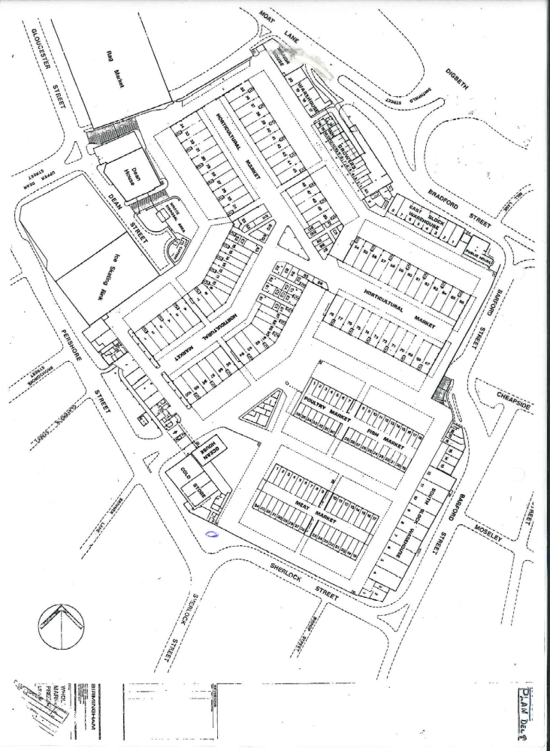

BULL RING OPEN MARKET

BULL RING RAG MARKET

BULL RING INDOOR MARKET

UPPER DEAN STREET

FORMER WHOLESALE MARKET SITE

UPPER DEAN STREET
TRAVELODGE

THE EMERGENCY EVACUATION MUSTER POINT IS THE EXTENDED PAVEMENT AREA ADJACENT TO THE TRAVELODGE HOTEL, UPPER DEAN STREET

PAGES 5-6 TO BE RETAINED BY MARKETS SERVICE

APPLICATION FOR A MARKET STALL
TRADER FORM

PLEASE NOTE: PLEASE COMPLETE THIS FORM IN BLOCK CAPITALS USING BLACK/BLUE INK. PLEASE ENSURE ALL SECTIONS ARE COMPLETED IN FULL.

The information you provide is confidential and subject to the requirements of the Data Protection Act 2018 and the General Data Protection Regulations. This personal data will be held and processed by Birmingham City Council for the purposes of identification, ensuring appropriate insurance is in place, right to work and the general management of Birmingham’s Markets.

The personal details you provide may also be shared with statutory bodies requiring such disclosure. For further information of Birmingham City Council’s privacy notice, please visit www.birmingham.gov.uk/privacy.

(PLEASE DELETE WHERE APPROPRIATE)

MARKET ON WHICH YOU WOULD LIKE TO TRADE RAG MARKET / OPEN MARKET

DAYS YOU WOULD LIKE TO TRADE – RAG MARKET TUESDAY / THURSDAY / FRIDAY / SATURDAY
DAYS YOU WOULD LIKE TO TRADE – OPEN MARKET TUESDAY / WEDNESDAY / THURSDAY / FRIDAY / SATURDAY

WHEN WOULD YOU LIKE TO START TRADING ………………………………………..….………………………………………………….

HOW MANY WEEKS WOULD YOU LIKE TO TRADE FOR ……………...…………………….……………………………………………...
(UP TO A MAXIMUM OF 6 WEEKS AS A CASUAL TRADER)

WHAT STALL(S) NUMBERS WOULD YOU LIKE TO TRADE ON ……….………………………………………………………………….

TRADE LINE DESCRIPTION …………………………………………………………….…………………………….………………………….

SPECIFIC DETAILS OF TRADE LINE ……………………..…………………………………………………………………………………….

………………………………………………………………………………….………………………………………………………………………

RAG MARKET ONLY – IF TRADING ALL TRADING DAYS, WOULD YOU LIKE STORAGE YES / NO
(FURTHER INFORMATION WILL BE PROVIDED)

TITLE (Mr/Miss/Mrs/Ms/Other) …………………………… SURNAME: ……………………………………………..……………..…

FIRST NAME ….……………………………………………… MIDDLE NAME: …………..……………………………………………..

DATE OF BIRTH (DD/MM/YYYY) ….……/…......../...........

ADDRESS ……………………………………………………….……………………………….……………………..……………....................

….…………………………………………………………………………………………………………….……………………………………….

POST CODE: ……………………………………………… MOBILE TELEPHONE NO ……………………………………………………..

EMAIL ADDRESS: ………………………………………………………………………………………………………....………....................

DO YOU HAVE THE LEGAL RIGHT TO WORK IN THE UNITED KINGDOM? YES NO

DO YOU HAVE ANY DISABILITY REQUIREMENTS? YES NO

IF YES, PLEASE PROVIDE FURTHER INFORMATION: …………………………………….………………………………………..…….

………………………………………………………………………………………………………………………………………………………..

………………………………………………………………………………………………………………………………………………………..

IN SIGNING THIS FORM YOU ARE GIVING EXPLICIT CONSENT FOR THE SPECIFIED PURPOSE OF THIS DOCUMENT BEING USED FOR MANAGING INFORMATION WHICH IS NECESSARY TO PROCESS YOUR PERSONAL DATA.

SIGNATURE OF TRADER: ……………………………………...…………… DATE: ……………………………….…………..

MARKET OFFICER SIGNATURE: ………………………………………….. DATE: ……………………………….…………..

MARKETS RULES AND REGULATIONS (2006) FOR THE OPERATION OF THE RETAIL MARKETS ISSUED

OFFICIAL USE ONLY:

ALL BUSINESSES

NATIONAL INSURANCE NUMBER: ……………………………………………………………………………………………....

PASSPORT/DRIVING LICENCE NUMBER: …………………………………………………………………………………..….

PUBLIC LIABILITY INSURANCE START DATE: ………………………………………………………………………………...

PUBLIC LIABILITY POLICY NUMBER/INSURER: ………………..……………………………………………………………..

……………………………………………………………………………………………………………………………………………

UTILITY BILL/BANK STATEMENT: ………………………………………………………………………………………………..
(this must be no more than three months old)

CATERING BUSINESSES ONLY

EVIDENCE OF REGISTRATION WITH THE AUTHORITY’S ENVIRONMENTAL HEALTH YES NO

……………………………………………………………………………………………………………………………………………

EVIDENCE OF WASTE COOKING OIL DISPOSAL CONTRACT (IF APPLICABLE) YES NO

……………………………………………………………………………………………………………………………………………

EVIDENCE OF DUTY OF CARE CERTIFICATE (REFUSE DISPOSAL) YES NO

……………………………………………………………………………………………………………………………………………

DOCUMENTS CHECK

SIGNATURE: ..………………………………………… OFFICER NAME (PLEASE PRINT): ………………………………….

DATE: ..…………………………………………

ADDITIONAL INFORMATION/AUTHORISED MARKET OFFICER NOTES:

