
Bristol, North Somerset & South Gloucestershire
Partners for better health

Nicotine Replacement Therapy (NRT)

Client Information

Nicotine is present in tobacco smoke and is a highly addictive substance. Tobacco smoke also contains over 4000 other dangerous chemicals including; tar, arsenic and cyanide which can cause cancer, heart disease, bronchitis and other smoking-related health problems.

When you stop smoking, your body may crave nicotine, which creates an urge to smoke again. You may experience nicotine withdrawal symptoms such as irritability, loss of concentration, and sleepless nights.

By using a clean, safe form of nicotine (NRT), withdrawal symptoms will be reduced making it easier to stop smoking and doubling your likelihood of staying Smokefree.

Nicotine replacement therapy is usually taken for up to 12 weeks after quitting smoking.

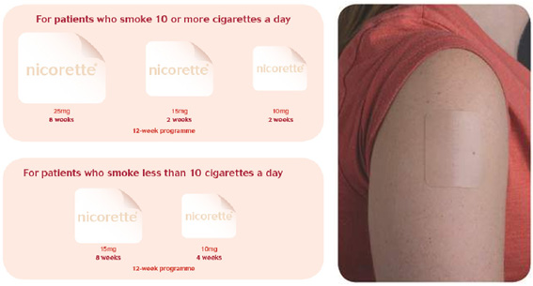 | Nicotine Patch  - Start using the patches first thing in the morning  - Use one patch every day  - Take the old patch off before putting the next one on  - Put the patch on a different area of clean, dry skin each day  - Common places to put your patch are your upper arm, upper torso & hip.  - Avoid putting patches on broken / scarred skin, hairy or tattooed skin  - To dispose of patches, fold the used patches in half with the sticky side  inside, wrap them up and place them in a bin out of reach of children
Mini-Lozenge  - One mini-lozenge to be rolled around the mouth until fully dissolved  - This should take around 10 minutes. The lozenge should not be chewed or  swallowed whole  - Maximum 15 mini-lozenges can be used a day |  |  | 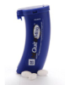
Cools Lozenge  - One cools lozenge to be rolled around the mouth until dissolved fully  - Dissolves in 10-20 minutes. The lozenge should not be chewed or  swallowed whole  Maximum of 15 mini-lozenges daily |  |  | 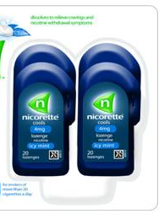
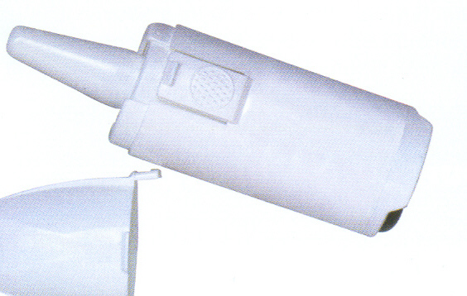 | Nasal Spray  - Gives fast relief to heavy smokers  - One spray should be administered to each nostril (this is one dose)  - Use once or twice an hour as required, Maximum of 64 sprays a day  - The nicotine is absorbed through the lining of the nasal passages  - Nasal spray should be used for the recommended 12 weeks, but not for  more than six months  - May cause nasal irritation, sneezing, watering eyes and coughing at first
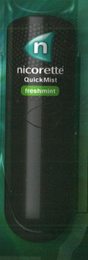 | Quick Mist  - Gives relief from cravings in 60 seconds  - Spray once away from body (it will come out as a single jet the 1st time) and  then spray ‘mist’ directly into the mouth  - Spray mist into the side of your mouth or under the tongue  - Use one or two sprays to the mouth as required. Do not exceed 2 sprays  per dose  - Up to 4 sprays per hour may be used. Do not exceed 64 sprays in any 24h period
Microtab  - Do not use more than 40 microtabs a day  - The microtab should be placed under the tongue and be allowed to dissolve  (this will take about 15-20 mins).  - Avoid chewing or swallowing it  - The nicotine is absorbed through the lining of your mouth.  - Avoid eating or drinking for 15 minutes before, during or directly after using,  as some beverages can reduce its effectiveness |  |  | 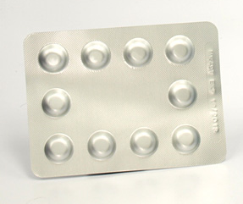
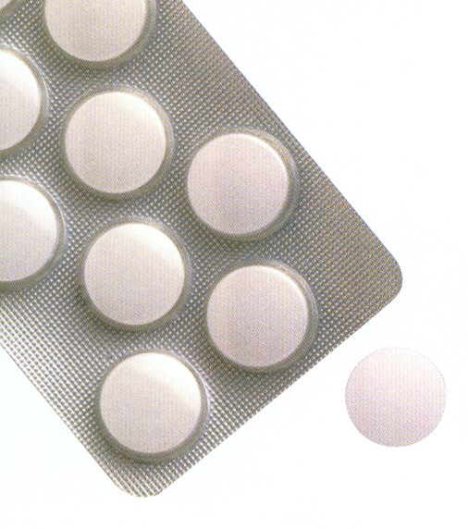 | Regular Lozenge  - One lozenge should be placed in the mouth and allowed to dissolve  - Periodically, the lozenge should be moved from one side of the mouth to the  other to rest against the side of the cheek. This should be repeated, until  the lozenge is completely dissolved (approximately 20 – 30 minutes).  - Do not chew or swallow whole  - You can use up to 15 lozenges (2mg or 4mg tablets) OR 30 lozenges (1mg  tablets)  - Avoid eating or drinking for 15 minutes before, during or directly after using,  as some beverages can reduce its effectiveness
Oral Film Strips  - Gives relief from cravings in 50 seconds  - Place one film on the tongue  - Close the mouth and press the tongue gently to roof of mouth until strip dissolves  - 1 strip to be used every 1-2 hours  - Do not exceed 15 a day |  | 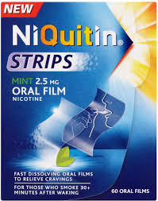
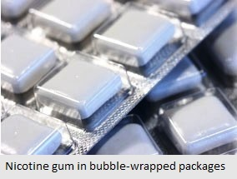 | Nicotine Gum  - Maximum of 15 pieces per day  - Chew the gum until the peppery taste becomes strong. Then rest the gum in the inside of your cheek. When the taste starts to fade repeat the process  - Chew and rest the gum for about 20 – 30 mins per piece, until the taste is gone  - The nicotine is absorbed through the lining of the mouth. Resting the gum  between your gum and cheek is very important to ease the craving  - Do not to swallow the gum  - Do not to chew the gum continuously, this can cause indigestion, stomach  ache and hiccups  - Avoid eating or drinking for 15 minutes before, during or directly after using  the gum, as this can reduce its effectiveness
Nicotine Inhalator  - Place a cartridge into your inhalator by lining up the white raised marks on each side of the inhalator  - Take small puffs on the mouthpiece until you can taste the nicotine  - Puff on the inhalator until your craving eases, typically between 5-10 puffs  - One cartridge lasts for approximately 40 mins of heavy use. Use until there is no more taste  - Do not exceed 6 cartridges per day  - Nicotine vapour is absorbed through the lining of the mouth  - On cold days you may have to warm in the palm of your hands to get the same amount of nicotine from the inhalator as you get on warmer days.  - Clean the mouthpiece several times a week by rinsing in water. |  | 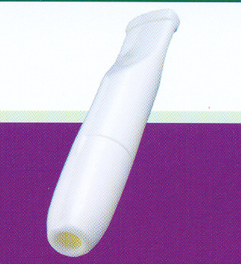

KEEP ALL NRT MEDICATION AWAY FROM CHILDREN AND PETS

©2012 BNSSG. All rights reserved. Not to be reproduced in whole or in part without the permission of the copyright holder.

