Final Project Proposal - Group 1, course CSDA1000SUMA18

|  |
| --- |
| Viviane Adohouannon1, Kate Alexander1, Juan Arangote1, Dian Azbel1, Vinayak Baburaj1, & Igor Baranov1 |
| 1 York University School of Continious Studies |
|  |

Abstract

*Keywords:*

Word count:

Final Project Proposal - Group 1, course CSDA1000SUMA18

# Abstract

The search for optimal assignment of flights to gates is of great importance to airport to elimate delays, maintain operations and maximize profits. In this paper the focus on the research is to determin the effects of airlines’ performance on airport gate utilization on airport financials. An international airport is the most populated and busiest travel area where many people used to move around the world. Gate assignment is one of the most important tasks for airport ground operations, which assigns appropriate airport gates with high efficiency reasonable arrangement. It is important to notice that flights delays and cancellation have a negative impact on airport performance and do not provide an excellent experience to travelers. This study aims to propose a new airport gate assignment method to effectively improve the comprehensive operation capacity and efficiency of John F. Kennedy International airport (JFK airport). It will also help to optimize the number of gate allocated to each airline and improve travelers experience.

# Introduction

# Competitive Analysis

In one research (Azmi, Razali, Ibrahim, Aziz, & Aziz, 2016), in order to solve discrete optimization problem, the SKF algorithm is combined with angle modulated approach. Airport gate allocation problem refers to the search for optimal assignment of flights to gates at an airport. Assignment of flight to gates has become very complex nowadays, especially for a big size airport. In this study, the airport gate allocation problem is solved using a recently introduced angle modulated simulated Kalman filter (AMSKF). The objective of this study is to minimize the total walking distance. A small case study with 14 flights and 16 gates has been chosen. Preliminary results show that SKF is a promising algorithm for solving the airport gate allocation problem.

Another paper (Barnhart, Fearing, Odoni, & Vaze, 2012) summarizes research trends and opportunities in the area of managing air transportation demand and capacity. Capacity constraints and resulting congestion and low schedule reliability currently impose large costs on airlines and their passengers. Significant capacity increases that would solve these problems are not expected in the near- or medium-term. This paper outlines first a number of directions for effecting improvement through marginal capacity increases and better management of demand and available capacity. It then describes strategic initiatives that airlines and civil aviation authorities might undertake over time horizons of months to years as well as tactical measures that may be adopted on a daily basis in response to dynamic, real-time developments like poor weather or schedule disruptions. Research challenges in these areas are identified and classified in terms of specifying, allocating, and utilizing capacity. The first two categories reject challenges faced by infrastructure providers, the last category challenges faced by airlines.

Others(Bihr, 1990) think that positioning of incoming flights should take into account the distribution of passengers among connecting flights. The larger the number of passengers arriving on flight X for destination A, the closer flight X should be positioned to the flight departing for A. This inquiry looks conceptually at this problem, reducing the distance passengers must walk from gate to gate. The criterion selected is minimization of the total passenger-distance travel for a given arrival-departure cycle. The problem can be conveniently cast as a 0,1 Linear Programming (LP) problem].

One report (Cook & Tanner, n.d.) is an update and extension of work published in 2004, also produced by the University of Westminster. This new report takes into account, as far as possible, relevant changes in the economic and regulatory environment since the earlier work. Whilst account has also been taken of the limited literature since 2004, the authors are not aware of any other new work comprehensively addressing European airline delay costs. Cost comparisons between the values reported earlier and the 2010 values are in unadjusted Euros, unless stated otherwise.

In another paper (Ding, Lim, Rodrigues, & Zhu, n.d.) the over-constrained Airport Gate Assignment Problem was studied, where the objectives are to minimize the number of ungated flights and the total walking distances or connection times. They approach the problem by first using a greedy algorithm to minimize ungated flights and by developing exchange moves which then facilitate the use of heuristics. Simulated Annealing and a hybrid of Simulated Annealing and Tabu Search are used.

Airport gate assignment is of great importance in airport operations. In this paper (Li, n.d.), the authors studied the Airport Gate Assignment Problem (AGAP), propose a new model and implement the model with Optimization Programming language (OPL). With the objective to minimize the number of conflicts of any two adjacent aircrafts assigned to the same gate, the authors build a mathematical model with logical constraints and the binary constraints, which can provide an efficient evaluation criterion for the Airlines to estimate the current gate assignment. To illustrate the feasibility of the model the authors construct experiments with the data obtained from Continental Airlines, Houston Gorge Bush Intercontinental Air-port IAH, which indicate that our model is both energetic and effective. Moreover, the authors interpret experimental results, which further demonstrate that our proposed model can provide a powerful tool for airline companies to estimate the efficiency of their current work of gate assignment.

To help researched see how your airport is performing with FlightStats monthly On-time Performance Report, this report (“Airline on-time performance reports,” n.d.) compares the on-time arrival performance of major and regional airports around the world .

The (“Data elements,” n.d.) report presents Load Factor (passenger-miles as a proportion of available seat-miles in percent ) for All Carriers and All Airports. Optimizing gate assignments at airport terminals is analysed in this article (“Optimizing gate assignments at airport terminals,” 1998). Airline On-Time Statistics and Delay Causes is presented here (“OST_R BTS Title from h2,” n.d.).

This thesis (Riedel, 2006) presents an approach for predicting operational performance of airlines on the basis of flight schedules and aircraft assignments. The methodology uses aggregate measures of properties of aircraft assignments, called Aircraft Assignment Key Performance Indicators (KPIs), and aims to find correlations between them and the operational performance of the airline. A simulation experiment is prepared to gather a large set of data points for analysis. A motivation is given for the use of control theoretic approaches in airline operations to utilize the KPIs as a basis for initial planning and corrective actions.

# Proposed Plan

The focus of this study will be John F. Kennedy Airport in New York. The study will analyze airline gate operations performance measures over a 1997 to 2008 of publicly available data from bureau of transportation statistics. JFK Airport is located in the neighborhood of Jamaica in the borough of Queens, in New York, 30km (16 Miles) southeast of Midtown Manhattan. One of the busiest international air passenger airports in North America and the sixth busiest airpots in United States with close to 60 million passengers usint the facility a year (2016 data). The airport features six passenger terminals and four runways (see Figure 1). More than ninty airlines operate at JFK Airport using the more than 128 gates across six terminals. The focus of the research is to determine the effects of airlines’ performance on airport gate utilization.

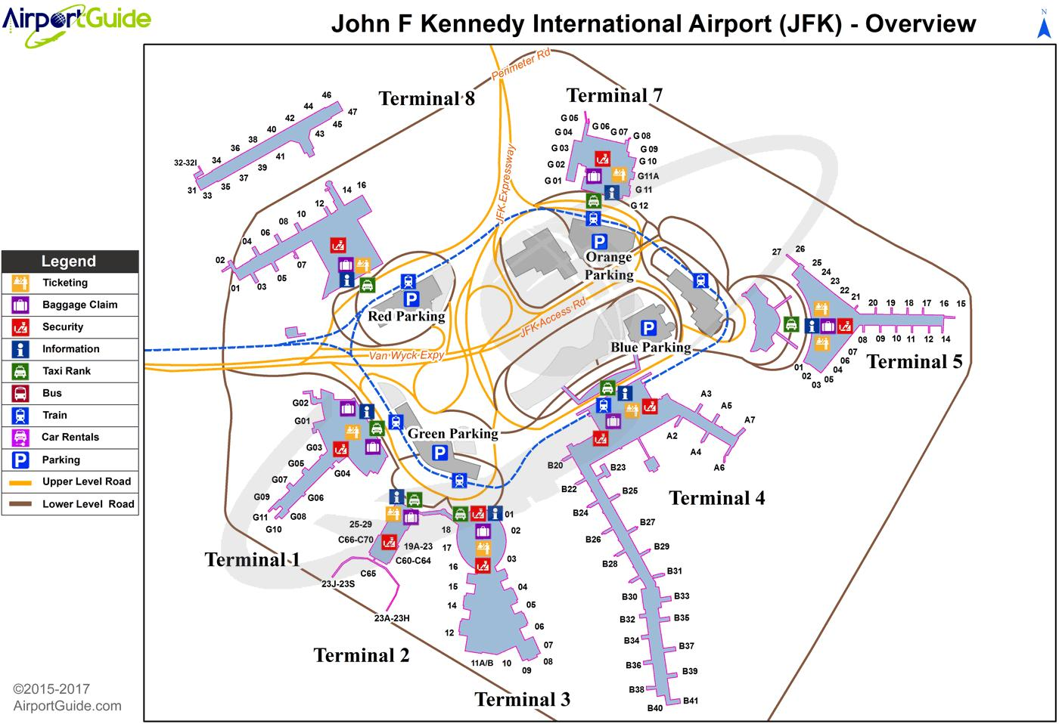

Figure 1 CRISP-DM Process Diagramm.

## Data Insights

Information from 22 years has been retrieved from airlines transportation database. These datasets are from 1987 to 2008 and are relative to United State airlines performance (see Table 2).

Variable descriptions

|  |  |
| --- | --- |
| **Name** | **Description** |
| Year | 1987-2008 |
| Month | 1 - 12 |
| DayofMonth | 1 - 31 |
| DayOfWeek | 1 (Monday) - 7 (Sunday) |
| DepTime | actual departure time (local, hhmm) |
| CRSDepTime | scheduled departure time (local, hhmm) |
| ArrTime | actual arrival time (local, hhmm) |
| CRSArrTime | scheduled arrival time (local, hhmm) |
| UniqueCarrier | unique carrier code |
| FlightNum | flight number |
| TailNum | plane tail number |
| ActualElapsedTime | in minutes |
| CRSElapsedTime | in minutes |
| AirTime | in minutes |
| ArrDelay | arrival delay, in minutes |
| DepDelay | departure delay, in minutes |
| Origin | origin IATA airport code |
| Dest | destination IATA airport code |
| Distance | in miles |
| TaxiIn | taxi in time, in minutes |
| TaxiOut | taxi out time in minutes |
| Cancelled | was the flight cancelled? |
| CancellationCode | A = carrier, B = weather, C = NAS, D = security) |
| Diverted | 1 = yes, 0 = no |
| CarrierDelay | in minutes |
| WeatherDelay | in minutes |
| NASDelay | in minutes |
| SecurityDelay | in minutes |
| LateAircraftDelay | in minutes |

For the year 2008, JFK airport has 118.804 flights from 11 different carriers. The top 4 most important carriers are JetBlue Airways with 45% of total traffic followed by Comair Inc. (16%), Delta Air Lines (14%) and American Airlines Inc. (10%). Number of flights per carrier at New York John F. Kennedy Airport (JFK) presented here (see Table 1).

Table 1

*Number of flights per carrier at New York John F. Kennedy Airport (JFK).*

|  |  |  |  |  |  |  |  |  |  |  |  |
| --- | --- | --- | --- | --- | --- | --- | --- | --- | --- | --- | --- |
| Month | B6 | DL | OH | AA | CO | MQ | UA | NW | US | YV | EV |
| Jan-08 | 4,540 | 1,275 | 1,518 | 1,068 | 103 | 667 | 445 | 154 | 172 | 81 |  |
| Feb-08 | 4,375 | 1,238 | 1,399 | 996 | 100 | 625 | 430 | 153 | 164 | 75 |  |
| Mar-08 | 4,928 | 1,380 | 1,372 | 1,035 | 109 | 645 | 447 | 176 | 186 | 78 |  |
| Apr-08 | 4,690 | 1,341 | 1,230 | 1,019 | 108 | 617 | 464 | 175 | 180 | 77 |  |
| May-08 | 4,425 | 1,422 | 1,117 | 1,043 | 107 | 639 | 463 | 182 | 186 | 79 |  |
| Jun-08 | 4,444 | 1,434 | 1,476 | 981 | 107 | 616 | 475 | 175 | 180 | 5 | 46 |
| Jul-08 | 4,764 | 1,494 | 2,508 | 1,048 | 111 | 666 | 472 | 178 | 186 |  | 76 |
| Aug-08 | 4,811 | 1,451 | 2,495 | 1,051 | 108 | 640 | 448 | 170 | 175 | 4 | 70 |
| Sep-08 | 3,886 | 1,338 | 1,446 | 936 | 29 | 616 | 383 | 150 | 147 | 33 | 2 |
| Oct-08 | 3,936 | 1,366 | 1,437 | 961 |  | 605 | 395 | 155 | 147 | 35 |  |
| Nov-08 | 3,935 | 1,306 | 1,450 | 872 |  | 687 | 374 | 142 | 171 | 85 |  |
| Dec-08 | 4,162 | 1,348 | 1,478 | 936 |  | 713 | 387 | 121 | 182 | 89 |  |
| Total | 52,896 | 16,393 | 18,926 | 11,946 | 882 | 7,736 | 5,183 | 1,931 | 2,076 | 641 | 194 |
|  | 45% | 14% | 16% | 10% | 1% | 7% | 4% | 2% | 2% | 1% | 0% |

*Note.* Month,JetBlue Airways (B6), Delta Air Lines Inc. (DL), Comair Inc. (OH), American Airlines Inc. (AA), Continental Air Lines Inc. (CO), American Eagle Airlines Inc. (MQ), United Air Lines Inc. (UA), Northwest Airlines Inc. (NW), US Airways Inc. (US), Mesa Airlines Inc. (YV), Atlantic Southeast Airlines (EV)

Delay trend IN/OUT in minute for top 4 carriers at JFK

Delay trend IN/OUT in minute for the top (JetBlue Airways) carrier at JFK.

|  |  |  |
| --- | --- | --- |
| JetBlue Airways | Delay IN | Delay OUT |
| Jan-08 | 12,802 | 35,088 |
| Feb-08 | 59,040 | 58,630 |
| Mar-08 | 55,435 | 62,378 |
| Apr-08 | 25,965 | 46,178 |
| May-08 | 16,423 | 15,769 |
| Jun-08 | 96,536 | 57,520 |
| Jul-08 | 115,981 | 96,075 |
| Aug-08 | 115,300 | 109,549 |
| Sep-08 | 3,036 | 22,868 |
| Oct-08 | -25,549 | 6,489 |
| Nov-08 | -13,828 | 26,594 |
| Dec-08 | 66,061 | 87,718 |
|  |  |  |
| Total | 527,202 | 624,856 |

Total Cancellations

|  |  |  |  |  |  |
| --- | --- | --- | --- | --- | --- |
| Month | American Airlines | JetBlue Airways | Delta Airlines | Comair | Total |
| Jan-08 | 30 | 55 | 16 | 63 | 164 |
| Feb-08 | 42 | 113 | 27 | 130 | 312 |
| Mar-08 | 24 | 72 | 22 | 83 | 201 |
| Apr-08 | 36 | 42 | 6 | 36 | 120 |
| May-08 | 19 | 10 | 7 | 22 | 58 |
| Jun-08 | 21 | 141 | 14 | 84 | 260 |
| Jul-08 | 41 | 188 | 29 | 193 | 451 |
| Aug-08 | 20 | 197 | 25 | 203 | 445 |
| Sep-08 | 15 | 63 | 19 | 49 | 146 |
| Oct-08 | 7 | 18 | 8 | 15 | 48 |
| Nov-08 | 2 | 37 | 6 | 33 | 78 |
| Dec-08 | 18 | 127 | 30 | 121 | 296 |
| ——– | —————————– | ———————- | ————————— | —————— | ——————– |
| Total | 275 | 1,063 | 209 | 1,032 | 2,579 |

## Model estimation

Scope of performance measures will be limited on arriving domestic flights as follows: - Arrivals - Domestic flights - Number of flights - Number of passengers - Number of delays coming in / going out - Number of Cancellation

Apply financial estimates of the performance using available research/data on: - Lost revenues for cancelled flights at JFK - Estimate delay costs using European proxy studies adjusted for currency parity between Euro and USD - Publicly available blended load factor for airline group (i.e. United Airlines, American Airlines) as opposed to individual airline blended cost.

## The process

For the development of this project we are using CRoss-Industry Standard Process for Data Mining (CRISP-DM) (see Figure 2) was developed by Daimler Chrysler (then Daimler-Benz), SPSS (then ISL) and NCR in 1999. Compiling the current proposal document is a part of this process (see Table 1), in it’s preparation our team has conducted 2 iteration of the CRISP-DM process.

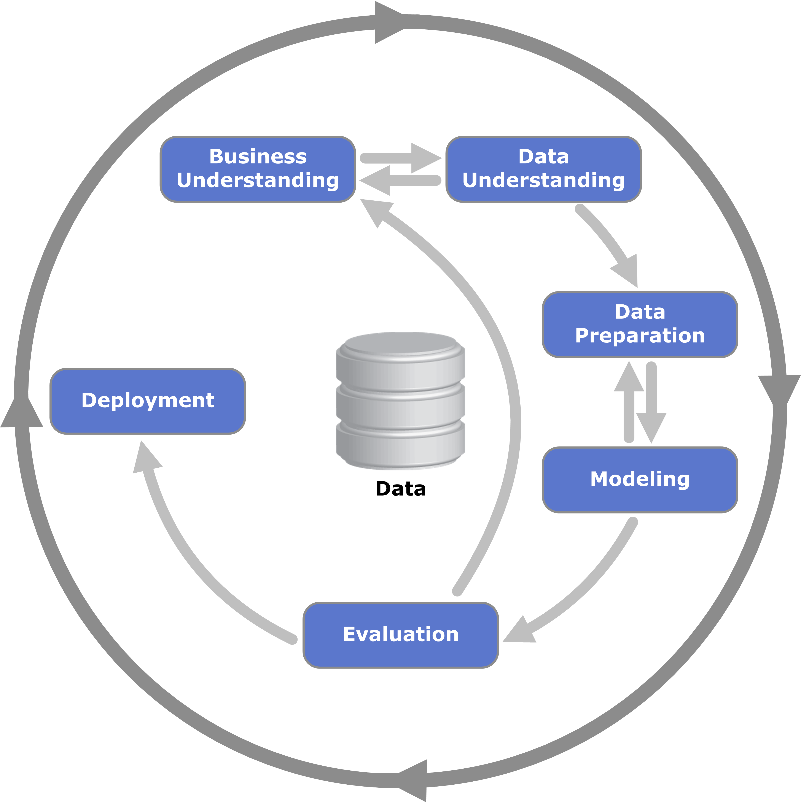

Figure 2 CRISP-DM Process Diagramm.

Proposed Plan Phases

|  |  |  |  |  |
| --- | --- | --- | --- | --- |
| **Phase** | **Task Name** | **Schedule** | **Resources** | **Status** |
| Business understanding |  | 3 days | All analysts | Completed |
| Data understanding |  | 2 days |  | In progress |
|  | Data collection |  |  | Completed |
|  | Data description |  |  | Completed |
|  | Data quality check |  |  | In progress |
|  | Exploratory analysis |  |  | In progress |
| Data preparation |  | 2 days |  | In progress |
|  | Selection |  |  | 2 iterations |
|  | Cleaning |  |  | 2 iterations |
|  | Construction |  |  | 2 iterations |
|  | Integration |  |  | 2 iterations |
|  | Formatting |  |  | 2 iterations |
| Modeling |  | 5 days |  | Not started |
|  | Generate test design |  |  |  |
|  | Build model |  |  |  |
|  | Interpreter model results |  |  |  |
|  | Model evaluation |  |  |  |
|  | Refine and repeat |  |  |  |
| Evaluation |  | 4 days |  | Not started |
|  | Assessment of results |  |  |  |
|  | Review of process |  |  |  |
|  | Determine actions |  |  |  |
|  | Refine and repeat |  |  |  |
| Deployment |  | 1 day |  | Not started |
|  | Deployment plan |  |  |  |
|  | Maintenance plan |  |  |  |
|  | Final report |  |  |  |
|  | Review project |  |  |  |

# Potential Risks

Use of assumptions including past performance to predict future performance. Simplifying cost estimates such as aggregate load factors and blended costs. Reliance of public data without management inputs. Data did not exclude normalization of data for abnormal, one-time events.

# Cost/benefit analysis

Understanding gate performance of airlines enable airport management to proper plan airline gate assignments optimally that reduces lost revenues, maximizes the use of gate facilities and defers/avoids expansion of capex due to inefficient use.

# Conclusion

Airports perform complex operations that involve close coordination between the airlines, passengers and airport authority. Optimizing gate operations benefit all these stakeholders; Airlines can avoid the direct cost of delays. Passengers are able to have a better airport experience. Airports are able to maximize the use of gate facilities and avoid unnecessary capital builds.

# References

Airline on-time performance reports. (n.d.). *FlightStats, Inc.* Retrieved from <https://www.flightstats.com/company/monthly-performance-reports/airlines/>

Azmi, K. Z. M., Razali, S., Ibrahim, Z., Aziz, N. A. A., & Aziz, N. H. A. (2016). Solving Airport Gate Allocation Problem Using Angle Modulated Simulated Kalman Filter. In (p. 11). Putrajaya Marriott Hotel, MALAYSIA. Retrieved from <http://umpir.ump.edu.my/11910/1/Solving%20Airport%20Gate%20Allocation%20Problem%20using%20Simulated%20Kalman%20Filter.pdf>

Barnhart, C., Fearing, D., Odoni, A., & Vaze, V. (2012). Demand and capacity management in air transportation. *EURO Journal on Transportation and Logistics*, *1*(1-2), 135–155. doi:[10.1007/s13676-012-0006-9](https://doi.org/10.1007/s13676-012-0006-9)

Bihr, R. A. (1990). A conceptual solution to the aircraft gate assignment problem using 0, 1 linear programming. *Computers & Industrial Engineering*, *19*(1-4), 280–284. doi:[10.1016/0360-8352(90)90122-3](https://doi.org/10.1016/0360-8352(90)90122-3)

Cook, A., & Tanner, G. (n.d.). European airline delay cost reference values, 86. Retrieved from <http://www.eurocontrol.int/sites/default/files/publication/files/european-airline-delay-cost-reference-values-final-report-v3.2.pdf>

Data elements. (n.d.). Retrieved from <https://www.transtats.bts.gov/data_elements.aspx?data=5>

Ding, H., Lim, A., Rodrigues, B., & Zhu, Y. (n.d.). THE AIRPORT GATE ASSIGNMENT PROBLEM, 6. Retrieved from <http://citeseerx.ist.psu.edu/viewdoc/download?doi=10.1.1.5.5375&rep=rep1&type=pdf>

Li, C. (n.d.). Airport Gate Assignment: New Model and Implementation, 5. Retrieved from <https://pdfs.semanticscholar.org/c43e/d93dce9e2be1c3649a525b67d4f3345ab31c.pdf>

Optimizing gate assignments at airport terminals. (1998). *Transportation Research Part A: Policy and Practice*, *32*(6), 437–454. doi:[10.1016/S0965-8564(98)00005-6](https://doi.org/10.1016/S0965-8564(98)00005-6)

OST_R BTS Title from h2. (n.d.). Retrieved from <https://www.transtats.bts.gov/OT_Delay/OT_DelayCause1.asp?pn=1>

Riedel, R. (2006, June). *An Approach to Predict Operational Performance of Airline Schedules Using Aircraft Assignment Key Performance Indicators* (PhD thesis). MIT, Boston, MA. Retrieved from <https://dspace.mit.edu/bitstream/handle/1721.1/35566/73829227-MIT.pdf;sequence=2>