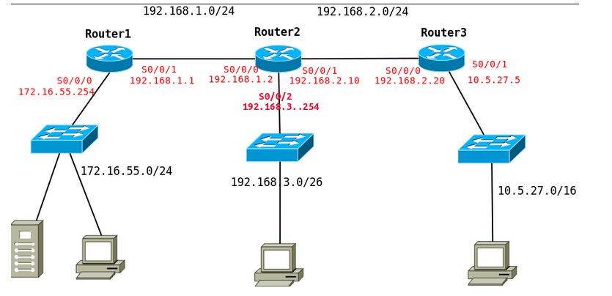

Router 1

Destino de red | Máscara | Puerta de enlace | Interfaz | Métrica
172.16.55.0 | 255.255.255.0 | 0.0.0.0 | S0/0/0 | 0
192.168.1.0 | 255.255.255.0 | 0.0.0.0 | S0/0/1 | 0
192.168.3.0 | 255.255.255.192 | 192.168.1.2 | S0/0/1 | 1
192.168.2.0 | 255.255.255.0 | 192.168.1.2 | S0/0/1 | 1
10.5.27.0 | 255.255.255.0 | 192.168.1.2 | S0/0/1 | 2

Router2

Destino de red | Máscara | Puerta de enlace | Interfaz | Métrica
172.16.55.0 | 255.255.255.0
192.168.1.0 | 255.255.255.0
192.168.3.0 | 255.255.255.192
192.168.2.0 | 255.255.255.0
10.5.27.0 | 255.255.255.0

Router3

Destino de red | Máscara | Puerta de enlace | Interfaz | Métrica
172.16.55.0 | 255.255.255.0
192.168.1.0 | 255.255.255.0
192.168.3.0 | 255.255.255.192
192.168.2.0 | 255.255.255.0
10.5.27.0 | 255.255.255.0

