Individual entrepreneur Leshukov Oleg Aleksandrovich
163009, RUSSIA, ARKHANGELSK, FEDOR ABRAMOV STREET, 9, Bldg. 1, Flat 80
INN 290132916385
OGRN 319290100005752,
Checking account 40802810600000941287
+79218804280

Professional Service Agreement

THIS AGREEMENT, made effective as of January 21nd, 2025 and made in duplicate by and between: ${first-name} ${last-name}an, (hereinafter referred to as the “Professional” or a “Party”); and Individual entrepreneur Leshukov Oleg Aleksandrovich (hereinafter referred to as the “Customer,” “Company,” or a “Party”);

WITNESSETH: In consideration of the respective covenants and promises herein contained, the parties hereto agree as follows:

1.

1.1.

1.2.

1.3

1.4

1.5

2.
2.1

Service and Duties

The Company hereby requests the Professional services from Professional, who agrees to provide services, in accordance with the terms and conditions herein, commencing on January 21nd, 2025. Contract is valid till January 21nd 2028. The work shall be performed remotely, and the Customer shall not provide, nor be obligated to provide, any office space for the Professional.

The Professional will perform for and on behalf of the Company’s business by devoting his time, his attention and all his energies to the Company’s business and affairs, except for illness and for reasonable vacations and except as and to the extent agreed in writing. The Professional agrees and recognizes that performance of his duties is personal, and any rights or obligations hereunder may not be assigned or delegated without first obtaining a written consent of the other party.

Within the scope of the Agreement, Company shall have the right to designate the amount, timing and nature of services to be performed; and Professional will maintain the necessary skills and licenses for the rendering of such services. Professional agrees to observe and abide by the corporate policies, rules and decisions of the Company in all business matters, as amended from time to time.

This agreement constitutes the Independent contractor relationship and the Professional will be part-time, with expected reasonable work hours as required by business activity. Professional agrees that his position will be classified as “professional” and “Professional” and that he will not be entitled for additional compensation for overtime.

${contract}.

Compensation.
Compensation. To maximize Professional’s concentration on tasks at hand and to enable
overall efficacy, Company shall pay to Professional a yearly fee of ${salary} USD.

  - Patries specifically agree that the compensation will be paid with bank transfer within Russian federation in Russian rubles.
  - Representation costs. The Company shall compensate the Professional for all reasonable pre- approved expenses related to the presentation of the company and business trips. All such expenses to be approved by the Company in accordance with its policies and in its sole and unfettered discretion; and
  - Out-of-scope work. Upon Company’s request and approval of the costs Professional can perform additional work that is not set out in the Paragraph 1 hereto. Professional will be paid upon the Invoice on the pre-approved amount, plus necessary and ordinary expenses.

Rights and obligations of Professional.

Professional undertakes to render services or perform work to Customer according to the scope, time limits and specifications set out in the Paragraph 1 here to.
  - Professional has all required licenses and education to render services set out in the Paragraph 2.1. hereto
  - Professional agrees to inform Customer at its request about the progress of rendering services/performance of work under the Agreement at any time.
  - Professional shall be entitled to require from Customer to timely accept and pay for services rendered/works performed, and to fulfill other obligations expressly provided for by the Agreement.

- Obligations of Customer

  - Customer agrees to timely provide Professional, at its request, with all materials and information necessary to render services/perform work pursuant to the Agreement.
  - Customer shall appoint a focal point for rendering, acceptance and payment of services/works under the Agreement, vest such person with respective authority and notice Professional thereof in writing.
  - Should Customer fail to process the compensation specified in paragraph 2 above, Professional has the right not to proceed to rendering services/performance of works or to suspend the rendering services/performance of works till the moment of full performance of such obligations by Customer.
  - Customer shall accept and pay for services/ work rendered/performed by Professional according to the terms hereof. If the Agreement stipulates that service/work shall be rendered/ performed by stages or after payment (pre-payment), Professional has the right not to proceed to rendering services/performance of works or to suspend the rendering services/performance of works till the moment of full performance of the obligation set out in the previous sentence.
  - In case of suspension of provision of services/works pursuit to paragraph 1.5, if services specify deadlines for performance of certain actions by Professional, such term shall be extended accordingly for the period during which the services/work were suspended.

  - Customer undertakes to ensure that the initial information provided to Professional was reliable and met requirements of Professional arisen in course of service rendering (provided that Professional shall give Customer a prior notice about such requirements). Customer shall not be entitled to refuse to accept services/results of work due to the fact that the initial information was incomplete, doubtful or incorrect. In cases directly provided by Paragraph 1 or prescribed by the law Professional is entitled to require and Customer is obliged to provide documentary evidence of reliability of information provided.

Termination of Services
  - Termination

This Agreement shall be deemed as “at will”, where Parties is voluntarily entered submitted themselves in these relations. Either party may terminate with or without cause upon giving the other 14 (fourteen) days prior written notice. No severance pay is provided upon proper termination.
5.2 Upon the death or incapacity of the Professional or the reorganization, insolvency, or bankruptcy of the Company.

Mediation and Arbitration
  - General:
The construction, interpretation and performance of this Agreement, and all transactions under it shall be governed by the laws of Russian Federation and any litigation or arbitration hereunder shall be brought before the Arbitrators and/or Russian Federation. The parties hereto specifically agree and submit to the jurisdiction of the arbitrators and Courts of Russian Federation for all matters involving this Agreement or relating to, or deriving therefrom.

Notice
Any notice, demand, or other communication which under the terms of this Agreement may be given or made, shall be in writing and shall be made or given by Registered Mail or personal delivery. Notice so given shall be deemed to have been legally effective in the case of personal delivery upon delivery, and in the case of Registered Mail, five days after the date when deposited prepaid with the U.S. Post Service.

  - Addresses. The current addresses and faxes of the parties are as follows:

Professional:
${first-name} ${last-name}
${addrHomeCountry}
${phone}
${first-name}.${last-name}@frostobali.com

Miscellaneous
  - Entire Agreement

Company:
Individual entrepreneur Leshukov Oleg Aleksandrovich
163009, RUSSIAARKHANGELSK, FEDOR
ABRAMOV STREET, 9, Bldg. 1, Flat 80
INN 290132916385, +79218804280

This instrument contains the entire Agreement of the parties superseding all prior

agreements, and it may not be modified or amended and no waiver shall be effective unless by written instrument signed by both parties hereto.
  - Governing Laws
The agreement shall be governed by and construed and enforced in accordance with the laws of the Russian Federation,
  - Invalid provision
In that event that any provision or portion of this agreement shall be determined as invalid or unenforceable or only partly enforceable for any reason, the remaining provisions of this agreement shall remain in full force and effect to the fullest extent permitted by law.
  - Specific Performance
The Professional recognizes that his services to be rendered under this agreement are unique. In addition to all remedies otherwise available to the Company such as obtaining damages, the Company may, therefore, at its option, elect to seek specific performance.
  - Survival of certain Provisions

All of the following provisions shall survive any termination, cancellation or revocation of this Agreement: 3,4,5,6,7 and 8.

WHEREOF the parties hereto execute this Agreement.

Professional:

[SIGNATURE]

AS TO PROFESSIONAL
${first-name} ${last-name}

Company:

AS TO COMPANY Individual entrepreneur

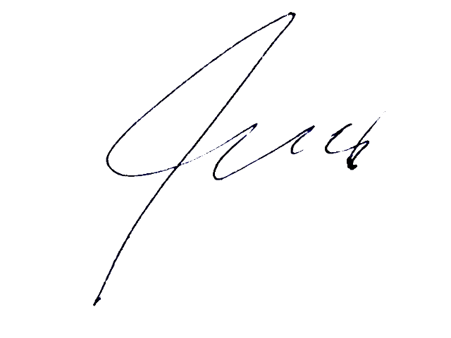

By: Leshukov Oleg Aleksandrovich, CEO

