Team:

PI: Iyad Rahwan, Cesar Hidalgo

Data Analysis: Lijun

Visualization: Bedoor

Iyad Rahwan: Iyad Rahwan is an Associate Professor of Media Arts & Sciences at the MIT Media Lab, where he leads the Scalable Cooperation group. Prior to joining MIT, he was an Associate Professor at Masdar Institute, an Abu Dhabi-based research institute established in cooperation with MIT. A native of Aleppo, Syria, Rahwan holds a PhD from the University of Melbourne, Australia.

Rahwan's work lies at the intersection of the computer and social sciences. His research explores mechanisms and technologies that promote collective intelligence and large-scale cooperation. In 2012, he led the winning team in the US State Department's Tag Challenge, in which he used social media to locate individuals in remote cities within 12 hours using only their mug shots. Rahwan's work appeared in major academic journals, including Science and Proceedings of the National Academy of Sciences, and was featured in major media outlets, including The Economist, Scientific American, Washington Post.

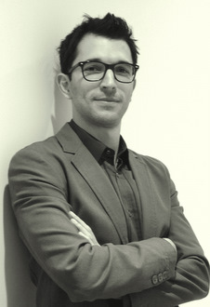

Cesar Hidalgo

César A. Hidalgo leads the Macro Connections group at The MIT Media Lab and is also an Associate Professor of Media Arts and Sciences at MIT. Hidalgo's work focuses on understanding the evolution of information in natural, social, and economic systems, and on the development of big data visualization engines that make available unwieldy volumes of data. Hidalgo's academic publications have been cited more than 5,000 times and his visualization engines have received more than 8 million visits. He is the author of Why Information Grows (Basic Books, 2015) and the co-author of The Atlas of Economic Complexity (MIT Press, 2014). He lives in Somerville Massachusetts with his wife Anna and their daughter Iris.

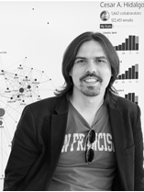

Lijun Sun

Lijun Sun is a Postdoctoral Associate at MIT Media Lab. His current research focuses on developing and applying crowdsourcing and data-driven approaches in the domain of civil systems and transportation. Before that, he worked at Future Cities Laboratory, Singapore-ETH Centre as a PhD student and then research fellow in the Mobility and Transportation Planning Module, combining smart card-driven public transport modeling and agent-based simulation to improve transit service quality and reliability. He holds a Ph.D. in Civil Engineering from National University of Singapore.

His research interests include data-driven transport modeling, mobility and travel behavior profiling, urban computing & urban complexity, computational social science and large-scale agent-based modeling/simulation. His research aims to provide a better understanding of urban and transportation systems and how scalable cooperation and artificial intelligence could benefit human society. His work has been featured in popular media outlets, including Wired, Citylab, Scientific American and MIT Technology Review.

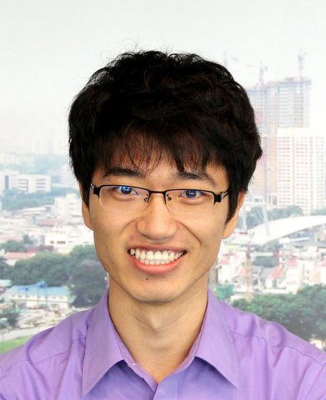

Skills to show:

Installation

Repairing

Night Vision

Food Production

Fine Arts

Building and Construction

Medicine and Dentistry

Social

Design

Transportation

Programming

Science

Finger Dexterity

Foreign Language

Assisting and Caring for Others

Clerical

Relationships

Cooperation

Analyzing Data or Information

Innovation

Achievement/Effort

Developing and Building Teams

Social Perceptiveness

Negotiation

English Language

Analytical Thinking

Achievement

Independence

Fluency of Ideas

Originality

Critical Thinking

Systems Analysis

Deductive Reasoning

Communicating with Persons Outside Organization

Coordination

Systems Analysis

Operating Vehicles, Mechanized Devices, or Equipment

Analytical Thinking

Mechanical

Science

Manual Dexterity