**Cognifyz Technologies Internship**

Statement – INTERNSHIP

Programmer - Veman Shrinivas Chippa

Ref. - CTI/A1/C34021

Written For -Cognifyz Technologies.

**Task 1**

**Task: String Reversal**

**Description: Write a program that takes a string as input and reverses it. Display the reversed string on the console.**

**Skills: String manipulation, loops.**

**Code:**

#include <stdio.h>

#include <conio.h>

#include <string.h>

void main() {

    char str[100], reversed[100];

    int length, i, j;

    // Clear the screen

    clrscr();

    // Title

    printf("\t\tString Reversal\n");

    printf("\t\t===============\n\n");

    // Input string

    printf("Enter a string: ");

    gets(str);

    // Calculate string length

    length = strlen(str);

    // Reverse the string

    j = 0;

    for(i = length - 1; i >= 0; i--) {

        reversed[j++] = str[i];

    }

    reversed[j] = '\0'; // Add null terminator to end the reversed string

    // Display the reversed string

    printf("\nReversed string: %s\n", reversed);

    printf("\n\t\t\t\t\t________________________________________");

    printf("\n\t\t\t\t\tStatement - INTERNSHIP");

    printf("\n\t\t\t\t\tProgrammer - Veman Shrinivas Chippa");

    printf("\n\t\t\t\t\tRef. : CTI/A1/C34021");

    printf("\n\t\t\t\t\tWritten For - Cognifyz Technologies.");

    printf("\n\t\t\t\t\t________________________________________");

    getch();

}

Output:

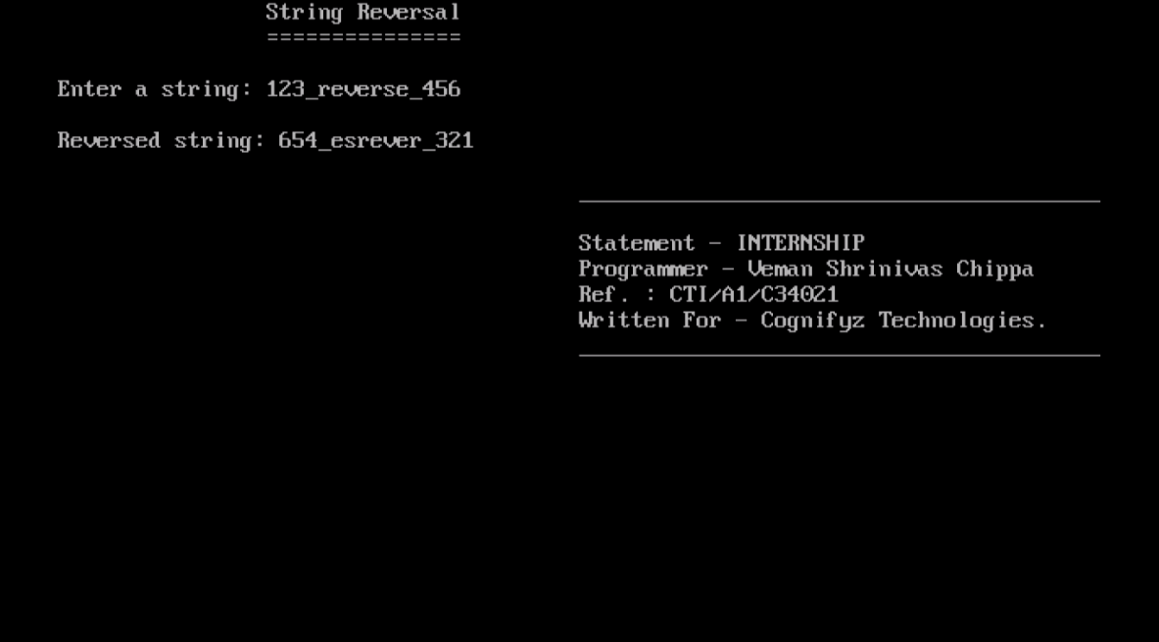

**Task 2**

**Task: Calculator Program**

**Description: Write a program that takes two numbers and an operator as input (+,-,*,/,%) and performs the corresponding arithmetic operation. Display the result on the console.**

**Skills: Basic input/output operations, conditional statements, and arithmetic operations.**

**Code:**

#include <stdio.h>

#include <stdlib.h>

#include<conio.h>

int main() {

    char a;

    int Fst, Scnd;

    clrscr();

    printf("\tInternship Project_1 -: Calculator Program ");

    printf("\n\t_________________________________________");

    printf("\n\n\nFor Addition press +");

    printf("\nFor Subtraction press -");

    printf("\nFor Multiplication press *");

    printf("\nFor Division press /");

    printf("\nFor Percentage press %%");

    printf("\n\nPress -: ");

    scanf(" %c", &a);  // Notice the space before %c to consume any whitespace

    switch(a) {

    case '+':

        printf("Enter First Number -: ");

        scanf("%d", &Fst);

        printf("\n\nEnter Second Number -: ");

        scanf("%d", &Scnd);

        printf("\n_________________________________");

        printf("\n\nAddition -: %d\n", Fst + Scnd);

        printf("\n__________________________________");

        break;

    case '-':

        printf("Enter First Number -: ");

        scanf("%d", &Fst);

        printf("\nEnter Second Number -: ");

        scanf("%d", &Scnd);

        printf("\n_________________________________");

        printf(" \n\nSubtraction -: %d\n", Fst - Scnd);

        printf("\n_________________________________");

        break;

    case '*':

        printf("Enter First Number -: ");

        scanf("%d", &Fst);

        printf("\nEnter Second Number -: ");

        scanf("%d", &Scnd);

        printf("\n_________________________________");

        printf("\n\nMultiplication -: %d\n", Fst * Scnd);

        printf("\n_________________________________");

        break;

    case '/':

        printf("Enter First Number -: ");

        scanf("%d", &Fst);

        printf("\n\nEnter Second Number -: ");

        scanf("%d", &Scnd);

        if (Scnd != 0) {

        printf("\n_________________________________");

        printf("\n\nDivision -: %d\n", Fst / Scnd);

        printf("\n\n_________________________________");

        } else {

        printf(" Error: Division by zero is not allowed.\n");

        }

        break;

    case '%':

        printf("Enter First Number -: ");

        scanf("%d", &Fst);

        printf("\nEnter Second Number -: ");

        scanf("%d", &Scnd);

        if (Scnd != 0) {

        // Calculate percentage

        double percentage = ((double)Fst / Scnd) * 100;

        printf("\n_________________________________");

        printf(" \n\nPercentage -: %.2f%%\n", percentage);

        printf("\n_________________________________");

        } else {

        printf(" Error: Division by zero is not allowed.\n");

        }

        break;

    default:

        printf("\n\n\t___________________________________________");

        printf("\n\n\n\t\t\t[]ERROR[]");

        printf("\n\n\t\t!INVALID INPUT PROVIDED!");

        printf("\n\t___________________________________________\n");

        break;

    }

    printf("\n\t\t\t\t\t________________________________________");

    printf("\n\t\t\t\t\tStatement - INTERNSHIP");

    printf("\n\t\t\t\t\tProgrammer - Veman Shrinivas Chippa");

    printf("\n\t\t\t\t\tRef. : CTI/A1/C34021");

    printf("\n\t\t\t\t\tWritten For - Cognifyz Technologies.");

    printf("\n\t\t\t\t\t________________________________________");

    getch();

}

Output:

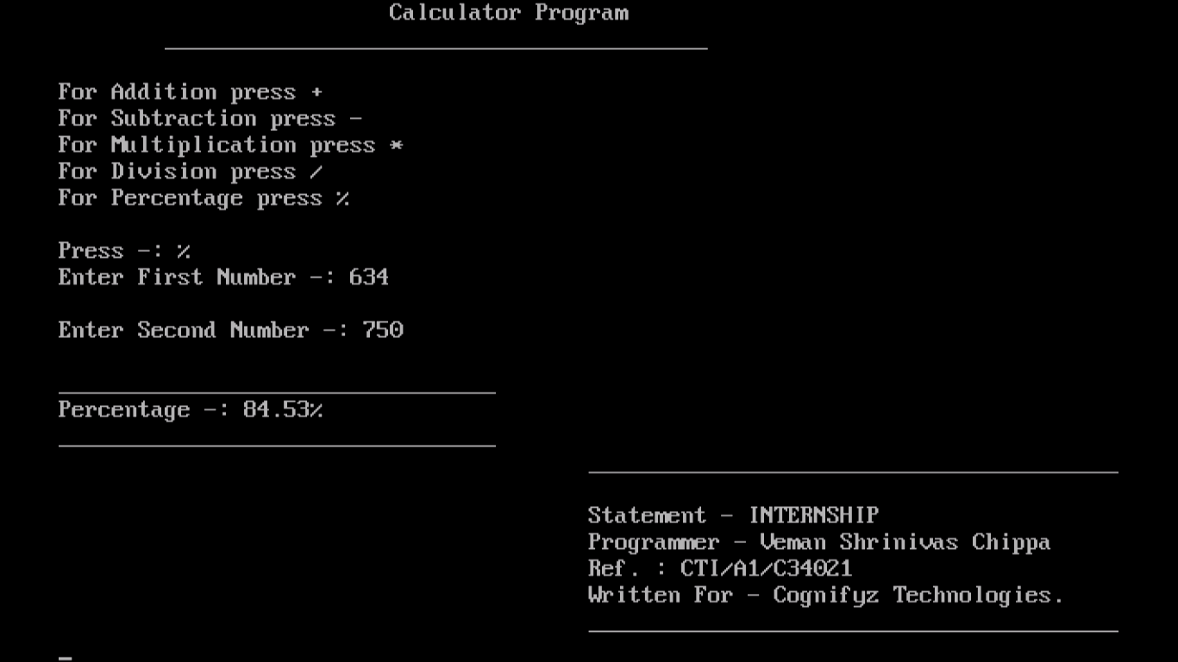

**Task 3**

**Task: Fibonacci Series**

**Description: Implement a program that generates the Fibonacci series up to a give number of terms. Prompt the user to enter the number of terms and display the series.**

**Skills: Loops, basic arithmetic operations.**

**Code:**

#include <stdio.h>

#include <conio.h>

void fibonacci_series(int n) {

    int a = 0, b = 1, next, i;

    printf("Fibonacci series up to %d terms:\n", n);

    for (i = 1; i <= n; ++i) {

    printf("\n\t\t\t\t%d ", a);

    next = a + b;

    a = b;

    b = next;

    }

    printf("\n");

}

int main() {

    int n;

    clrscr();

    printf("\t\tFibonacci Series\n");

    printf("\t\t========================\n\n");

    printf("\nThis Program generates the Fibonacci series up to a given number of terms.");

    printf("\n\n\nEnter the number of terms: ");

    scanf("%d", &n);

    if (n <= 0) {

    printf("\nInvalid input. Please enter a positive integer.\n");

    } else {

    // Generate and display the Fibonacci series

    fibonacci_series(n);

    }

    printf("\t\t\t\t\t________________________________________");

    printf("\n\t\t\t\t\tStatement - INTERNSHIP");

    printf("\n\t\t\t\t\tProgrammer - Veman Shrinivas Chippa");

    printf("\n\t\t\t\t\tRef. : CTI/A1/C34021");

    printf("\n\t\t\t\t\tWritten For - Cognifyz Technologies.");

    printf("\n\t\t\t\t\t________________________________________");

    getch();

    return 0;

}

**Output :**

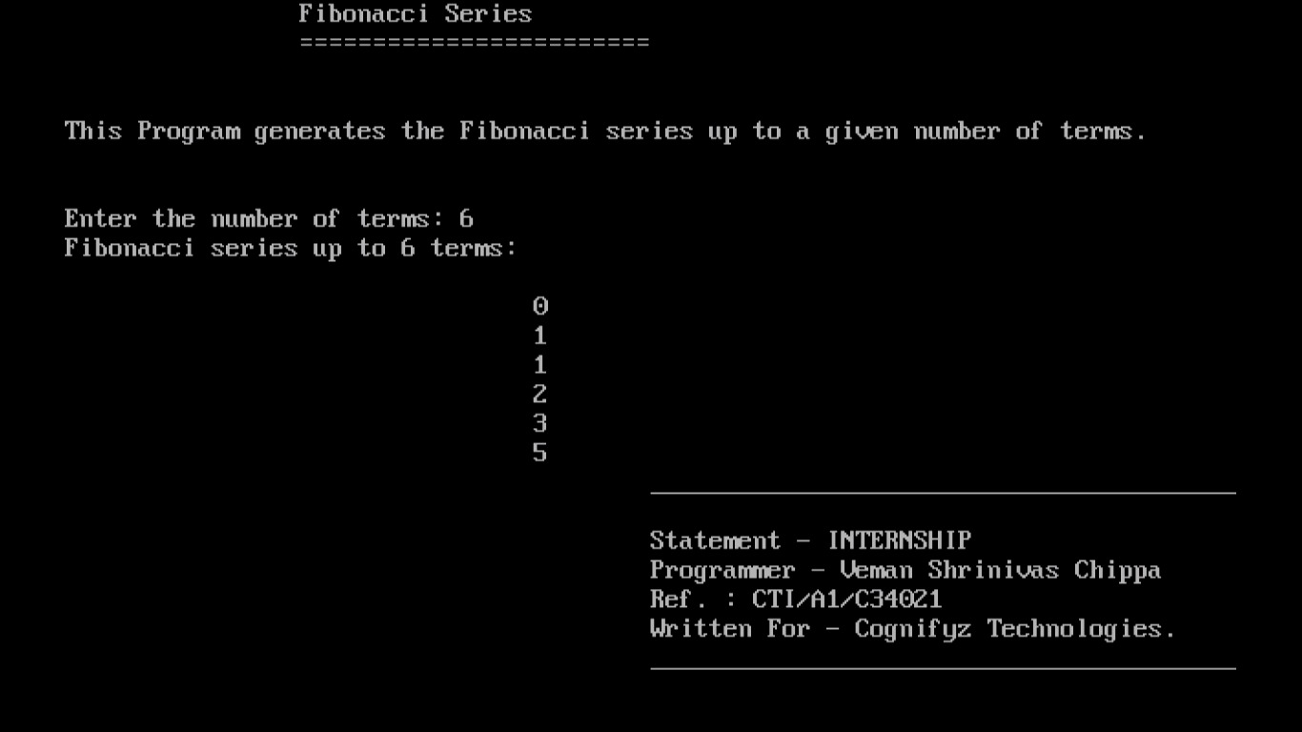

**Task 4**

**Task: Guessing Game**

**Description: Implement a number guessing game. Generate a random number and prompt the user to guess the number. Provide hints such as "higher" or "lower" to help the user narrow down the guess. Continue until the user guesses the correct number.**

**Skills: Random number generation, user input, conditional statements, loops.**

**Code:**

#include <stdio.h>

#include <stdlib.h>

#include <time.h>

#include <conio.h>

void main() {

    int secretNumber, guess, attempts = 0;

    char playAgain;

    // Seed the random number generator

    srand(time(NULL));

    // Clear the screen

    clrscr();

    do {

        // Generate a random number between 1 and 100

        secretNumber = rand() % 100 + 1;

        // Reset attempts for each game

        attempts = 0;

        // Title

        printf("\t\tNumber Guessing Game\n");

        printf("\t\t====================\n\n");

        // Game loop

        do {

            // Prompt the user to guess the number

            printf("Guess the number (between 1 and 100): ");

            scanf("%d", &guess);

            // Increment attempts

            attempts++;

            // Provide hints

            if (guess < secretNumber) {

                printf("Higher!\n\n");

            } else if (guess > secretNumber) {

                printf("Lower!\n\n");

            } else {

                printf("\nCongratulations! You guessed the number %d in %d attempts.\n\n", secretNumber, attempts);

            }

        } while (guess != secretNumber);

        // Ask if the user wants to play again

        printf("Do you want to play again? (y/n): ");

        scanf(" %c", &playAgain);

        printf("\n");

    } while (playAgain == 'y' || playAgain == 'Y');

    // Goodbye message

    printf("Thanks for playing! Goodbye!\n");

    // Wait for user input before closing

    printf("\nPress any key to exit...");

    printf("\n\t\t\t\t\t________________________________________");

    printf("\n\t\t\t\t\tStatement - INTERNSHIP");

    printf("\n\t\t\t\t\tProgrammer - Veman Shrinivas Chippa");

    printf("\n\t\t\t\t\tRef. : CTI/A1/C34021");

    printf("\n\t\t\t\t\tWritten For - Cognifyz Technologies.");

    printf("\n\t\t\t\t\t________________________________________");

    getch();

}

**Output:**

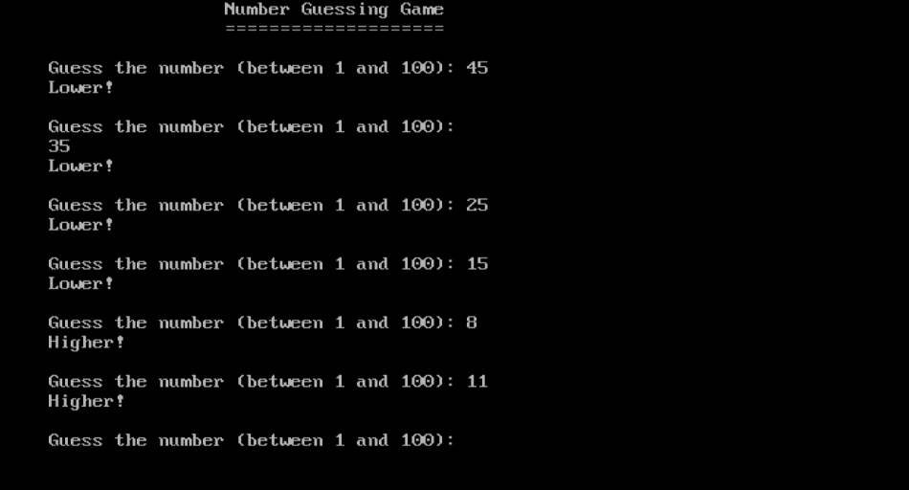

**Task 5**

**Task: Palindrome Checker**

**Description: Write a program that checks whether a given word or phrase is a palindrome. A palindrome is a word or phrase that reads the same forwards and backwards. Prompt the user to input a word or phrase and display whether it is a palindrome or not.**

**Skills: String manipulation, loops, conditional statements.**

**Code:**

#include <stdio.h>

#include <conio.h>

#include <string.h>

#include <ctype.h>

// Function to check if a string is a palindrome

int is_palindrome(char str[]) {

    int length = strlen(str);

    int left = 0;

    int right = length - 1;

    while (left < right) {

        // Ignore non-alphanumeric characters

        while (left < right && !isalnum(str[left])) left++;

        while (left < right && !isalnum(str[right])) right--;

        // Compare characters

        if (tolower(str[left]) != tolower(str[right])) {

            return 0;

        }

        left++;

        right--;

    }

    return 1;

}

int main() {

    char str[100];

    clrscr();

printf("\t\tPalindrome Checker\n");

    printf("\t\t========================\n\n");

    printf("\nThis Program checks given word or phrase is a palindrome or not!");

    printf("Enter a word or phrase: ");

    gets(str);

    // Check if the input is a palindrome

    if (is_palindrome(str)) {

        printf("\"%s\" is a palindrome.\n", str);

    } else {

        printf("\"%s\" is not a palindrome.\n", str);

    }

    printf("\n\n\n\t\t\t\t\t________________________________________");

    printf("\n\t\t\t\t\tStatement - INTERNSHIP");

    printf("\n\t\t\t\t\tProgrammer - Veman Shrinivas Chippa");

    printf("\n\t\t\t\t\tRef. : CTI/A1/C34021");

    printf("\n\t\t\t\t\tWritten For - Cognifyz Technologies.");

    printf("\n\t\t\t\t\t________________________________________");

    getch();

    return 0;

}

**Output:**

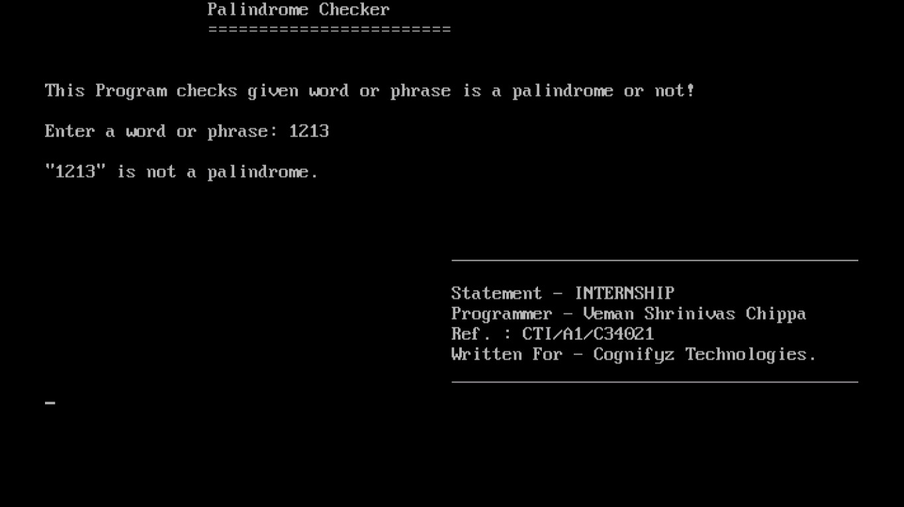

**Task 6**

**Task: Student Grade Calculator**

**Description: Create a program that calculates the average grade of a student. Prompt the user to enter the number of subjects, and then input the grades for each subject. Calculate the average grade and display it to the user.**

**Skills: Loops, arrays, basic arithmetic operations.**

**Code:**

#include <stdio.h>

#include <conio.h>

void main() {

    int numSubjects, i;

    float grades[100], sum = 0.0, average;

    // Clear the screen

    clrscr();

    // Title

    printf("\t\tStudent Grade Calculator\n");

    printf("\t\t========================\n\n");

    printf("\n\nThis Program Calculates the Average Grade of Students");

    printf("\n_________________________________________________________");

    // Prompt the user to enter the number of subjects

    printf("\n\nEnter the number of subjects: ");

    scanf("%d", &numSubjects);

    // Input grades for each subject

    for(i = 0; i < numSubjects; i++) {

    printf("Enter grade for subject %d: ", i + 1);

    scanf("%f", &grades[i]);

    sum += grades[i];

    }

    // Calculate the average grade

    average = sum / numSubjects;

    // Display the average grade

    printf("\n========================");

    printf("\nAverage grade: %.2f\n", average);

    printf("========================\n");

    printf("\t\t\t\t\t________________________________________");

    printf("\n\t\t\t\t\tStatement - INTERNSHIP");

    printf("\n\t\t\t\t\tProgrammer - Veman Shrinivas Chippa");

    printf("\n\t\t\t\t\tRef. : CTI/A1/C34021");

    printf("\n\t\t\t\t\tWritten For - Cognifyz Technologies.");

    printf("\n\t\t\t\t\t________________________________________");

    getch();

}

**Output:**

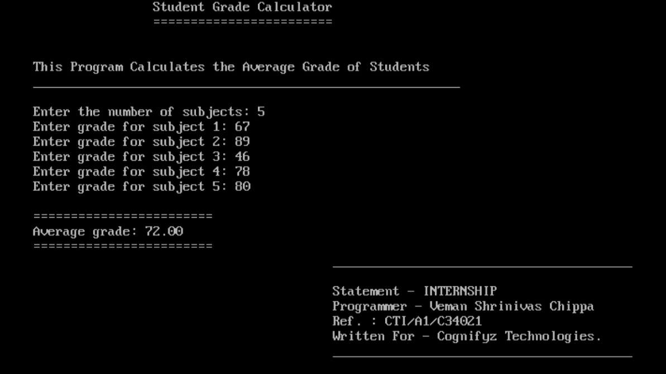

**Task 7**

**Task: Rock-Paper-Scissors Game**

**Description: Implement a simple rock-paper scissors game. Prompt the user to choose either rock, paper, or scissors, and generate a random choice for the computer. Determine the winner based on the game rules and display the result.**

**Skills: Random number generation, user input, conditional statements.**

**Code:**

#include <stdio.h>

#include <stdlib.h>

#include <time.h>

#include <conio.h>

void main() {

    int testerChoice, systemChoice;

    char *choices[] = {"Rock", "Paper", "Scissors"};

    srand(time(NULL));

    clrscr();

    printf("\tRock-Paper-Scissors Game\n");

    printf("\t________________________\n\n");

    printf("Choose any of the convinent option:\n");

    printf("1. Rock\n");

    printf("2. Paper\n");

    printf("3. Scissors\n");

    printf("\nEnter your choice (1/2/3): ");

    scanf("%d", &testerChoice);

    systemChoice = (rand() % 3) + 1;

    printf("\nYou chose: %s", choices[testerChoice - 1]);

    printf("\nComputer chose: %s\n", choices[systemChoice - 1]);

     if(testerChoice > 3)

    {

    printf("Invalid input provided!");

    exit;

    }

    if (testerChoice == systemChoice) {

    printf("\n_____________________________");

    printf("\nIt's a draw!\n");

    printf("\n_____________________________");

    }

    else if ((testerChoice == 1 && systemChoice == 3) ||

           (testerChoice == 2 && systemChoice == 1) ||

           (testerChoice == 3 && systemChoice == 2))

    {

    printf("\n_____________________________");

    printf("\nYou win!\n");

    printf("\n_____________________________");

    }

    else

    {

    printf("\n_____________________________");

    printf("\nSystem wins!\n");

    printf("\n_____________________________");

    }

    printf("\n\t\t\t\t\t________________________________________");

    printf("\n\t\t\t\t\tStatement - INTERNSHIP");

    printf("\n\t\t\t\t\tProgrammer - Veman Shrinivas Chippa");

    printf("\n\t\t\t\t\tRef. : CTI/A1/C34021");

    printf("\n\t\t\t\t\tWritten For - Cognifyz Technologies.");

    printf("\n\t\t\t\t\t________________________________________");

    getch();

}

**Output:**

