Project: ECE552
Phases I, II, & III

Write a circuit simulator program in a standard programming language (e.g. C++, java, perl, python, matlab) which will take a SPICE like input netlist and perform some analysis of your choice on it. The project will be completed in three phases. The first two phases are very basic and will be required in every project and therefore will be common to all the projects. The final phase will be the implementation of some more advanced analysis, i.e. AC and transient analysis.

Phase | Due date | Credit
I | Oct. 8 | 15%
II | Nov.8 | 15%
III | Dec.8 | 20%

Phase Submission
All phases are due by e-mail at 5pm. Any submission later than that is subject
to a 3 point loss. For every submission, I will reply to you to confirm your submission within 24 hours (if you submit in weekends, my reply may not be within 24 hours but will not be later than Monday noon 12:00 oclock). If you don't get this confirmation, please contact me again.

Report
Document your results in a single written report after phase III. Results of phase I and II should be reported as the final results and running times only. A report is only required for phase III. It should be a concise summary of your work and should highlight important features of your design. Explain why you chose a particular algorithm over alternatives (if possible). The report should contain
- a brief mathematical description of the algorithm for the particular analysis implemented
- important implementation issues you faced
- results on the circuit netlists, run times and CPU clock frequency of you computer, number of iterations for Newton-Raphson or number of time-steps (as appropriate)

Be concise! Don’t put any source code in the report! You will e-mail me your source code after each phase of the project.

Comment your code to make it easy to understand when graded at the end of the semester! Also, make it easy to compile and run your code for the different phases of the project. You should have one program that can do all the different types of analyses (dc analysis, transient analysis, ac analysis) rather than multiple programs which are hardcoded.

Phase I
Write a program which, given a spice netlist with linear elements (linear resistors, independent current sources, independent voltage source, voltage controlled voltage source, voltage controlled current sources, current controlled voltage source and current controlled current sources), will assemble the MNA matrix and solve it for node voltages and branch currents of independent voltage sources, CCCS’s, VCVS’s, and CCVS’s. You do not need to calculate branch currents of other elements such as resistors or VCCS’s. Node “0” is always to be associated with the ground node.

Capacitors should be open-circuited and inductors should be short-circuited for dc analysis. You don’t need to handle loops of inductors/independent voltage sources or cutsets of capacitors/independent current sources. In order that your program runs fast enough on the large test case, convert node name strings to integer numbers internally and use hashes to do lookups rather than performing searches using arrays. It’s in your best interest to make the program reasonably fast so that the later, more complex phases can run fast as well and you can do debugging easily.

For each phase of the project you can check your results by running Hspice, but the results might not match exactly due to diode/bjt model differences. You need to figure out on your own what are the correct results.

Do not assume that the devices are listed in order in the input file. For example, some current controlled voltage source may depend on some other voltage source and either could be listed first. The program should give an error on duplicate device definitions and also if current controlled sources depend on voltage sources that are not present in the netlist. If the input has multiple errors, you must report at least one of them in detail (e.g. device/node names) before dieing, but reporting all of them is the best of course.

Use a complex-number capable sparse matrix solver to solve the MNA matrices. You should ideally use an open source sparse matrix solver available on the web and avoid writing it yourself. It needs to handle complex numbers for the small signal ac analysis that will be performed later.

Provide your output by e-mail attachment for the following three netlists:
- representative
- should be in format:
- voltage at node … = …
- current through source … = …
- large
- report the run-time with the sparse matrix routine and machine clock frequency for the following circuit and provide the output for ONLY nodes 0 to 20
- error
- give all the details regarding the error message including device/node names

The voltage of each node should have 7 effective digits and be in scientific notation, which means it should be in the format of *.******E***. e.g. 1.234567x10^7

Grading:
- Each test case is worth 5 points
- If your result is wrong, you will lose all 5 points for that test case. For the large test case, if your program can finish the job in 1 hour on a 2.6G CPU, you won't lose any points for time. If your program finishes the job longer than 1 hour but less than 1 day, you lose 2 points. If your program cannot finish the job within 1 day, you lose all 5 points. Runtime on different CPUs will be scaled to 2.6G CPU accordingly. Make sure you estimate the actual cpu run-time by using for example the ‘time’ unix command, not the real time elapsed.

Phase II
Incorporate the nonlinear devices (i.e., diodes and BJTs) into your MNA formulation and perform DC analysis of the following circuits and send the results and code by e-mail attachment:
- Diode
- Bjt

Each test case is worth half the points for the phase.

Simplified SPICE Netlist Format
The devices that can appear in the netlist are:
- resistor: rxxx node1 node2 value
- voltage source: vxxx node1 node2 independent source input
- current source: ixxx node1 node2 independent source input
- vccs: gxxx node1 node2 controlling node 1 controlling node 2 value
- vcvs: exxx node1 node2 controlling node 1 controlling node 2 value
- ccvs: hxxx node1 node2 vyyy value (different than spice format)
- cccs: fxxx node1 node2 vyyy value (different than spice format)
- diode: dxxx anode node cathode node
- bjt: qxxx collector node base node emitter node polarity
- capacitor: cxxx node1 node2 value
- inductor: lxxx node1 node2 value
where xxx/yyy are any arbitrary strings of any length, node1, node2, controlling node 1 and controlling node 2 are any arbitrary strings of any length, and “value”, “width” and “length” are floating point numbers. For voltage/current sources, node1 denotes the “From” node and node2 denotes the “To” node. “Polarity” can either be “npn” or “pnp” thereby indicating whether the BJT is npn or pnp. Independent source input can be a floating point number (DC value), an ac source, or a sinusoidal source. The syntax can be explained by the following:

examples:

v1 1 2 2
voltage source v1 between nodes 1 and 2 of dc value 2 Volts.

v1 1 2 ac=2
voltage source v1 between nodes 1 and 2 of ac value 2 Volts.

v1 1 2 sin 0.5 2 1e9
sinusoidal voltage source v1 between nodes 1 and 2 with offset 0.5 Volts, amplitude 2 Volts and frequency 1 GHz.

For CCVS and CCCS, we use the name of the controlling source to notify the controlling source instead of node names. Therefore, the stamping strategy is a little bit different from what we have in the book. For example, for a CCVS we use ‘f1 0 e v1 8’ instead of ‘f1 0 e a b 8’. It is not as flexible as real spice model, but it is enough to model many practical circuits. Notice that v1 might appear later than f1 in the input so you need to find the two nodes that v1 connects to after reading all the inputs. Also, you need to be careful for the CCVS just to add only one new row and column because the voltage source is separately stamped. If you stamp the voltage source again like in the book you will get a singular matrix.

Netlist 1 (representative)
r1 a b 2
r2 b 0 3
e1 c 0 a b 4
i1 0 d 5
r3 c d 6
r4 d 0 7
f1 0 e v1 8
r5 e f 9
r6 f 0 10
h1 g 0 v1 11
r7 g h 11
r8 h 0 12
g9 g h e f 13
v1 a 0 1

Netlist 2 (error)
v1 a 0 1
r1 a b 2
r2 b 0 3
e1 c 0 a b 4
i1 0 d 5
r3 c d 6
r4 d 0 7
f1 0 e v2 8
r5 e f 9
r6 f 0 10
h1 g 0 v3 11
r7 g h 11
r8 h 0 12
g9 g h e f 13

Phase III
In phase III, you will implement the AC and transient analysis. Please read Chapter 10 in textbook “Electronic and System Simulation Methods” before you start programming. All methods in this chapter have been discussed in class.
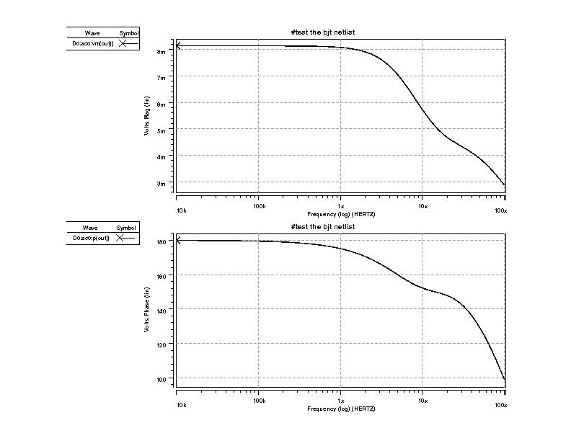
First, try to implement the AC analysis in your code. The netlist BJT can be used to test your program. Please plot the frequency response like below:

The x coordinate is Frequency in log scale. You can decide the initial, final frequency and the step size. In the plotted figure, the initial frequency is 10KHz, final frequency is 100MHz, and 100 points are simulated in each decade. So when you do the AC analysis solve the linear equations at each frequency point. Print out the magnitude (in dB) and phase (in degrees) of the output voltage, dividing the output voltage magnitude by the input voltage magnitude to get the gain. Then you can use a plotting tool (e.g. gnuplot or matlab) to get the figure.
In the final report, also include the AC analysis results for 741_amp. The output of 741-amplifier is node 22 and during dc analysis the AC source should be stamped as a 0 volt independent voltage source (which means short) while during AC analysis you should stamp it as an ac source.
In transient analysis, please use netlist amp1. You should adjust the step size yourself. You may have some convergence issues. Try to use some methods mentioned in class and in Ch 10.4 such as damped Newton-Raphson. It’s up to you to decide whether to use Forward Euler, Backward Euler, or Trapezoidal Integration for capacitors and inductors and whether to use Thevenin or Norton forms. In addition, non-linear capacitors’ transient model needs to have their capacitance values linearized and evaluated using Newton-Raphson. Also, there are a lot more derivatives that are necessary to take for the diode/bjt transient analysis than one might realize at first so be careful. In amp1, the input signal is a sinusoidal wave with peak magnitude of 10mv and period of 100us. Please plot the output voltages in your final report.
For both ac and transient analyses it’s recommended to test your code first on simple RC networks, then including diodes, and then including bjts.

