**23.01.2019**



**MIDDLE EAST TECHNICAL UNIVERSITY ELECTRICAL-ELECTRONICS ENGINEERING DEPARTMENT**

**EE463 POWER ELECTRONICS I**

**Fall 2018**

**HARDWARE PROJECT REPORT**

**Team Name: Smart Grid**

**Team Members: İven GÜZEL 2030831**

**Onur KÜLAHLIOĞLU**

**Ekin SAÇIN**

**To be submitted to: Ozan KEYSAN**

Table of Contents

1. INTRODUCTION 3

2. DESIGN DECISIONS 3

2.1. Topology Selection 3

2.2. Gate Driver 3

3. COMPUTER SIMULATIONS 3

4. COMPONENT SELECTION 3

5. IMPLEMENTATION STEPS 3

6. TEST RESULTS 3

7. CONCLUSION 3

APPENDIX A: Source Code of Arduino Gate Driver 3

APPENDIX B: TIPS for Next Year’s Students 3

REFERENCES 3

# INTRODUCTION

This report presents the details of EE463 Hardware Project. The aim of this project is to design and complete the setup of a controlled AC to DC motor drive. The teams must define a topology in order to make a proper design for feeding motor from three phase AC supply.

All requirements and results for selected topology is presented in this report. Selected components for chosen topology are listed. The simulation results and design schematic are provided Simulink, MATLAB. Finally, the test results of the demonstration are presented due to using equipment in laboratory.

# DESIGN DECISIONS

## Topology Selection

In this project, we were required to implement a controlled rectifier for the armature voltage input of the motor. According to topologies we have learned this semester we had mainly three options.

**3- Phase or Single-Phase Thyristor Rectifier:**

For these solutions, we believe that 3 phase thyristor rectifier is preferable over the single phase one, since with a dc link capacitor connected to its output terminals, it offers a more dc like voltage waveform. In these topologies output voltage value is controlled with firing angles of thyristors. It should be noted that each thyristor requires its own driver and implementing gate driver circuits and the controller unit is a serious problem and we decided that it would be a challenge for our design. Also, synchronization problems could occur between firing angles and phases.

**3 Phase Diode rectifier+ Buck Converter:**

This solution requires a three-phase diode rectifier, a switch which could be MOSFET or IGBT, a diode, a DC link capacitor, gate driver circuit for the switch and a controller unit. Output voltage is controlled with Buck converter. For Buck converter a low pass filter could be used, however this part can be skipped since the motor itself is an LR low pass filter.

This solution requires only a single gate driver circuit; therefore, it possesses no synchronization problem like in the thyristor case. We believe this is the simplest solution; therefore, we decided to go with it.

**3 Phase Diode + Boost Converter:**

Although this solution is very similar to the previous one, we decided not to use it since boost converter increases the voltage however it reduces the current input.

## Gate Driver

An isolation is needed between the microcontroller of the gate driver and the controlled rectifier topology. For this purpose, we used an optocoupler (TLP250) as our gate driver circuit as it can be seen in Figure 2.1. From low voltage side of the optocoupler we implement the duty cycle information (PWM) using an Arduino Uno.

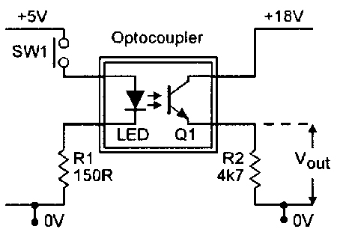

Figure 2.1- Optocoupler as the gate driver

Low voltage side of the optocoupler can be thought as a LED. PWM output of Arduino is conected to anode of the LED. A resistor is needed to be connected to the cathode of the LED in order to prevent it from burning. A floating voltage source should be connected between Vcc and Vee legs of the optocoupler, since to open the gate of the IGBT or Mosfet that are used as switch, the voltage at the gate should be bigger that the summation of the threshold voltage of the switch and emitter voltage (for IGBT) or source voltage (for Mosfet). Therefore; the lower port of this floating source is connected to the emitter of the IGBT (or source of the Mosfet). To feed the gate any one of two middle legs of the Optocoupler could be used.

We create the PWM input using Arduino. However, switching of the IGBT should be in high frequencies and therefore; a manipulation is needed to done on Arduino’s clock. The source code given in Appendix A, increases switching frequency to 3.6kHz and slowly increases duty cycle from 0 to 0.94 and decreses it back to 0 again.

# COMPUTER SIMULATIONS

After choosing the topology of the driver, we started to determine the proper equipment by analyzing the simulation results. Voltage ripple, average output voltage, and current were adjusted by changing the parameters of the equipment. We measured the terminals of the DC link capacitor to determine the voltage ripple by changing the capacitor values and measure the terminals of the diode as output voltage. Also, we measured the armature current of the DC motor. We tried to adjust output voltage at 220 Volts which is the rated voltage of the machine. We used EKİN BURAYA SİMULASYONDA VERDİĞİN İNPUT DEĞERİNİ YAZ! voltage as input voltage of the driver circuit.

In this part, some simulations were made by MATLAB Simulink for three different cases. We arranged the parameters of the equipment with respect to the datasheet of the equipment that we bought. In these cases, the duty cycle was changed and some important parameters were observed. The value of duty cycle was adjusted with the pulse generator. The circuit schematic of simulations is in Figure 3-1.

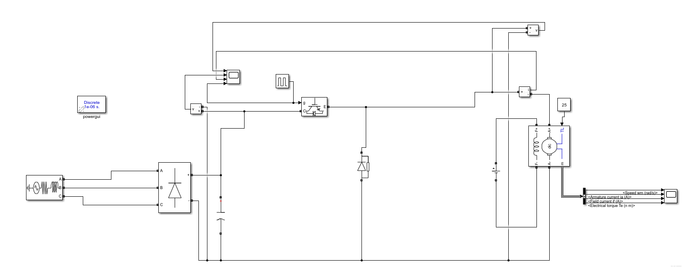

Figure 3.1- The circuit schematic of converter in Simulink

As an extreme case, when we adjust the duty cycle of the gate-input as 1, we observed the following results seen in the Figure-3.2, 3.3 and 3.4.

* PWM Duty Cycle = 1

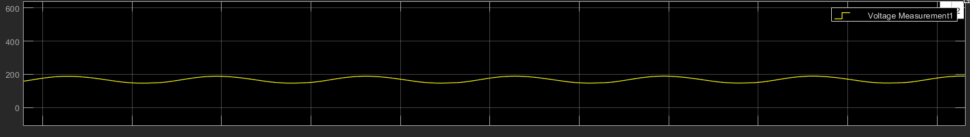

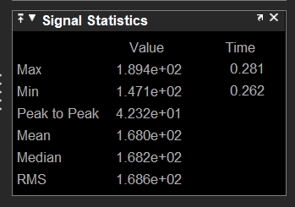

Figure 3.2- Diode Voltage

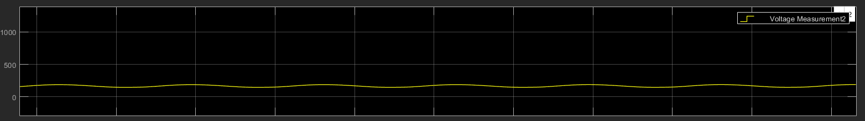

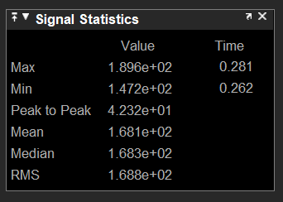

Figure 3.3- Voltage of DC link capacitor

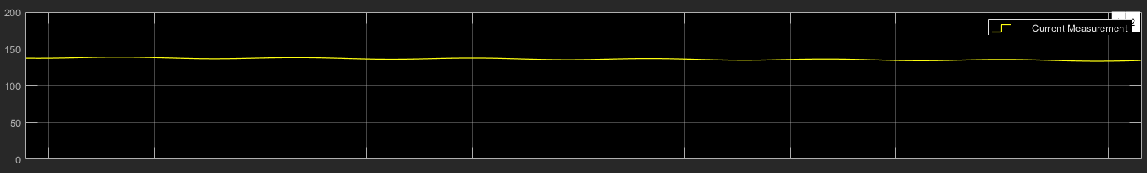

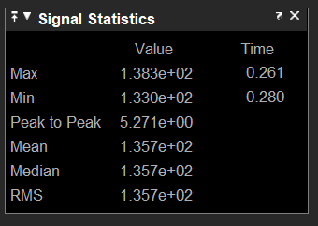

Figure 3.4- Motor current

To get more realistic results, we arranged the duty cycle of the gate-input as 0.5 and we observed the voltage of the DC link capacitor and diode as an input and output voltages as seen in the Figure-3.5 and 3.6. Besides, we obtained the armatüre current of the DC motor.

* PWM Duty Cycle = 0.5

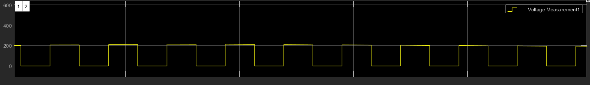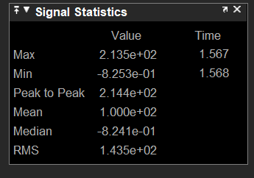

Figure 3.5- Diode Voltage

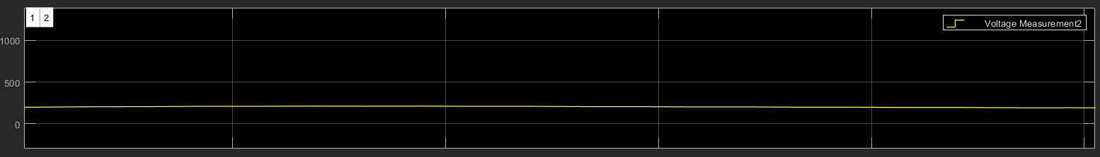

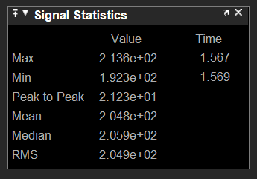

Figure 3.6- Voltage of DC link capacitor

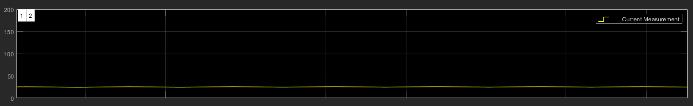

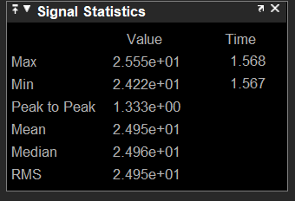

Figure 3.7- Motor current

As another extreme case, we changed the duty cycle of the gate-input as 0.2. Probably, it is not enough to rotate the machine, but we wanted to observe the characteristics of the circuit at this duty cycle. The simulation results can be seen in the Figure- 3.8, 3.9 and 3.10.

* PWM Duty Cycle = 0.2

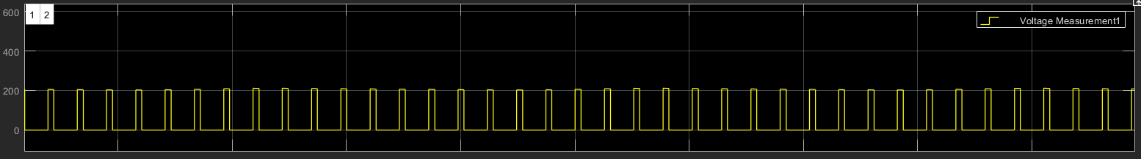

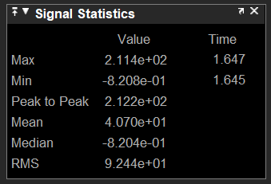

Figure 3.8- Diode Voltage

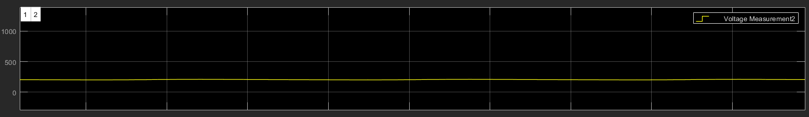

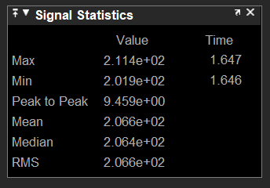

Figure 3.9- Voltage of DC link capacitor

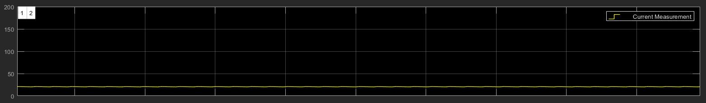

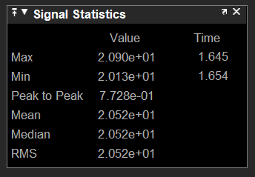

Figure 3.10- Motor current

# COMPONENT SELECTION

## 4.1 Cost Analysis

|  |  |
| --- | --- |
| MAIN COMPONENTS | COST(TL) |
| 3-Phase diode rectifier module | 60 |
| IGBT | 40 |
| Freewheeling diode | 20 |
| Capacitor(x3) | 3x20 |
| Arduino | 23 |
| Optocoupler | 15 |
| Heat Sink(x3) | 3x5 |
| Ventilator | 20 |
| Stripboard | 10 |
| Plastic box | 40 |

Other than these components, we have used ceramic capacitors, resistors, cables, connectors, thermal paste, sockets and battery.

# IMPLEMENTATION STEPS

# TEST RESULTS

We have tested all subparts after purchasing them to make sure that they are suitable for the project. Firstly, we have tested diode rectifier module and 540 µF DC link capacitor by using resistive load. As seen in the Figure-6.1, output voltage has almost no ripple thanks to the capacitor.

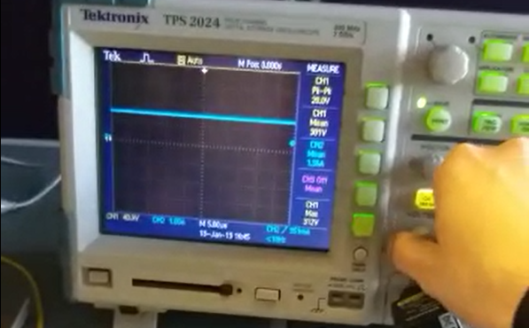

Figure-6.1: Output voltage of the diode rectifier module with DC link capacitor

We also looked at the gate signals of the IGBT generated by the Arduino with the help of an oscilloscope. Results for 2 different duty cycle is seen in the Figure-6.2.

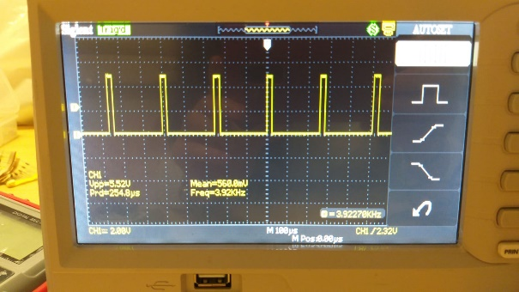 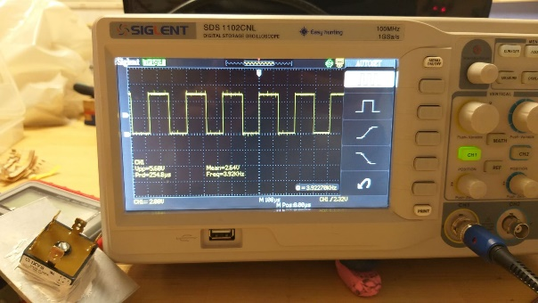

Figure-6.2: Output of the Arduino with 2 different duty cycle levels.

After tested the 2 subsystems mentioned above, we build the whole circuit and tested with resistive load and low input voltage. We observed overvoltage at the beginning of each cycle of the output voltage. This is dangerous for high power application. This could have burned our components, so we decided to use RC snubber to decrease the overvoltage. You can see the effect of the snubber in the Figure-6.3.

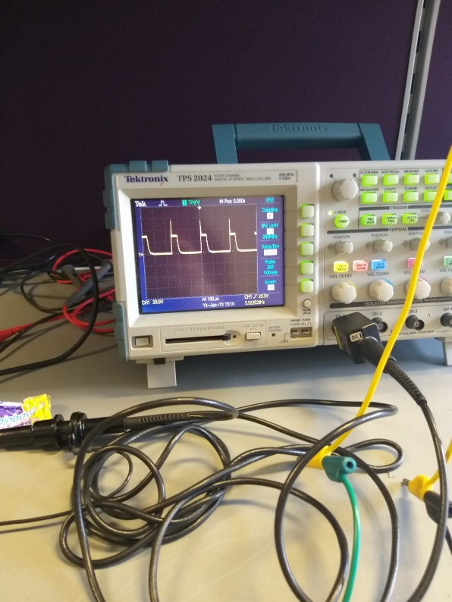 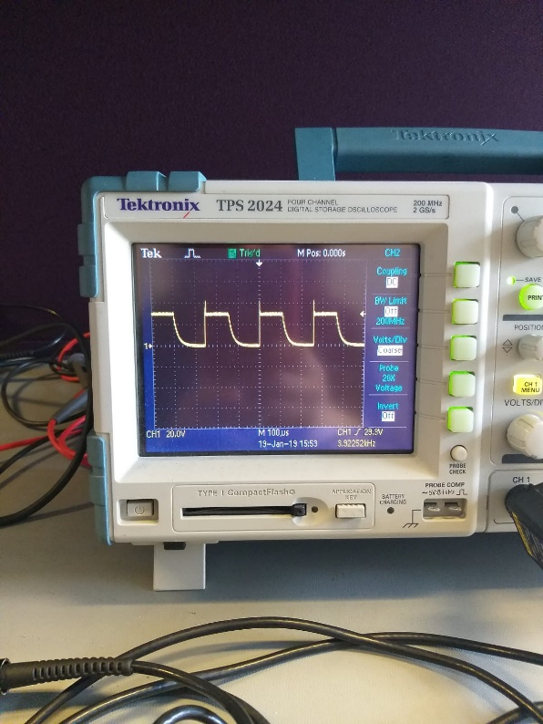

Figure-6.3: Output voltage without snubber (left side) and with snubber (right side).

Finally, we were ready to test our circuit with RL load. Test results were what we expected as seen in the Figure-6.4. We managed to control the output voltage of the load by changing the duty cycle of the gate voltage of the IGBT.

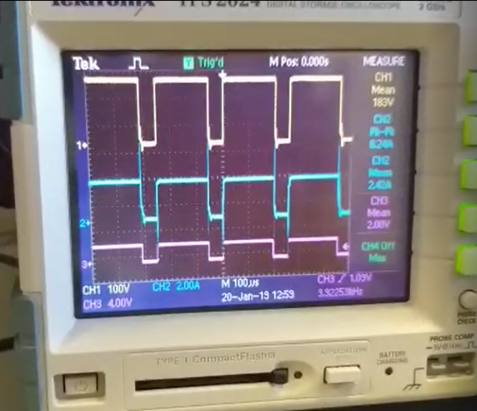 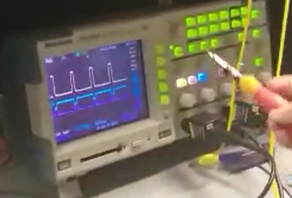

Figure-6.4: Output voltage and current with RL load with different duty cycles

All tested were successful at the power electronics laboratory, so we decided to test our design in the machinery laboratory with DC motor. Our driver was operating well until there were some problems with the DC motor. Results before the problem are seen in the Figure-6.5.

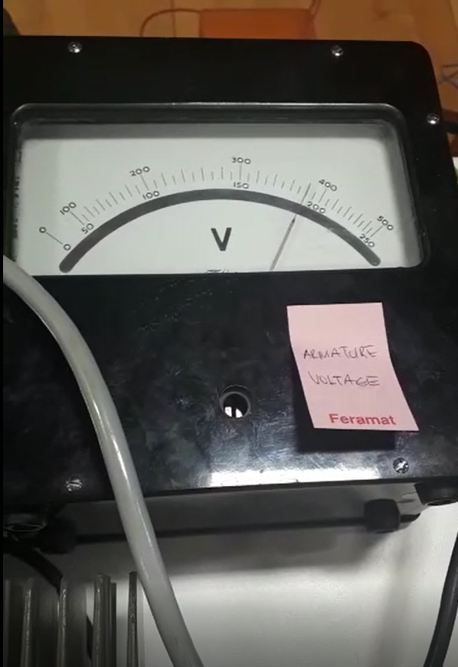 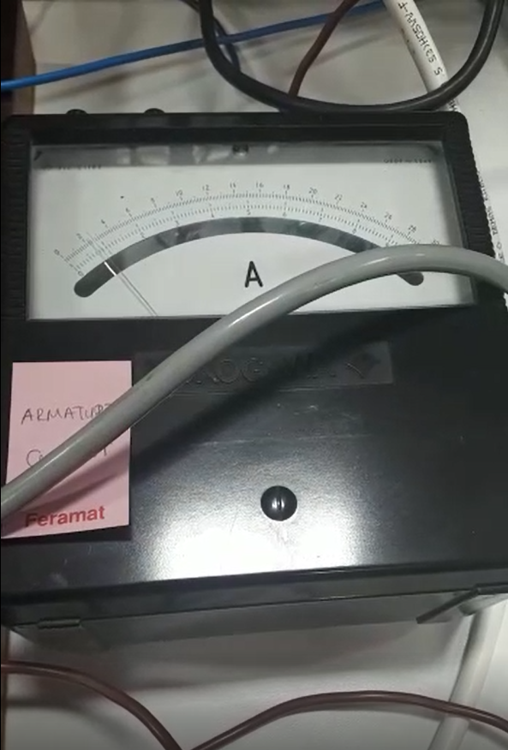

Figure-6.5: Input voltage and current of the DC motor.

We tried to arrange the output voltage of the driver at the rated voltage of the DC motor which is 220 Volts. Motor was drawn about 2.2 amperes at no load and 6 amperes at full-load. At the full-load, motor was drawn about 10 amperes on the demo day due to effect of series resistance at the load side. At no load, the temperature of the driver was around 30 degrees as seen in the figure-6.6, but at the full load, it was up to 70 degrees.

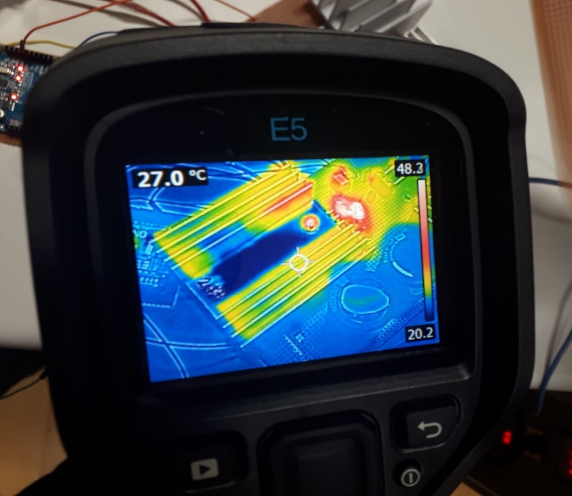

Figure-6.6: Input voltage and current of the DC motor

# CONCLUSION

<https://www.youtube.com/watch?v=s0M1ChqQ4oM&feature=youtu.be>

# APPENDIX A: Source Code of Arduino Gate Driver

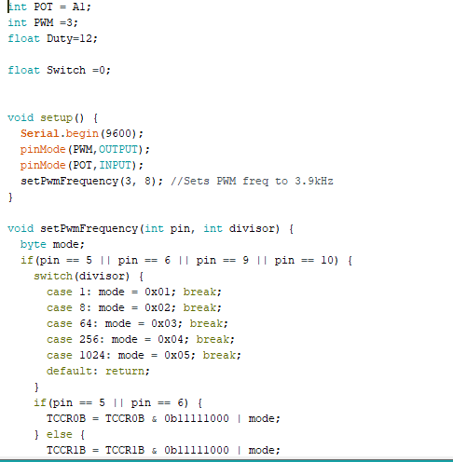

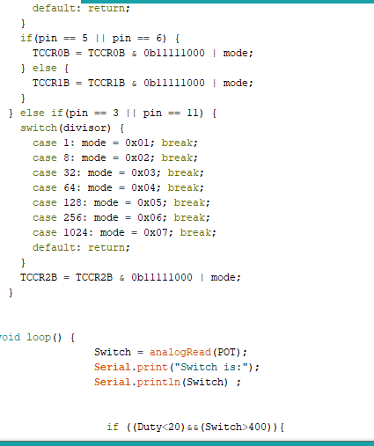

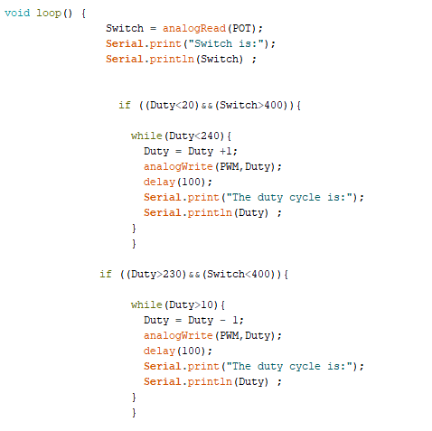

# APPENDIX B: Tips for Next Year’s Students

# REFERENCES