**23.01.2019**



**MIDDLE EAST TECHNICAL UNIVERSITY ELECTRICAL-ELECTRONICS ENGINEERING DEPARTMENT**

**EE463 POWER ELECTRONICS I**

**Fall 2018**

**HARDWARE PROJECT REPORT**

**Team Name: Smart Grid**

**Team Members: İven GÜZEL 2030831**

**Onur KÜLAHLIOĞLU**

**Ekin SAÇIN**

**To be submitted to: Ozan KEYSAN**

Table of Contents

1. INTRODUCTION 3

2. DESIGN DECISIONS 3

2.1. Topology Selection 3

2.2. Gate Driver 3

3. COMPUTER SIMULATIONS 3

4. COMPONENT SELECTION 3

5. IMPLEMENTATION STEPS 3

6. TEST RESULTS 3

7. CONCLUSION 3

APPENDIX A: Source Code of Arduino Gate Driver 3

APPENDIX B: TIPS for Next Year’s Students 3

REFERENCES 3

# INTRODUCTION

This report presents the details of EE463 Hardware Project. The aim of this project is to design and complete the setup of a controlled AC to DC motor drive. The teams must define a topology in order to make a proper design for feeding motor from three phase AC supply.

All requirements and results for selected topology is presented in this report. Selected components for chosen topology are listed. The simulation results and design schematic are provided Simulink, MATLAB. Finally, the test results of the demonstration is presented due to using equipment in laboratory.

# DESIGN DECISIONS

## Topology Selection

## Gate Driver

# COMPUTER SIMULATIONS

In this part, some simulations were made by MATLAB Simulink for three different cases. In these cases, duty cycle was changed and some important parameters were observed. The value of duty cycle was adjusted with pulse generator. Due to the results of simulations, we can determine the proper euipment. The circuit schematic of simulations is in Figure.

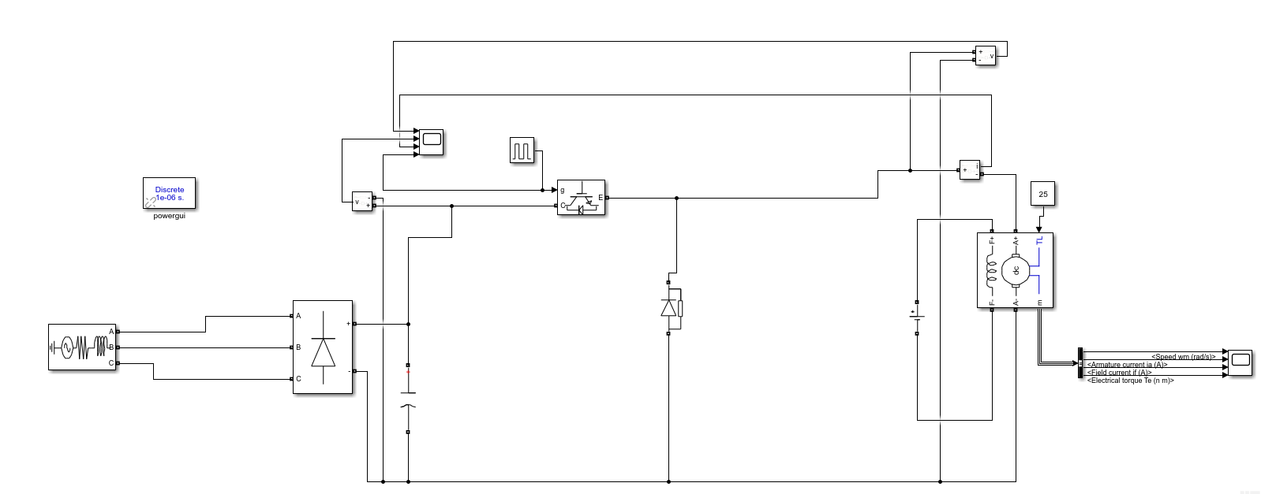

Figure 3.1- The circuit schematic of converter in Simulink

* PWM Duty Cycle = 1

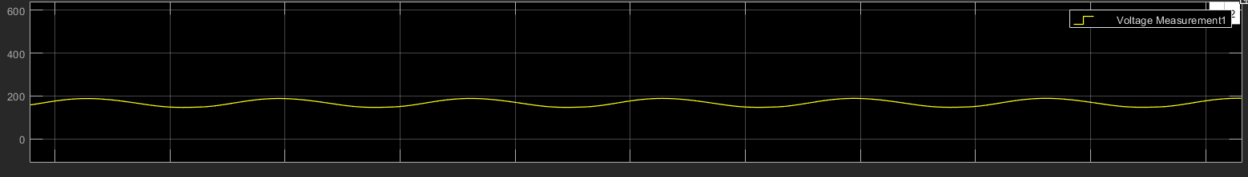

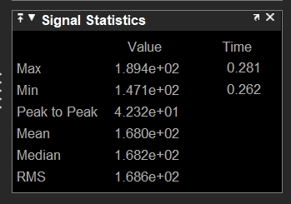

Figure 3.2- Diode Voltage

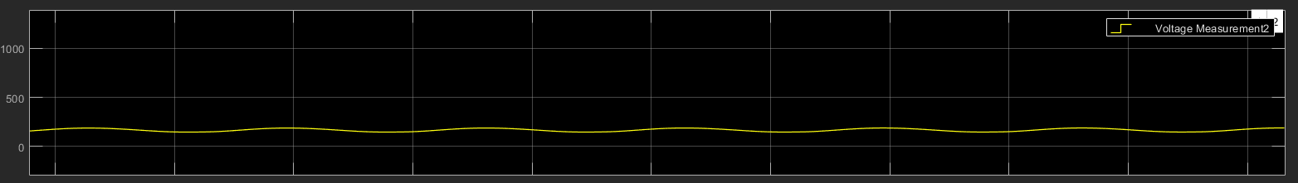

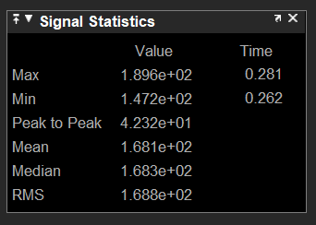

Figure 3.3- Voltage of DC link capacitor

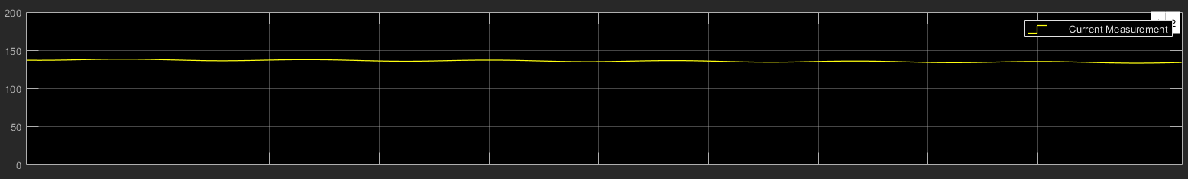

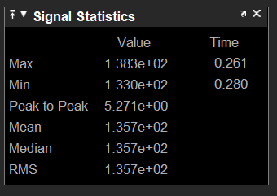

Figure 3.4- Motor current

* PWM Duty Cycle = 0.5

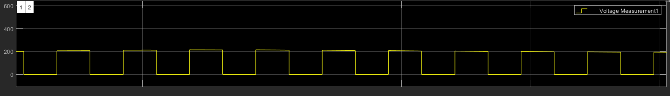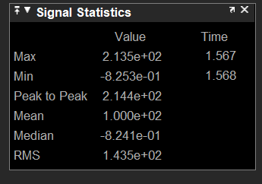

Figure 3.5- Diode Voltage

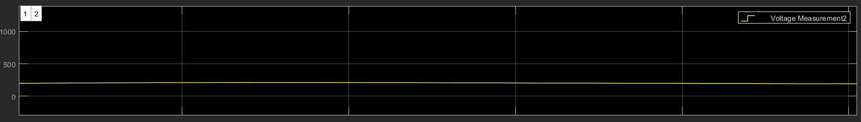

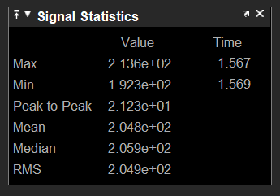

Figure 3.6- Voltage of DC link capacitor

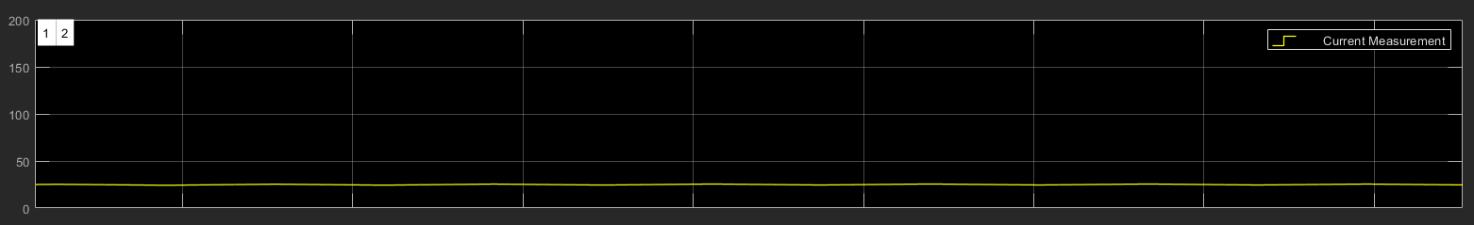

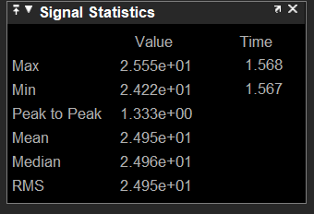

Figure 3.7- Motor current

* PWM Duty Cycle = 0.2

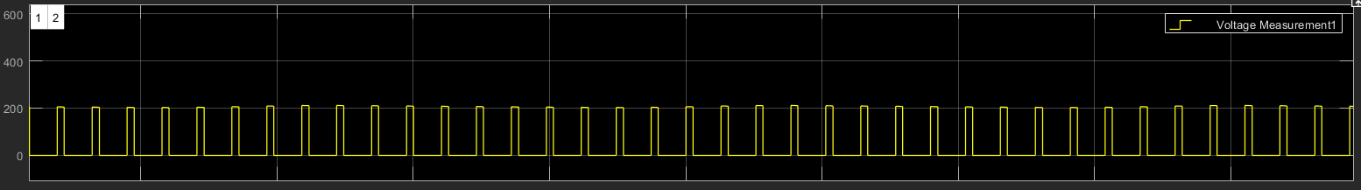

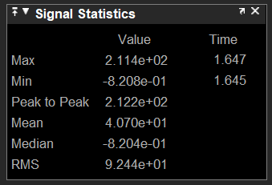

Figure 3.8- Diode Voltage

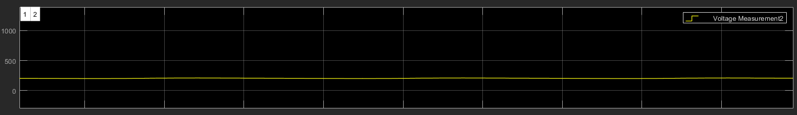

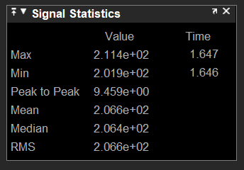

Figure 3.9- Voltage of DC link capacitor

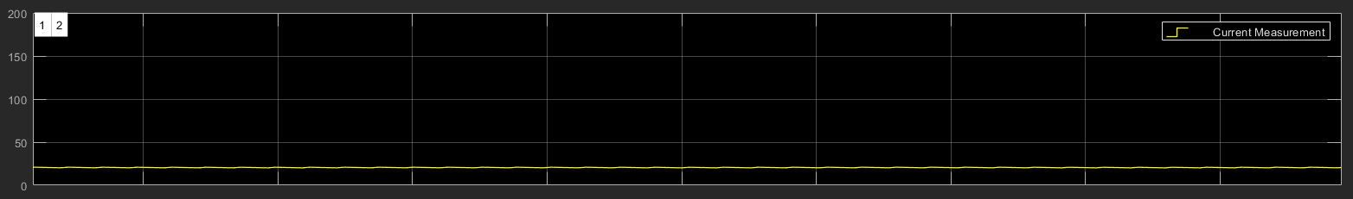

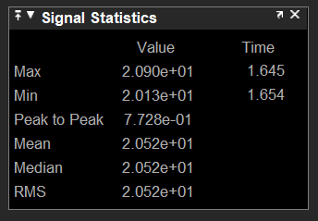

Figure 3.10- Motor current

# COMPONENT SELECTION

# IMPLEMENTATION STEPS

# TEST RESULTS

# CONCLUSION

# APPENDIX A: Source Code of Arduino Gate Driver

# APPENDIX B: Tips for Next Year’s Students

# REFERENCES