

EE 463 Term Project 1

Fall 2018

Hakkı GÜLCÜ

Tel: +90 534 397 29 66

mail: [hakkigulcu35@gmail.com](mailto:hakkigulcu35@gmail.com)

İven GÜZEL

Tel: +90 507 168 26 81

mail: [ivenguzel@gmail.com](mailto:ivenguzel@gmail.com)

**Supervisor:** Ozan KEYSAN

Date of Submission: 24.11.2017

# Contents

1. **Introduction**..............................................................................................................1

**2) Q1 Solution**.............................................................................................................2

1. **Q2 Solution**......................................................................................................3

**4) Q3 Solution**......................................................................................................3

1. **Conclusion**.............................................................................................................2

**6) Reference**.............................................................................................................2

# Introduction

Today, computers, televisions and mobile phones have become indispensable in our lives. We can't think of a life without them. So how do we get the energies of these devices?

In many power electronics applications, the input power is 50 - 60 AC power from the mains and is converted to DC in the application. Diode rectifiers can be used in industry where there is no control voltage required or in applications where power transmission is not required. In diode rectifiers, the power flow is only one way from mains to load. Diode rectifiers are preferred in DC power supply, AC motor drives and many other areas.

In this Project contribute to comprehend analysis of single phase rectifier under different type loads. In order to analyze the circuit, it is expected to get RMS, THD and Pf measurements corresponding to voltages and Currents of Circuits.

.

Q1.

The simulation of a Simulink model involves solving the dynamic system that is changing in time represented by the block diagram. Simulink engine takes care of all the computation to solve the block diagram. Simulink solver determines the time steps for which the simulation results are computed according to the changing behavior of the simulation. In Figure 1, if the dynamics of the system changes abruptly the Variable Step Solver (Set to work in Auto) chooses smaller time steps. However, if we choose to use the Discrete Step Solver and use a step size that is comparable with the period of the dynamic system, the solver might miss some of the changes in the dynamic behavior of the system.

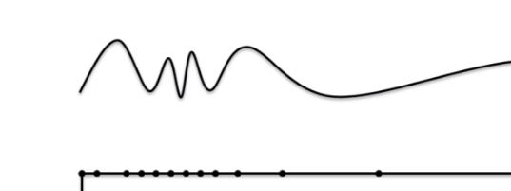

Figure 1: Chosen step sizes of an example signal by the Solver

In this question discrete time step calculations in the simulation of a single-phase uncontrolled rectifier that is feeding a resistive load (R=100Ω) is performed. Simulation results with step size 1.5 msec, 10 µsec and 1 µsec can be observed in Figure 2, 3, and 4, respectively. Since 1.5 msec is comparable with 10msec we see a distorted signal.

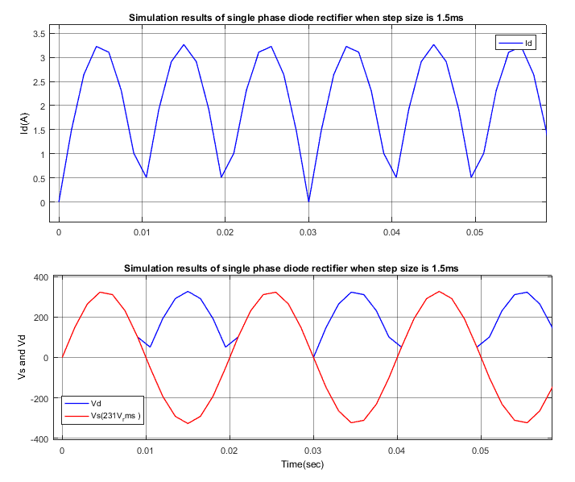

Figure 2: Simulation Results of Id, Vd and Vs when step size is 1.5e-3

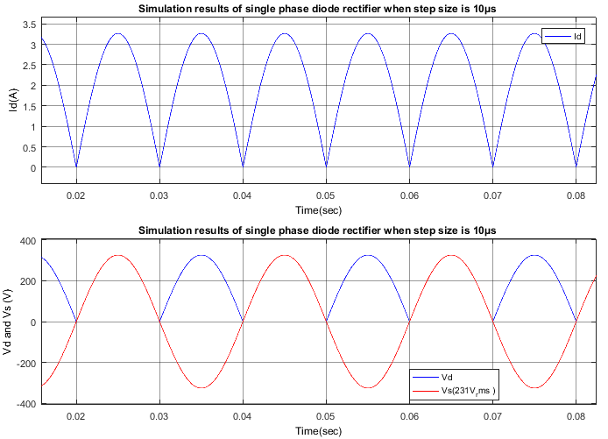

Figure 3: Simulation Results of Id, Vd and Vs when step size is 1e-5

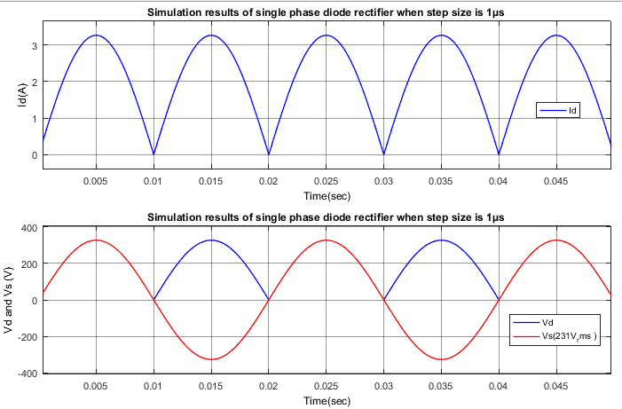

Figure 4: Simulation Results of Id, Vd and Vs when step size is 1e-6

# Q2.1.

Line current and the output voltage waveforms of R=25Ω load can be observed in Figure 5. FFT Analysis of the signals yields that Dc component (Vmean) of Vout is 207.9V whereas THD of the line current is 0. It is expected since the waveform of the line current is a pure sine wave.

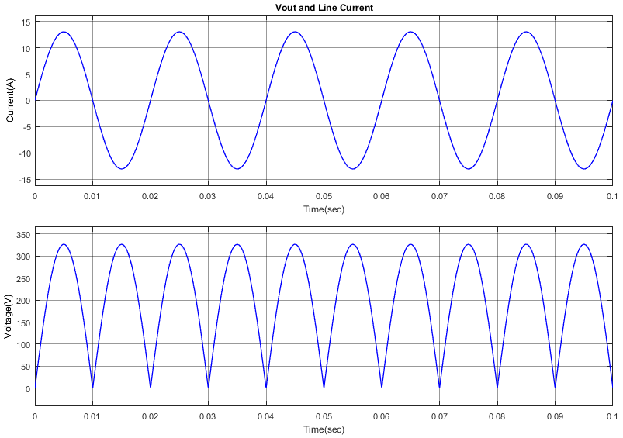

Figure 5: Line current and Output Voltage of R=25Ω load

Line current and the output voltage waveforms of R=25Ω and L=10mH load can be observed in Figure 6. As it can be seen that Vout is the same (Vmean =207.9V) but now there are distortions in the line current waveform. Higher harmonics of the current signal scaled by the first harmonic can be seen in Figure 7. THD of the waveform is 4.57%.

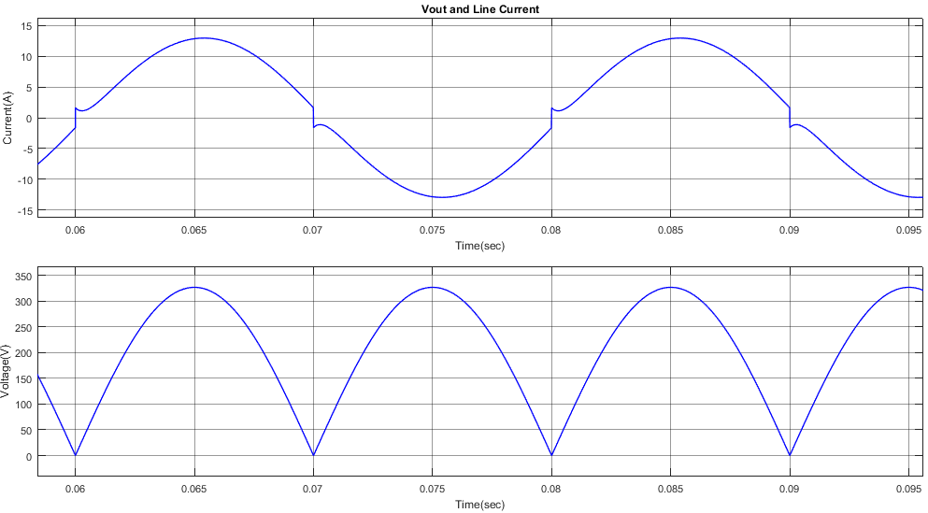

Figure 6: Line current and Output Voltage of R=25Ω L =10mH load

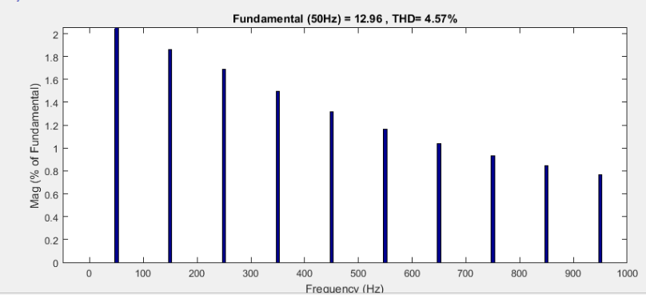

Figure 7: Bar graph of the higher harmonics (Relative to the fundamental) of the line current when the load is R=25Ω L =10mH

Line current and the output voltage waveforms in steady state when the load is R=25Ω and L=1H can be observed in Figure 8. Vout is still the same (Vmean =207.9V) and distortions in the line current waveform increased. Higher harmonics of the current signal scaled by the first harmonic can be seen in Figure 9. THD of the waveform is 48.25%.

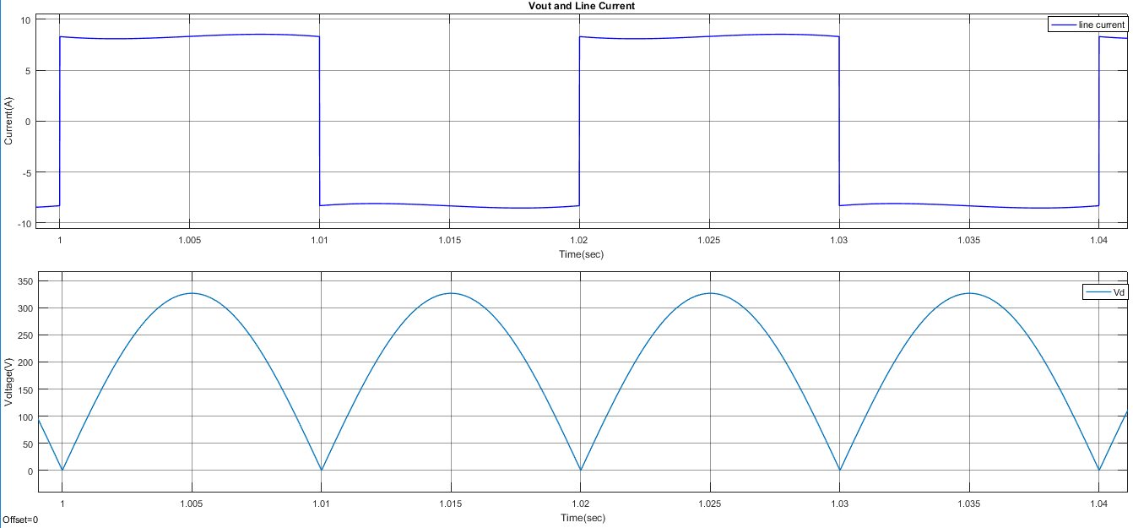

Figure 8: Line current and Output Voltage of R=25Ω L =1H load

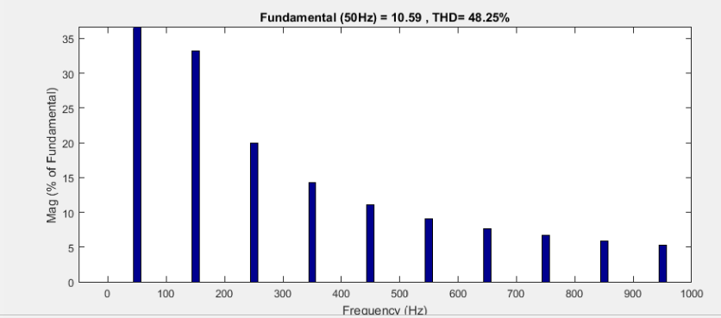

Figure 9: Bar graph of the higher harmonics (Relative to the fundamental) of the line current when the load is R=25Ω L =1H

# Q2.2.

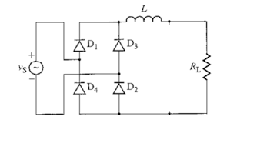

Figure 4

In Figure 4 when Vs in its positive cycle D1 and D2 is on so the current passing them is equal to Iline and voltage drop of them is equal to zero since the diodes are ideal; whereas the voltage drops on D3 and D4 are equal to Vs

In figure 5, the plots showing voltage drop and the current passing through on a single diode in steady state is shown. For simulation we used the third load in part 2.1.

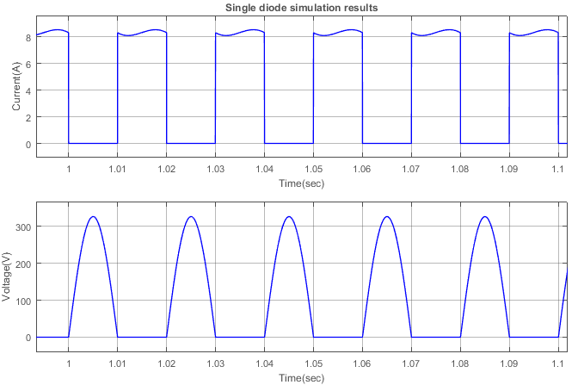

Figure 5

*Figure 5: Voltage drop and the current passing through on a single diode in steady state*

To select a practical diode for an application several parameters should be considered such as absolute ratings and how they change with temperature rise, thermal parameter, static electrical parameters to evaluate conduction loss, and dynamic parameters to evaluate switching losses. However, for this particular circuit frequency of the grid is 50 Hz which makes some dynamic parameters such as forward & reverse recovery time and switching losses insignificant. A general-purpose diode with standard recovery time should be sufficient.

From Figure 5, the peak voltage drop on diodes is 326.6V whereas Vav is 104V whereas, the maximum repetitive current passing is 8.5A and Iav is 4.158A.

To choose a discrete diode limiting factors will be maximum repetitive peak voltage (Let’s look for a diode with 400V) and If(av) (Let’s look for a diode with 5-6 Amps). We can use 6A4 diode for $0.176 from Micro Commercial Components ( <http://www.mccsemi.com/up_pdf/6A05-6A10(R-6).pdf> ) or S5GC diode for $0.15 from Diodes Incorporated (<https://www.diodes.com/assets/Datasheets/ds16007.pdf> ).

To choose a single-phase diode rectifier module we should look for 9-9.5 Amp output rectified output current and again similar maximum repetitive peak voltage values under standard purpose single phase bridges section. Note that I searched for 10Amps because there were less options in 9Amps. We can use MP10 04G-G for $1.61 or GBU 1004-G for $1.33 (<http://www.comchiptech.com/admin/files/product/GBU10005-G%20Thru402044.%20GBU1010-G%20RevC.pdf> )from Comchip Technology (<http://www.comchiptech.com/admin/files/product/MP10005G-G%20Thru242784.%20MP1010G-G%20RevC.pdf> )

Obviously, buying four discrete diodes is a cheaper solution. From maximum ratings points of view using discrete diodes is a better selection as well. Also, by using discrete devices we can increase the surface area, this could be useful to decrease thermal rise. However, the power modules are normally assembled in relatively small area to save space and this is the main advantage of the modules.

## Q2.3

From Figure 6, we can see that VRRM of the 100Ω load is 327V according to this Iload is in phase with Figure 6 and peaks at 3.27A; therefore, we need to find the required capacitance for output voltage ripple smaller than 65V.

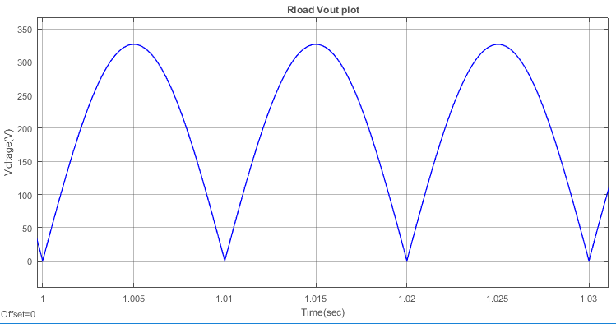

Figure 6:Vout of 100Ω load

To choose the required capacitance time constant should be significantly longer than the time interval between the successive peaks of the rectified waveform (1). When the ripple is small compared to the output peak voltage it behaves (2) where Iload is the maximum load current.

$τ=R_{load}*C≫\frac{1}{2f_{line}}$ (1)

$$V_{ripple}=\frac{I_{load}}{2f_{line}C } \left(2\right)$$

According to (2), for approximately 50V ripple C should be 654μF which makes τ 6.5 times the time interval between successive peaks of the rectified waveform. In figure 7, you can observe the output waveforms, note that ripple is approximately 40V. Then, an aluminum electrolytic capacitor whose working voltage is above 305V should be looked for. I chose 620μF capacitor from Cornell Dubilier Electronics with call number CGS621T300R2L. (<https://media.digikey.com/pdf/Data%20Sheets/United%20Chemi-Con%20PDFs/U36D%20Series.pdf> )

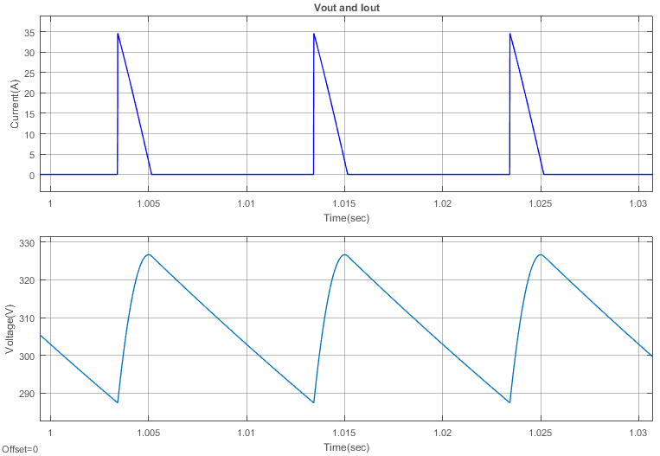

Figure 7: Voltage drop and the current passing through the load in steady state

# Q3

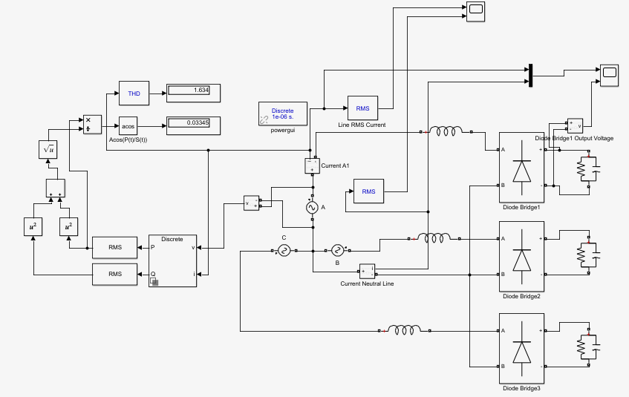

Figure 8: Schematic of the Circuit in Q3 part

## Q3.1

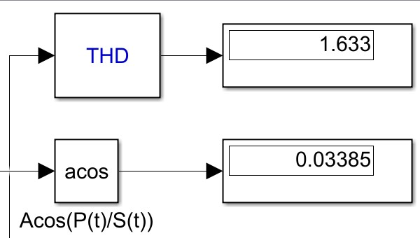

Figure 9: Power Factor and THD of İnput Current

Corresponding to pf=0.03385 and THD=163.3%

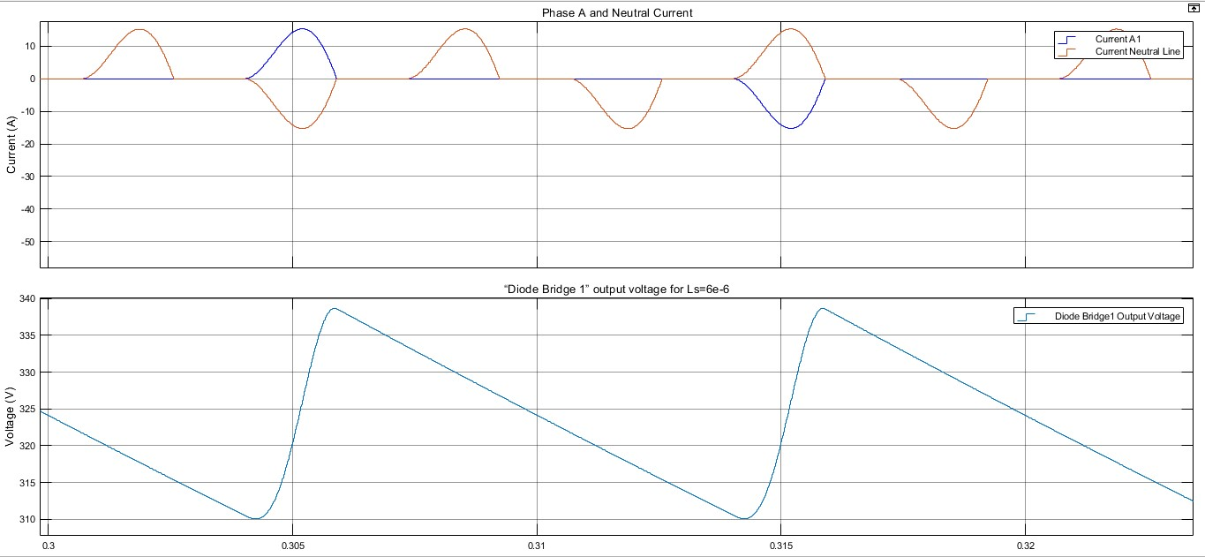

Figure 10: Waveforms for Phase A Current and Neutral Wire Current – DiodeBridge1 vs Time(s)

## Q3.2

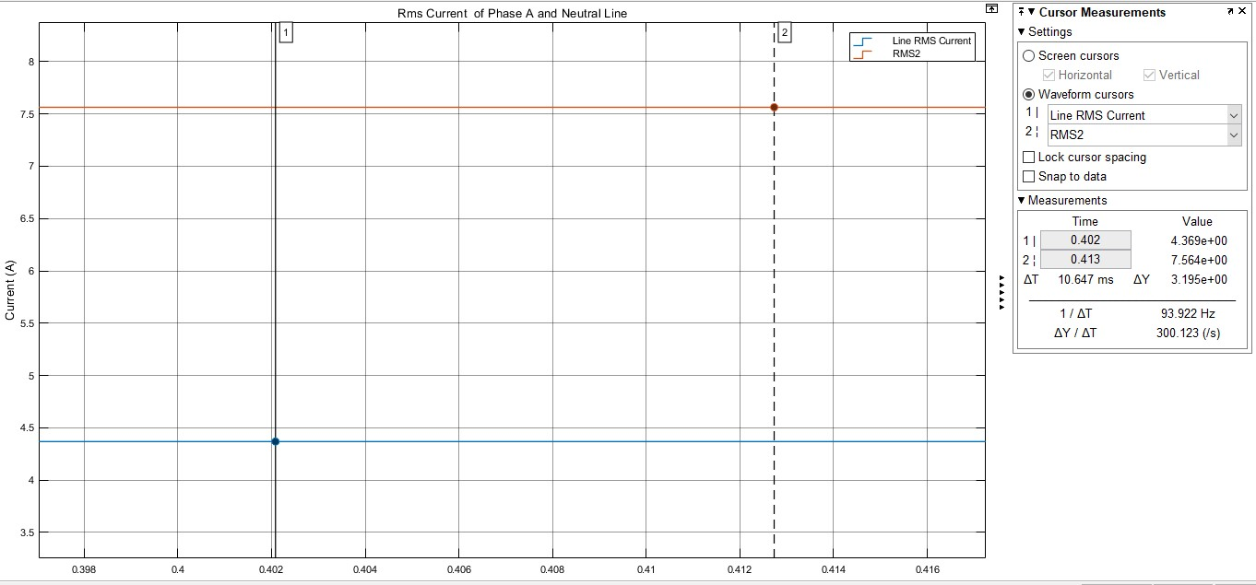

Figure 11: RMS Current of PhaseA and Neutral Line vs Time (s)

As seen figure11, RMS value of current of phase A corresponding to 4.369 A .Therefore we expect that neutral line is equal to 4.369*√3 and it is equal to expected value which is that 7.564 A. Because, neutral line is equal to summation of IphaseA+IphaseB+IphaseC in Figure 10 we observed there is 120degree phase difffrence between IphA,IphB and IphC .

## Q3.3

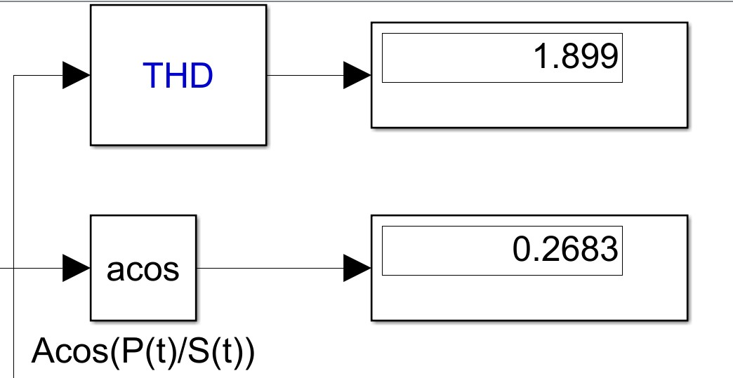

Figure 12: Power Factor and THD of İnput Current (Ls=0)

Corresponding to pf=0.2683 and THD=189.3% . Power factor is greater than Q3.1 . Because in part Q3.1 , there is a line inductive effect. It compensate power factor. Therefore we get higher pf value.

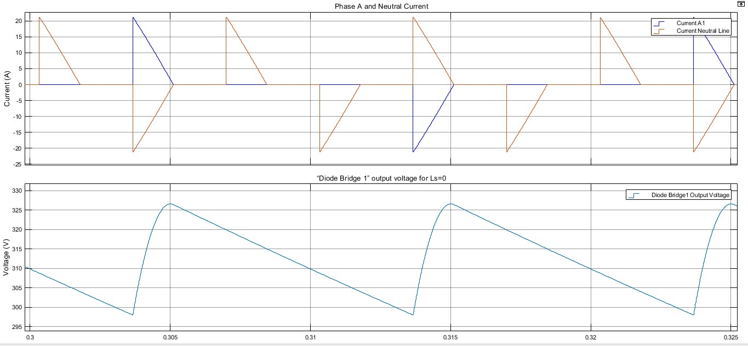

Figure 13:Waveforms for Phase A Current and Neutral Wire Current – DiodeBridge1 (Ls=0)

We observe higher peak current value. The reason is that , current decreases and increases harmonicly related to time and, inductance resists this current change. Therefore in figure 11, we observed small peak and smooth current curve. On the otherhand, figure 13, we get sharp current curve because of absence inductance line.

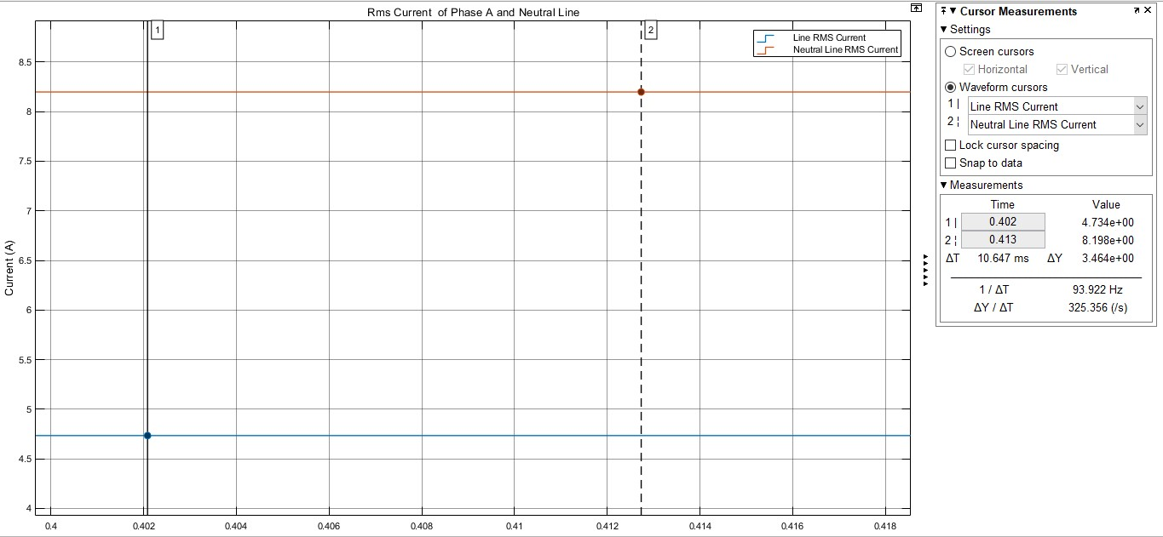

Figure 14:Figure 11: RMS Current of PhaseA and Neutral Line

# Conclusion

In part 1 , we observe effect discrete time step size of single-phase diode rectifier. We compared the results and comment on the differences  step size and we learn what is the importance of step size in a digital simulation environment.

In part 2, we analyzed behavior of single phase diode rectifiers under different types loads.

In part 3 , We observed rectifier’s behavior on conditions whether there is a line İnductance effect.

Obviously, the project achieves that we gain how to analyze the single phase rectifiers. Also we comprehended effects of Pf , THD ,RMS factors on analysis.

# Reference

- <https://www.digikey.com/>

- Power Electronics: Converters, Applications, and Design, N. Mohan, T. Undeland,

- <https://www.mathworks.com/help/physmod/sps/power-electronics_power-electronics.html>

- <http://keysan.me/presentations/ee463_diode_rectifiers.html#1>