

**MIDDLE EAST TECHNICAL UNIVERSITY**

**DEPARTMENT OF ELECTRICAL & ELECTRONICS ENGINEERING**

**E463 – PROJECT #2**

**İven Güzel (2030831)**

**Etki Açılan (2165694)**

**16.12.2018**

Table of Contents

1) Single Phase Controlled Rectifiers 2

# **INTRODUCTION**

This report is prepared for the second software project of EE463 Fall2018 class in order to understand single phase controlled and three phase diode rectifiers operation and characteristics. Throughout the project Turkish grid system which has 400Vll and 50Hz operation is used.

First question compares fully and half controlled single phase rectifiers. In the second question, a pulse modulated DC motor which is fed from a three-phase grid via a three-phase full bridge uncontrolled rectifier is observed. Plots of armature current, speed and torque of the motor, ripple characteristics of torque and the overall drive efficiency are discussed. Finally, in the last question alternative rectifier topologies for HVDC systems such as 12-pulse diode rectifier is explained.

# **QUESTIONS**

## **QUESTION 1**

**a) Hand calculations**

For the calculation of the required firing angle α to acquire an average output current value of 40 A for fully controlled topology, average output voltage is given by (1)-(3).

(1)

(2)

(3)

Voltage drop due to commutation is found by (4)

(4)

Since Id is 40A, combining (3) and (4), we acquire (5) and (6)

(5)

(6)

Therefore; output average voltage Vd is (7).

(7)

Since output average current Iav is 40A and given by (8), combining (7) and (8) together we yield (9), therefore; α is (10).

(10)

For half controlled topology, similar calculations are carried out in (10) and (11), yielding α in (12).

Output current simulation results of fully controlled and half controlled topologies can be observed in Figure 1 and 2, respectively.

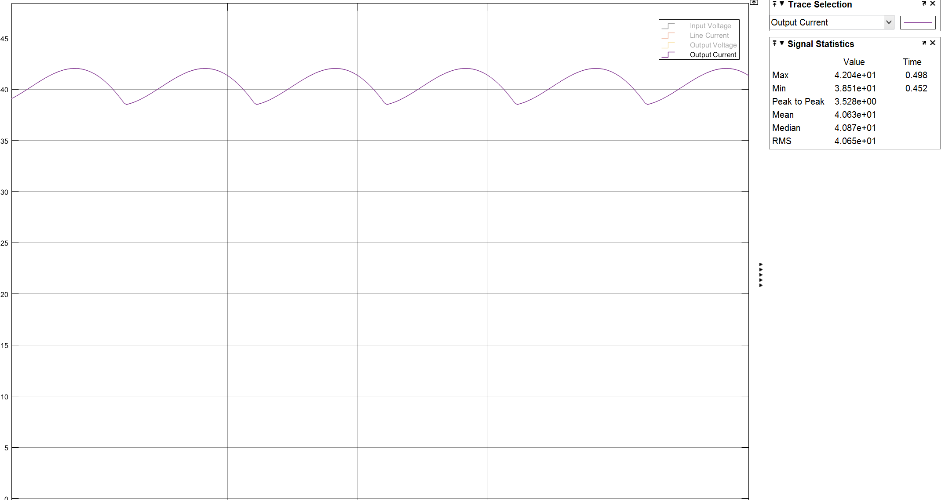

Figure 1: Output Current Simulation Result of Fully Controlled Topology

As can be seen from Figure 1, the calculations for fully controlled topology is consistent with simulation results. The simulated result is 40.6A. This little amount of discrepancy could be because we round numbers while calculating.

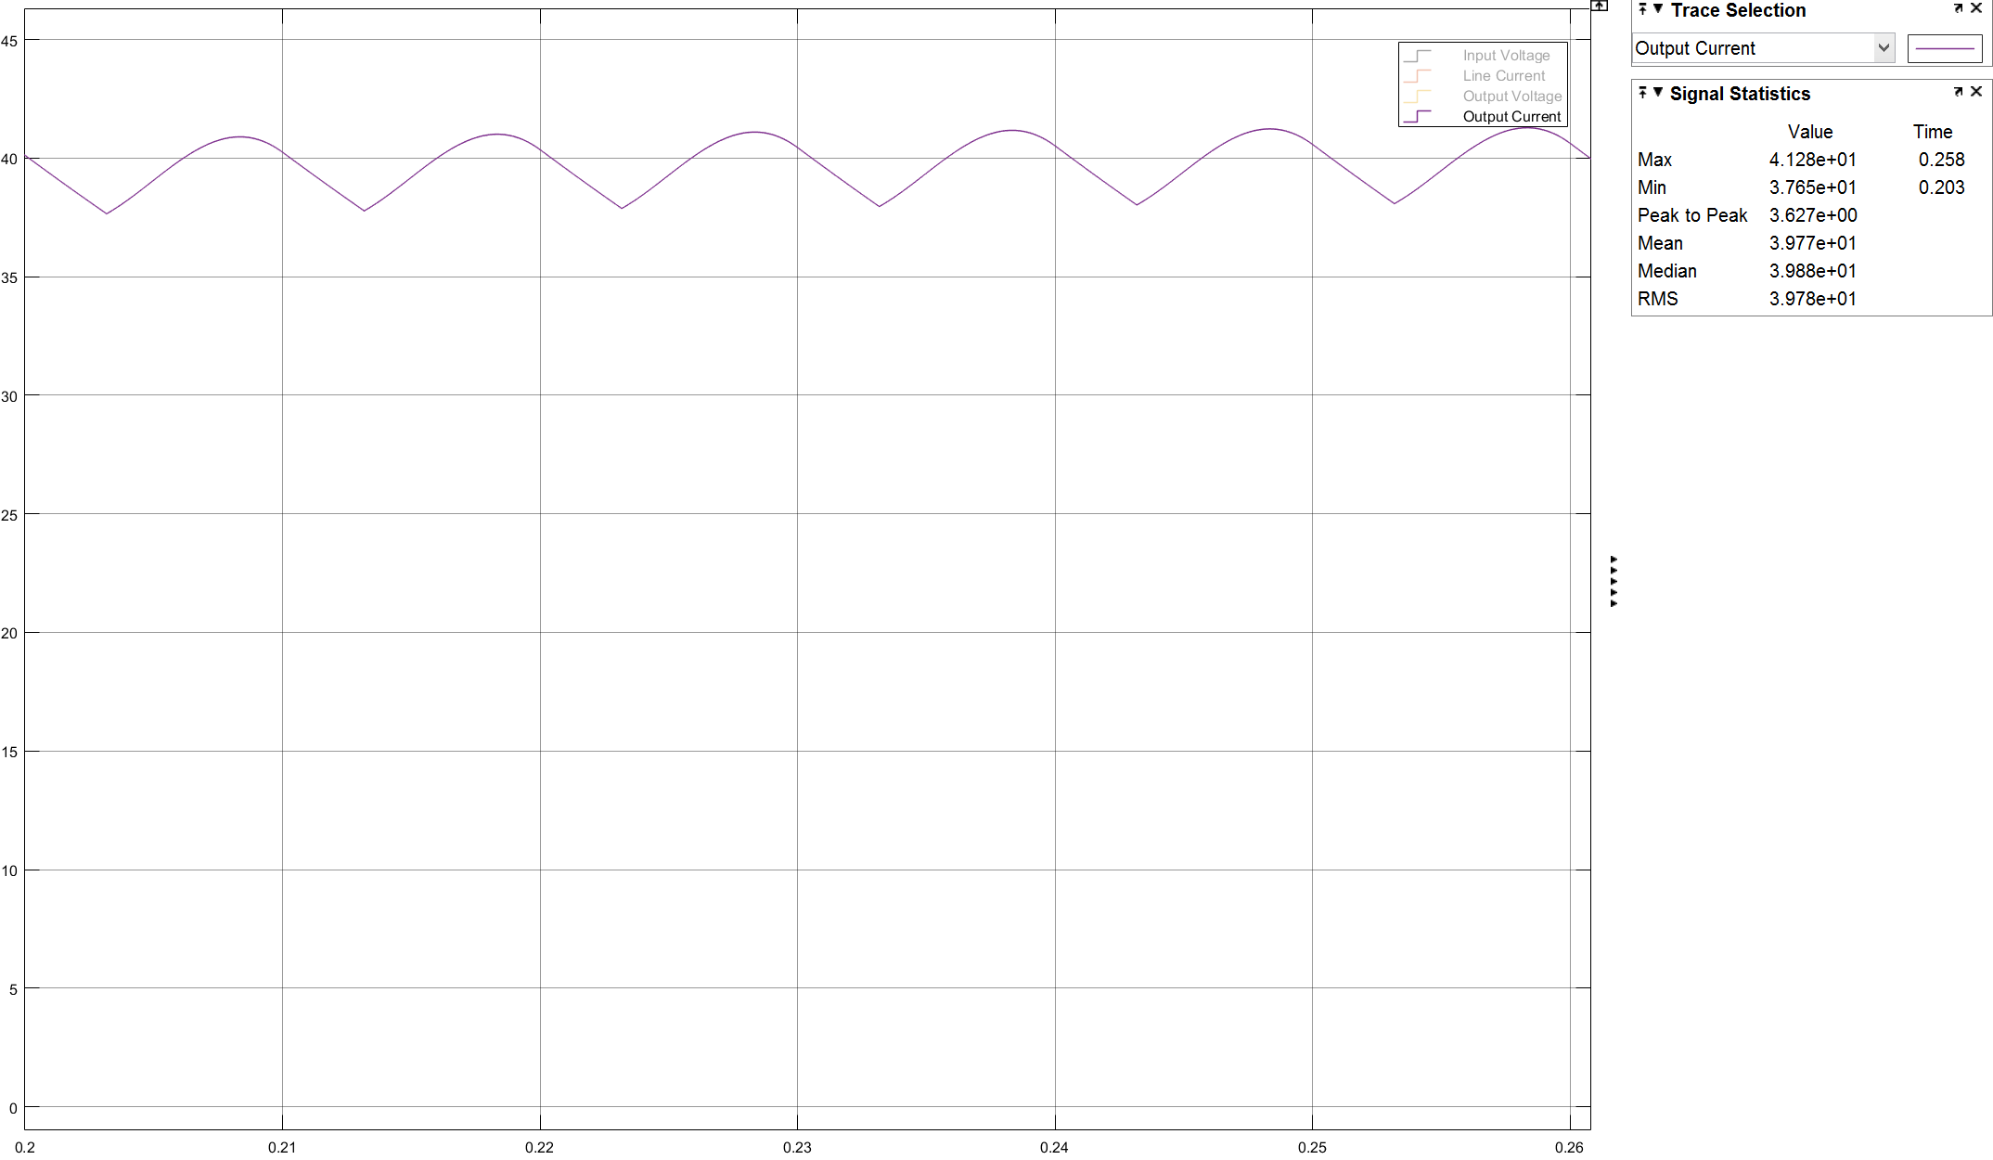

Figurel 2: Output Current Simulation Result of Half Controlled Topology

As it can be seen from Figure 2 and the calculations of half controlled topology, they are also consistent with each other. The simulation result was 39.77A where the required value was 40A. The little discrepancy is because of the same reason.

### **Graphical results of Vs and Is and THD values of Is**

Figure 3 shows the input current and voltage of fully controlled topology Figure 4 shows the input current and voltage of half controlled topology. Figure 5 shows the THD of input current for fully controlled topology. Figure 6 shows the THD of input current for half controlled topology.

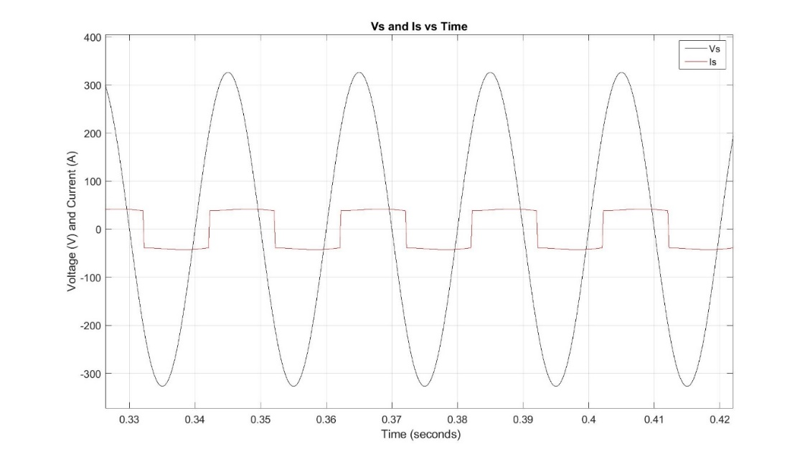

Figure 3: Vs and Is vs Time of Fully Controlled Topology

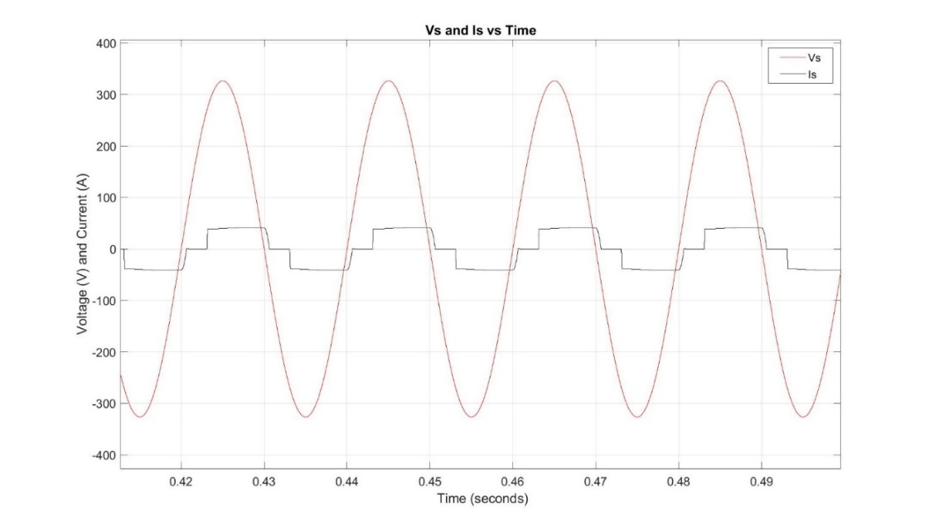

Figure 4 Vs and Is vs Time of Half Controlled Topology

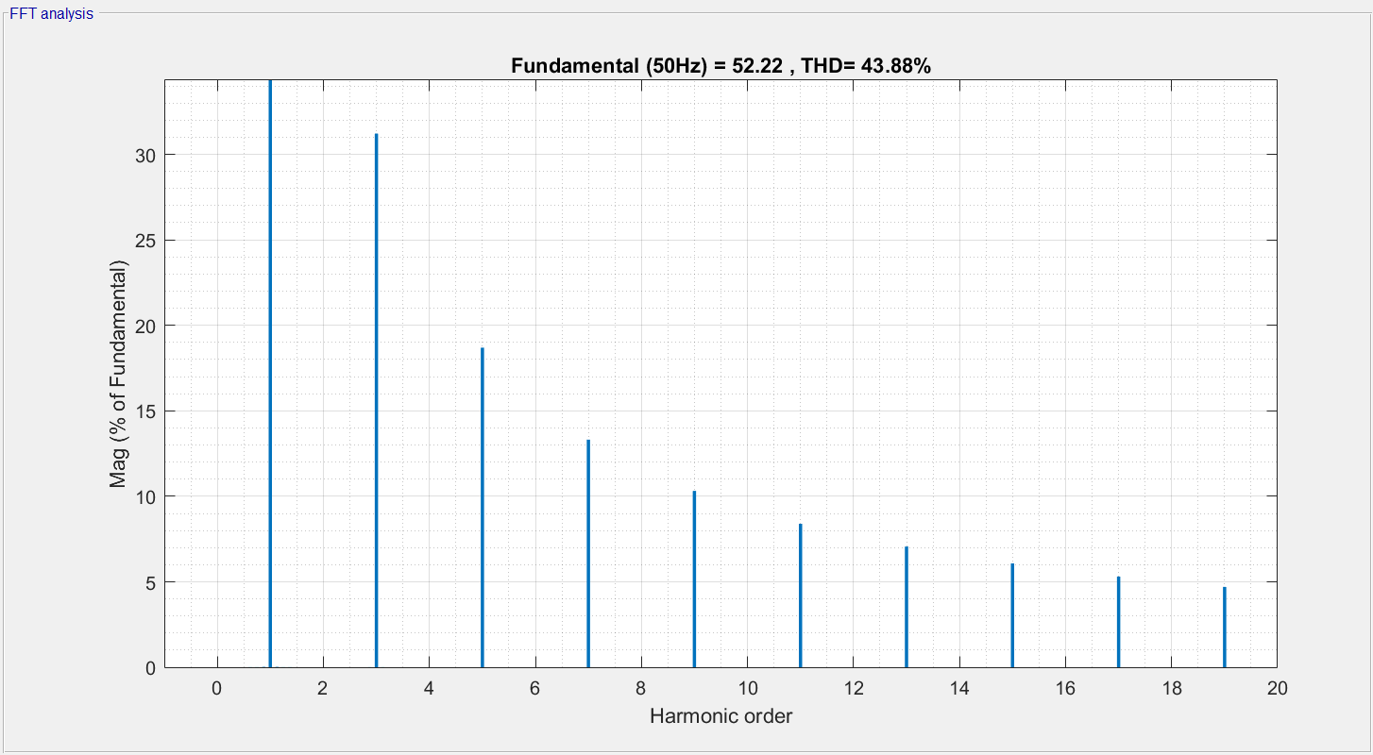

Figure 5 THD of Is for Fully Controlled Topology

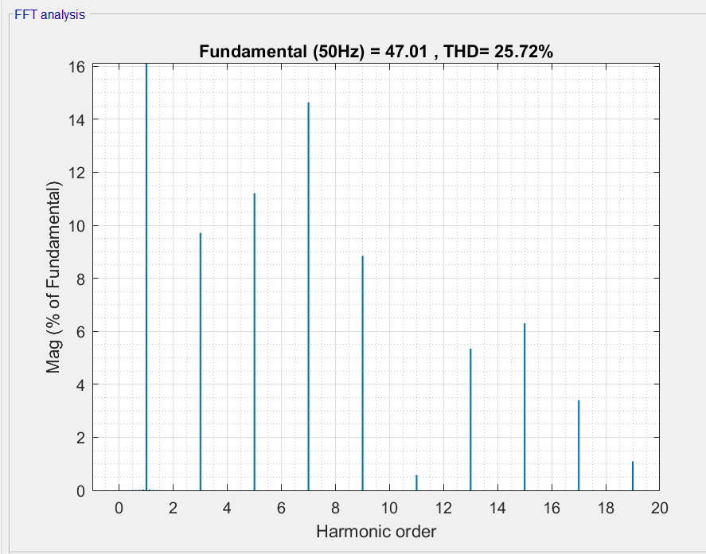

Figure 6 THD of Is for Half Controlled Topology

The fully controlled topology allows unidirectional power flow. By means of this, it can operate as a rectifier and an inverter. The output voltage can be negative. It has two more thyristors instead of two diodes as in the case of half controlled topology. This results more complex and expensive gate drive circuitry. It can be used any industrial application where utilization of the inverter mode operation is important. However, they have worse input power quality than half controlled topology. The half-controlled topology is also called unidirectional converter because of the fact that the voltage cannot be negative. This results that we only have control in the half of the wave. Also, since the voltage cannot be negative, the power flow is permitted only from AC to DC side. It cannot operate at inverter region. While the output is zero at negative cycle, the load current drawn is also zero. This results a more sinusoidal form than the fully controlled topology for input current and less THD. Its application areas include where inverter operation is unnecessary or not desirable.

2) DC MOTOR DRIVE

1. Armature curent, speed and torque of the current stand-still to steady-state graphs

Figure 7 shows armature current, speed and torque of the motor from stand-still (zero speed) to steady-state vs time.

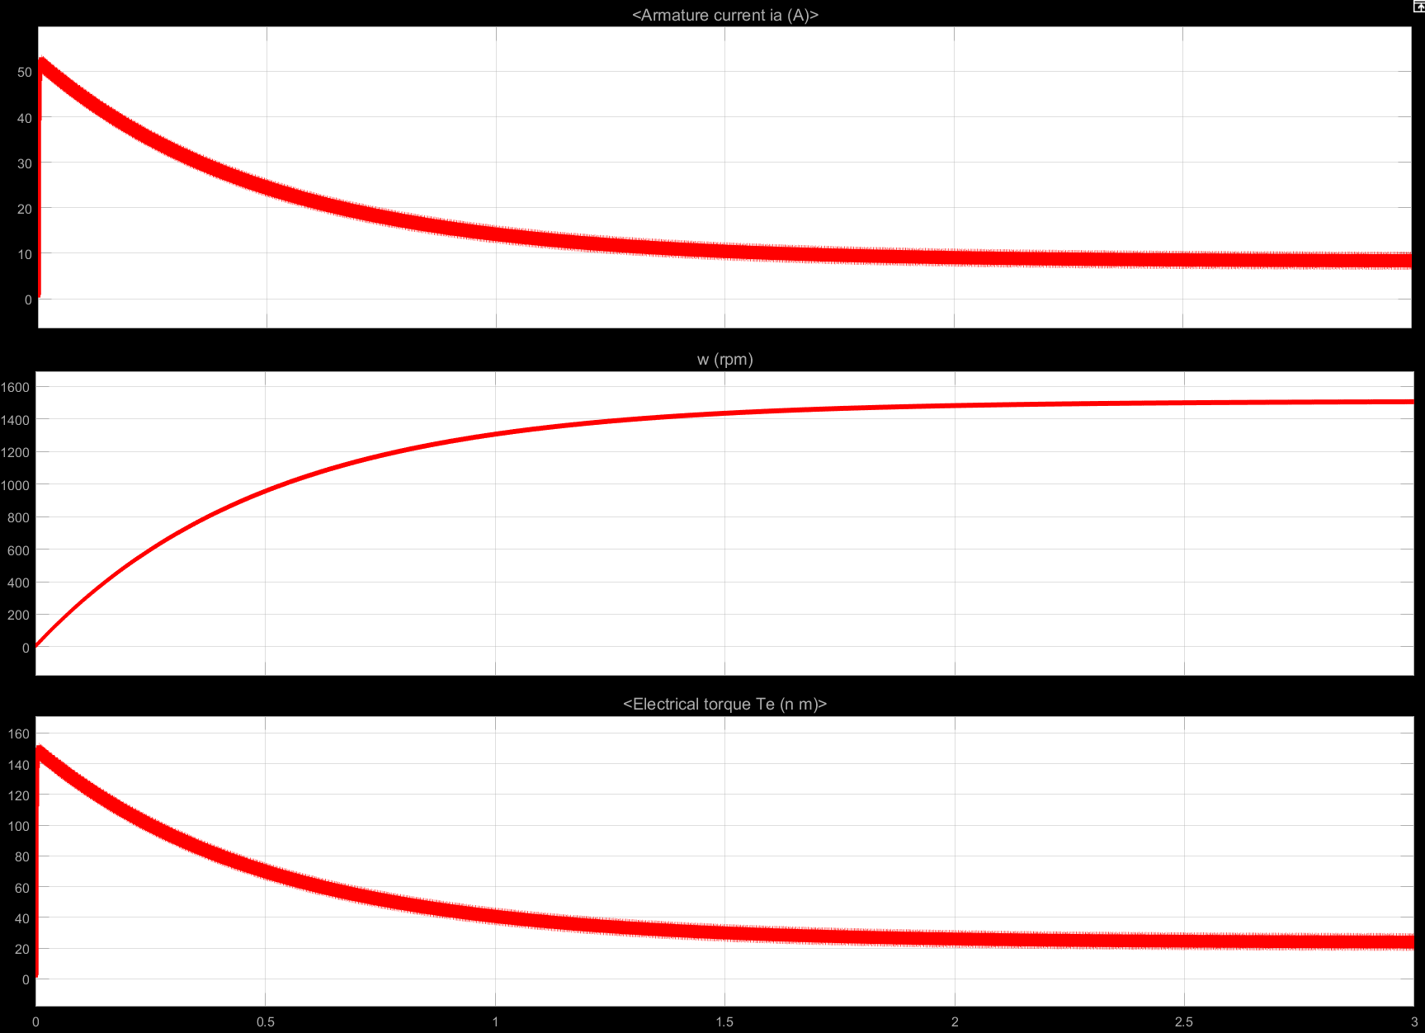

Şekil 7 Armature current, speed and torque of the motor from stand-still (zero speed) to steady-state

1. Characteristics of torque ripple and THD of line current

Figure 8 shows the electrical torque in close up and the statistics of it.

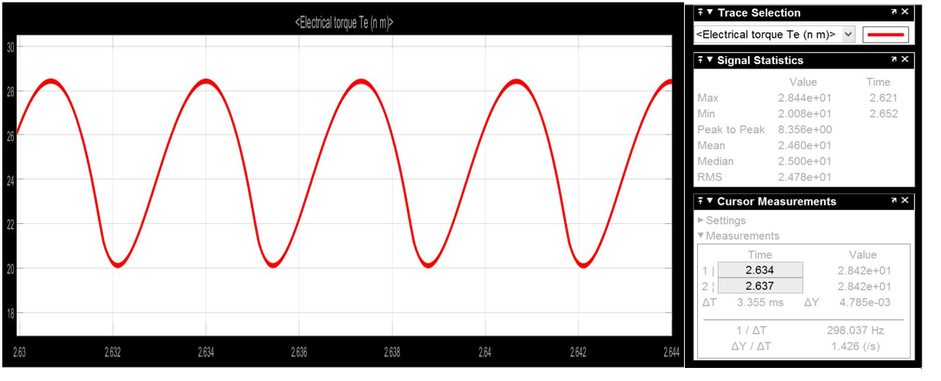

Şekil 8 Electrical torque and its statistics

As can be seen from Figure 8, the output electrical torque frequency is 300 Hz. It is 6 times larger than the grid frequency which is 60 Hz. This is expected since in each cycle there are 3 positive and 3 negative peaks of 3 different phases. Since the voltage is line-to-line, the frequency becomes 6 times larger than the grid frequency at torque ripple.

Figure 9 shows the THD of line current.

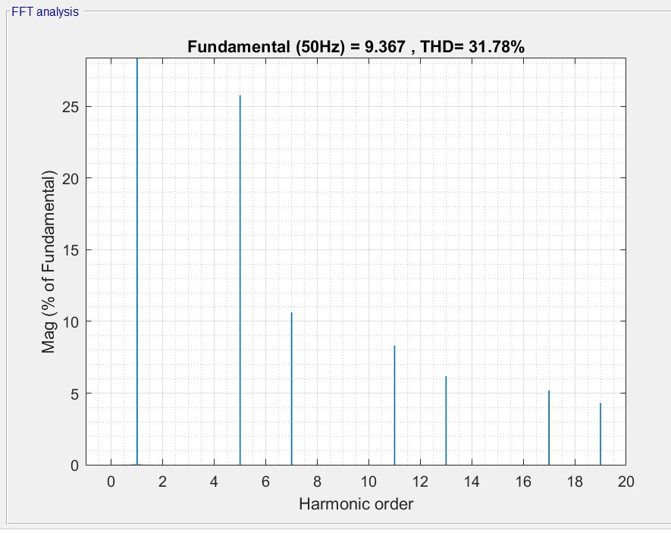

Şekil 9 THD of line current

**BURAYA YORUM ETC.**

1. Proposed Methods for Reducing the Torque Ripple Below 10% of the Average Torque

* LC Filter

The filter used for this method is called ‘Choked Input L-section Filter’. The inductance in LC filter behaves as high impedance for AC component and as short circuit for DC components. For higher frequency components, the reactance increases even more. It is a good filter for higher frequency components. Also, by the energy charging and discharging, it smoothens the output. This filter reduces the ripple inversely proportional to capacitance and inductance values.Therefore, in order to get a narrow band filter, those values must be very high. Large inductors and capacitors are problems for this topology. However, LC filter suppresses the negative effects of shunt C filter and series L filter. All in all, an efficient output is obtained.

Figure 10 shows the LC filter topology.

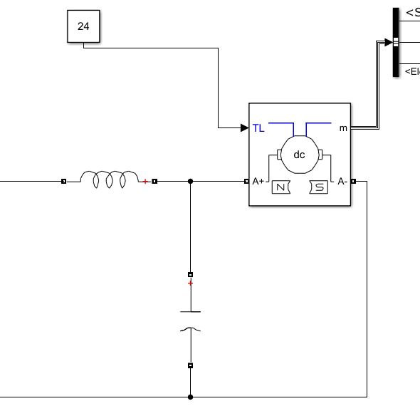

Şekil 10 LC Filter

Figure 11 shows the graphs of armature current, electrical torque and rpm of dc machine at steady state.

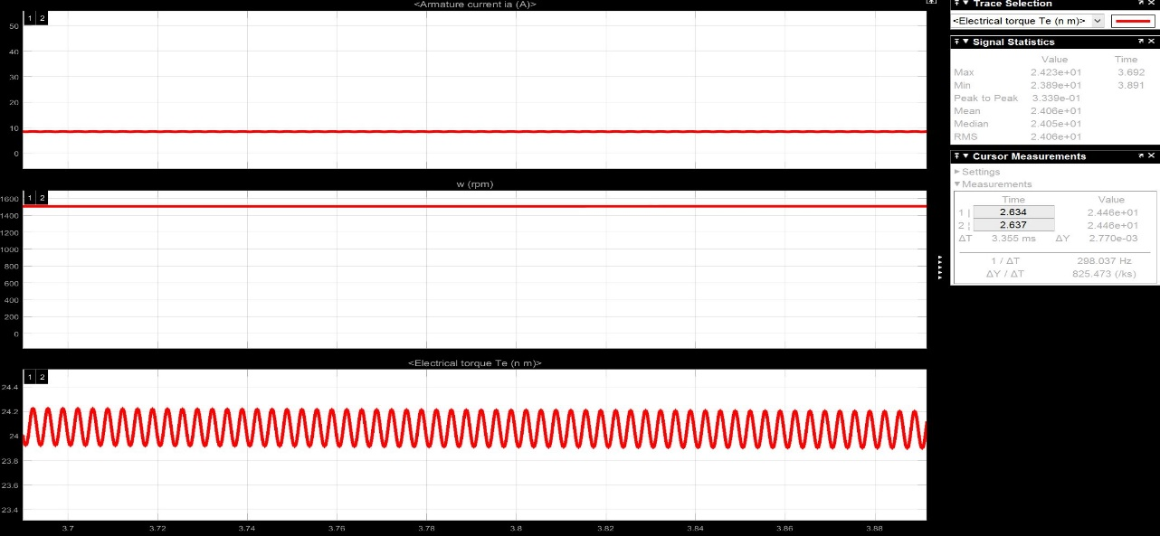

Şekil 11 Armature current, electrical torque and rpm of dc machine at steady state

The ripple can be increased and decreased by varying the inductance and capacitance.

Figure 12 shows the THD of line current.

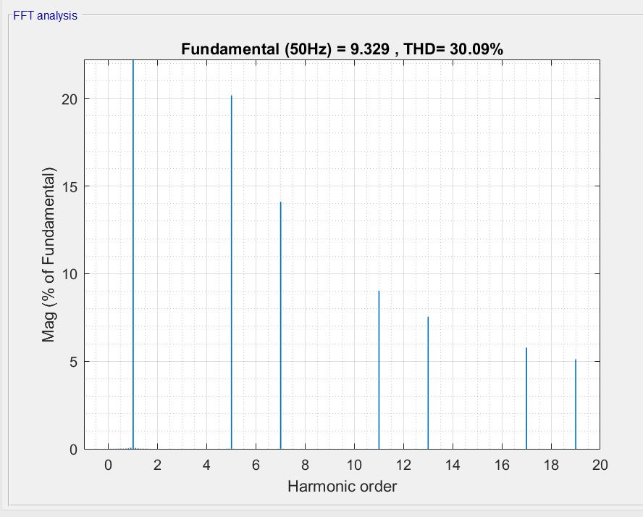

Şekil 12 THD of line current

* RC Filter

Instead of series inductor in choke input LC filter, this topology has series resistor. One of the drawbacks is the voltage drop on the resistor. However, this depends on chosen resistance value and load resistance. Also, because of the resistor, heat dissipation is high. This leads to low efficiency and heat problems. But, the circuitry is very simple and cheap. It doesn’t need to have large inductors, therefore cost and space issues can be solved.

Figure 13 shows the RC filter topology.

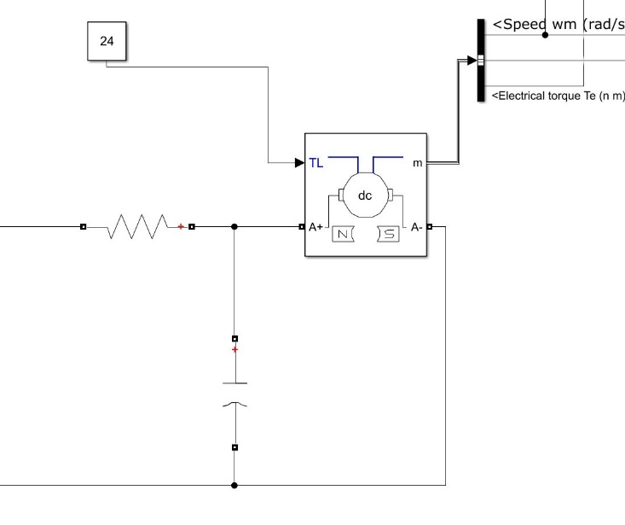

Şekil 13 RC filter topology

Figure 14 shows the graphs of armature current, electrical torque and rpm of dc machine at steady state.

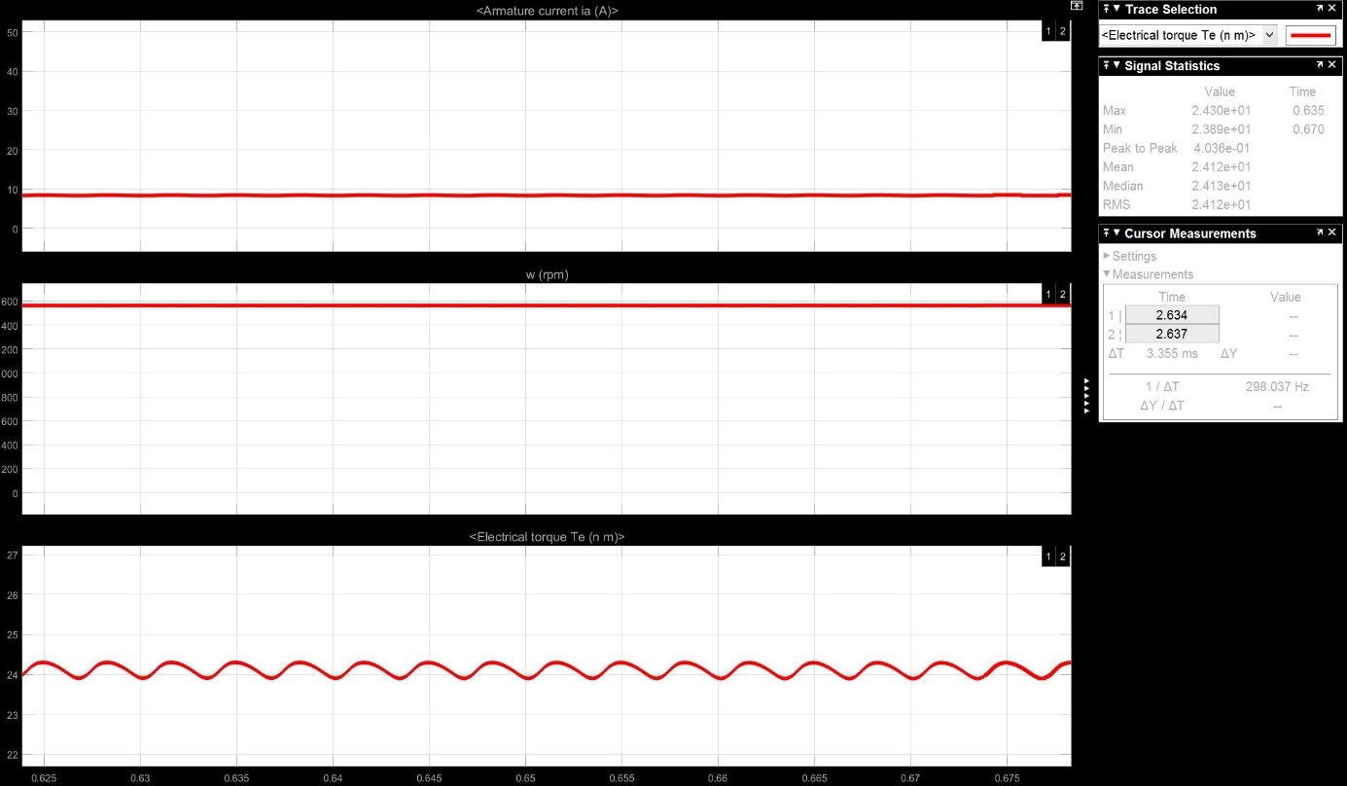

Şekil 14 Armature current, electrical torque and rpm of dc machine at steady state

The ripples can be changed by varying the R and C.

Figure 15 shows the THD of line current.

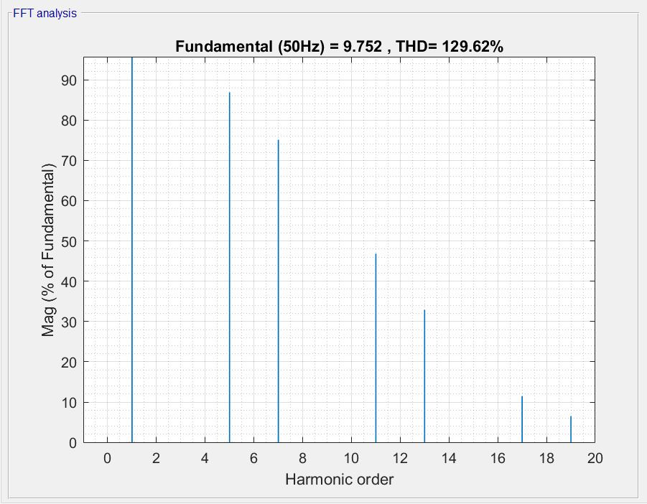

Şekil 15 THD of line current

1. Overall Efficiency and Losses

At the steady state, because of the losses during the transmission of electrical power to mechanical power, it is known that there will occur some losses. These losses are because of

* Source side losses
* Diodes losses
* Motor losses

The electrical power will be converted to mechanical power, apart from these losses. Table 1 shows the losses and power flow values.

Table 1: Power flow and losses

|  |  |  |  |  |  |
| --- | --- | --- | --- | --- | --- |
| Input Electrical Power | Source Loss | Diodes Loss | Electrical output power | Motor Loss | Mechanical Output |
| 4586 W | 13,18 W | 27,82 W | 4545 W | 737 W | 3808 W |

By using this simulated results, the efficiencies are calculated as can be seen from Table 2.

Table 2: Efficiencies

|  |  |
| --- | --- |
| Efficiency Motor(%) | Efficiency Total (%) |
| 83,78437844 | 83,0353249 |

The percentage shares of losses can be seen in Table 3 and Figure 4.

Table 3: Percentage shares of losses

|  |  |  |
| --- | --- | --- |
| Source Loss | Diodes Loss | Motor Loss |
| 1,69% | 3,58% | 94,73% |

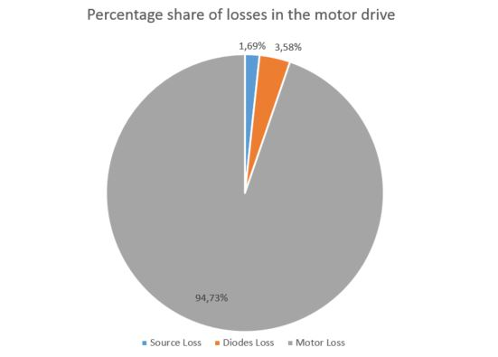

Şekil 16 Percentage share of losses in the motor drive