## **QUESTION 3**

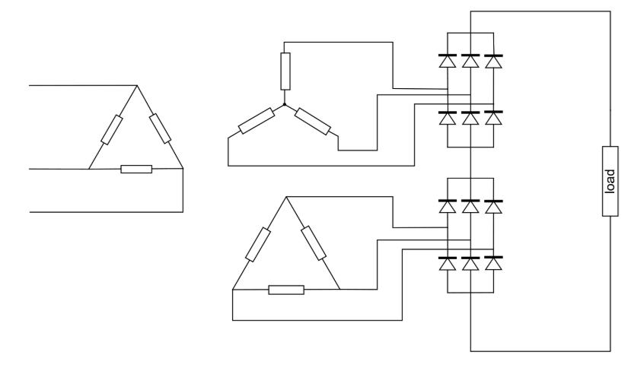

Figure 1 shows a 12-pulse uncontrolled bridge rectifier. Primary delta leads the secondary wye by 30o, hence secondary delta leads secondary wye by 30o as well. Therefore; the three-phase voltages supplying bridges are displaced by 30°. Therefore, the peak values of the output voltage are given by (1) and mean of the output voltage is found by (2) and (3).

$\sqrt{2}V_{ll}+ \sqrt{2}V_{ll}e^{j30}=1.931\sqrt{2}V_{ll}$ (1)

$$V_{d}=\frac{1}{\frac{π}{6}}*\left(1.931\sqrt{2}V_{ll}\int_{-\frac{π}{12}}^{\frac{π}{12}}{\cos\left(wt\right)d\left(wt\right)} \right) (2)$$

$$V_{d}=2.7V_{ll } (3)$$

Advantages of this rectifier is reduced THD level and voltage ripple output, increased output voltage; whereas the main disadvantage is the size of the equipment.

b) we know that mean output voltage of a three phase full bridge diode rectifier is given by (4) whereas 12-pulse rectifier’s is (3).

$$V_{d}=1.35V_{ll} (4)$$

Therefore we must choose 12 pulse bridge rectifier supply as Vll =200V.