Q2-)

In this part of the project we are asked to design a buck converter To achieve succesful opertaration we need determine values of switching frequency and commercially avaliable circuit elements. Let’s begin with using ;

Vin x D = Vout ,

Since we know input and output voltages. Duty ratio is found 0.5. For D=0.5 we know that ;

Iout / ILB, max > 1 so that we can avoid being at discontinuous conduction mode. Since

ILB, max = Ts x Vin / 8 x L putting know values into this equation we found;

L / Ts > 1 or L x fs > 1

After finding this final relationship we can determine switching frequeny and inductor. In order not to select too big induztor we select fs=20 kHz. Selected inductor and its parameters listed in Table 2.1.

Table2.: Selected inductor and its parameters

|  |  |
| --- | --- |
| Product code | IHB5EB331K |
| Datasheet | <http://www.vishay.com/docs/34015/ihb.pdf> |
| Inductance | 330 µH |
| Current Rating | 7.3 A |
| DCR | 49 mOhm (max) |
| Price | $16.99625 |

Note that altough we can select an inductor with smaller inductance value we select an inductor with highest possible inductance value that meets our criteria. Reasons is with higher inductances we can get lower ΔiL  so that we can have lower output voltage ripple.

ΔVout / Vout =π2 x (1-D) x (fc / fs) / 2

Considering voltage ripple and corner frequency should be much smaller than switching frequency. Taking these factor into account a capacitor is selected. Capacitor product code and its parameters are listed in Table 2.2.

Table .2: Selected capacitor and its parameters

|  |  |
| --- | --- |
| Product code | EGXF350ELL751MU15S |
| Datasheet | <http://www.chemi-con.co.jp/cgi-bin/CAT_DB/SEARCH/cat_db_al.cgi?e=e&j=p&pdfname=gxf> |
| Capacitance | 750 µF |
| Voltage-Rated | 35 V |
| ESR | 67 mOhm (@100kHz) |
| Price | $0.81218 |

Selected MOSFET is and its parameters also included in Table 2.3.

Table2.: Selected MOSFET and techcal properties of it

|  |  |
| --- | --- |
| Product code | FDS5680 |
| Datasheet | <https://www.fairchildsemi.com/datasheets/FD/FDS5680.pdf> |
| Drain-Source Voltage | 60 V |
| Gate-Source Voltage | -+20 V |
| Continuous drain current | 8 A |
| Pulsed drain current | 50 A |
| Power disspation | 2.5 W |
| Price | $1.86000 |

In our application maximum drain current is 43 A for few miliseconds, thus selected MOSFET meets that requirement too.

Lastly diode product code and it’s parameters indicated in Table 2.4.

|  |  |
| --- | --- |
| Product code | MBR860MFS |
| Datasheet | <https://www.onsemi.com/pub/Collateral/MBR860MFS-D.PDF> |
| Peak Repetitive Reverse Voltage | 60 V |
| Average forward current | 8 A |
| Peak surge current | 150 A |
| Forward Voltage | 0.8 V |
| Price | $0.80000 |

After selecting all components Buck converter is simulated ,n Simulink and resulted steady state graps indicated in Figure 2.1 and Figure 2.2.

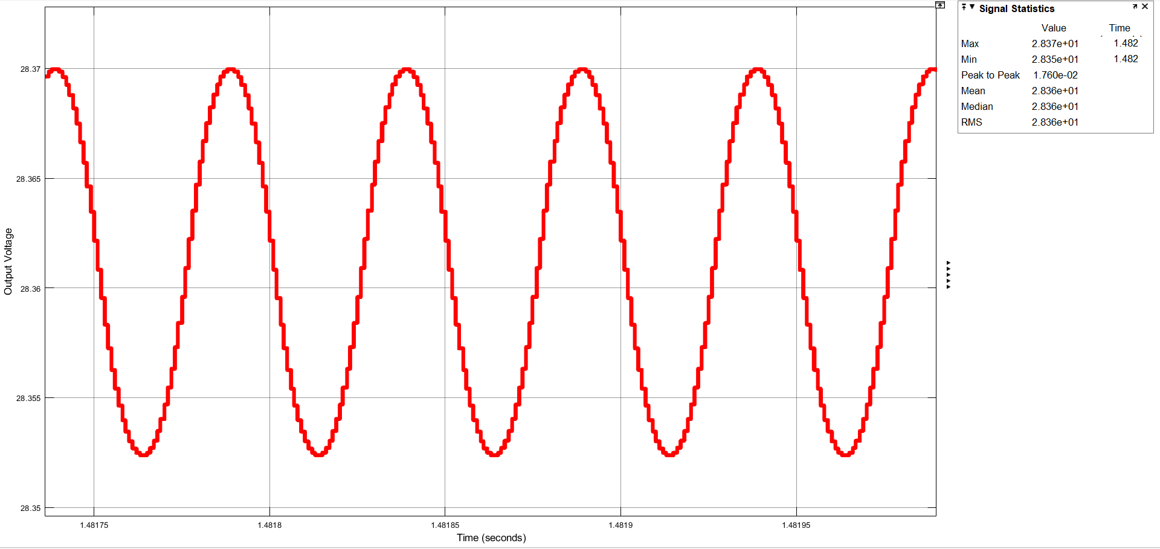

Figure : Output voltage at steady state

