

**25.03.2019**

**MIDDLE EAST TECHNICAL UNIVERSITY**

**DEPARTMENT OF ELECTRICAL & ELECTRONICS ENGINEERING**

**EE472**

**Spring 2019**

**Term Project 2:**

**Power Flow Analysis Using Newton-Raphson Iterations in MATLAB Environment**

**Student:** İven GÜZEL

**Student Number:** 2030831

**Instructor:** Murat GÖL

Table of Contents

1. INTRODUCTION 3

2. RESULTS 3

2.1. Methods to Improve Computational Performance 3

2.2. Test Results 4

2.3. Convergence Threshold 8

3. CONCLUSION 10

APPENDIX 1: SOURCE CODE 10

# INTRODUCTION

In a good power system operation, there should be no transmission line or transformer limit violation, all generating units should operate under their reactive power capacity, and bus voltages should be within the operating limit under the system’s normal operation or any of its contingencies. Power flow analysis is an important tool to determine how a system should be modified or constructed to remove likely contingencies or to serve a new load. Therefore; solving a power flow problem using data from an input file in common data format (cdf) is an important step in power system operation planning.

In this project, implementing a function in MATLAB environment that can form the bus admittance matrix (Ybus) of a system by Building Block Method and find complex bus voltages by solving the power balance equations using Newton Raphson iterations is aimed. The function must be able to find the voltage magnitudes and angles of all buses from different systems in common data format (cdf). Source code of this function can be found in Appendix I. Moreover, this report contains discussions on computational methods used to improve computational performance, test results, and convergence threshold of iterations in the Results section.

# RESULTS

## Methods to Improve Computational Performance

The methods that are used to improve the computational performance of the function are generally decided by following MATLAB’s suggestions to have the operation faster.

First of all, as few numbers of vectors and matrices as possible are changing size in every loop iteration to make the function faster.

Secondly, to find Δx values in every iteration inverse of the Jacobian matrix should be taken as it can be seen in Equation (1). Computational cost of taking the inverse of an (nxn) matrix is n3. Therefore; as the bus number of the system increases, iteration time increases significantly. Furthermore, with increasing bus number the required iteration number to reach a tolerable error increase as well. As an alternative, to decrease the computation time division comment is used in the function.

$${(x}^{k+1}-x^{k})=-J^{-1}\left(x^{k}\right).F\left(x^{k}\right) (1)$$

Table 1, provides the elapsed time between bus admittance matrix is formed using the cdf file and the IEEE bus systems converges using the two different methods mentioned above. These times are recorded before the reactive power limits of the generators are checked, therefore; they include only one set of Newton-Raphson iterations.

Table 1: Solution Durations of Division and Inversion Methods

|  |  |  |  |
| --- | --- | --- | --- |
| Method | IEEE 14 Bus | IEEE 118 Bus | IEEE 300 Bus |
| Inverse of the Matrix | 0.0559 | 0.1810 | 1.7800 |
| ‘\’ comment | 0.0506 | 0.1542 | 1.2028 |

As a third method I wanted to use the sparsity property of the bus admittance matrix. However, I had a warning from MATLAB suggesting that sparse indexing expression of Ybus matrix will likely to be slow Also, storing the Ybus as a sparse matrix caused errors while I was implementing the solution of the power flow problem. As a solution, I decided to accumulate nonzero values after the computation of Ybus is done and then only calculate power balance equations and Jacobians that use the nonzero value indexes. Unfortunately, I did not have time to implement this method.

## Test Results

In the Part 1 of the project I did not include phase shifting transformer information to my code. Therefore, after adding this property, I have checked if I get correct bus admittance matrices with the test cases provided by the course assistant. First 5 test cases are consistent with my results. As the assistant suggested as well, Test case 6 and 7 contain slight errors due to the fact that these cases are formed in PET environment and it does not include phase shifting transformers.

From Figure 1 to 6 error between the found angle & voltages and the ones obtained from the cdf files of IEEE bus 14, 118 and 300 systems can be observed.

As it can be seen error in bus voltages are in the order of 10-3 and the error in theta values are slightly larger. Some bus voltage errors are considerable larger than the others in IEEE 188 and IEEE300 bus systems. They are due to a mistake in the lines where reactive power limits of the generators are checked. Unfortunately, I did not have the time to fix this error. However, I believe these errors are still tolerable values.

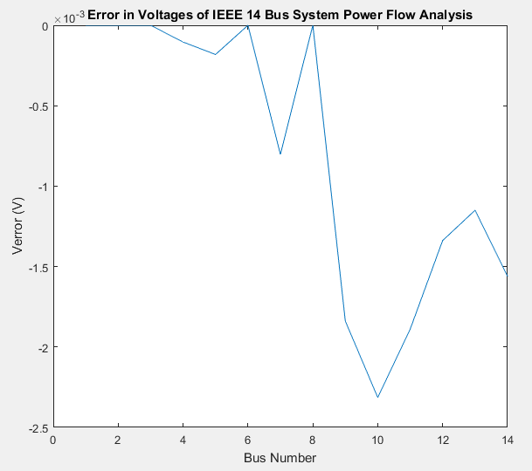

Figure 1: Error in Voltages of IEEE Bus 14 System

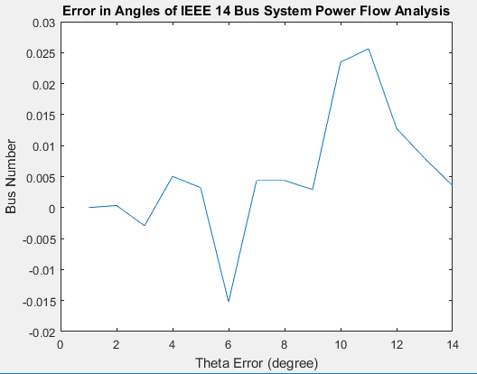

Figure 2: Error in Angles of IEEE Bus 14 System

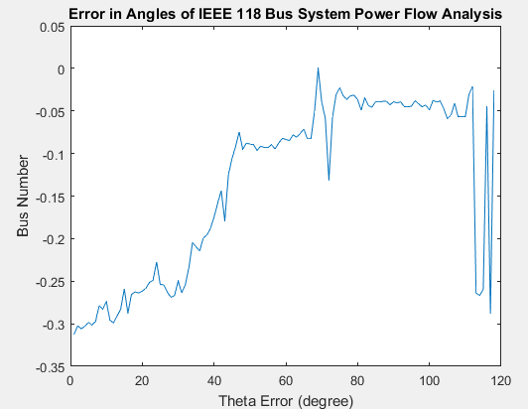

Figure 3: Error in Angles of IEEE Bus 118 System

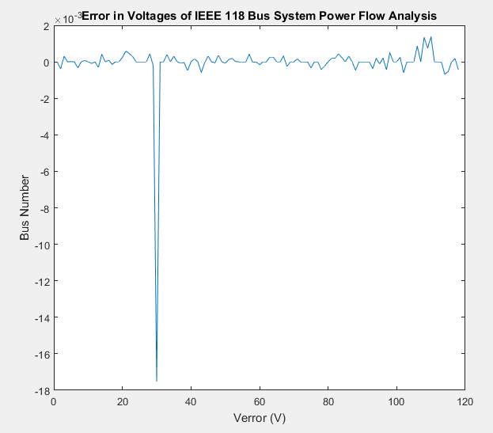

Figure 4: Error in Voltages of IEEE Bus 118 System

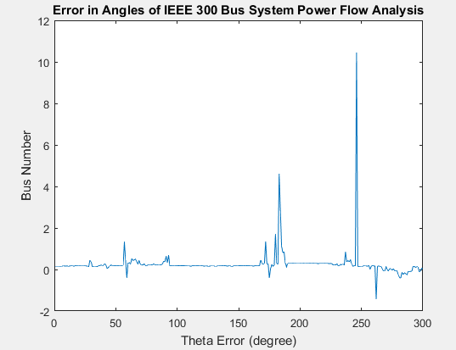

Figure 5: Error in Voltages of IEEE Bus 300 System

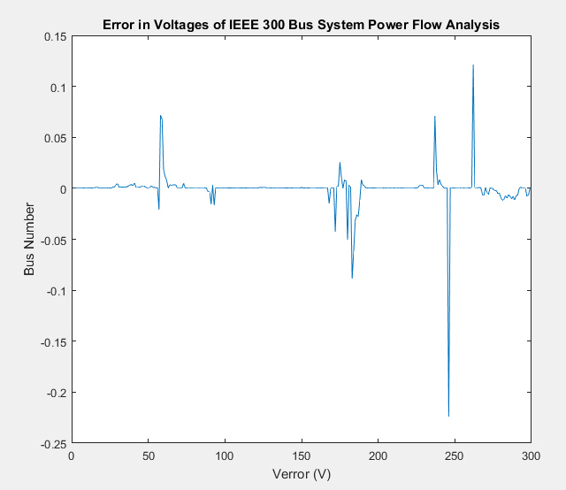

Figure 6: Error in Voltages of IEEE Bus 300 System

## Convergence Threshold

In Figure 7, 8, and 8 tolerance versus iteration of different bus systems can be seen. From these plots it can be seen that Newton-Raphson method has quadratic converges thanks to this convergence is fast. In fact, I limited the tolerance to 10-5 for convergence. Convergence is so fast that decreasing this value to 10-4 did not affect the iteration numbers for different bus systems as it can also be observed in Table 2, which shows the tolerance in each iteration.

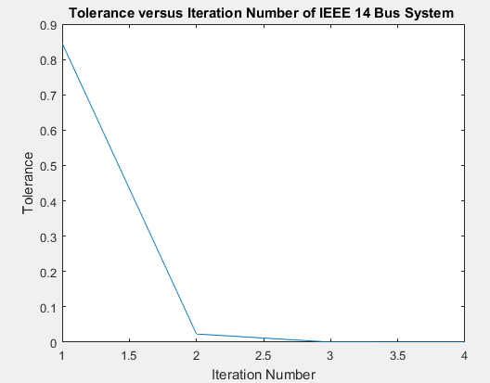

Figure 7: Tolerance of IEEE 14 Bus system

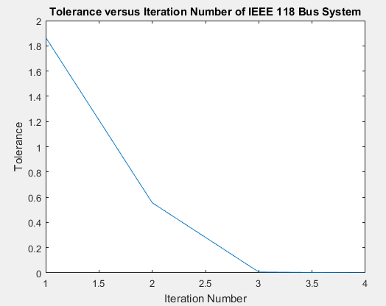

Figure 8: Tolerance of IEEE 118 Bus system

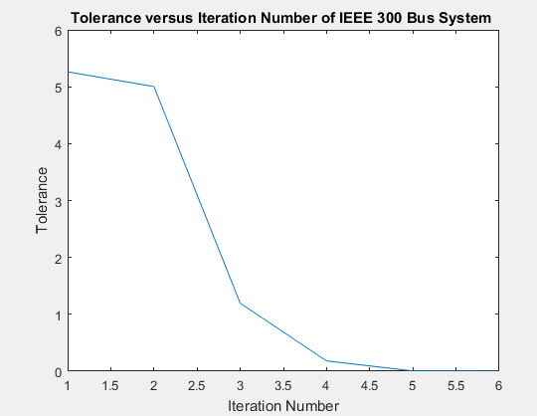

Figure 9: Tolerance of IEEE 300 Bus system

Table 2: Tolerance in each iteration

|  |  |  |  |
| --- | --- | --- | --- |
| Iteration Number | IEEE 14 Bus | IEEE 118 Bus | IEEE 300 Bus |
| 1 | 0,8461 | 5.3 | 5.263 |
| 2 | 0,0232 | 1.287 | 5.003 |
| 3 | 0,00024 | 0.0252 | 1.193 |
| 4 | 2.6x10-8 | 2.1x10-5 | 0.181 |
| 5 |  | 2.39x10-11 | 0.0047 |
| 6 |  |  | 3.06x10-6 |

# CONCLUSION

To sum up, in this project a function that solves power flow analysis has been implemented. Due to a mistake in implementing Q limits of generating buses I have larger errors compared to other buses in some buses but these errors are still small.

# APPENDIX 1: SOURCE CODE

function [V,theta] = e203083_guzel_Power_Flow(path_ieee_cdf)

%READING DATA FROM THE TEXT FILE

fileID = fopen(path_ieee_cdf); %opens the file for binary read access by giving file identifier

tline = fgetl(fileID); %returns the next line of fileID (removes nexline char)

file = tline;

while ischar(tline)

tline = fgetl(fileID);

file = char(file,tline);

end %cdf file is written and ready to be worked on

fclose(fileID);

%% CREATE Ybus

[Nbus,PQ,PV,BusIndex,G,B,Slack,S,Qmin,Qmax,VSlack,Nbus_first,V_real,Theta_real,Theta_Slack] = createYbus(file) ;

%% RUN NEWTON RAPHSON ITERATIONS (without Q limits of the generators)

tic;

[V,theta,Q,tol_vec] = NewtonRap(Nbus,PQ,PV,BusIndex,G,B,Slack,S,VSlack,Theta_Slack) ;

Tdiv =toc;

%% CHECK Q LIMITS

i = 1 ;

while(1)

ind=find(BusIndex == PV(i,1));

if Qmin(ind,1)>Q(ind,1) || Q(ind,1)>Qmax(ind,1)

file(ind+Nbus_first-1,(26)) = num2str(0) ;

[Nbus,PQ,PV,BusIndex,G,B,Slack,S,Qmin,Qmax,VSlack,Nbus_first,V_real,Theta_real,Theta_Slack] = createYbus(file) ;

[V,theta,Q] = NewtonRap(Nbus,PQ,PV,BusIndex,G,B,Slack,S,VSlack,Theta_Slack) ;

file(ind+Nbus_first-1,(26)) = num2str(2) ;

end

i = i+1 ;

if i-1==length(PV)

break;

end

end

theta = radtodeg(theta);

function [Nbus,PQ,PV,BusIndex,G,B,Slack,S,Qmin,Qmax,VSlack,Nbus_first,V_real,Theta_real,Theta_Slack]= createYbus(file)

%This local function takes cdf file as input and creates Ybus

BMva=100; %Sbase (MVA)

%% FIND the NUMBER of BUSES

first_row = 1;

while(1) %Find where BUS info starts

if file(first_row,1:3) == 'BUS'

break;

else

first_row = first_row + 1;

end

end

first_row = first_row + 1; %Because bus data starts in the next line from 'BUS'

row_num = first_row;

while(1) %Count the rows until you see '-999'

if file(row_num,(1:4)) == '-999'

break;

end

row_num = row_num + 1;

end

Nbus_first = first_row;

Nbus_last = row_num -1 ; %row_num is the line with -999

Nbus = Nbus_last - Nbus_first +1; %Number of buses in the system

%% FIND the NUMBER of BRANCHES

Nbranch_start = row_num + 2;

row_num = Nbranch_start;

while(1) %Look for -999

if file(row_num,(1:4)) == '-999'

break;

end

row_num=row_num+1;

end

Nbranch_last = row_num - 1; %row_num is where -999 is.

Nbranch = Nbranch_last - Nbranch_start +1; %Number of branches

%% CREATING Ybus and FINDING INJECTED POWER & Q LIMITS & BUS TYPES

BusIndex = zeros(Nbus,1);

Ybus = zeros(Nbus,Nbus);

countpq = 1 ;

countpv = 1 ;

PQ = [] ;

PV= [] ;

Qmin = zeros(Nbus,1);

Qmax = zeros(Nbus,1);

for m=1:Nbus

G = str2double(file(Nbus_first + (m-1) ,(107:114)));

B = str2double(file(Nbus_first + (m-1),(115:122)));

Ybus(m,m)= G + 1i*B ;

Qmin(m,1) = str2double(file(Nbus_first + (m-1) ,(99:105)));

Qmax(m,1) = str2double(file(Nbus_first + (m-1) ,(91:97)));

P_cdf(m,1) = str2double(file(Nbus_first + (m-1),(60:66))) - str2double(file(Nbus_first + (m-1),(41:48))) ;

V_real(m,1) = str2double(file(Nbus_first + (m-1) ,(28:33)));

Theta_real(m,1) = str2double(file(Nbus_first + (m-1) ,(34:40)));

if (str2double(file(Nbus_first + (m-1),(25:26))) == 0 || (str2double(file(Nbus_first + (m-1),(25:26))) == 1)) %Type PQ buses

PQ(countpq,1) = str2double(file(Nbus_first + (m-1),(1:4))) ; %bus name

PQ(countpq,2) = str2double(file(Nbus_first + (m-1),(60:66))) - str2double(file(Nbus_first + (m-1),(41:48))) ; % Pg-Pl for PQ buses

PQ(countpq,3) = str2double(file(Nbus_first + (m-1),(68:74))) - str2double(file(Nbus_first + (m-1),(50:57))) ; % Qg-Ql for PQ buses

countpq = countpq +1 ;

end

if (str2double(file(Nbus_first + (m-1),(25:26)))) == 2 %Type PV buses

PV(countpv,1)= str2double(file(Nbus_first + (m-1),(1:4))) ; %Stores bus name

PV(countpv,2)= str2double(file(Nbus_first + (m-1),(28:32))) ; % Stores final voltage values (pu)

PV(countpv,3) = str2double(file(Nbus_first + (m-1),(60:66))) - str2double(file(Nbus_first + (m-1),(41:48))) ; % Pg-Pl for PV buses

countpv = countpv +1 ;

end

if (str2double(file(Nbus_first + (m-1),(25:26)))) == 3 %Type Slack

Slack(1,1) = str2double(file(Nbus_first + (m-1),(1:4))) ; %bus name

VSlack = str2double(file(Nbus_first + (m-1),(28:32))) ; %theta slack is assumed to be zero

Theta_Slack = str2double(file(Nbus_first + (m-1),(34:40))) ;

end

BusIndex(m,1) =str2double(file(Nbus_first+ (m-1) ,(1:4))) ; %Bus names might be different than our index, so store these for branch relations

end

for m=1:Nbranch %This loop constructs Ybus

send_bus = str2double(file(Nbranch_start+m-1,(1:4)));

rec_bus = str2double(file(Nbranch_start+m-1,(6:9)));

R = str2double(file(Nbranch_start+m-1,(20:29)));

X = str2double(file(Nbranch_start+m-1,(30:40)));

B = str2double(file(Nbranch_start+m-1,(41:50)));

Turn_ratio = str2double(file(Nbranch_start+m-1,(77:82)));

TR_type = str2double(file(Nbranch_start+m-1,(19)));

if TR_type == 4

Phase_angle = str2double(file(Nbranch_start+m-1,(84:90)));

Turn_ratio = (Turn_ratio*cos(Phase_angle*0.0174532925)+ Turn_ratio*sin(Phase_angle*0.0174532925) ); %For Phase shifters 1 deg=0.0174532925 radians

end

if Turn_ratio == 0 %they put zero sometimes to indicate no transformers

Turn_ratio = 1;

end

Y1 = find(BusIndex == send_bus); % To see which index sending bus name corresponds

Y2 = find(BusIndex == rec_bus); % To see which index receiving bus name corresponds

Ybus(Y1,Y1) = Ybus(Y1,Y1) + (1/(R + 1i* X)) / (Turn_ratio^2) + 1i*B/2; % When the type is TL it does not hange anything since n=1

Ybus(Y2,Y2) = Ybus(Y2,Y2)+ (1/(R + 1i* X)) + 1i*B/2;

Ybus(Y1,Y2) = Ybus(Y1,Y2) - ((1/(R + 1i* X)) / (conj(Turn_ratio)));

Ybus(Y2,Y1) = Ybus(Y2,Y1) - ((1/(R + 1i* X)) /Turn_ratio) ;

end

%% PROJECT 2:

G = real(Ybus) ; %These values were in Pu

B = imag(Ybus) ;

Slack = find (Slack == BusIndex) ;

S = [P_cdf([1:Slack-1,Slack+1:end]);PQ(:,3)] ; % [Injected power of all buses except slack's , Injected react power of Q buses] ==> True values

S = S / BMva ; % Find pu values

Qmin = Qmin / BMva ; % Find pu values

Qmax = Qmax / BMva ;

end

function [V,theta,Q,tol_vec] = NewtonRap(Nbus,PQ,PV,BusIndex,G,B,Slack,S,VSlack,Theta_Slack)

theta = zeros(Nbus,1) ; % flat start

theta(Slack) = degtorad(Theta_Slack);

V = ones(Nbus,1) ; % flat start

V(Slack) = VSlack ;

for i=1:length(PV)

ind=find(BusIndex == PV(i,1)); % PV(:,1) stores bus names , bus index might be different than bus name

V(ind,1) = PV(i,2) ; %We know V of PV buses so add this info

end

tol = 100 ; % We will check if the tolerance converges

it_number = 0;

while(tol>0.00001) %SET THE ACCEPTABLE ERROR in the APPROXIMATION HERE !!

%% POWER BALANCE EQUATIONS

P = zeros(Nbus,1);

Q = zeros(Nbus,1);

for r=1:Nbus

for j=1:Nbus

P(r,1)=P(r,1)+V(r)*V(j)*(G(r,j)*cos(theta(r)-theta(j))+B(r,j)*sin(theta(r)-theta(j)));

Q(r,1)=Q(r,1)+V(r)*V(j)*(G(r,j)*sin(theta(r)-theta(j))-B(r,j)*cos(theta(r)-theta(j)));

end

end

% % % % % for i=1:length(PV)

% % % % % ind=find(BusIndex == PV(i,1));

% % % % % S_est(i,1) = P(ind,1) ;

% % % % % end

S_est = P([1:Slack-1,Slack+1:end]) ; %Write P&Q in column format

for i=1:length(PQ)

ind=find(BusIndex == PQ(i,1));

S_est(length(PV)+length(PQ)+i,1) = Q(ind,1) ;

end

%% JACOBIAN MATRICES

J_11=zeros(Nbus,Nbus); %J11 =delP/del(theta)

for r=1:Nbus

m=r;

for j=1:Nbus

n=j;

if m==n

for n=1:Nbus

J_11(r,j)=J_11(r,j)+V(m)*V(n)*(-G(m,n)*sin(theta(m)-theta(n))+B(m,n)*cos(theta(m)-theta(n)));

end

J_11(r,j)=J_11(r,j)-V(m)^2*B(m,m);

else

J_11(r,j)=V(m)*V(n)*(G(m,n)*sin(theta(m)-theta(n))-B(m,n)*cos(theta(m)-theta(n)));

end

end

end

%% Formation Of J_12

J_12=zeros(Nbus,length(PQ));

for r=1:Nbus

m=r;

for j=1:length(PQ)

n=find(PQ(j,1)==BusIndex);

if m==n

for n=1:Nbus

J_12(r,j)=J_12(r,j)+V(n)*(G(m,n)*cos(theta(m)-theta(n))+B(m,n)*sin(theta(m)-theta(n)));

end

J_12(r,j)=J_12(r,j)+V(m)*G(m,m);

else

J_12(r,j)=V(m)*(G(m,n)*cos(theta(m)-theta(n))+B(m,n)*sin(theta(m)-theta(n)));

end

end

end

%% Formation Of J_21

J_21=zeros(length(PQ),Nbus);

for r=1:length(PQ)

m=find(PQ(r,1)==BusIndex);

for j=1:Nbus

n=j;

if m==n

for n=1:Nbus

J_21(r,j)=J_21(r,j)+V(m)*V(n)*(G(m,n)*cos(theta(m)-theta(n))+B(m,n)*sin(theta(m)-theta(n)));

end

J_21(r,j)=J_21(r,j)-V(m)^2*G(m,m);

else

J_21(r,j)=V(m)*V(n)*(-G(m,n)*cos(theta(m)-theta(n))-B(m,n)*sin(theta(m)-theta(n)));

end

end

end

%% Formation Of J_22

J_22=zeros(length(PQ),length(PQ));

for r=1:length(PQ)

m=find(PQ(r,1)==BusIndex);

for j=1:length(PQ)

n=find(PQ(j,1)==BusIndex);

if m==n

for n=1:Nbus

J_22(r,j)=J_22(r,j)+V(n)*(G(m,n)*sin(theta(m)-theta(n))-B(m,n)*cos(theta(m)-theta(n)));

end

J_22(r,j)=J_22(r,j)-V(m)*B(m,m);

else

J_22(r,j)=V(m)*(G(m,n)*sin(theta(m)-theta(n))-B(m,n)*cos(theta(m)-theta(n)));

end

end

end

J_11=J_11([1:Slack-1,Slack+1:end],:);

J_11=J_11(:,[1:Slack-1,Slack+1:end]);

J_12=J_12([1:Slack-1,Slack+1:end],:);

J_21=J_21(:,[1:Slack-1,Slack+1:end]);

J=[J_11 J_12 ; J_21 J_22]; % Jacobian Matrix

%% MISMATCH VECTOR F(x)

Fx = S_est - S ;

%X=inv(J)*Fx;

X = J\Fx ;

theta([1:Slack-1,Slack+1:end],1) = theta([1:Slack-1,Slack+1:end],1)- X(1:Nbus-1,1) ; %Remove the slack bus info and update theta values

for i=1:length(PQ) %Update unknown voltage values which are the voltage values of PQ buses

ind=find(BusIndex == PQ(i,1));

V(ind,1) = V(ind,1) - X(Nbus-1+i,1) ;

end

tol = norm(X) ; % Check the total error in Delta(X)

it_number = it_number +1;

tol_vec(it_number,1) = tol;

end

%%FINAL P&Q VALUES

P = zeros(Nbus,1);

Q = zeros(Nbus,1);

for r=1:Nbus

for j=1:Nbus

P(r,1)=P(r,1)+V(r)*V(j)*(G(r,j)*cos(theta(r)-theta(j))+B(r,j)*sin(theta(r)-theta(j)));

Q(r,1)=Q(r,1)+V(r)*V(j)*(G(r,j)*sin(theta(r)-theta(j))-B(r,j)*cos(theta(r)-theta(j)));

end

end

end

end