Noroff

Front-End Development

Project Exam 1

Ørjan Iversen

16.06.2019

Link to microsite:

http://front-development.com/project-exam-1/index.html

Introduction

Planning:

- Functional spec
- Gantt chart

Research

Design:

- Graphic
- Interface
HTML

CSS

Content:

- SEO
- WCAG

Javascript

Implementation

Conclusion

References

Introduction:

A microsite is a branded content site that lives outside of the company homepage.
There are many benefits of having a microsite. They target a specific demographic, highly optimized for certain content and have greate promotional value.

In this report I will go through the process of creating the project exam 1 task of building a microsite for SpaceX. This site will be an exstention to the main SpaceX website.
This microsite builds around ongoing content from the main site, mainly focuses on SpaceX launches.
This report will cover all the steps made from conception to completion. I will go through the project planning which includs functional spec, Gnatt chart, target audience, storyboards, prototype and the coding process with HTML, CSS and Javascript. Also search enging optimization and web content accessibility guidelines to make sure the microsite is usable for everyone.

Planning;

Project Plan:

Building a microsite with the focus on space technology for SpaceX or NASA. This website is an addition to an existing website. The focus of the site is to provide information about launches and contain information about SpaceX. There will be contact options and countdown for future launches. Also a complete searchable archive of all SpaceX launches. All platforms will be able to access the website. There will be a target audience that will be the main focus, so the language and functions will appeal more to the specific group. The main focus of the project is to raise awareness about space program activity

Dates:
This project have a lifespan of 5 weeks. With an end 16.06.2019

Work Breakdown Structure(WBS)

Phases:

    - Pre-project:

1.1 Project plan.
1.2 Functional specifications.
1.3 Gantt chart.

    - Planning:

2.1 Target Audience.
2.2 Personae.
2.3 Storyboards.
2.4 Wireframe and prototype.

    - Strategy:

3.1 Design.
3.2 UI.

    - Functionality:

4.1 HTML semantics.
4.2 CSS structure.
4.3 JSON API/Javascript.

    - Testing:

5.1 SEO.
5.2 WCAG.
5.3 Responsiveness.
5.4 Bugs.

    - Delivery:

6.1 Rollout.
6.2 Report.

Functional Specification:

The site shall:

    - Focus on space technology and program activity.

    - Develop a microsite for all devices. Be responsive.

    - Appeal to a ceratin audience.

    - Site Specifications:

4.1 General platform specification for all pages:
4.1.1 SpaceX logo which links to SpaceX mainsite.
4.1.2 Page links in header
4.1.3 Large image under header.
4.1.4 Countdown to next launch in subheader.
4.1.5 Social media links displayed sticky on left side.
4.1.6 Footer with logo.

  - Main page:

4.2.1 Full screen image container.

  - About page:

4.3.1 Parallax effect in scrollable container.
4.3.2 Images with headline.
4.3.3 Information underneath images.

  - Launches:

4.4.1 Info about search option
4.4.2 Search bar for launches.
4.4.3 Display searched launch with patch, information, links and relevant image.

  - Contact:

4.5.1 Information about contact form
4.5.2 Contact form

  - Development Specifications:

4.6.1 Contact form with javascript validation.
4.6.2 JSON API fetch for launch information.
4.6.3 Countdown clock for next launch, with link to the relevant launch.
4.6.4 The site shall be easy to update.
4.6.5 User friendly.
4.6.6 Site language tech-heavy.
4.6.7 Social media icons which links to SpaceX media sites.

Gnatt chart:

Milestones:

        - Pre-plannig finished.
1.1 Project plan, Gnatt chart and functional specification complete.

        - Design accomplished.
2.1 Prototype complete.
        - HTML, CSS and Javascript written.
3.1 All functional and technical code complete.

        - Website is tested for bugs and ready for launch.
4.1 Cross-platformbrowser testing and website modifications finished.

        - Project done.
5.1 Website up and running and report delivered.

Target Audience:

To attract the relevant target audience it is important to find the relevance between what you want to say and what they are interested in. By being SMART: specific, measurable, achiveable, relevant and time-bound, it is easier to understand what kind of audience that this microsite is aiming for.
The target audience for this microsite is space enthusiast and the tech-savvy people of Generation C(Connected).
Space enthusiast is one who is ardently absorbed in interest like space, space technology and space travel. The age group that is targeted is between 25-year-olds to the moon landing babies of 1969, 50-year-olds.
The top end of the scale is because they were born and raised with space exploration and the evolution of technology. The low end of the scale is because they are most likely done with their education, grown up with the modern use of technology and future orientated. There are no gender, wealth or ethnicity challenges here. Almost everyone has a computer, tablet or phone, or they have access through schools, libraries and public areas. Their common interests are space and technology. Since most of this happens across the pond, in the USA, it is important to create a media-friendly site that is easy to use and share.
Generation C is not bound by age, it is a mindset for a group bound by values and interests. Since there is no age limitation to this group, nor age, wealth, geography or ethnicity, they are solely defined by connectivity. This group is hard to pinpoint the main characteristics, therefore, it is important to reach them where they are, online. Social media, blogs, chats, online sites.
Statistics from thinkwithgoogle: https://www.thinkwithgoogle.com/consumer-insights/meet-gen-c-youtube-generation-in-own-words/

- 59% say the internet is their main source of entertainment and
- 38% turn to their phone first when they want to be entertained
- 66% spending the same amount of time or more time watching online videos compared to TV.
- 55% say they’re connected to 100 or more people through social sites
- 15% are connected to 500+ people.
- 38% say they share videos on a social network after watching them on YouTube.

To attract and keep their attention it is important to have a well-designed website and be functional on all platforms. The online presence of the company should be heavy. By allowing them to access the site through social media pages, facebook, reddit, snapchat, Instagram etc. and share information to make them want to click on and spread across the web. It is important to have the microsite be up to date and everything works at all times. And by adding more up to date commentary during the live feed and create more vibrant and entertaining videos.
This group is especially important to reach because of their ability to share content to the wider audience and create greater interest for the space program, launches and the future development of the space travel.

Persona:

Persona 1:

Name: Laila

Age: 25-30 yo

Gender: Female

family: Single

Job title/Role: Instructor of Computer Science

Education level: BAS. Bachelor of Applied Science

What she cares about:
- Education
- Technology
- Friends
- Family

User needs:
She needs up to date information from the site she is using. Also a functional multiplatform site.
What she needs is popup notifications on the phone when activities she's interested in happens.

User environment:
She is highly skilled in using all kinds of digital platforms and the most common social media apps.
Most of her time she uses her phone to access the web with wifi and 4G. She is online most of the day.

Quote:

“ I loves Sci-Fi movies, will we be able to travel to different galaxys in my life time?”

Persona 2:

Name: Ivar

Age: 45-50 yo

Gender: Male

Family: Married with 4 grown children

Job title/Role: Railway Engineer

Education level: Railway Engineering with Projectt Managment MSc

What he cares about:
- Sports
- Family
- Food & drink

User needs:
Because he is a busy man and is mutch on the road he is not capable to access the web when he wants. So he needs an email newslist option to keep up to date about his interests.

User environment:
He mostly use his computer at home to browse the web. Is a moderate user of a smart phone but is not interested in modern social media. Standard internet connection.

Quote:
“Did the moon landing actually happen”?

Persona 3:

Name: Jonny

Age: 35-40 yo

Gender: Male

Familiy: Domestic partnership

Job title/Role: Actuary

Education level: Master from Blindern

What he cares about:
- Football
- Crosscountry skiing
- Traveling

User needs:
Clear information about future plans and launches. A videofeed that works without delays and bugs.
Detailed technological information.

User environment:
Uses the platform that is nearest. There is no differents from using a computer, smart phone or a tablet. Average time online. Uses high-speed internet access.

Quote:
“How will future technology influence sports?”

Persona 4:

Name: Jeanette

Age: 15-20 yo

Gender: Female

Family: Parents and one sibling

Job title/Role: Student

Education level: High School

What she cares about:
- Friends
- Socialicing
- The future

User needs:
What she needs is the posibility to share links and videos through social media. Gather feedback from her posts and chat to people with common interestes.

User environment:
Very much in the loop when it comes to current trends and technology. Loves to update her instagram and share tweets. Mostly uses 4G connection.

Quote:
“I think the flying car is right around the corner”

Persona 5:

Name: Napoleon

Age: 40-45 yo

Gender: Male

Job title/Role: Software Programmer

Education level: Self educated

What he cares about:
- Hunting
- Hiking
- Gadgets

User needs:
Always on the go, receivs to many e-mails every day. Does not have time to look up information.
There has to be a good archive option for articles, older videos and history.

User environment:
He is tech-savvy and always has the newest gadget on the marked. Burning interest for IoT so he is always online and his life is run from his smart phone. 4G is the main access point for the web. But also knows how to go offline to enjoy nature.

Quote:
“The past, presence and future can live in harmony”

Link to prototype:

https://xd.adobe.com/view/cb7c9858-4336-44eb-792f-50e641f5b1a9-bd4d/

Wireframe:
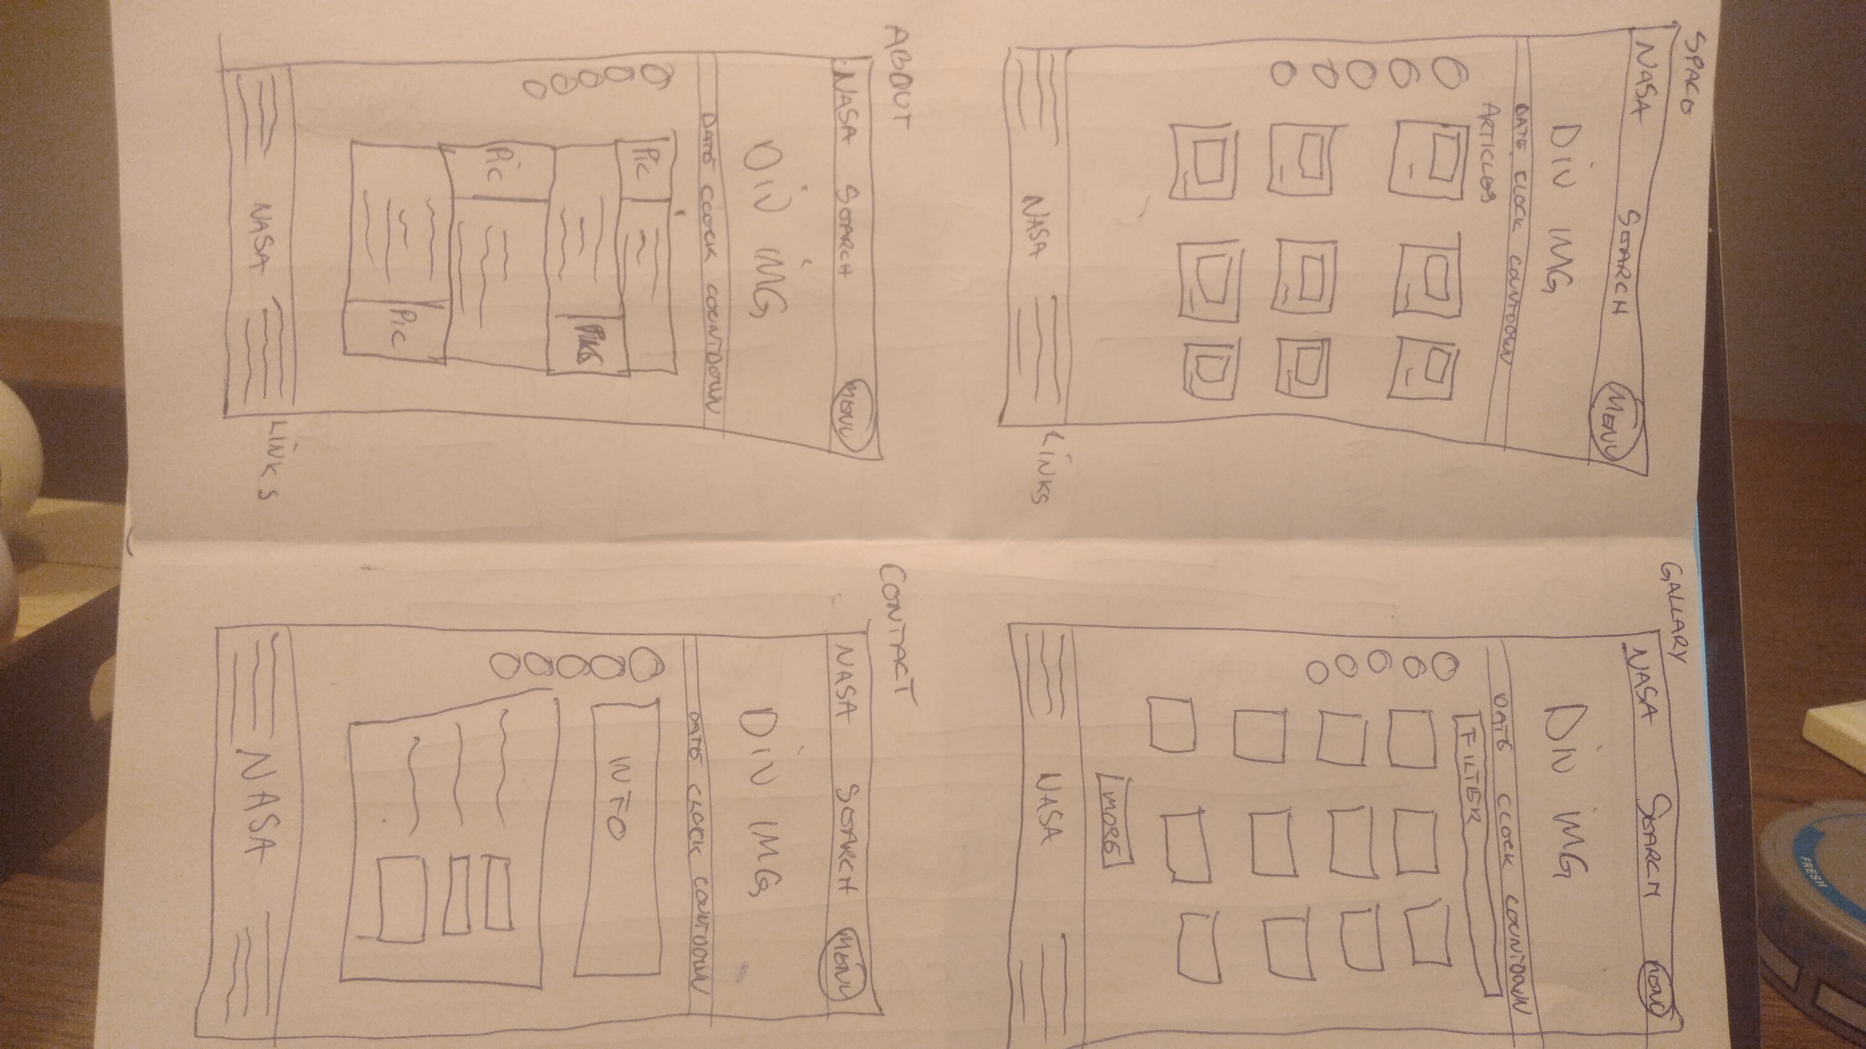

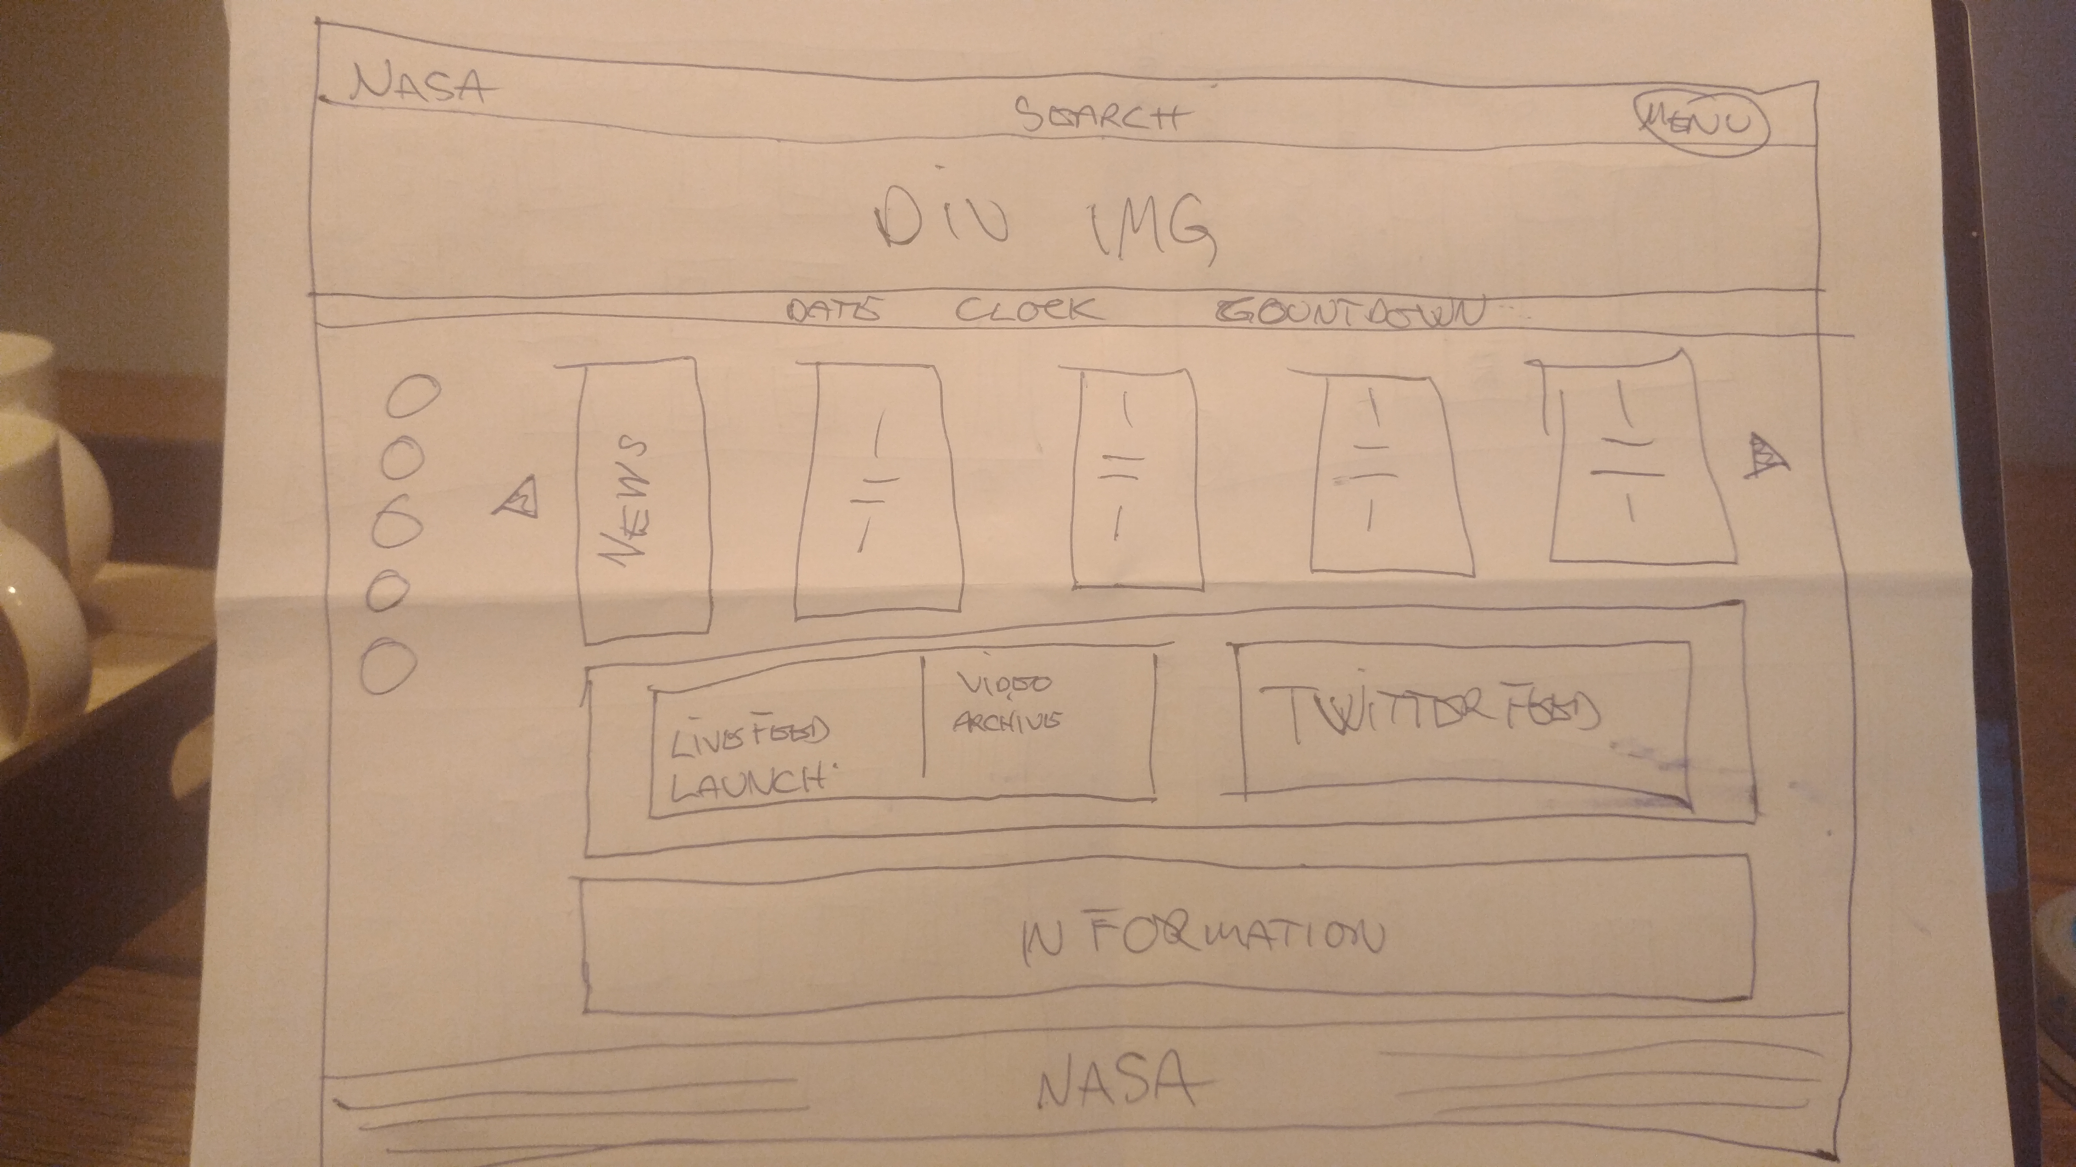

Storyboards:

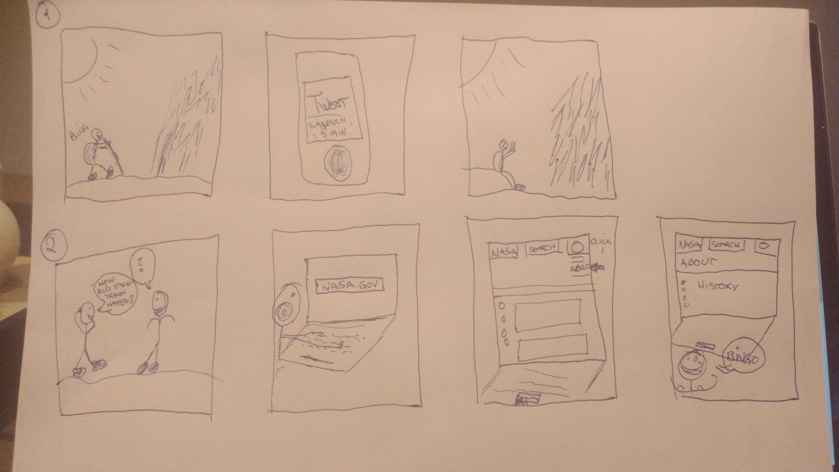

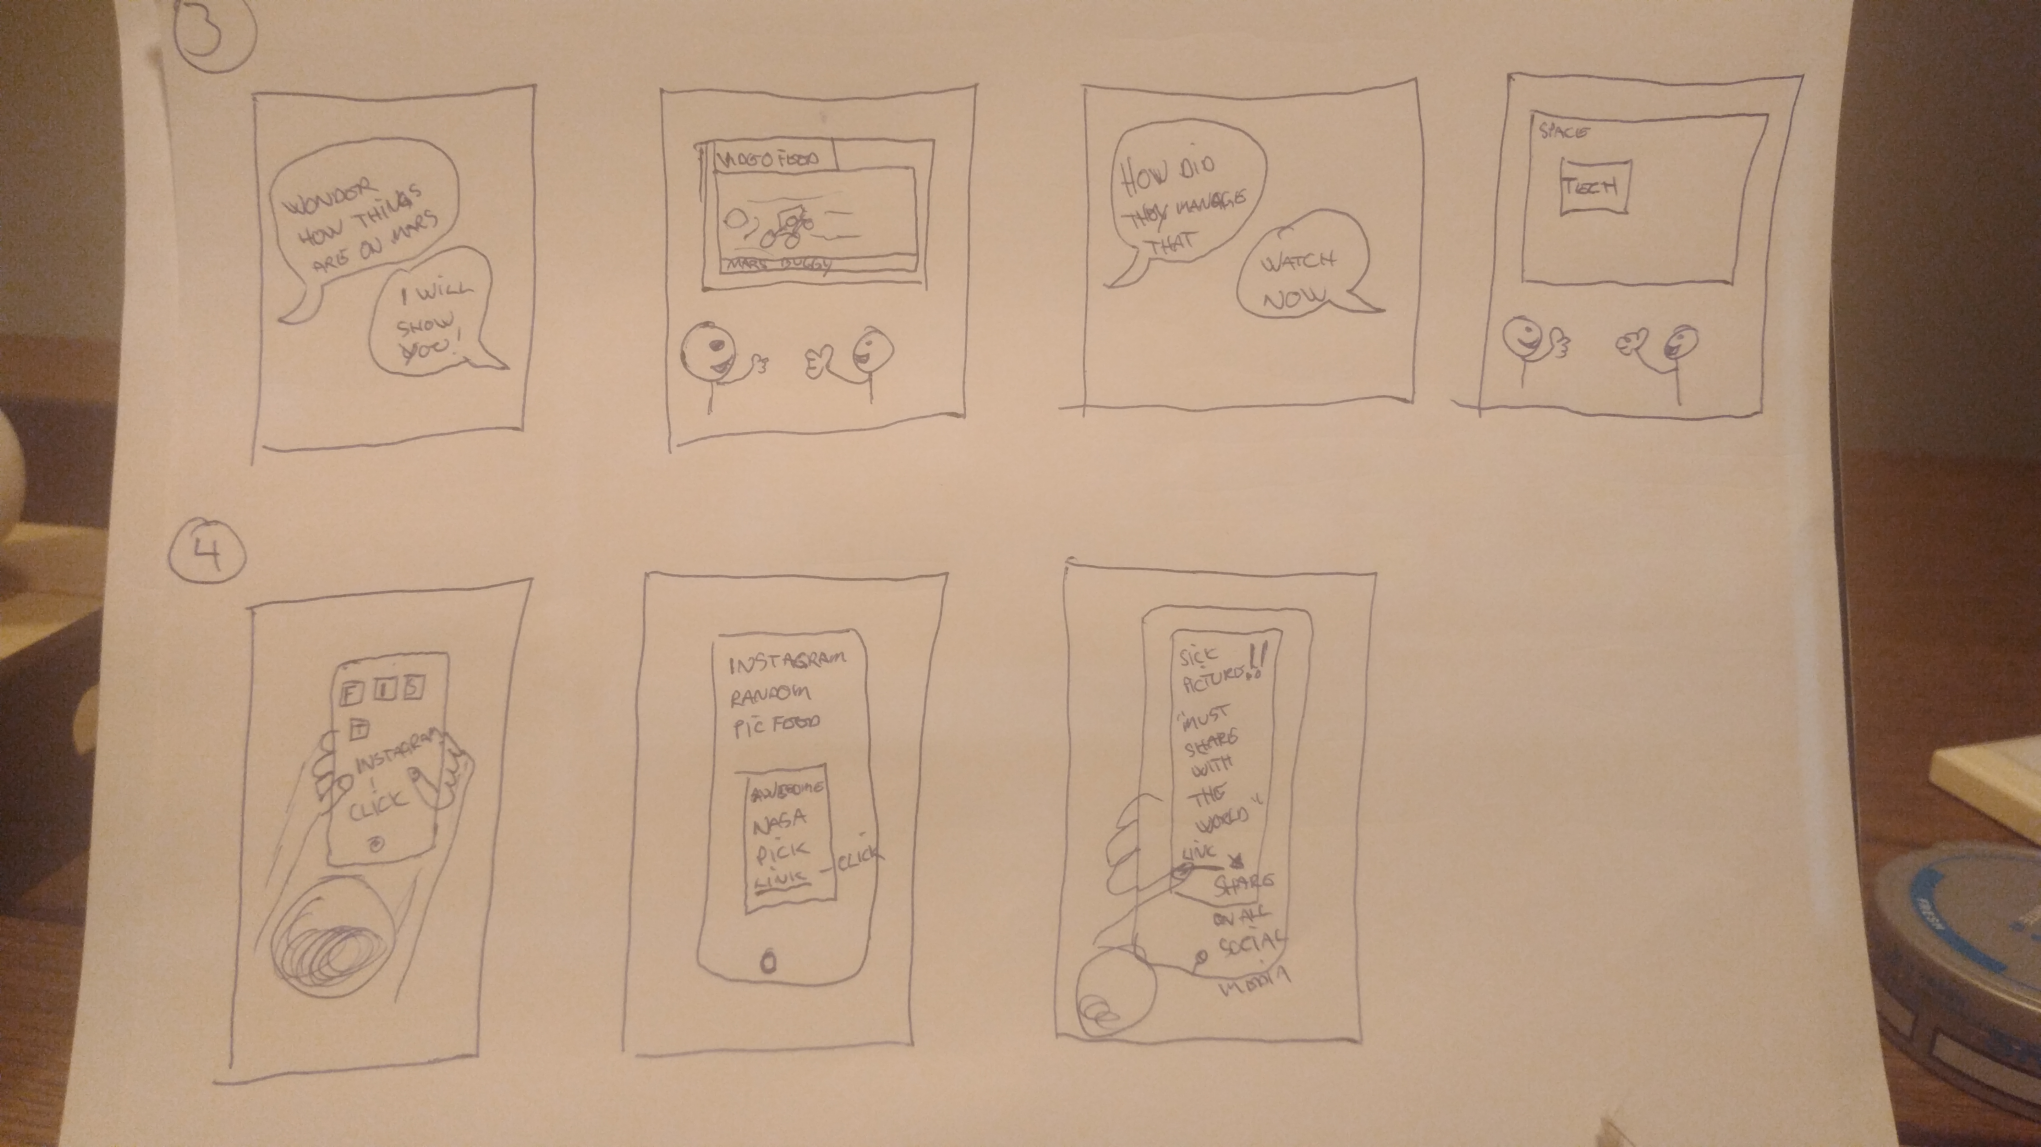

Design:

When working on the graphic design for this microsite I had specific aspects in mind. Since this is a microsite connected to SpaceX own main site I chose a yin and yang approach. SpaceX.com has a black and white color scheme on their header and footer so I went with a white and black theme for my microsite. The setup for header and footer are simple and not overcomplicated. Basic use of the logo and links. I then desicded to use SpaceX own color pallett from their logo to use on many of the paragraphs and headlines. The idea behind these choices is that the user should feel that they are on a site that is spaceX own subsite. I wanted the header and footer not to be a content catch-all, jam links and to mutch information in small spaces, so I kept I clean and clutter free.

Space is something I have given this site. By giving elements distance all around and using negative space or whitespace to create a breatheable website. I implemented this on almost all pages, execpt the homepage. The homepage is

HTML:

HTML stands for hypertext markup language. An HTML file contains the structure of the page itself.

When planning the layout I first made it to busy. To much happening on each of the pages. So I reduced the amount of elements on each page and added more room for the elements still left on the page.

I started with the header and footer to have a start and ending for the pages. Here the semantic tags <header> and <footer> are used to form content. These tags tell the browser how the display the content on the website. Setting up both of them with SpaceX own logo that also link direct to SpaceX.com. This was done by adding spaceX.com in to <a href=” ”> connected to the <img src=>. Under the logo I set up links to the other pages on the microsite. Here I created a <nav> tag, to define a set of navigations links, <ul> and <li><a href> to hold the subpages links.

Same as the header and footer there is a countdown clock to the next launch done by SpaceX. This subheader displays the name of the next launch and time left. The information about the launch is also a link to an information page containing the full info spec and also have a live stream feed, this done by using the <p> tag that has a <a href=” ”> in it.
By using HTML, CSS and Javascript this subheader was created. I started by setting up a wrapper to hold all the elements. Adding <id=> tags so that it is possible for the Javascript to access the HTML and implementing the countdown effect. By adding the non-semantic <span> element

Every page except the home page, there are social media links on the left hand side of the page. These are styled with the correct colors and logo. They link directly to the relevant social media pages of SpaceX. They are set up in a unordered list <ul> with the list tag <li> to create the list of icons. For styling the list is placed in between a <div> with a defined class.

Each of the subpages have the parallax effect, except the index page. This is an scrolling effect that tries to emulate the experience of foreground objects. This effect can be implemented different ways and often with Javascript. But I chose to use pure CSS. This is because for a smoother experince and less strain on the CPU and not drawing extra from the DOM. The about page also have an added parallax effect to display different information. There is little markup in the HTML file, a <section> tag with a class to contain size, display and text properties and defining some <div class=> to be accessed from the CSS file. The rest of the markup for the parallax is <h1> tag for a headline and <p> tag for a information paragraph.

The index/home page contains images which display images. There are also text captions on each of the images which links to SpaceX information site. There are images of each of SpaceX two rockets and the dragon spacecraft. Using the <div> tag with a defined class <div class=> the images are attached, doing this in the CSS file.

To create the launches page there are not much happening in the HTML file. There are lots and lots of <div class=> , <p class=> and a couple of <a href=” “ class=> tags for the CSS and Javascript files to access. There is a search button, defined with the <button> tag, which is connected to an search field, that is an <input type=”text”> tag, to preform a search function through a external API/JSON file.

The last page is the contact form page. This page has a contact form for user that want to get in touch with SpaceX personell. Here I have used different types of tags. The <form> tag to create a form for information input. The <fieldset> tag is for grouping together elements in a form. <input> tag with different types. <input type=”text”> for name and adress, <input type=”email”> for a e-mail account and <input type=”feedback”> for entering a message together with personal contact information. At the end of the form there is a button for submitting the form and the button I created by the tag <input type”submit”>. All the different input tags have a <oninput=”validateForm()”> tag. This is to execute Javascript code to validate the form when the user inputs text.

CSS:

CSS stands for cascading style sheets and is for creating, organizing and encoding sets of rules for website layouts.

I started the CSS file in the same way I started the HTML file, with the header and footer. Both of them are set to 100% with to cover the entire page. The footer is to a fixed position to keep it at the bottom of the page. They both have the SpaceX logo present. In the header there are links to the different pages. They have been fitted with a hover effect, so when the cursor moves over them, they change color to a SpaceX blue from SpaceX grey.
The header, footer and countdown containter are styled simple with little but font-size, white background and SpaceX color palette for some of the text.

The social media icons have got the position of sticky so that they follow on the left hand side when scolling. I added a hover transition effect that means that when a cursor moves across the icons they move/transition from their start position to a width of 50px and this is set to 1 second duration.

The parallax effect that is on most of the pages have got different images relevante to the topic they are connected to. Her the opacity have been set to 0.70, to get av degree of transparency. Width is set at 100% to cover the page and the images are set to no-repeat. There is one image container under the header and one over the footer that displays this effect.

The extra parallax effect in the about page contains a static section where information relevante to a topic is added. Here I have used a pseudo-element, ::after. This element display and positions content. This container is scrollable and have a with of 80% so that theres is negative space around. Also does not interfear with the icons on the lefthand side. This follows on the launches and contact pages.

Below the countdown clock there is a fullscreen images that is displaying the falcon 9, falcon heavy and the dragon. Content is centered and there are hover effects on the arrows.

On the launches page there only is a headline with some text caption under and a search field. Minimal of styling need.

The contact page contains a form with five input fields and over there is a headline with some information under. These two containers are styled with SpaceX blue border.

Javascript:

On this microsite there is Javascript for fire different functions.
First is the countdown clock that is on all the pages. This field displays a clock that ticks down to the next launch done by SpaceX.
To achive this effect I created a function I called nextLaunch().
Then I set up global variables for the date and time,
var now = new Date();
var launchDate = new Date(“ relevante launch time”);.
Var currentTime = now.getTime();
var launchTime = launchDate.getTime();

Var remTime = launchTime – currentTime;

remTime(remainig) is to find the difference between the time now and the future launch date.

Now I need to convert the remainig time into a usable format. So I wanted to display the countdown clock in days, hours, minutes and seconds. Therefore I declared four new variables for the remainig time.

var s = Math.floor(remTime / 1000);
var m = Math.floor(s / 60);
var h = Math.floor(m / 60);
var d = Math.floor(h / 24);

The Math.floor() function is used to return the largest integer value that is less than or equal to a number. Hours are divided by 24, number hours in the day and the same goes for the rest.

h %= 24;
m %= 60;
s %= 60;

This gives me the remaining hours, minutes and secounds. Current time to launch time.

h = (h < 10) ? "0" + h : h;
m = (m < 10) ? "0" + m : m;
s = (s < 10) ? "0" + s : s;

Here I am jusing a conditional operator to, after the zero comes the true part and after the colon thers is the false part.

document.getElementById("timer-days").textContent = d;
document.getElementById("timer-days").innerHTML = d + "<span class='label'>D</span>";

document.getElementById("timer-hours").innerHTML = h + "<span class='label'>H</span>";
document.getElementById("timer-mins").innerHTML = m + "<span class='label'>M</span>";
document.getElementById("timer-secs").innerHTML = s + "<span class='label'>S</span>";

To access the id's marked up in the HTML I targeted the id by using the document.getElementById.
By doing this you can output the Javascript.

setTimeout(currentTime, 1000);
}

To make the function active the setTimeout calls a function after a specified number of milliseconds, in this case 1 second.

nextLaunch();

Start function.

The second piece of Javascript written was for the launches. This code was to make an API/JSON call. I wanted to gather all the launches SpaceX have done and allow user to search from 1-103, to display each launch one by one. Information I descided was important to display was:

Mission patch
Flight number
Mission name
Launch year
Rocket type
Launch site
Details
Links to wikipedia and a youtube video
Image from that mission.

To get all this information I used this url: https://api.spacexdata.com/v3/launches/.
And to display this information I had to use a fetch method. But I wanted to use a method that is more future oriented. Still not fully supported. Before the fetch method there was the XMLHttpRequest, which was a good method but demanded many lines of code. Then the fetch method arrised with the promise code. Here the .then() function is used for resolving the fetch function. But this could lead something called, nested callbacks. This hinder readability and may lead to bugs.

So I tried using Async/Await. A/A is like promises, non blocking. This way asynchronous code lokk and behave more like synchronous code.

const fetchLaunch = async (launches) => {
const api_call = await fetch(`https://api.spacexdata.com/v3/launches/${launches}`);

const data = await api_call.json();
return { data }
};

const showData = () => {
fetchLaunch(inputValue.value).then((res) => {

The function has the keyword async before it and the await keyword can only be used inside functions defined with async.

To display the results fetched I used the innerHTML to access the id's in the HTML to show the results.

To validate the form I wanted to validate on using submit and colors. When all the fields are correctly filled in the button turns green and if not it stays red when you are entering your information.

I used the trim() method to remove whitespace from both ends of the string. To validate the email input I used regulare exprestions so that the correct structure of an e-mail have to be entered.

And ended the form by addding an EvenListener to listen for the submit button.

var regEx = /\S+@\S+\.\S+/;

regEx.test(inputEmail.value) && inputFeedback.value.trim() !== "" ) { button.style.backgroundColor = 'green'
} else {
button.style.backgroundColor = 'red';
}
}

form.addEventListener('submit',

SEO & WCAG:

To make this microsite search engine optimized I used clear and defined headlines and titles. In the head section I added a description and the content of the site. Also wrote keywords.

This is where my time ran out.....

References:

https://hackernoon.com/6-reasons-why-javascripts-async-await-blows-promises-away-tutorial-c7ec10518dd9

https://dev.to/shoupn/javascript-fetch-api-and-using-asyncawait-47mp

https://www.schemecolor.com/spacex-logo-colors.php

https://developer.mozilla.org/en-US/docs/Web/JavaScript/Reference/Template_literals#Syntax

https://eloquentjavascript.net/18_http.html

https://api.spacexdata.com/v3/launches/

