**Final Project**

**Reconstruct 3D from stereoscopic side-by-side images**

**1.Goal:**

The objective is to calculate the 3D coordinates of the brightest pixel correspondences between the left and right images in a stereoscopic image sequence, utilizing feature matching and triangulation, and output the result as a colored XYZ point cloud file.

**2.Solution:**

Main flow:

1. Read image and split into left and right views:

Read the input stereoscopic image file and vertically split the image into left and right views along the center.

1. **Line detection:** Detect lines in the image using Canny edge detection and HoughLines function, which seems to have no practical use in this program.
2. **Extract SIFT features and descriptors:** Use the SIFT algorithm to extract keypoints and compute descriptors for both the left and right views.
3. **Match SIFT features between left and right views:** Use FlannBasedMatcher to match the SIFT features between the left and right views, obtaining a set of corresponding 2D point pairs.
4. **Compute Fundamental Matrix and remove outliers:** Use the RANSAC method to compute the Fundamental Matrix from the matched 2D point pairs and remove outliers that do not satisfy the epipolar constraint.
5. **Triangulate to calculate 3D points:** Substitute the filtered 2D point pairs and camera intrinsic and extrinsic parameters into the triangulation equation to calculate the corresponding 3D point coordinates.
6. **Output colored 3D point cloud:** Iterate through all calculated 3D points, retrieve the RGB color value of the corresponding pixel in the left view, and write the (X, Y, Z, R, G, B) information line by line to the output XYZ file, forming a colored 3D point cloud.

**3.Result**

My result:

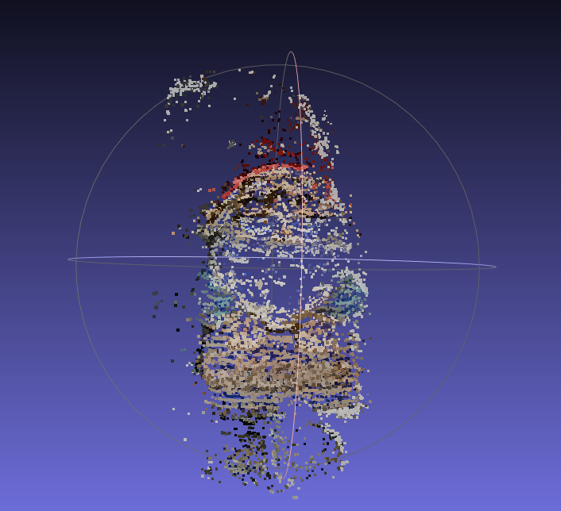 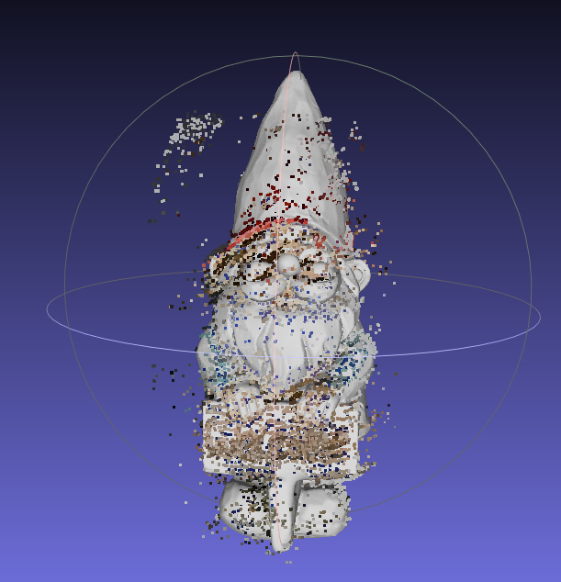

compare my result with the ground truth:

