**Midterm Project**

**Create 3D points from cast shadows on a 3D object**

**1.Goal:**

The goal is to transform each red shadow in the 55 images into real three-dimensional space and save their coordinates as a point cloud.

**2.Solution:**

Main flow:

1. Image Loading and Color Segmentation:

Firstly, we read the images and convert them to the HSV color space to define the range of red more easily. Next, we create a mask using color segmentation to extract the regions of red shadows.

1. Contour Extraction and Corner Coordinate Calculation:

By applying morphological transformations (dilation and erosion) to the mask, we can better define the shape of the red regions. Then, we find the contour boundaries of the red regions and calculate the coordinates of the four corners, which will be used for subsequent perspective transformations

1. Perspective Transformation and Three-dimensional Coordinate Calculation:

First, we use perspective transformation to map the 2D image to real 3D space. Using the known 3D coordinate system and relationships between the four corners in the image, we calculate the transformation matrix and project the 2D image into 3D space.

x: Subtracting 27.5 adjusts the coordinates for proper positioning.

y: Mirror flipping shifts the image origin from top-left to bottom-left for standard 3D orientation.

z: Similar mirror flipping moves the image origin from top-left to bottom

left.

1. Saving Point Cloud:

Finally, we save the coordinates of all computed 3D points to an XYZ file, forming point cloud data. This completes the transformation from images to three-dimensional point clouds.

**3.Result**

My result:

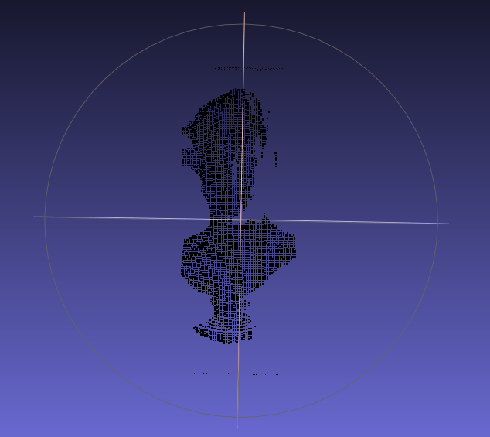 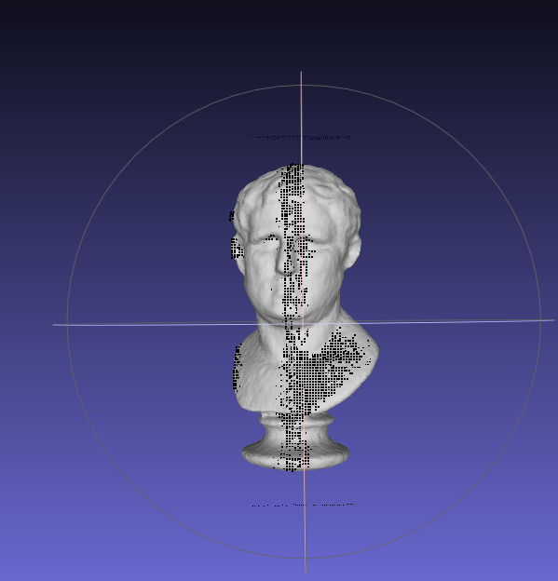

compare my result with the ground truth:

