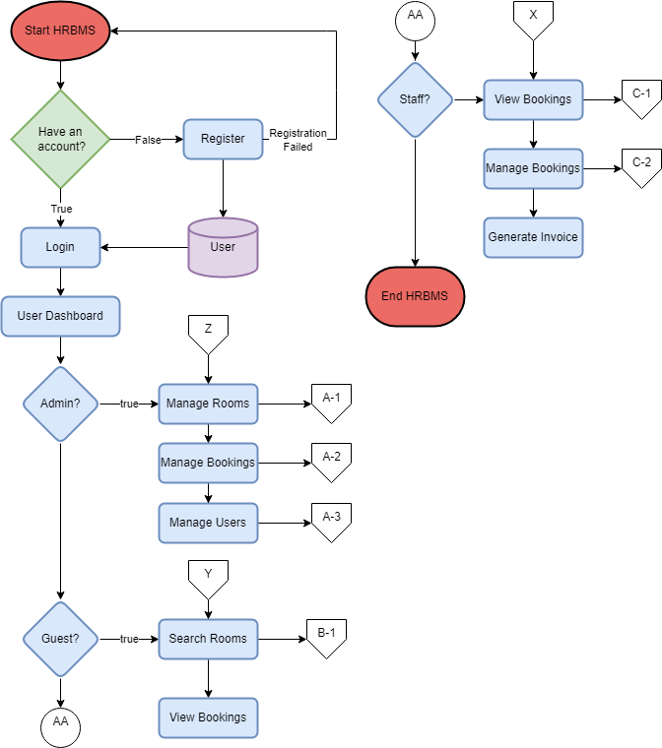FlowChart

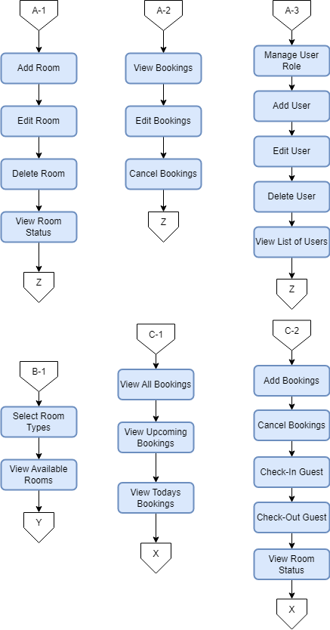

* The flowchart starts with the user logging into the system.
* If the user doesn’t have an account he/she can register.
* The user is then directed to a specific section of the system based on their role: Admin, Guest, or Staff.
* If the user is an Admin, they can manage hotel rooms, bookings, and users. They can add, edit, delete, and view room information, booking information, and user information.
* If the user is a Guest, they can search for available rooms based on their preferences and can book a room with a help of a staff.
* If the user is a Staff member, they can view bookings and manage bookings, including adding bookings, editing bookings, canceling bookings, checking in guests, checking out guests, and viewing room status.