**CS3096 Computational Intelligence Laboratory**

**Assignment 5 17/**10/2018

1. Build and expert system for troubleshooting a device(of your choice). For example an expert system for trouble shooting a PC/Printer/Laptop. Implement the expert system using PROLOG /LISP . Also prepare a document that explains the user interface of the system(It should a manual that can be used for getting help in how to use your system. It should contain a clear title and problem definition).

(Example :

Title : An Expert system for trouble shooting a Personal Computer

Diagram for the rule base example:

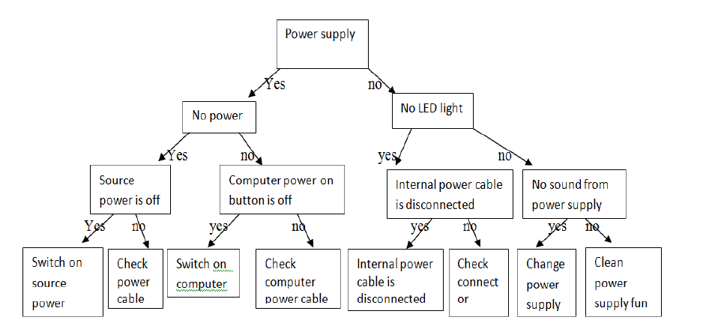

You can provide more information on using the user interface also).