FedControl

Starting FedControl
Double-Click on the MMS FedControl icon on the RTI Server desktop:
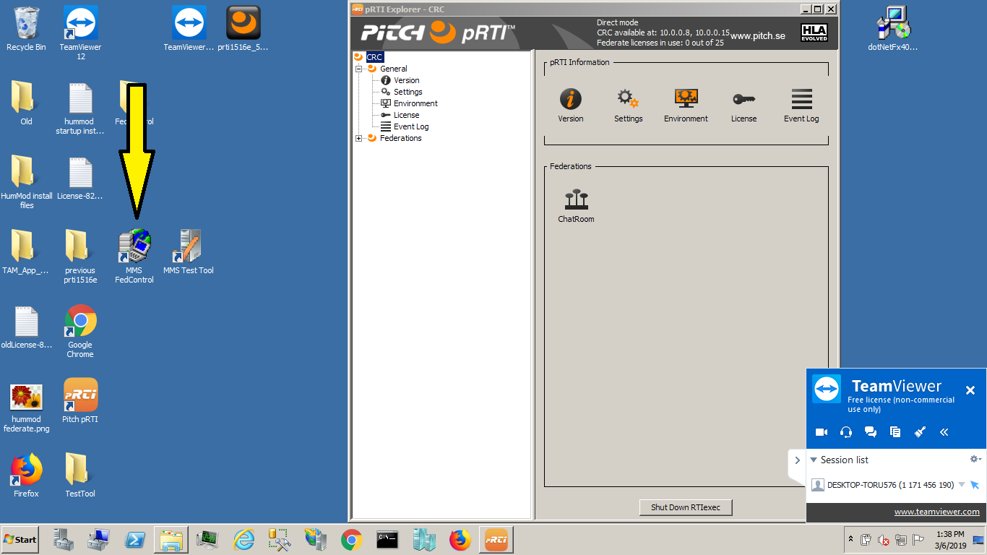

Basic Control
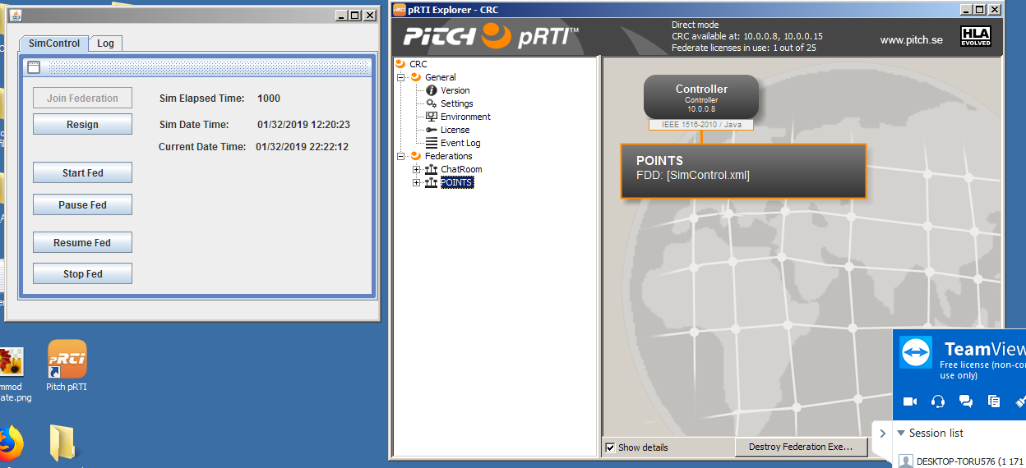
- Join Federation: Joins Fed Control to the federation. It will show up as “Controller” in the pRTI Explorer
- Resign: resigns Fed Control from the federation
- Start Fed: sends start interaction and begins sending the DateTime for the federation. It will currently update the DateTime every 5 seconds
- Pause Fed: sends pause interaction and pauses the federation clock. It does not reset the clock
- Resume Fed: sends resume interaction and starts the federation clock from where it last left off.
- Stop Fed: sends stop interaction and stops and resets the federation clock

TestTool

Starting TestTool
Double-click on MMS Test Tool icon on the RTI Server desktop:
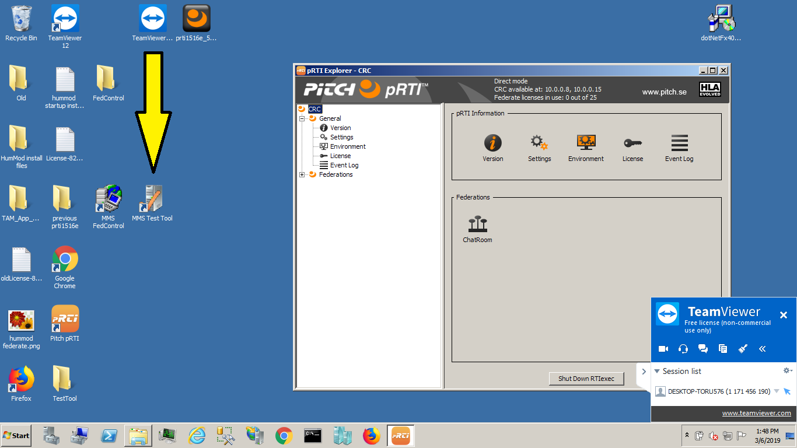

Joining/Resigning
On the SimControl tab:
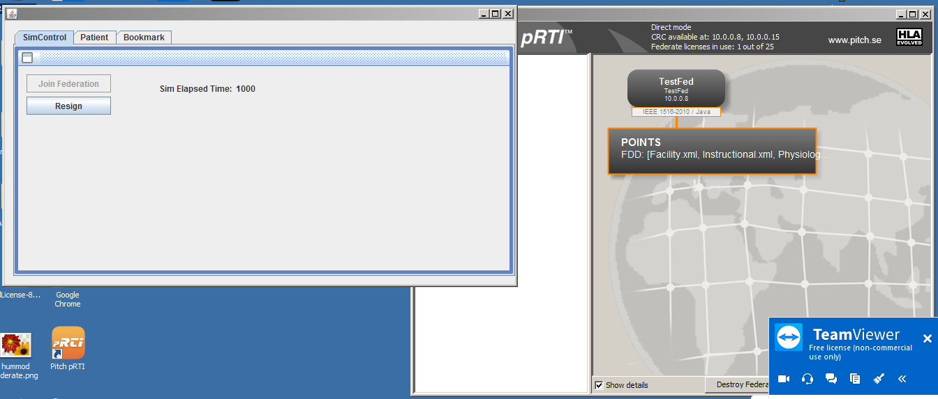
- Join Federation: Joins TestTool to the federation. It will show up as “TestFed” in the pRTI Explorer
- Resign: Resigns TestTool from the federation

Displaying Patients and Treatments
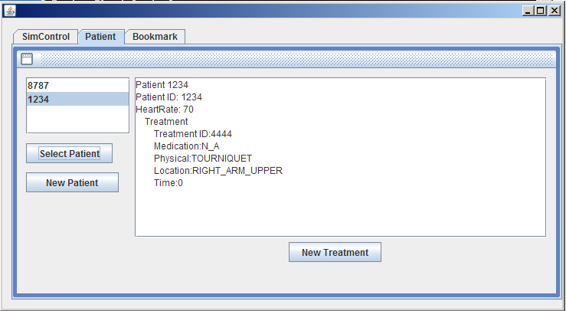
- Patients published in the federation will be listed in the list in the upper-left corner of the patient tab.
- To view patient and treatment details: select the ID and then press “Select Patient”
  - If the patient or treatment was not published by the TestTool, then it will display “Ghost” next the patient or treatment ID:
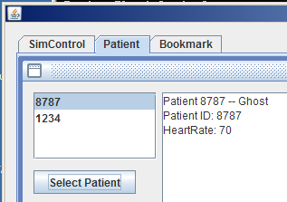

Creating new Patient
- Click the New Patient button
  - Enter patient ID (Mandatory)
  - Enter values for any of the other attributes that you wish to send
  - Press Add button

Creating new Treatment
- Click on the patient you wish to add a treatment to and press Select Patient
- Click New Patient
- Enter treatment ID
- Select Medication, Body Location, and Physical Treatment. NONE is a valid option
- Press Add
NOTE: you can add a treatment to a patient created by another federate
NOTE: ignore the patient id in the add treatment dialog. I need to pull that.

