**Home page – Change this design**

**Menu should come as per the latest design (New design will be provided by U)**

**ADMIN LOGIN**

1. Menu for Admin Login should be as below

* Dashboard
* Vendors
* Consultants
* Activity Logs (This should capture all the activity logs of both vendor and consultant)
* MIS Reports (this should have aging report against each vendor)
* Status (Admin will have Year and Month filter based on that admin should be able to see all the vendor list and against that status (Pending from Consultant side or Pending from Vendor side)
* Downloads ( Admin will be able to filter based on Year and month and get the final uploaded Compliance certificate)- Print option should be there.
* Notifications
* Settings (Admin should have access to reset the new password for both Vendor and Consultant)

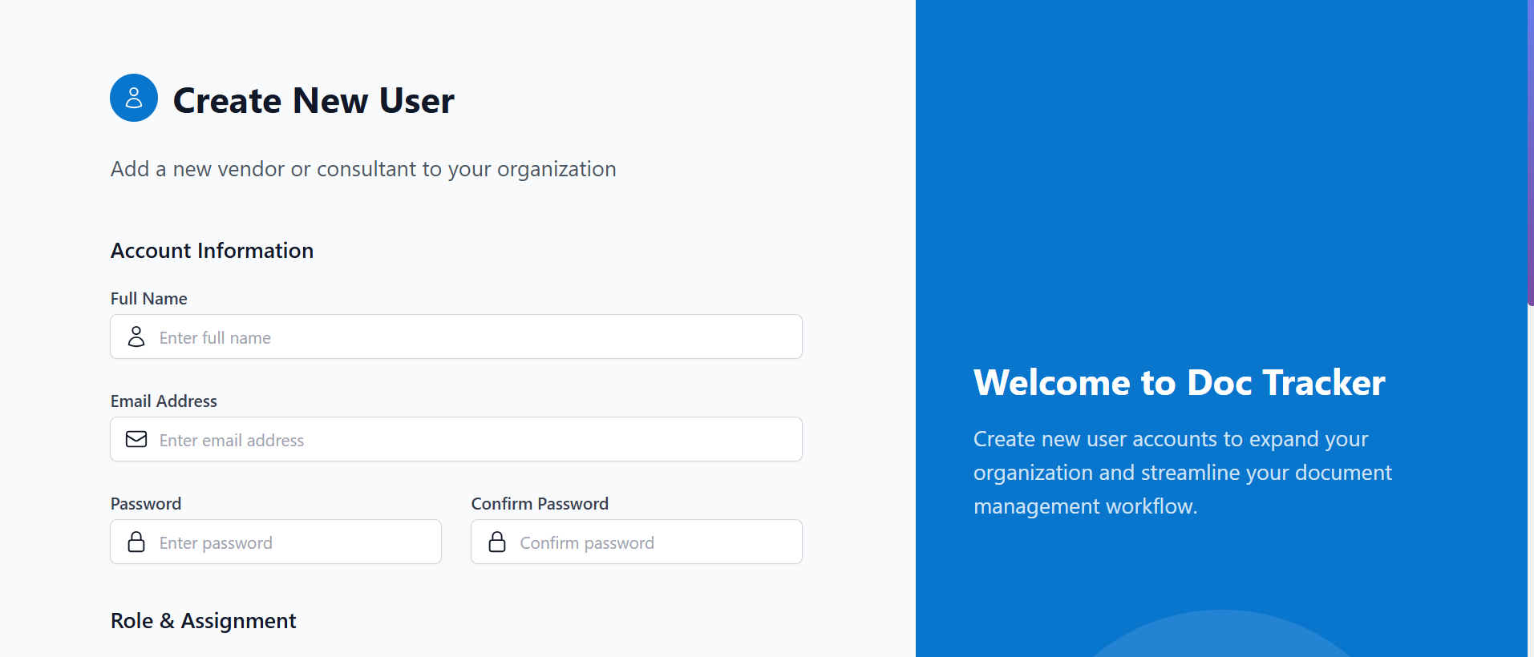

Please change Doc Tracker…

Top Banner design should be changed across all the logins.

1. This is not working. and, when the user clicks on forgot password, user should get the old password to their registered email id. **they should not reset to new password**.
2. Button should not go to Home Page instead login page of the user.

Login Approval count is showing wrong

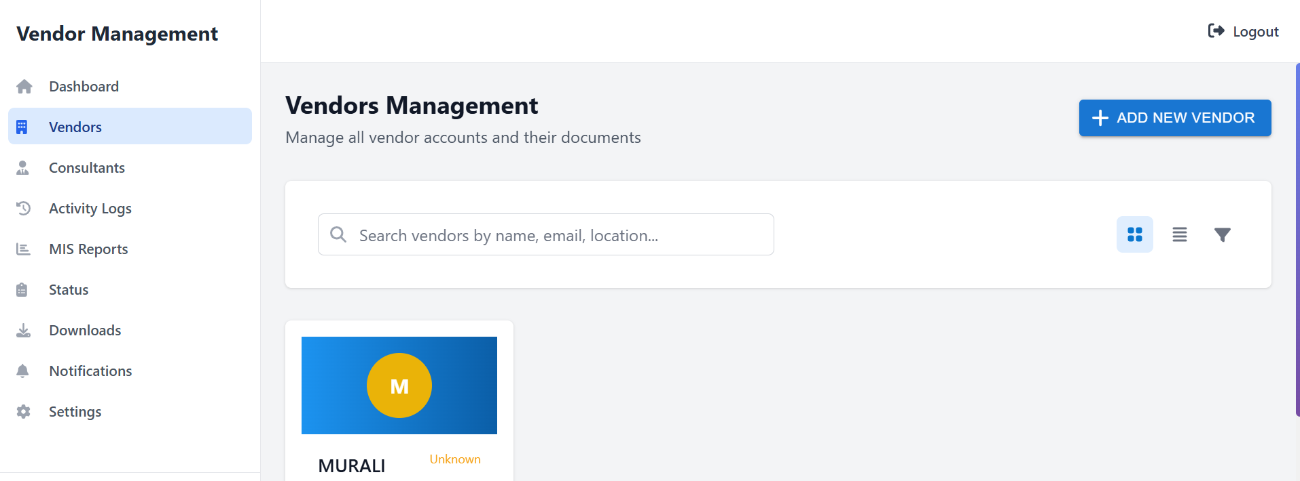

Add New vendor is not working

View, edit all the functionalities are not working

**We should be able to change the mapped consultant and edit basis details**

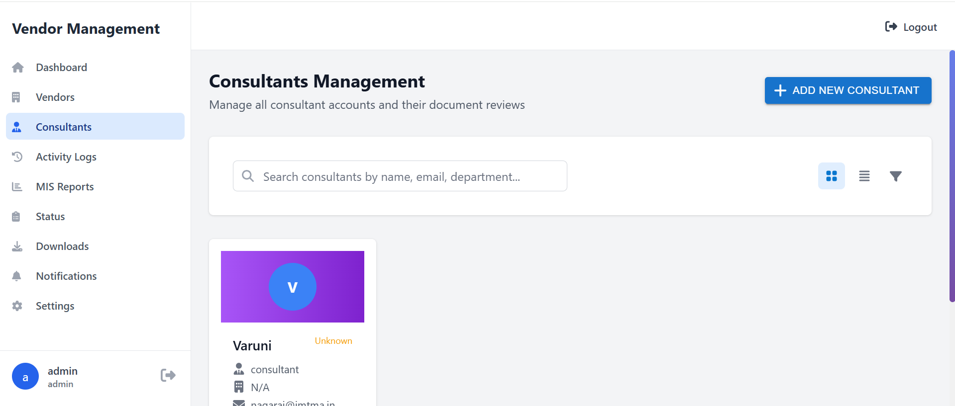

Same as Vendor, Consultants Menu ( Add new consultant, edit, view not working)

Not sure what do you mean by create test data?

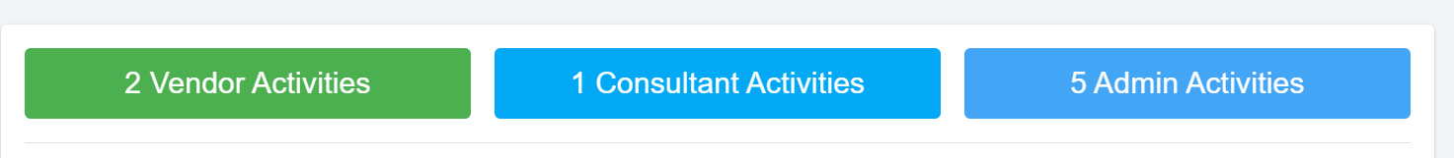Colour combination of both Consultant and Admin is same, pls change the color

Start date and end date when we filter data is not showing.

Use Gmail id ([imtmavms@gmail.com](mailto:imtmavms@gmail.com)) for sending emails

status page is not showing any data…

Downloads page is not showing any data…..

View, edit not working for both consultant and vendors

Vendors (Agreement Period option to edit in Admin page for every vendor) **this is very important**

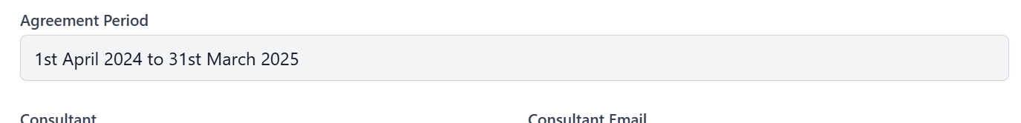

Even after unchecking of Requires login approval, it doesn’t allow the vendor to login directly.

**User Management is not showing in the left Menu.. Please add**

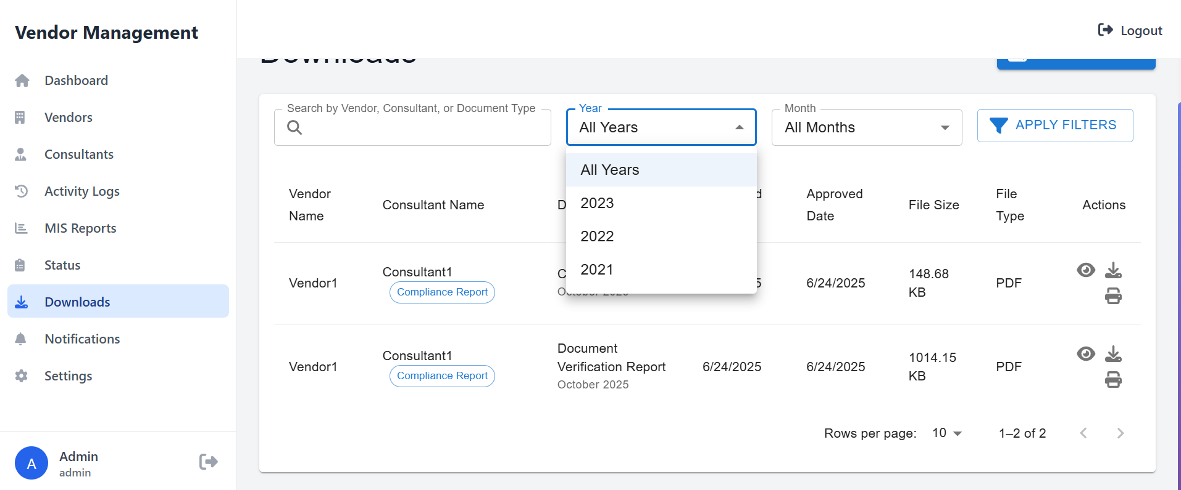

Years should start only from 2025, and also print and eye icon not working

Document status is blank

1. and one main thing is vendor approval is done only once after creation,,, later there will not be any appovals for loging in... this is important
2. Agreement period for each vendor should be made available in the admin portal so that we can edit every year