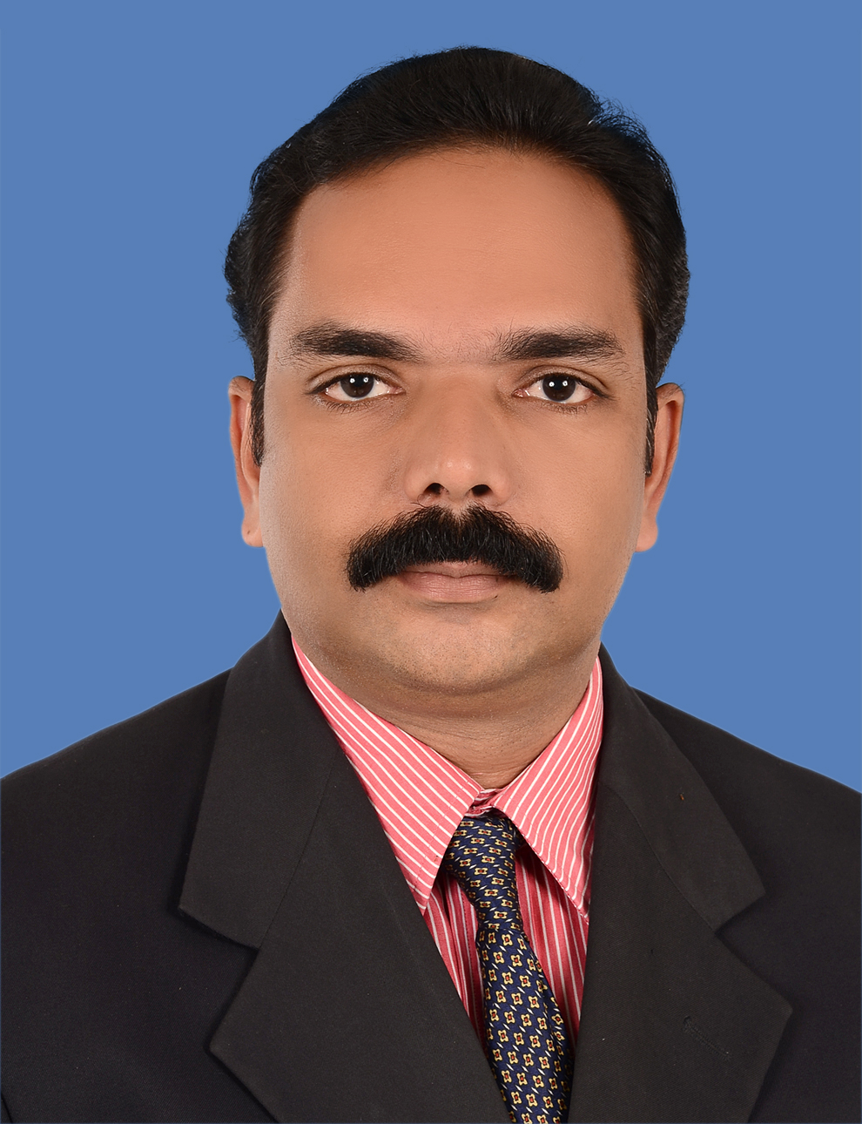
‘Udaya Bhavan’ ,  Puthukkari,  Chirayinkeezhu PO,  Thiruvananthapuram,  Kerala - 695 304 | Phone : Resi: +91-470-2642 656  Mobile: +91 83010 29469  : +91 98951 26469  E-mail : soorajgouridas@gmail.com  : joygdas@yahoo.com
Sooraj Kumar.G
Summary

Motivated with strong work ethics, high levels of discretion & reliability. Eager to contribute to a progressive organisation. 23 years’ experience in Accounts and 3 years experience in Marketing. The ability to manage, discipline combined with dedication and faith helps me achieve my goals.

Work Experience
1. Presently Working as Accounts Manager in SYON SUPPLIERS Group of Firms,
Distributors for Crompton Greaves Consumer Electricals Ltd., Britannia Industries
Limited & Voltas Ltd. since September 2016

2. Worked as Accounts Manager in Goodwill Group of Concerns,
Manufacturers of PVC Pipes & Water Tanks, KINFRA PARK, Trivandrum from
December 2015 to August 2016.

3. Worked as Accounts Manager in M/s. Siddhi Vinayak Group of Firms,
Authorized dealers for PIAGGIO VEHICLES PRIVATE LIMITED and GREAVES
COTTON LTD, Trivandrum from May 2011 to Dec 2015.
4. Worked as Accounts Officer in Hercules Automobiles Int’l (P) Ltd., Authorised MARUTI SUZUKI Dealer, Trivandrum from Dec 2007 to April 2011.
5. Worked as Accountant in GEFAB - Group of Companies - Contractors, Trivandrum from December 1999 to November 2007.
6. Cyber Corporation - Dealers in Computer Peripherals, Trivandrum from November 1997 to October 1998
7. K.C. Mathew Sons - Timber and Sanitary Ware Dealers, Trivandrum, from June 1995 to October 1997.
8. Worked as Audit and Accounts Trainee with M/s. Iyer & Nair Chartered Accountants, Trivandrum from September 1993 to April 1995.

Independent Responsibility of:
- Maintaining Accounts of Trading, Manufacturing, Contracting, Distribution and
Automobile Dealership Business & Services.
- Bank Reconciliation, Branch Accounting & reconciliation.
- Maintaining of Debtors & Creditors Ledger and Debtors Control Account.
- Preparing projected Financials for Banks & Financial Institutions.
- Preparing and Filing of Sales Tax and Service Tax Returns & TDS.
- Preparing Trial Balance, Profit & Loss Account and Balance Sheet.

Education - Academic
1. B. Com (Accounting) Degree from University of Kerala , Trivandrum in 1993.
- Passed Pre-Degree from University of Kerala, Trivandrum in 1990.
Technical
1. Passed Diploma in Office Automation (MS Word and Excel) from Multi Data Computer Education, Trivandrum in 1998.
2. Data Entry & Console Operation from LBS Centre for Science & Technology, Trivandrum in 1993.
- Technical experience includes working experience with MS Word, Excel and Tally’s Accounting Packages - Version 4.5, 5.4, 6.3 Release 3.1, 7.2., Tally 9 Gold Release 1 Multi User and Tally ERP 9 Release 6.4.9
Personal Details
Father’s Name : M. Gouridas
Date of Birth : 20th May, 1972
Nationality : Indian
Driving License No. : 21/1246/1995
Passport No. : L 3023611 - Valid up to 29.07.2023
Languages Known : English, Hindi, Malayalam and Tamil
Marital Status : Married
Interests and Hobbies : Driving, Music, Cinema, Playing Chess and Badminton.
Present Address : PNRA 617, Prasanth Nagar,
Pongummoodu, Thiruvananthapuram.

Reference
K Sreedhar (Managing Director),
Siddhi Vinayak Automobiles,
Kulathoor PO., Thiruvananthapuram.
Mob. 93888 33212

Chirayinkeezhu

10.01.2020 SOORAJKUMAR.G

