Resume

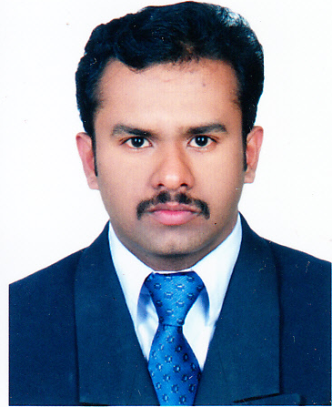
SREEJUMON. S
T.C 49/2139(1),
Ashvilla,Studio Road
Nemom,
Trivandrum, pin-695020
Kerala, India - :
E-mail: sreejumon214@gmail.com

Mob No india-0091 9946237704

Professional Summary

Highly motivated Senior Accounts Executive experienced in automotive , Construction & Geo technical Engineering operations field.

Skills- Logistics Coordination, Sales and Business Development

CURRENT POSITION:

Working as Senior Business Development Executive Finance & Purchase Coordinator ( Handing Site Audit )in RTF INFRA PVT LTD (Trivandrum –India) Jun 2019 – Present..

WORK EXPERIENCE:GULF

Saud Bahwan-Toyota Oman & UAE (Automobile Industry) as a Sales Consultant (Handling logistics & sales operations) in International Re Export Business- from June 2012- to May 2016.

- Dealing with the logistics operations (sales coordination) of Toyota, Lexus, Hino and Daihatsu spare parts.
- Dealing with customers from all over the world, especially African, Iraq & GCC countries.
- Contacting customers for orders, quotations and payments.
- Enhancing relationship with the customer ensuring smooth flow of business.
- Determined the most cost-effective procedures and routes for shipments by (Sea & Air).
- Gathered, logged and monitored all shipping data & Customs documents.
- Managing shipment schedules to maximize productivity and cut costs.
- Communicated with dispatchers, warehouses and customers regarding Re export.
- Documented all the necessary documents like BL, COO, Invoice and Packing List.
- E-mailed suppliers, carriers and customers with shipping updates.
- Documented all customer inquiries and comments thoroughly and quickly.
- Responded to all customer inquiries& orders thoroughly and professionally.
- Greeted customers in a timely fashion, while quickly determining their needs.
- Answered customer questions about Price, stock and dispatch details,
- Monitoring International Fund Transfer from customers for shipments.
- Coordinating with local cargo agents for re exporting.
- Maintaining customer accounts statement and reconciling with company accounts.

WORK EXPERIENCE:INDIA- KERALA

- Three Years Experience in (Crescent Construction Company (India) /Eurotech General Contracting LLC (UAE) as Senior Executive Finanace & Site Operations( ISO 9001 Certified Company) Contracting Govt Projects of (MES, IISER,BSNL,CPWD,NBCC,KIIFBI,KITCO,NBCC)

- Seven Years Experience in India (Kerala) (Automobile Industry –Accounts & Administration In charge (Passenger cars dealer of (TATA &FIAT) & HONDA, from May 2005 to May 2012.

- Sales Co-ordination of cars coming for service.
- Achieving targets based on the number of cars.
- Implementing ideas for betterment of customer service.
- Verification of Cash Book, Petty Cash Book, Bank Book, Ledger, Journal Register.
- Preparation of Payment Vouchers, Receipts, Debit note and Credit note.
- Creditors Reconciliation (and aged Analysis).
- Reconciliation of Bank accounts.
- Recouncilation of Receivables and Payables statements.
- Preparation of sales Tax and Service Tax reports.
- Preparation & Verification of daily sales & purchase proceeds through (Tata Motors) Online software (Siebel).
- Monthly report generation – P & L, B/S
- Preparation of salary Slip and final settlement of employees.
- Maintaining daily Fund Flow analysis and othor Banking Transactions.
- Preparation of Pay roll.
AREAS OF INTEREST:

- Sales coordination & customer support.
- Re export in International business.
- Accounts reconciliation.
- Monitoring International sales.

Education

MBA Finance (ICFAI-Tripura)
Pursuing.

Kerala University — Bachelor of Commerce (B.com)
2005-Pass Out

IT SKILLS:

- Tally 9(with working experience) & (Advanced Diploma in Computerized Financial Mgt)
- Well versed with MS Office & Internet Applications.
- Experience in Online Web Portals of TATA Motors (India) &Toyota (Japan).

PERSONAL PROFILE:

Age & Date of Birth : 34yrs., 05th Jan 1985

Marital Status : Married

Father’s Name : Sreekantan Nair.V

Languages Known : Malayalam, English, Hindi,

Pass Port No & Exp Date N1612722, 05/08/2025
:
Indian Driving License Exp 2006- 2026

DECLARATION

I, SREEJUMON S hereby declare that all the above particulars stated are true to the best of my knowledge & belief and I further states that no material fact has been distorted or concealed myself.

(SREEJUMON)

