CURRICULAM VITAE
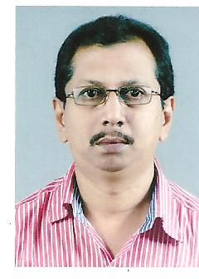

JAYAKUMAR.S.
TC-14/431(2)
KUMARAPURAM
THIRUVANANTHAPURAM

Phone -6282138650
Email- 1962jayakumar@gmail.com

OBJECTIVE :- To obtain position as Accountant

EDUCATIONAL ATTAINMENT

Bachelor of Commerce 1983 University of Kerala,

COMPUTER SKILLS

Proficient in MS Office package, Excel and Accounting package such as Peachtree , Tally etc.

INFORMATIONS :-

Nationality : Indian
Religion : Hindu
Date of Birth : 30-10-1962
Marital Status : Married

EXPERIENCE

Since December 2015 : Ben Aqua Products, Kochuveli,Trivandrum,
as Cashier/Accountant

Since January 2013 : M/s ZincoSteel Fabrication LLC, DIP,
Dubai, UAE, as Accountant

Since January 2009 : M/S Golden Arrow Industries,Sharjah,UAE
(Interior Decoration Company)
as Accountant

Since Aug 2003 to Jan 2009 : Accountant and Financial controller
With Sree Bhadra Pictures (P) Ltd
Trivandrum, Kerala. India

1996 Jan to Aug 2003 : Accountant with M/S Kuttikkattil
Enterprises, Thekkummoodu, Kerala
Trivandrum.The company has been
a prime Trading co.

1989 Feb to 1996 Jan : Accountant with M/S JP Associates,
Thycaud, Trivandrum, Kerala, India.

1985 Oct to 1989 Feb : Training in accounting and auditing
with a Charterd Accountant’s firm.

PERSONAL SKILLS & COMPETENCES

Languages Malayalam, English

Organization Skills Conscientious and responsible in
work, Self-motivated and hard
working, Mature personality with
good interpersonal skills
Ability of working independently and
as a team.

Reference: Available upon request.

