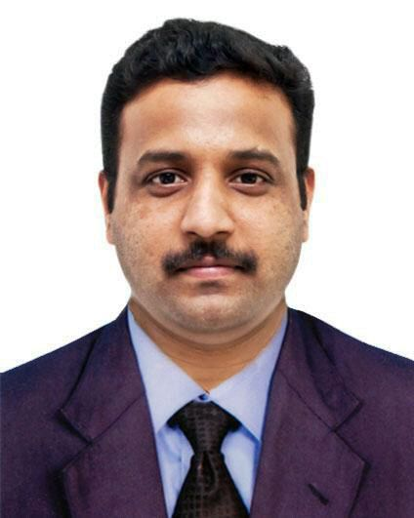
Gopa kumar.S
Devdeyam
Bhoothakulam P.O
Kollam, Kerala
Mobile: 0091- 8086279697
E-mail: gopanatmaj@gmail.com
Objective

- Intend to build a career with leading corporate of Hi-Tech environment with committed and

dedicated people, which will help me to explore myself fully and realize my potential. And

willing to work as a key player in challenging and creative environment.

Academic Credentials

- Graduation B.com (Kerala University-2001-2004)

- Higher Secondary (Kerala Higher Secondary Examination Board1998-2000)

- Secondary School Leaving Certificate (Kerala Board-1997)

Additional Qualifications

- Post GraduatDiploma in Computer Application (MS Office, Office automation, Visual Bapsic, Oracle etc.)

- Proficient in Computerized Accounting & Payroll (Microsoft Navigation (ERP), MYCOM Smart Finance (ERP), Fact Sharp (Payroll), X-infinity (Payroll).

Work Experiences

Ansar Group of Companies: One of the leading multi national retail business groups have more than 1,000 million dirham yearly turnover.
Ansar Gallery-Qatar&Bahrain as Accounts Officer from January-2008 to March-2020
(Renowned shopping mall in Qatar & Bahrain)

Financial Management:
- Maintain day to day financial control of the service within the budget heads and day to day decisions on the running of the organization.

- Maintain accounts payable and receivable, internal branch transactions and import formalities.

- Ensure that all finances are properly administered and monitored including credit control.

- Advice the proper allocation of resources and ensure that appropriate financial regulations and controls are in place and in use at all times.

- Prepare and review of detail budgets and evaluation on cost reduction opportunities.

- Make regular reports on income and expenditure and variations from budgets.

- Monitoring, analyzing and interpreting cash flows.

- Conduct periodical audits and liaison with external auditors.

- Ensure that each subordinate staffs are adequately managed and supervised.

- Undertake such other duties and tasks may lien with scope of this post.

V.S. Trading company as Accounts Executive from November 2004 to December 2006.

Profile: - Reporting:-Accountant

- Responsible for Bank Procedures.

- Managing Intra-Company Transactions.

- Continuous monitoring & control of expenses.

- Preparing, Screening and vouchering the Bills.

- Responsible on Creditors Account maintaining.

- Assisting in Internal Check & Facilities Management.

- Assisting in Stock Audits and preparation of Variance reports.

- Responsible for Accounts Payables, Receivables & Payroll Processing.

Personal Details

- Father's Name : Mr. G. Saidharan Pillai.

- Permanent Address : Devadeyam.
Bhoothakulam P.O.
Kollam, Kerala-691302

- Date of Birth : 11-05-1982.

- Gender : Male.

- Nationality : Indian.

- Marital Status : Married.

- Languages Known : English, Hindi and Malayalam.

