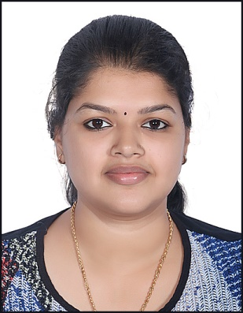

REVATHY.M.R
Mob : +91 8281227416
+91 8075101040
revathysanthosh6505@gmail.com
Nationality: Indian, DOB: 1994

CAREER OBJECTIVE
Seeking a position to make use of my skills , abilities and experience in accounts and audits that offers a high professional growth and to secure a position in an organization that would fully employ my excellent communication, public relations, problem-solving & leadership skills, combined with my knowledge of Banking and Financial Accounting
.

CAREER SUMMARY

A highly successful Accounts Associate pursuing Bachelor Degree in commerce with computer application with
3 years of experience in all aspects of accounting ,controlling banking operations ,cash operations management. Easy going nature & able to work with all members of staff regarding finance issues to resolve problems. Proven ability to manage multiple assignments efficiently while meeting tight deadline schedules.

EMPLOYMENT EXPERIENCE

1 year experience as Accountant in Co-operative Bank , India

1 year experience as HR Manager in Trinity construction, Dubai

2 year experience as Assistant Accountant in The Monarch Laundry & Dry Cleaning LLC, Dubai

Accounting Associate

❖ Work Profile

- Challengeable Expertise in all aspects of accounting
- Preparation of books of accounts
- Well expertise in Internal auditing and assisting Audit works
- Handling all bank transactions and Bank reconciliation
- Stock supervision and maintaining
▪ Responsible for receiving, processing and recording customer invoices using accounting software and system
▪ Accounts Receivable and Accounts Payable-
Communicating with vendors, customers and different departments in their organization to resolve outstanding
payments and clarify issues related to accounting policies and procedures.
▪ Handling vendor queries.
▪ Extracting weekly reports & daily reports for management.
▪ Interact with suppliers and Business unit
▪ Co-ordinating with payment team for adequate payment.
▪ Provide adequate information to the Invoice team to prepare accruals during the month end.
- Preparing tax report

EDUCATION AND CERTIFICATION

University of Kerala, India 2014

❑ B.Com – Computer Application

Government of Kerala 2011
❑ Higher Secondary-Commerce

SPECIAL SKILLS

Computer & IT –

★ Accounting Package-Tally
★ Microsoft Office™ (Word™, Excel™ PowerPoint™)
★ Windows™ (7™, XP™, 8™)

Language –

English – Fluent
Malayalam – Native
Tamil – Fluent

Strength –

Self-motivation and honesty

Decisive and forward thinking, with strong vision and strategic capability.

Ability to network and liaise with clients at every level.

Capable of operating within highly competitive industries.

Excellent communication skills both written and verbal

Motivational and credible with highly effective interpersonal skills

Ability to persist with a task until objective is achieved

Strong and quick acquiring of new technologies

PROFESSIONAL DETAILS

Date of Birth - 11th January 1994

Marital Status - Married

Passport Number - N0641098

Passport Expiry Date - 2025

Declaration:

I hereby declare, that the above written particulars are true to the best of my knowledge and belief.

Date : REVATHY. M.R

