My CV–MBA With 10+ years of Accounting Experience
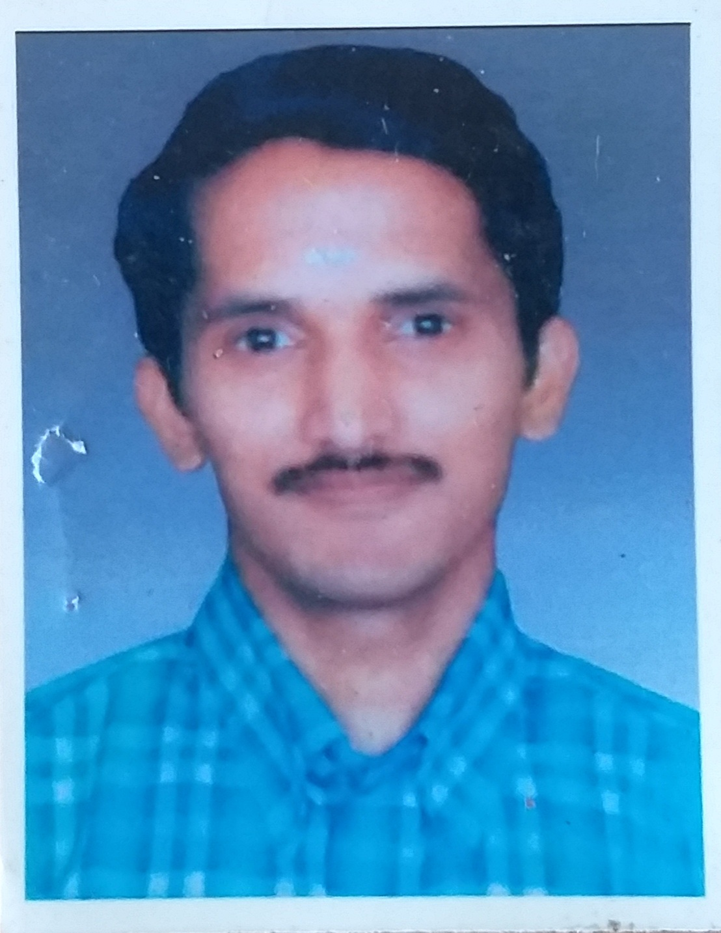
Sujith Raghavan
“Thulasidalam”
KP 12/23(B),Vadakekotta,
Ammannagar,Karakulam.P.O
Thiruvananthapuram.PIN-695564
Mobile No:94475 29600Email : suji_pr@rediffmail.com

CAREER OBJECTIVE:

To serve an organization as a professional with full commitment through best individual and organizational efforts to have continuous self-development by way of learning and exposure to new challenges.

WORK EXPERIENCE & JOB PROFILE

07/2010-Present Poomkudy Motors Pvt Ltd,Thiruvananthapuram
(Authorised distributors of Trucks and Vans)
I am the Senior Accounts Executive in this ISO 9002 Certified Compnay.Key responsibility areas:-
- Preparation of Bank Reconciliation statement
- Preparation of Receivable and Payable statement
- Liasioning with Customers and following-up payments
- Purchase and sales accounting
- Reconciliation of Customers and Vendors Account
- Cash Management
- Preparation of salary statement
- Assisting Internal audit and statutory audit
- Interbranch Reconciliation
- Other Assignment given by the management
(The accounting package used here is Oracle financial)

07/2009-06/2010 Alfa Steel Building Solutions,Bangalore
(Manufacturers of Roofing sheet)
Key responsibility areas:-

- Reconciliation of Bank Account and Dealing with Bankers
- Preparation of MIS
- Preparation of Receivable and Payable statement
- Liasioning with Customers and following-up payments
- Purchase and sales accounting
- Reconciliation of Customers and Vendors Account
- Petty cash Management
- Assisting auditors during Internal audit and Statutory Audit
- Preparation and filing of Vat,Service Tax and TDS
(The accounting package used here is Tally ERP 9)

09/2007-02/2009 Pursuit Technologies Pvt Ltd,Bangalore
Accounts Executive (Premium Business Partner of HP Products)

Key responsibility areas:-

- Preparation of Trial Balance & Balance Sheet.
- Reconciliation of Bank Accounts and dealing with Bankers.
- Preparation of Receivables and Payables and Follow up
- Computation of salary
- Petty cash Management
- Finalization of accounts and dealing with Auditors.
(The accounting package used here is Tally )

03/2005-08/2007 Faxtel Systems India Pvt Ltd,Bangalore
Accounts Executive (Traders of IT Products)

Key responsibility areas:-

- Purchase and sales accounting
- Reconciliation of Bank Accounts and dealing with Bankers.
- Computation of salary
- Petty cash Management
- Finalization of accounts and dealing with Auditors.
- Preparation of MIS
- Preparation of Receivable and Payable statement
(The accounting package used here is Tally )

11/2003-02/2005 All Seasons Herbs Pvt Ltd,Bangalore
Accounts Executive (Manufacturers of Ayurvedic products)

Key responsibility areas:-

- Purchase and sales accounting
- Reconciliation of Bank Accounts and dealing with Bankers.
- Computation of salary
- Petty cash Management
- Preparation of MIS
- Preparation of Receivable and Payable statement
(The accounting package used here is Tally )

04/2002-10/2003 Intra Vidyut Ltd,Bangalore
Accounts Executive (Manufacturers of Transformers)

Key responsibility areas:-

- Purchase and sales accounting
- Petty cash Management
- Preparation of MIS
- Preparation of Receivable and Payable statement
- Assisting auditors during Internal audit and Statutory Audit
- ESI & PF Calculation
(The accounting package used here is Tally )

04/1999-03/2002 B.Prashanth Hegde & Co
Audit Assistant Chartered Accountants,Bangalore

Nature of Work
Statutory and Internal audits of public and private ltd companies

Statutory Audit clients
Gina Engineeing Pvt Ltd,HCL Infosystems,Metal Structures Pvt Ltd

Internal Audit clients
Cimar Infosystems,ITC Infotech and Sasken Telecommunicatons

QUALIFICATIONS:
MBA (Specialised in Finance from Symbiosis,Pune)
BCom from Calicut University
SAP(Finance Module from Global Infotech,Bangalore)

TRAITS:

I take my responsibilities very seriously and prioritize them highly.
I value other person highly as a human being.

PERSONAL PROFILE:

Date of Birth : 20th May 1977

Marital Status : Married

Language Known : English, Malayalam, Hindi

Permanent Address : Punchadath House,
P.O Moorkanikkara
Thrissur(DT),Kerala(ST)-680752

Declaration : I hereby declare that the above mentioned information is correct to the best of my knowledge.

Date :

Place : Sujith Raghavan

